**Trophic transfer of PFAS potentially threatens vulnerable Saunders's gull (*Larus saundersi*) via the food chain in the coastal wetlands of the Yellow Sea, China**

Dini Zhang1,2,a, Wei Liu1,2,3,a*, Yu Xin4, Xiaoshou Liu3, Zhenhua Zhang1,2 and Yan Liu1,2**

1State Environmental Protection Key Laboratory of Biodiversity and Biosafety, Ministry of Ecology and Environment of China, Nanjing, China

2Nanjing Institute of Environmental Sciences, Ministry of Ecology and Environment of China, Nanjing, China

3Institute of Evolution and Marine Biodiversity, Ocean University of China, Qingdao, China

4Department of Ecological Monitoring, Nantong Environmental Monitoring Centre of Jiangsu Province, Nantong, China

Correspondence

*\** Correspondence to: Wei Liu, Nanjing Institute of Environmental Sciences, Ministry of Ecology and Environment of China, Nanjing, China

*\*\** Correspondence to: Yan Liu, Nanjing Institute of Environmental Sciences, Ministry of Ecology and Environment of China, Nanjing, China

E-mail addresses: lw_ecology@163.com (Wei Liu), [liuyan@nies.org](mailto:liuyan@nies.org) (Yan Liu)

aThese authors contributed equally to this work.

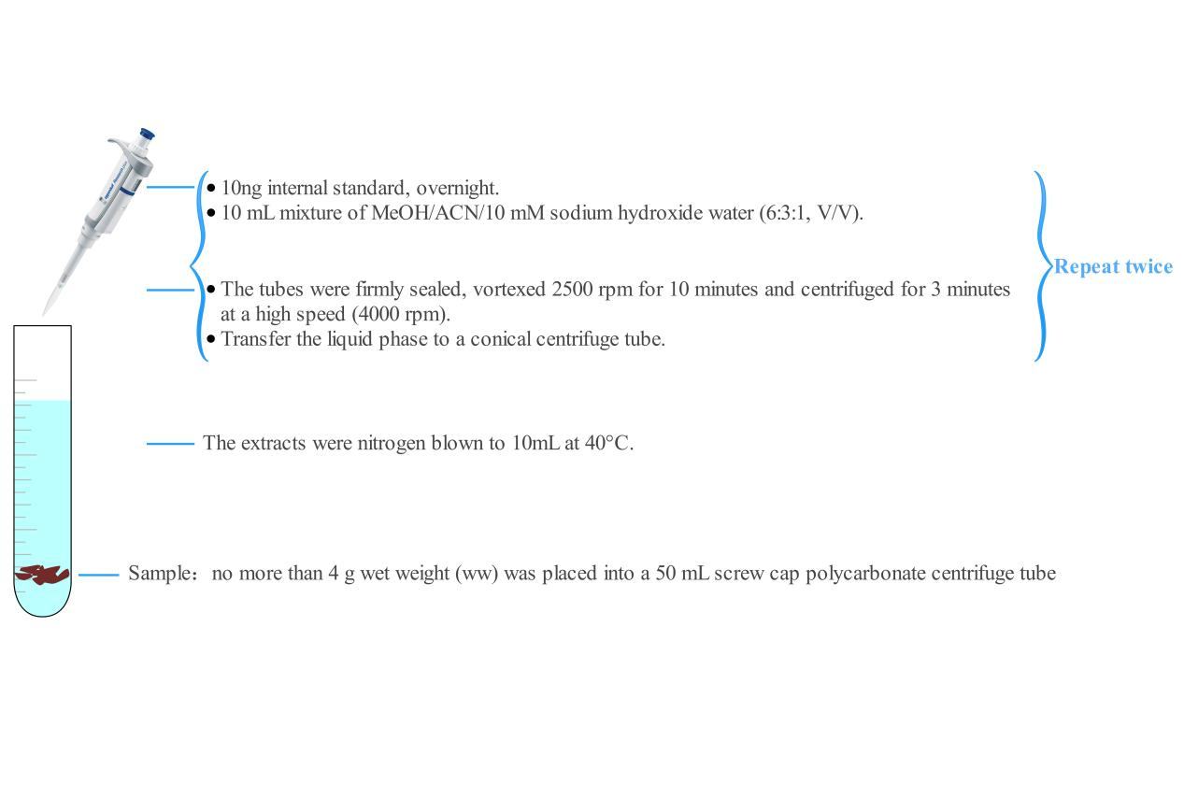

**Figure S1**. Sample extraction methods

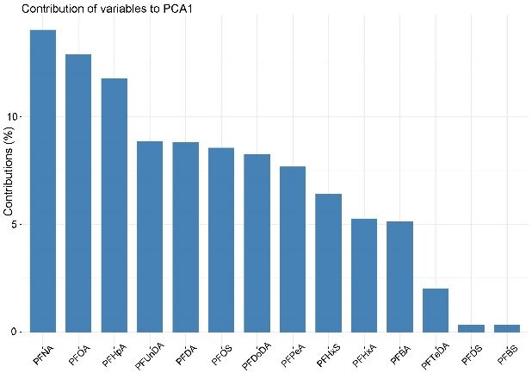 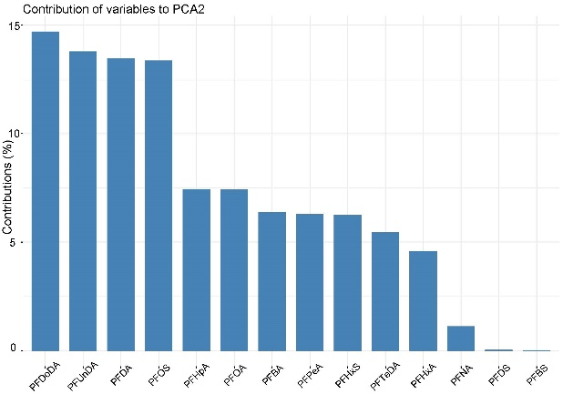

**Figure S2**. The contribution (%) of variables of two principal component

**Table S1**. UHPLC-ESIMS/MS conditions for target PFAS

|  |  |  |  |  |
| --- | --- | --- | --- | --- |
| Instrument | Waters Acquity UHPLC system (Milford, MA, USA) coupled to a Xevo Triple-Quadrupole (Xevo-TQD) AB SCIEX 5500 mass spectrometer (SCIEX Corp, Framingham, MA, USA) with an electrospray ionization (ESI) source | | | |
| Analytical column | Shimadzu Shim-pack G1ST-C18 column (2.1 × 100 mm, 2 μm) | | | |
| Column temperature | 40℃ | | | |
| Injection volume | 5 μL | | | |
| Mobile phase | A: methanol; B: 5 mM ammonium acetate in ultrapure water | | | |
| LC Gradient | Duration (min) | Flow (ml/min) | A (%) | B (%) |
| 0.8 | 0.3 | 40 | 60 |
| 2.9 | 0.3 | 90 | 10 |
| 0.9 | 0.3 | 90 | 10 |
| 1.4 | 0.3 | 40 | 60 |
| 2 | 0.3 | 40 | 60 |
| ESI detection parameters | Curtain gas at 35 psi  Ion spray voltage at 4500 V  Temperature at 500℃  Ion source gas 1: 50 psi  Ion source gas 2: 60 psi  collision gas: "medium." | | | |
| MS detection parameters | Entrance potential at 10 V  Collision cell exit potential at 13 V  Declustering potential at 80 V | | | |

**Table S2**. Precursors and productions at optimum collision energy (eV) values for 14 PFAS and 9 surrogate standards.

|  |  |  |  |  |  |
| --- | --- | --- | --- | --- | --- |
| Analytes | Molecular weight | Precursorion（m/z） | Production（m/z） | Collision energy (eV) | Retention time (min) |
| PFBA | 214.04 | 212.70 | 168.70* | 11 | 2.81 |
| PFPeA | 264.05 | 263 | 219*/175 | 15,15 | 3.32 |
| PFHxA | 314.05 | 313 | 269*/119 | 11,18 | 3.63 |
| PFHpA | 364.06 | 363 | 319*/169 | 15,15 | 3.87 |
| PFOA | 414.07 | 413 | 369*/169 | 13,21 | 4.09 |
| PFNA | 464.08 | 463 | 419*/169 | 16,15 | 4.28 |
| PFDA | 514.08 | 513 | 469*/269 | 14,16 | 4.50 |
| PFUnDA | 564.09 | 563 | 519*/269 | 13,21 | 4.72 |
| PFDoDA | 614.10 | 613 | 569*/269 | 15,25 | 4.96 |
| PFTeDA | 714.11 | 713 | 669*/169 | 15,31 | 5.48 |
| L-PFBS | 300.19 | 299 | 80*/99 | 33,42 | 3.34 |
| L-PFHxS | 400.20 | 399 | 80*/99 | 40,35 | 3.86 |
| L-PFOS | 500.22 | 499 | 80/99* | 64,34 | 4.25 |
| L-PFDS | 600.22 | 599 | 80*/99 | 50,45 | 4.96 |
| 13C4 PFBA | 217 | 217 | 172* | 11 |  |
| 13C2 PFHxA | 315 | 315 | 270* | 11 |  |
| 13C4 PFOA | 417 | 417 | 372* | 13 |  |
| 13C5 PFNA | 468 | 468 | 423* | 16 |  |
| 13C2 PFDA | 515 | 515 | 470* | 14 |  |
| 13C2 PFUnDA | 565 | 565 | 520* | 13 |  |
| 13C8 PFDoDA | 615 | 615 | 570* | 15 |  |
| 13C4 PFHxS | 403 | 403 | 103* | 35 |  |
| 13C4 PFOS | 503 | 503 | 99* | 34 |  |

Note: * Quantification ion

**Table S3**. Matrix spike recoveries (RE) of target compounds for five sample matrix with the relative standard deviation (RSD) values

|  |  |  |  |  |  |  |  |  |  |  |
| --- | --- | --- | --- | --- | --- | --- | --- | --- | --- | --- |
|  | Bird | | Clamworm | | Bivalve | | Shrimp | | Sediment | |
|  | RE% | RSD% | RE% | RSD% | RE% | RSD% | RE% | RSD% | RE% | RSD% |
| PFBA | 104.19 | 3.06 | 106.68 | 5.55 | 102.32 | 3.84 | 104.51 | 4.21 | 106.59 | 6.10 |
| PFPeA | 82.65 | 6.64 | 106.88 | 5.74 | 96.38 | 9.83 | 109.25 | 8.43 | 108.01 | 5.05 |
| PFBS | 94.95 | 14.82 | 79.29 | 4.33 | 82.68 | 17.71 | 85.87 | 17.81 | 80.10 | 19.96 |
| PFHxA | 106.94 | 4.89 | 114.70 | 3.96 | 105.52 | 4.85 | 113.38 | 3.06 | 106.41 | 5.04 |
| PFHxS | 119.74 | 4.44 | 109.87 | 8.85 | 116.82 | 6.28 | 112.96 | 2.44 | 121.63 | 8.16 |
| PFOA | 83.62 | 6.15 | 113.83 | 7.46 | 107.43 | 4.71 | 103.66 | 4.10 | 107.97 | 13.08 |
| PFHpA | 84.07 | 9.79 | 95.29 | 12.67 | 87.62 | 18.58 | 85.07 | 15.37 | 78.46 | 10.69 |
| PFOS | 106.94 | 7.15 | 105.71 | 3.66 | 111.81 | 8.42 | 97.30 | 12.51 | 119.77 | 13.40 |
| PFNA | 116.61 | 4.24 | 115.38 | 4.82 | 121.07 | 1.61 | 112.80 | 1.44 | 112.98 | 7.23 |
| PFDA | 108.13 | 8.51 | 107.41 | 9.43 | 115.45 | 7.70 | 106.60 | 3.03 | 108.98 | 14.22 |
| PFUnDA | 111.61 | 0.79 | 107.37 | 19.04 | 113.07 | 8.10 | 102.91 | 12.74 | 112.79 | 6.72 |
| PFDS | 112.58 | 4.39 | 108.71 | 14.80 | 120.29 | 3.98 | 111.97 | 3.68 | 102.95 | 14.78 |
| PFDoDA | 111.27 | 2.86 | 116.24 | 3.03 | 113.90 | 9.50 | 109.07 | 16.55 | 115.40 | 4.50 |
| PFTeDA | 87.40 | 15.68 | 72.98 | 12.49 | 95.33 | 17.58 | 111.22 | 6.42 | 115.93 | 4.24 |

**Table S4**. The input and output parameters of in the Ecopath model.

|  |  |  |  |  |  |  |  |
| --- | --- | --- | --- | --- | --- | --- | --- |
| Group name | Trophic level | Biomass in habitat area (t/km²) | Concentration of PFAS (ng/g) | Production / biomass (/year) | Consumption / biomass (/year) | Ecotrophic Efficiency | Production / consumption (/year) |
| Gull | 4.70 | 0.10 | 593.72 | 0.10 | 4.33 | 0.00 | 0.02 |
| Shrimp | 4.40 | 142.86 | 9.42 | 7.60 | 28.90 | 0.20 | 0.26 |
| Bivalve | 4.09 | 428.57 | 27.49 | 2.00 | 8.60 | 0.20 | 0.23 |
| Clamworm | 3.50 | 0.71 | 103.23 | 9.00 | 33.00 | 0.30 | 0.27 |
| Sediment | 1.00 | 18.00 | 1.67 | - | - | 0.89 | - |

**Table S5.** Diet composition matrix for Saunders's gull Ecopath model.

|  |  |  |  |  |
| --- | --- | --- | --- | --- |
| Prey \ predator | Gull | Shrimp | Bivalve | Clamworm |
| Gull | 0 | 0 | 0 | 0 |
| Shrimp | 0.29 | 0 | 0 | 0 |
| Bivalve | 0.23 | 0.5 | 0 | 0 |
| Clamworm | 0.38 | 0.4 | 0.8 | 0 |
| Sediment | 0.1 | 0.1 | 0.2 | 0.2 |

**Table S6**. Concentrations of 13 PFAS in chest muscle from juvenile and adult gull.

|  |  |  |  |  |  |  |
| --- | --- | --- | --- | --- | --- | --- |
| ng/g ww | Juvenile (n=3) | | Adult (n=5) | | LOD | LOQ |
| Mean±SD | Median (range) | Mean±SD | Median (range) |
| PFOA | 234.19±383.86 | 13.33(11.82-677.44) | 144.11±69.77 | 170.35(21.18-189.38) | 0.02 | 0.06 |
| PFBA | 86.19±149.28 | nd(nd-258.57) | 222.71±199.20 | 130.39(15.50-517.70) | 0.01 | 0.03 |
| PFUNDA | 81.71±47.94 | 68.9(41.47-134.75) | 2.67±3.13* | 0.64(nd-6.31) | 0.03 | 0.09 |
| PFDA | 49.12±30.10 | 41.43(23.62-82.32) | 1.81±3.51* | 0.39(nd-8.07) | 0.01 | 0.03 |
| PFNA | 16.87±15.03 | 9.43(7.00-34.17) | 7.42±10.58 | 3.91(1.08-26.21) | 0.03 | 0.1 |
| PFDODA | 21.27±10.51 | 21.62(10.59-31.60) | 2.92±5.76* | 0.12(nd-13.18) | 0.04 | 0.12 |
| PFHPA | 8.44±14.62 | nd(nd-25.33) | 4.63±5.75 | 1.63(nd-12.36) | 0.02 | 0.06 |
| PETeDA | 2.48±0.84 | 2.81(1.53-3.12) | 1.91±4.21 | nd(nd-9.43) | 0.04 | 0.12 |
| PFPeA | 2.7±4.68 | nd(nd-8.10) | 0.31±0.70 | nd(nd-1.56) | 0.03 | 0.1 |
| PFHxA | 1.80±3.12 | nd(nd-5.41) | nd | nd | 0.03 | 0.1 |
| ∑PFCAs | 504.77±506.98 | 273.03(155.08-1086.21) | 388.49±246.02 | 325.16(66.69-714.06) |  |  |
| PFOS | 398.03±292.53 | 274.54(187.49-732.05) | 16.13±23.52* | 6.48(0.62-57.78) | 0.05 | 0.15 |
| PFHxS | 1.46±2.53 | nd(nd-4.38) | 2.77±2.60 | 2.85(nd-6.64) | 0.01 | 0.03 |
| PFBS | nd | nd | nd | nd | 0.01 | 0.03 |
| PFDS | nd | nd | nd | nd | 0.02 | 0.06 |
| ∑PFSAs | 399.49±290.96 | 274.54(191.87-732.05) | 18.90±25.77* | 10.01(0.62-64.41) |  |  |
| ∑PFAS | 904.26±433.12 | 1005.08(429.62-1278.07) | 407.40±246.37* | 389.57(67.31-722.60) |  |  |

* represents statistically difference at p < 0.05 between juvenile and adult gull group. “nd” means not detected.

**Table S7** The explanation of Variance Explained (%) with the increase of the number of principal components

|  |  |  |  |
| --- | --- | --- | --- |
| No | Eigen | | |
| Eigenvalue | Variance Explained (%) | Cumulation of Variance Explained (%) |
| 1 | 5.06 | 36.15 | 36.15 |
| 2 | 3.77 | 26.95 | 63.11 |
| 3 | 1.40 | 9.97 | 73.08 |
| 4 | 1.05 | 7.49 | 80.57 |
| 5 | 0.96 | 6.87 | 87.44 |
| 6 | 0.82 | 5.87 | 93.31 |
| 7 | 0.54 | 3.86 | 97.17 |
| 8 | 0.24 | 1.70 | 98.87 |
| 9 | 0.09 | 0.62 | 99.48 |
| 10 | 0.04 | 0.30 | 99.79 |
| 11 | 0.02 | 0.13 | 99.92 |
| 12 | 0.01 | 0.08 | 100 |
| 13 | 0.00 | 0.00 | 100 |
| 14 | 0.00 | 0.00 | 100 |

**Table S8**. Concentrations of PFAS in gull chest muscle, clamworm, bivalve, shrimp and sediment sample.

|  |  |  |  |  |  |  |  |  |  |  |  |  |
| --- | --- | --- | --- | --- | --- | --- | --- | --- | --- | --- | --- | --- |
| ng/g ww | Gull chest muscle(n=8) | | Clamworm(n=5) | | Bivalve(n=5) | | Shrimp(n=6) | | Sediment(n=9) | | LOD | LOQ |
| Mean±SD | Median(range) | Mean±SD | Median(range) | Mean±SD | Median(range) | Mean±SD | Median(range) | Mean±SD | Median(range) |
| PFOA | 177.89±216.92 | 163.97(11.82-677.44) | 71.86±39.10 | 82.59(30.97-117.04) | 22.42±11.25 | 21.60(8.2-37.25) | 1.91±1.61 | 1.11(0.47-4.23) | 0.92±0.00 | 0.34(0.05-4.84) | 0.02 | 0.06 |
| PFBA | 171.52±184.48 | 127.40(nd-517.70) | 20.09±18.24 | 13.24(4.14-46.05) | 1.83±2.46 | 0.53(nd-5.68) | 0.85±1.43 | 0.21(nd-3.65) | 0.27±0.04 | 0.22(0-0.79) | 0.01 | 0.03 |
| PFUNDA | 32.31±48.33 | 6.09(nd-134.75) | 0.35±0.57 | 0.09(nd-1.34) | 0.61±0.37 | 0.51(0.50-1.20) | 1.86±1.02 | 2.31(nd-2.73) | nd | nd | 0.03 | 0.09 |
| PFDA | 19.55±29.42 | 4.33(nd-82.32) | 0.38±0.65 | nd(nd-1.5) | 0.80±0.62 | 0.74(nd-1.47) | 0.62±0.28 | 0.67(0.09-0.89) | nd | nd(nd-0.01) | 0.01 | 0.03 |
| PFNA | 10.96±12.35 | 5.52(1.08-34.17) | 1.39±0.93 | 1.98(0.2-2.18) | 1.15±0.92 | 1.50(nd-2.21) | 1.54±0.73 | 1.64(0.42-2.41) | nd | nd(nd-0.05) | 0.03 | 0.1 |
| PFDODA | 9.80±11.86 | 5.94(nd-31.60) | nd | nd(nd-0.12) | nd | nd | 0.38±0.24 | 0.45(0-0.64) | nd | nd(nd-0.08) | 0.04 | 0.12 |
| PFHPA | 6.06±9.16 | 0.81(nd-25.33) | 1.69±2.02 | 0.83(nd-5.14) | 0.13±0.11 | 0.10(nd-0.27) | nd | nd | nd | nd | 0.02 | 0.06 |
| PETeDA | 2.13±3.22 | 0.82(0-9.43) | nd | nd | nd | nd | nd | nd | nd | nd | 0.04 | 0.12 |
| PFPeA | 1.21±2.84 | 0(0-8.10) | 3.18±2.46 | 1.82(1.31-7.16) | nd | nd | nd | nd | nd | nd | 0.03 | 0.1 |
| PFHxA | 0.68±1.91 | 0(0-5.41) | 2.35±3.28 | nd(nd-6.77) | nd | nd | nd | nd | nd | nd(nd-0.18) | 0.03 | 0.1 |
| **∑PFCAs** | **432.10±334.13** | **313.89(66.69-1086.21)** | **101.32±62.53** | **100.68(36.94-184.34)** | **26.94±10.61** | **26.40(14.28-41.77)** | **7.15±0.97** | **7.35(6.04-8.39)** | **1.22±0.03** | **0.82(0.05-5.12)** |  |  |
| PFOS | 159.34±252.65 | 33.94(0.62-57.78) | 0.87±0.33 | 0.84(0.58-1.42) | 0.51±0.40 | 0.25(0.21-1.02) | 1.90±0.70 | 1.86(0.87-2.81) | 0.44±0.00 | nd(nd-3.98) | 0.05 | 0.15 |
| PFHxS | 2.28±2.48 | 1.83(0-6.64) | 1.03±1.02 | 0.525(nd-2.14) | 0.04±0.07 | 0.02(nd-0.16) | 0.31±0.27 | 0.29(nd-0.77) | nd | nd | 0.01 | 0.03 |
| PFBS | nd | nd | 0.01±0.02 | nd(nd-0.05) | nd | nd | 0.06±0.12 | nd(nd-0.31) | nd | nd | 0.01 | 0.03 |
| PFDS | nd | nd | nd | nd | nd | nd | nd | nd | nd | nd(nd-0.08) | 0.02 | 0.06 |
| **∑PFSAs** | **161.62±251.72** | **37.67(0.62-274.54)** | **1.91±1.01** | **1.42(1.01-3.02)** | **0.56±0.38** | **0.37(0.24-1.02)** | **2.27±0.91** | **2.41(0.87-3.21)** | **0.45±1.32** | nd**(**nd**-3.97)** |  |  |
| **∑PFAS** | **593.72±392.95** | **486.79(67.31-1278.07)** | **103.23±62.18** | **103.71(39.92-185.76)** | **27.49±10.84** | **37.50(14.64-42.79)** | **9.42±1.33** | **10.17(7.64-10.87)** | **1.67±2.82** | **0.82(0.05-9.10)** |  |  |

“nd” means not detected.

**Table S9** Summary of studies reporting the exposure to PFAS in seabirds muscle worldwide.

|  |  |  |  |  |  |  |  |
| --- | --- | --- | --- | --- | --- | --- | --- |
| **Species** | **Tissue** | **PFOS** | **PFOA** | **PFAS** | **Concentration(ng/g)** | **Reference** | **Region** |
| Brown pellcan (*Pelecanus occidentalis*) | muscle | 0.8 |  | PFHxS, PFOS, PFOA, FOSA | <1.00-2.7 | Olivero-Verbel et al., (2006) | Colombia |
| Black guillemot (*Cepphus grylle*)  Glaucous gull (*Larus hyperboreus*) | Liver,  muscle | 13.5  65.8 | nd | PFHxS, PFOS, PFHxA, PFOA, PFNA, PFDcA, PFBS, PFDcS, PFUnA, PFDoA, PFTeA | n.d.-65.8 | Haukås et al., (2007) | Barents Sea east of Svalbard |
| Black-footed albatross (*Phoebastria nigripes*) | muscle | 3.92 | 0.12 | PFBS, PFHxS, PFOS, PFDS, PFBA, PFPeA, PFHxA, PFHpA, PFOA, PFNA, PFDA, PFUnA, PFDoA, PFTrDA, PFTeDA, PFHxDA, PFODA, PFEtCHxS | n.d.-6.93 | Chu et al., (2015) | North Pacific Ocean |
| Black-tailed gull *(Larus Crassirostris*) | muscle | 1.37 | - | PFOS | 1.37 | Chen et al., (2018) | China |
| Herring gull (*Larus argentatus*)  Great shearwater (*Puffinus gravis*) | muscle | 24.74 | - | PFBS, PFPeS, PFHxS, PFHpS, PFOS, PFNS, PFDS, PFBA, PFPeA, PFHxA, PFHpA, PFOA, PFNA, PFDA, PFUnA, PFDoA, PFTrDA, PFTeDA, 4:2 & 6:2 & 8:2 FTS, FOSA, N–Me-FOSAA, N–Et-FOSAA, PFEtCHxS, PMPA, PFO2HxA, PEPA, PFO3OA, HFPO-DA, PFO4DA, PFO5DoDA, Nafion BP4, Nafion BP2, Nafion BP1, NVHOS | n.d.-64.1 | Robuck et al., (2021) | United States |