Table S1. Initial element content in litters of *Eriobotrya japonica*.

|  |  |  |  |  |  |
| --- | --- | --- | --- | --- | --- |
| Element | C (g/kg) | N (g/kg) | K (g/kg) | Cellulose | Lignin |
| Content | 464 | 16.5 | 14 | 19% | 24% |

Table S2. The chemical property of the soil

|  |  |  |  |
| --- | --- | --- | --- |
| Element | SOC (g/kg) | TN (g/kg) | TP (g/kg) |
| Content | 36.5 | 3.40 | 0.016 |

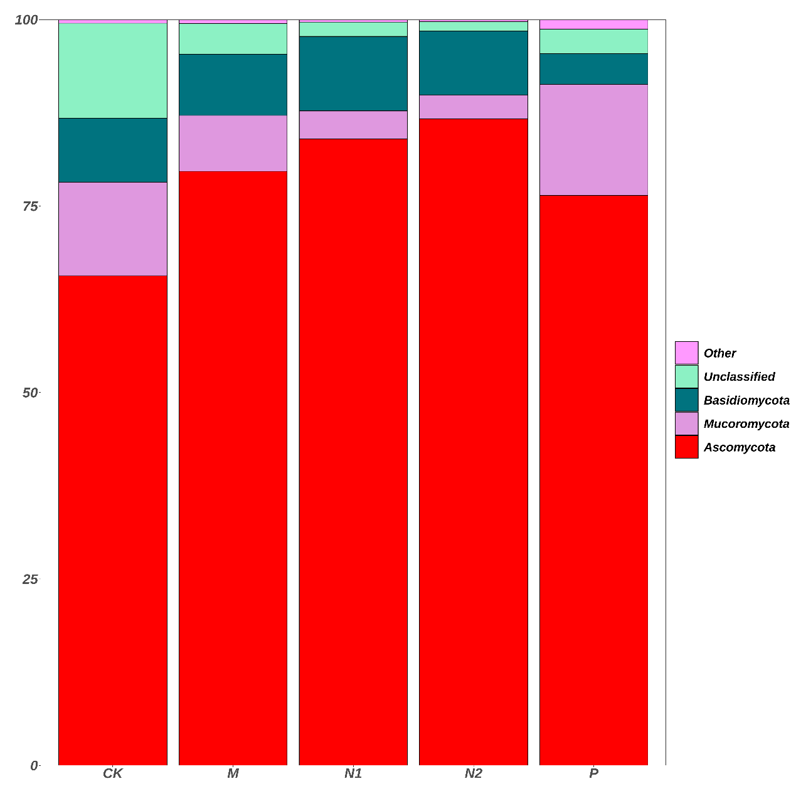

Fig. S1. Phyla-level relative abundances of soil fungal community composition across all treatments.

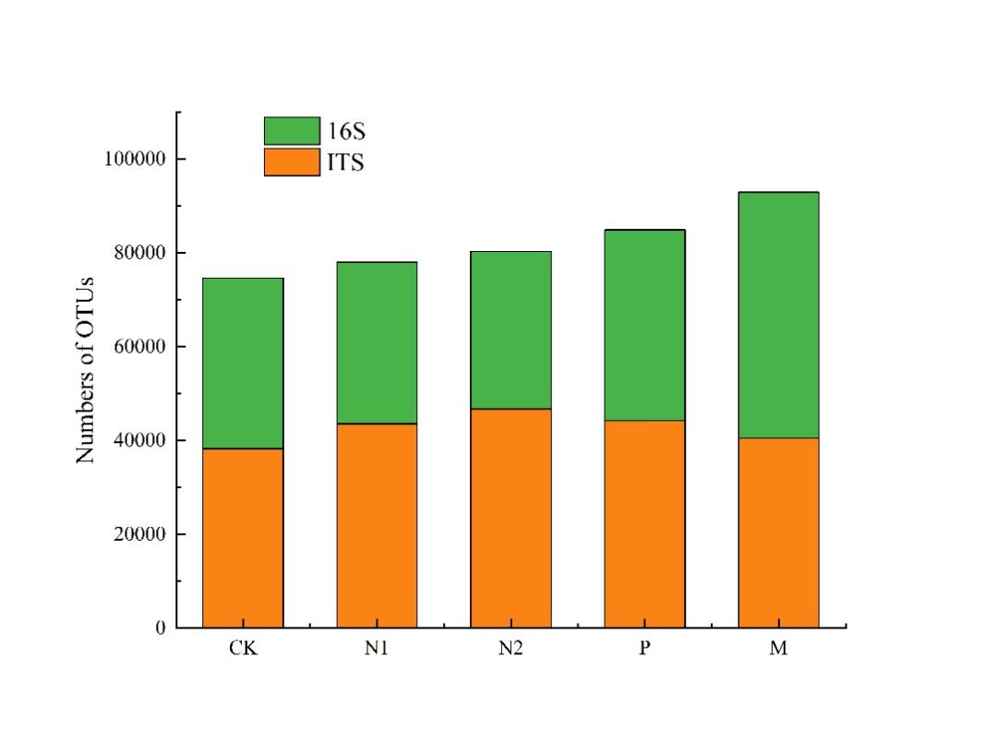

Fig.S2. Number of OTUs in different treatments in the later stage of litter decomposition

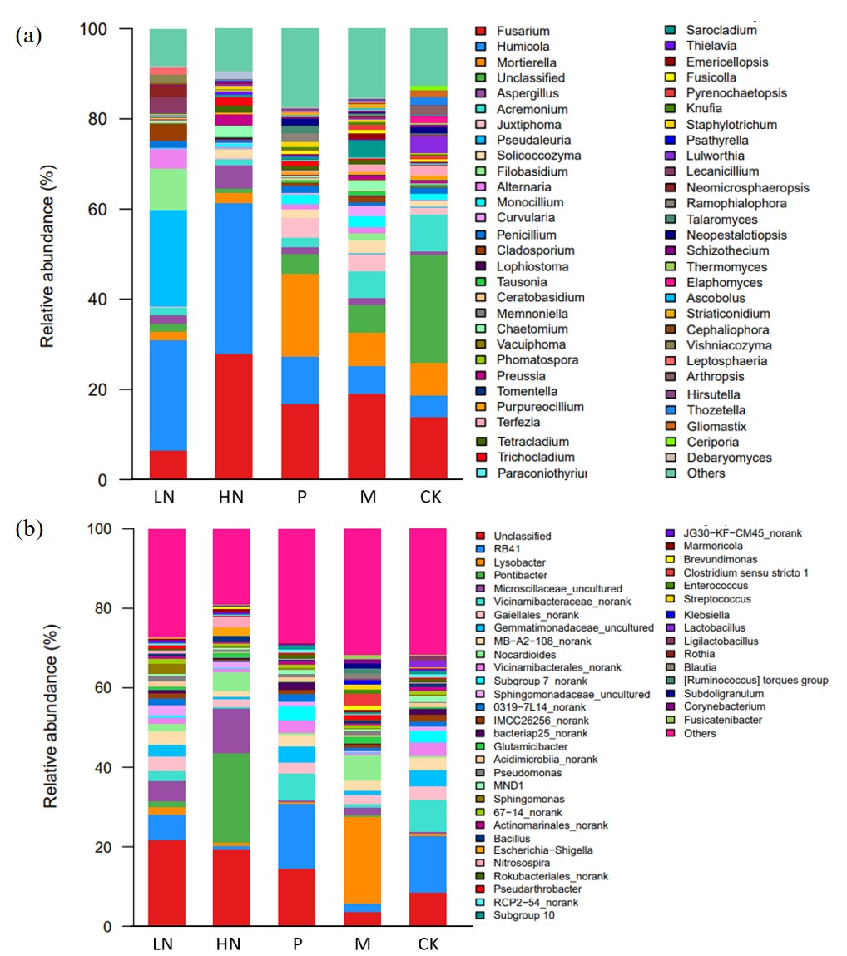

Fig. S3. Genus-level relative abundances of soil fungal (a) and bacterial (b) community composition across all treatments.