Supplementary Material

# Supplementary Data

## Supplementary Figures

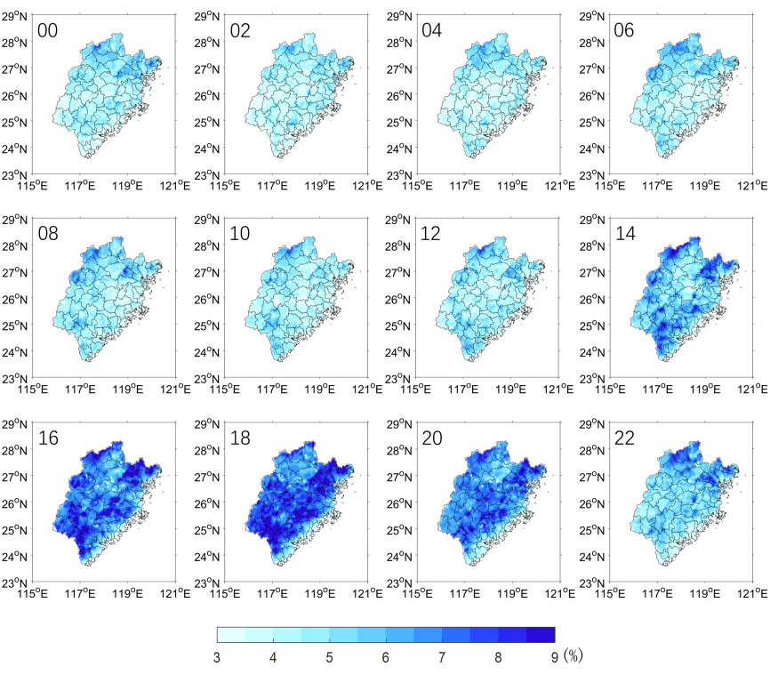

**Supplementary Figure A1.** The Spatial Distribution of Convective Precipitation Frequency in Fujian Province. (every two hours)

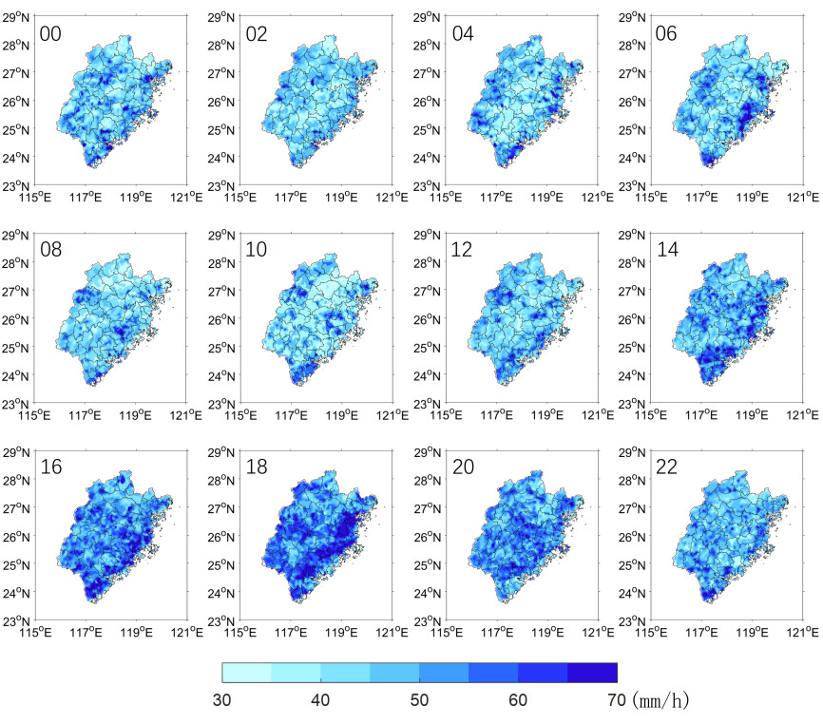

**Supplementary Figure A2.** The Spatial Distribution of Convective Precipitation Intensity in Fujian Province. (every two hours)



**Supplementary Figure A3.** Diurnal Variation in Relative Humidity during the Pre-flood Season(blue: pre-flood season, red: post-flood season).

|  |  |
| --- | --- |
|  |  |
| (**a**) | (**b**) |

**Supplementary Figure A4.** Diurnal Variation of Temperature (Blue: Pre-Flood Season, Red: Post-Flood Season): (a) Air Temperature; (b) Surface Temperature

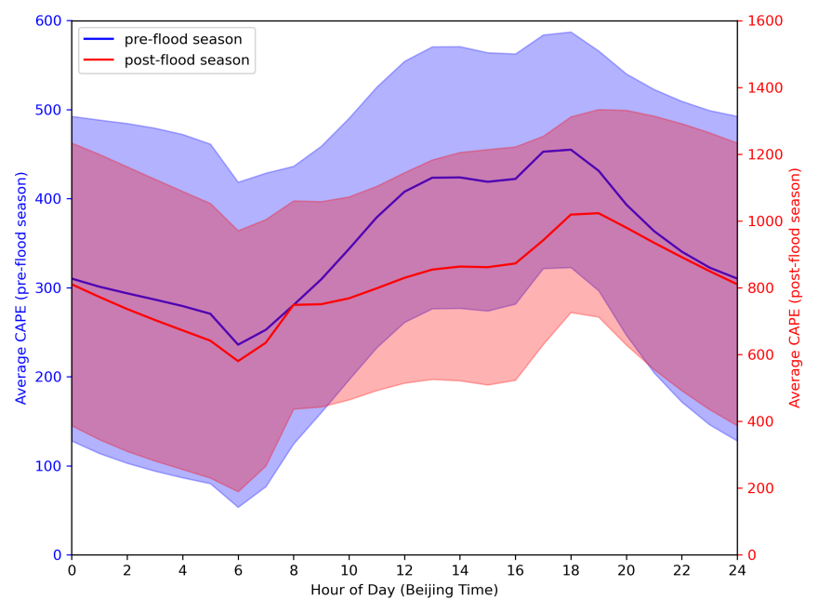

**Supplementary Figure A5.** convective available potential energy(CAPE) (Blue: Pre-Flood Season, Red: Post-Flood Season), unit：J·kg-1.