**Latent Growth Curve Analysis**

Following CFA validation of construct identification in Study 2, We examined whether the changes in each variable were linear using latent growth curve modeling (LGCM).

LGCM was used to understand and model the growth or change trajectories of individual or group-level data over time. This analytical approach facilitated the exploration of how key constructs, including Decentering, Reappraisal, and Wellbeing, change and develop over time. To perform the LGCM analysis, we utilized the ‘lavaan’ package in R (Rosseel et al., 2017) and applied the same model fit criteria (i.e., RMSEA, and CFI) to assess the goodness-of-fit of the LGCM models.

The LGCM analyses were conducted for each variable in the MMT (Decentering, Reappraisal, Wellbeing), as well as for Stress. No significant changes over time were observed in the slopes for any of the variables. However, significant variances in the slopes were noted for both Wellbeing factors, Decentering-Disidentification, and Stress, indicating individual differences in temporal trajectories. Conversely, the slopes for the four Reappraisal factors and the two Decentering factors (Meta-awareness and Nonreactivity) demonstrated no significant changes.

**Slope Variance Results for Key Variables**

|  |  |  |
| --- | --- | --- |
| **Description** | **Estimate** | **p-value** |
| WB-Positive | 0.045 | **0.013** |
| WB-Negative | 0.040 | **0.026** |
| RP-Change Efficacy | 0.021 | 0.129 |
| RP-Perspective Taking | 0.009 | 0.406 |
| RP-Approach Positive | 0.021 | 0.172 |
| RP-Decrease Negative | 0.026 | 0.155 |
| DC-Meta-awareness | 0.009 | 0.311 |
| DC-Disidentification | 0.027 | **0.003** |
| DC-Nonreactivity | 0.002 | 0.838 |
| Stress | 0.011 | **0.036** |

*Note*. Estimates are unstandardized estimate results. WB = Wellbeing, RP = Reappraisal, DC = Decentering.

## Commonality Analyses

We used Decentering factors Disidentification and Nonreactivity, and Reappraisal factors Change Efficacy and Approach Positive as predictors for the WB composite score. We wanted to determine whether Decentering and Reappraisal had different levels of associations or shared mostly common variance. Our results indicated that Disidentification, Nonreactivity, and Approach Positive contributed to predicting WB using method 1, with low common variance. For the WB method 2 Positive factor, Disidentification, Change Efficacy, and Approach Positive contributed to predicting WB, whereas Nonreactivity, Change Efficacy, and Approach Positive contributed to predicting WB Negative Factor. The total common variance (C1-C9) was lower than .13 in all cases, indicating that the majority of the association was through unique factor variance (U1-U4).

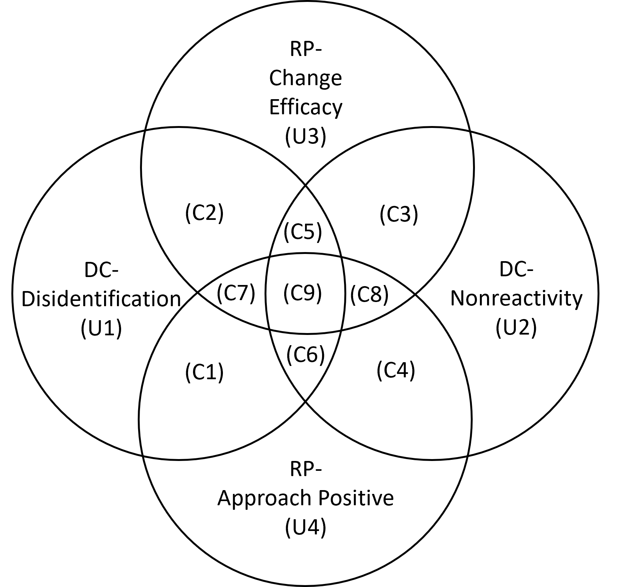

**Figure** S1. DC=Decentering, RP= Reappraisal. C1-C9 represent common variance while U1-U4 represent unique factor variance.