Supplementary Materials

# Alleviation of bovine serum albumin on the neurotoxicity of silver nanoparticles in zebrafish (*Danio rerio*) larvae

Zhenhua Yan a, b, *, Yuqiong Yang a, b, Yufang Chen a, b, Yixin Zhou b, Pengpeng Su a, b, Saiyu Yuan c

a Key Laboratory of Integrated Regulation and Resource Development on Shallow Lakes of Ministry of Education, Hohai University, Nanjing 210098, China

b College of Environment, Hohai University, Nanjing 210098, China

c The National Key Laboratory of Water Disaster Prevention, Hohai University, Nanjing 210098, China

* Correspondence to: Key Laboratory of Integrated Regulation and Resources Development on Shallow Lakes of Ministry of Education, College of Environment, Hohai University, Nanjing 210098, China.

E-mail address: hwahuer@hhu.edu.cn (Z. Yan)

# Table S1 The list of quantitative real-time PCR primer sequences for target genes.

|  |  |  |
| --- | --- | --- |
| **Primer** | **Forward primer sequences** | **Reverse primer sequences** |
| *β-actin*  *elav13*  *mbp*  *syn2a*  *gap43*  *gfap*  *nestin*  *ngn1*  *th*  *dat*  *mao*  *chat*  *vacht*  *ache* | CTGTCTTCCCATCCATCGTGGGTC  AGACAAGATCACAGGCCAGAGCTT  AATCAGCAGGTTCTTCGGAGGAGA  GTGACCATGCCAGCATTTC  TGCTGCATCAGAAGAACTAA  GGATGCAGCCAATCGTAAT  GTCACAGATCAATCGCCTCAT  TGCACAACCTTAACGACGCATTGG  ATGGCTTGGAGGACCTAGAATAT  ACCAACGGTGGAATCTATGTG  CATGGTGATCGAGGAGGAAG  GTACGACAAACCCATGCAGTT  TTCGGCGAGCTGGTGTT  TGTCTTTATCTGAATGTGTGGGTA | CTCCATATCATCCCAGTTGGTGACA  TGGTCTGCAGTTTGAGACCGTTGA  AAGAAATGCACGACAGGGTTGACG  TGGTTCTCCACTTTCACCTT  CCTCCGGTTTGATTCCATC  TTCCAGGTCACAGGTCAG  TTGCTTCGTCTTCCACCTTAAT  TGCCCAGATGTAGTTGTGAGCGAA  ACATCCTCTGCACTTCTCTTCA  AACAACCATGAACAGGAGGAA  CGTGATTTTCGTGCCAGAATAAA  GCACAAGCACTATTCCCTCAAA  GCGACGGAGTAGGAGATGT  TGCGTCTGATGAGCCATTAAG |

# Table S2. The PCR reaction parameters for different genes.

|  |  |
| --- | --- |
| **Gene name** | **PCR reaction parameter** |
| *β-actin* | a. 1× (3 minutes at 95°C)  b.23×(15 seconds at 94°C; 20 seconds at 65°C; 20 seconds at 72°C) |
| *elav13* | a. 1× (3 minutes at 95°C)  b.32×(15 seconds at 94°C; 20 seconds at55°C; 20 seconds at 72°C) |
| *ngn1* | a. 1× (3 minutes at 95°C)  b.30×(15 seconds at 94°C; 20 seconds at 60°C; 20 seconds at 78°C) |
| *gap43* | a. 1× (3 minutes at 95°C)  b.33×(15 seconds at 94°C; 20 seconds at 55°C; 20 seconds at 72°C) |
| *syn2a* | a. 1× (3 minutes at 95°C)  b.32×(15 seconds at 94°C; 20 seconds at 55°C; 20 seconds at 72°C) |
| *mbp* | a. 1× (3minutes at 95°C)  b.24×(15 seconds at 94°C; 20 seconds at 55°C; 20 seconds at 78°C) |
| *gfap* | a. 1× (3minutes at 95°C)  b.33×(15 seconds at 94°C; 20 seconds at 55°C; 20 seconds at 72°C) |
| *nestin* | a. 1× (3minutes at 95°C)  b.38×(15 seconds at 94°C; 20 seconds at 65°C; 20 seconds at 78°C) |
| *chat* | a. 1× (3minutes at 95°C)  b.32×(15 seconds at 94°C; 20 seconds at 60°C; 20 seconds at 78°C) |
| *vacht* | a. 1× (3 minutes at 95°C)  b.35× (15 seconds at 94°C; 20 seconds at 55°C; 20 seconds at 78°C) |
| *ache* | a. 1× (3minutes at 95°C)  b.35×(15 seconds at 94°C; 20 seconds at 65°C; 20 seconds at 78°C) |
| *th* | a. 1× (3minutes at 95°C)  b.37×(15 seconds at 94°C; 20 seconds at 65°C; 20 seconds at 78°C) |
| *dat* | a. 1× (3minutes at 95°C)  b.35×(15 seconds at 94°C; 20 seconds at 65°C; 20 seconds at 78°C) |
| *mao* | a. 1× (3minutes at 95°C)  b.35×(15 seconds at 94°C; 20 seconds at 65°C; 20 seconds at 78°C) |

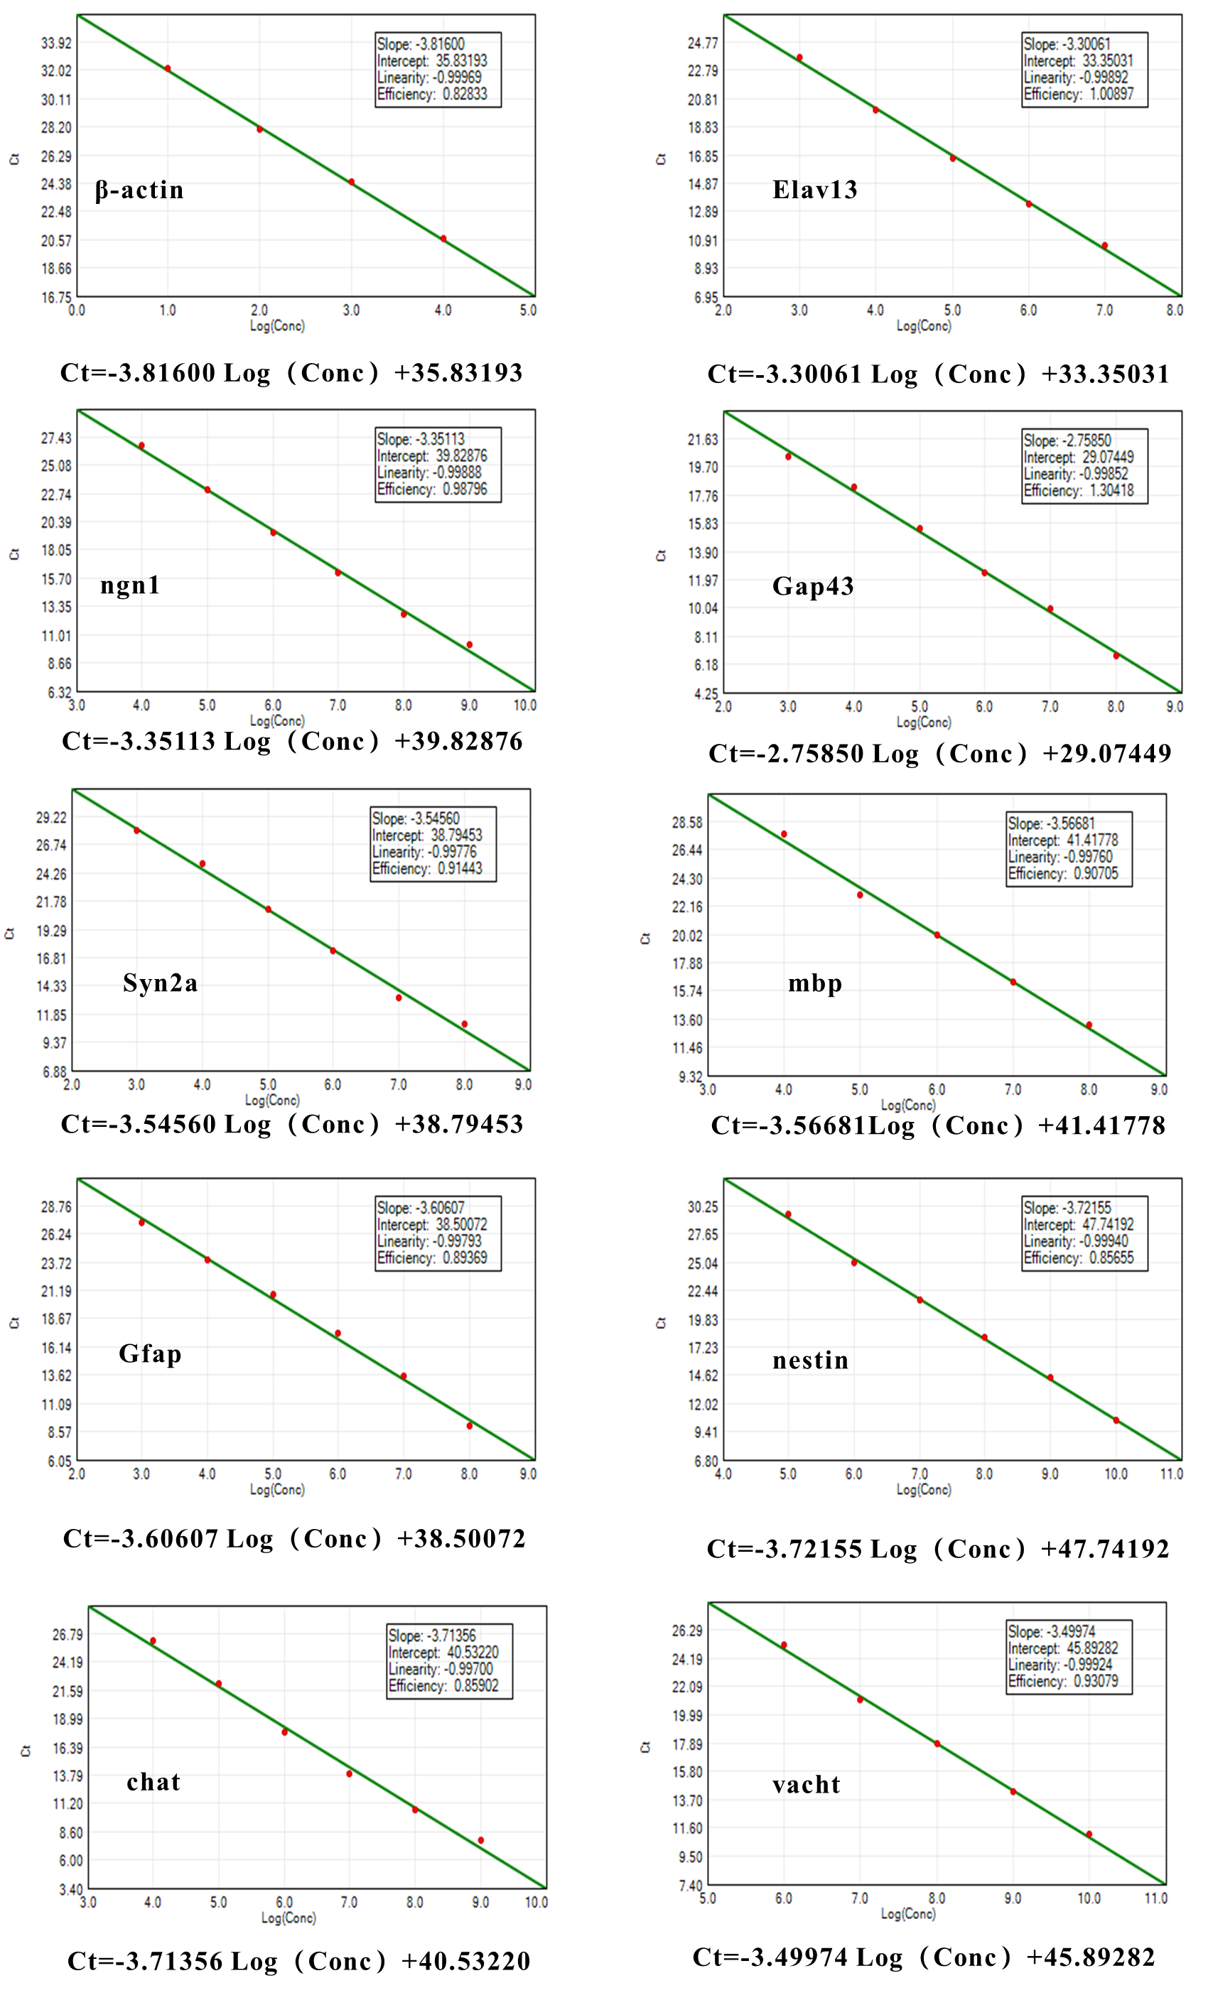

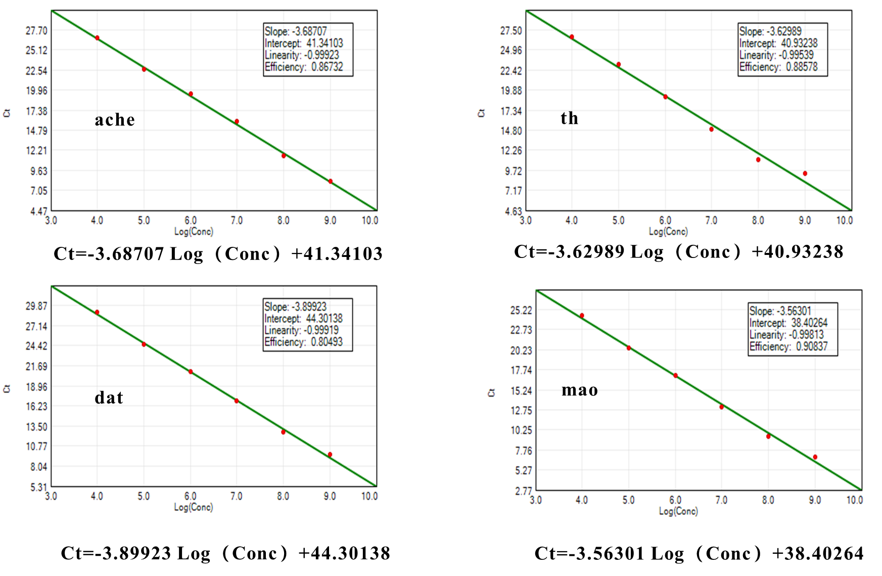

# Fig. S1. The standard curves of all detected genes by qRT-PCR analysis.

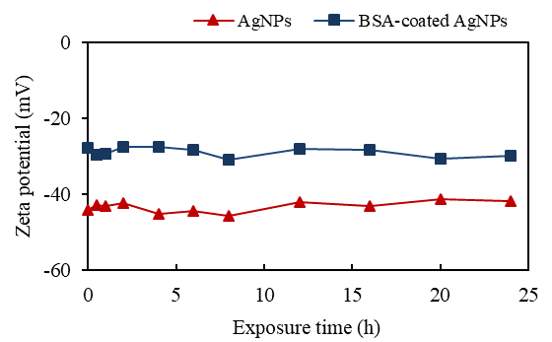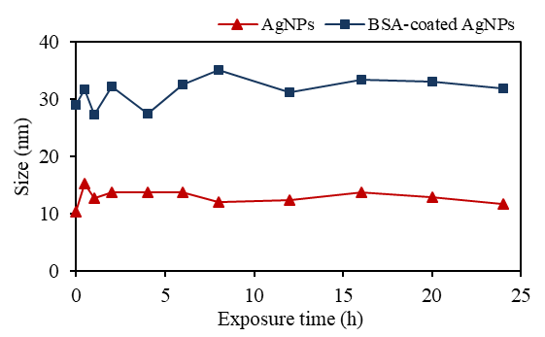

# Fig. S2. The changes of zeta potential (A) and size (B) of AgNPs and BSA-coated AgNPs within 24 hours.

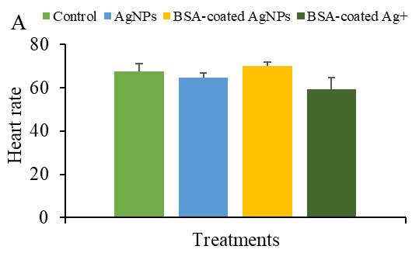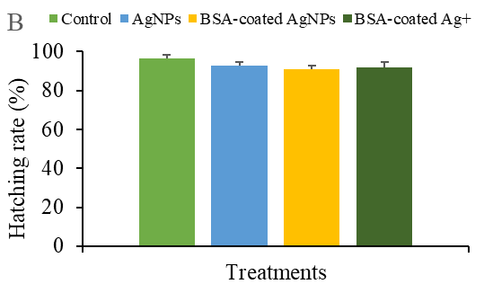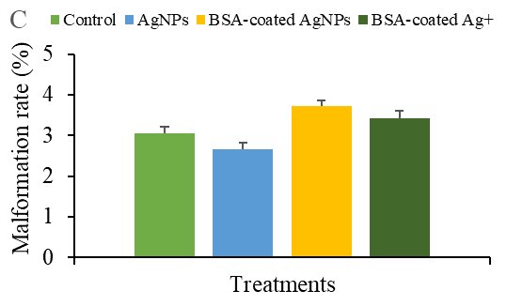 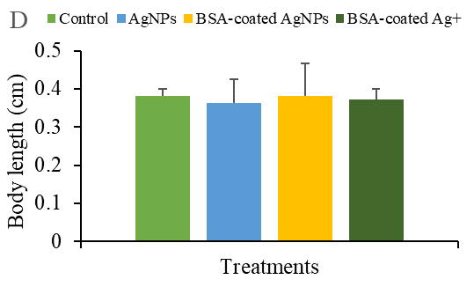

# Fig. S3. The 72 hpf hatching rate (A), 72 hpf heart rate (B), 120 hpf malformation rate (C), and 120 hpf body length (D) of zebrafish larvae in different treatments.