Supplementary Material

Supplementary Figures and Tables

Supplementary Figures
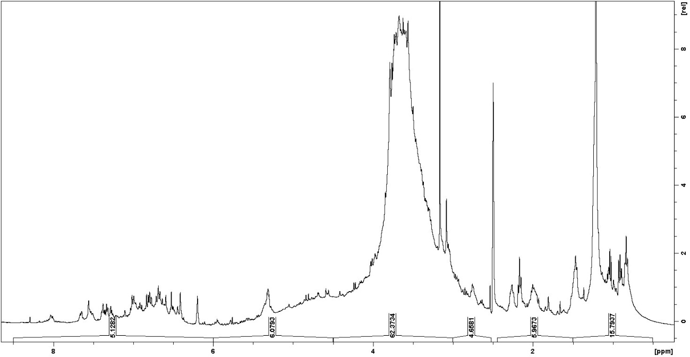
Supplementary Figure 1. ¹H NMR spectrum of the MEMLL.

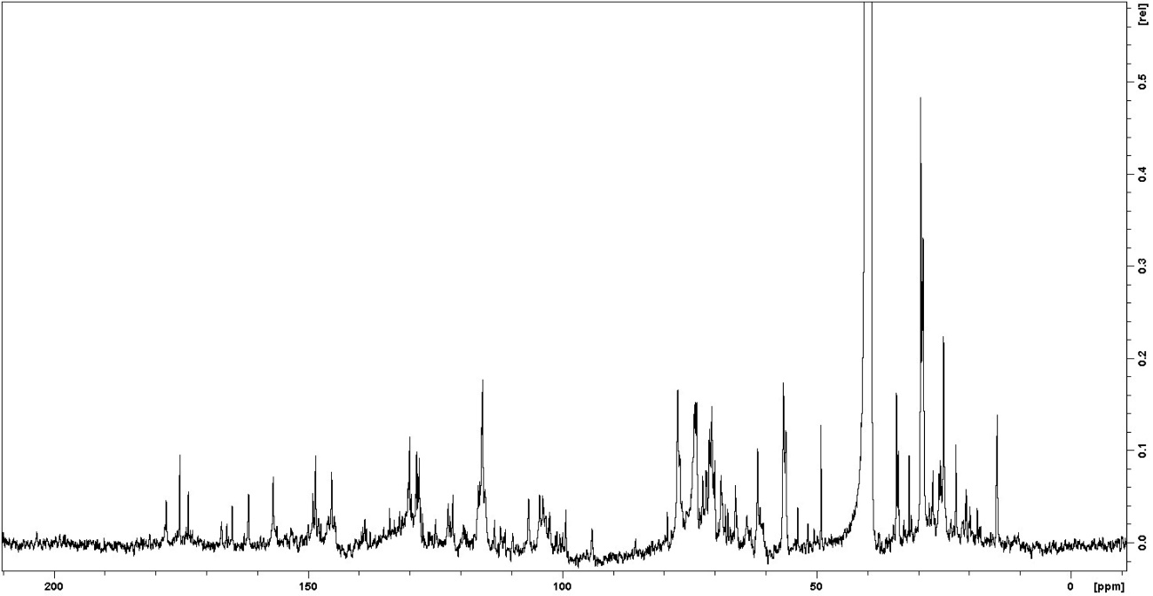
Supplementary Figure 2. ¹³C NMR spectrum of the MEMLL.

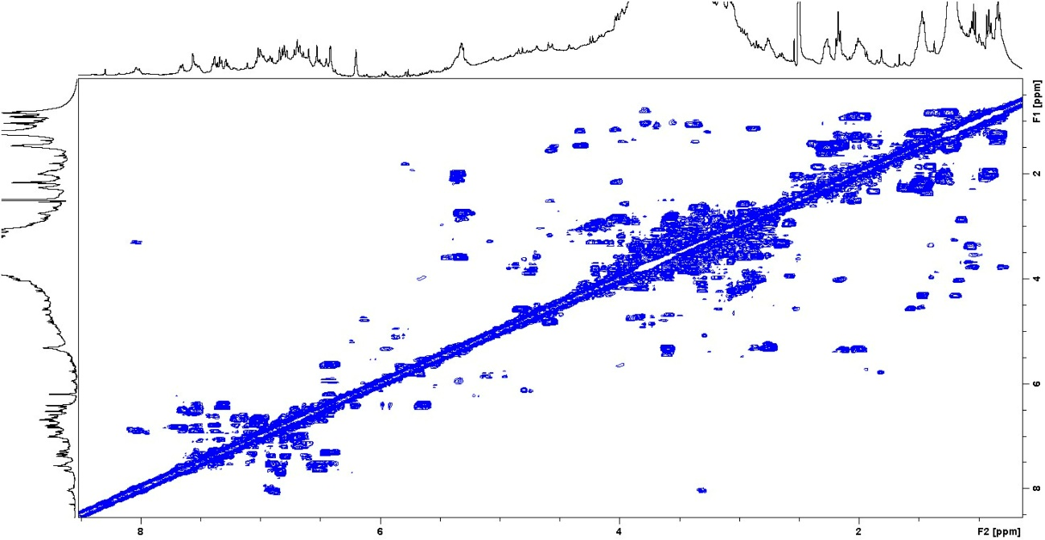
Supplementary Figure 3. HOMO-COSY NMR spectrum correlation map from the MEMLL.

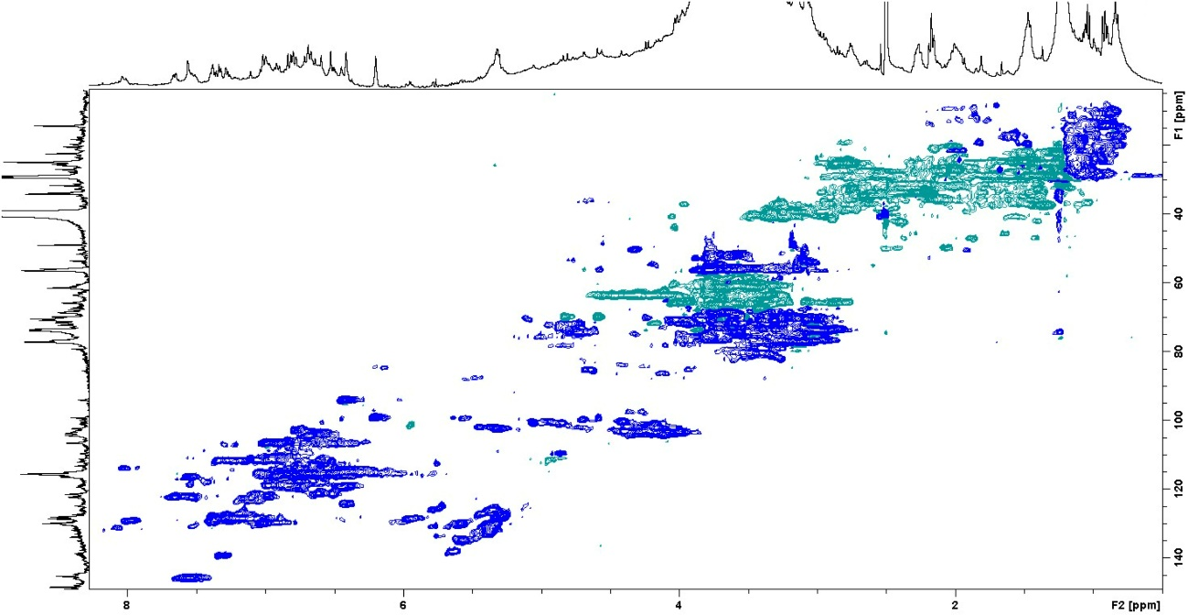
Supplementary Figure 4. HSQC NMR spectrum correlation map from the MEMLL.

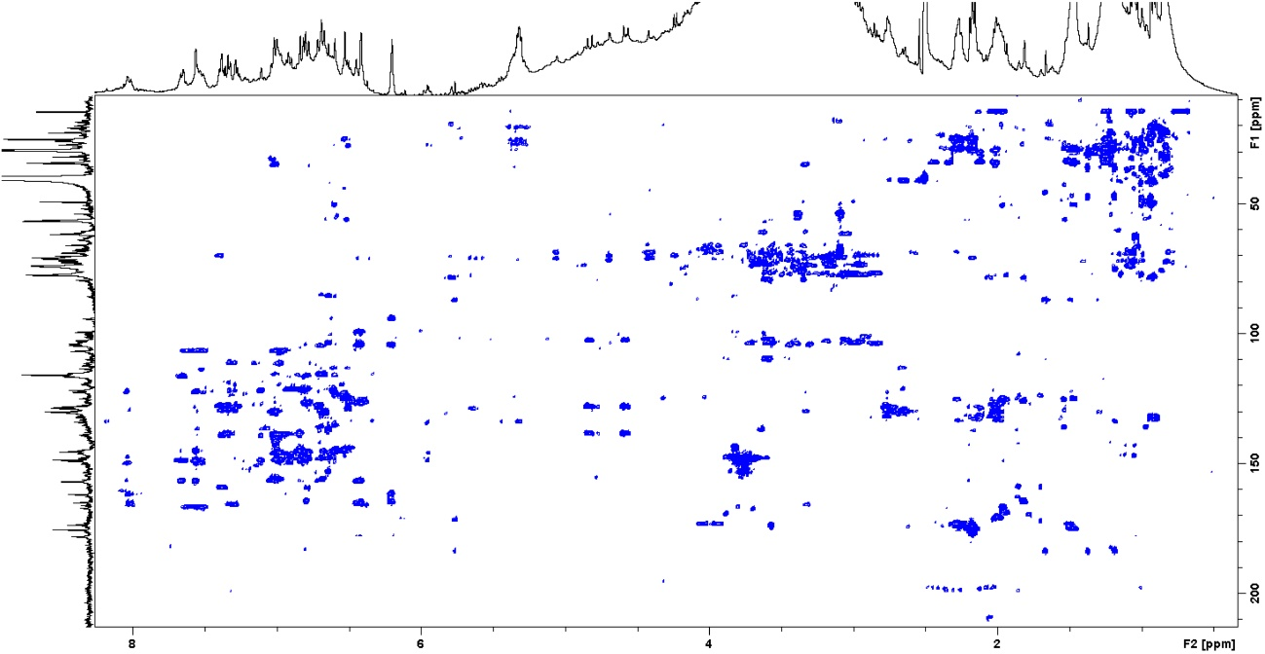
Supplementary Figure 5. HMBC NMR spectra correlation map from the MEMLL.

Supplementary Tables

Supplementary Table 1. Characterization of the MEMLL by ¹H NMR.
Chemical shift (ppm)* | Assignments | Area (%)
0.5 – 1.5 | C-CH_{n} | 15.79
1.5 – 3.0 | CH_{n}-C=C; CH_{n}-COR; CH_{n}-COOR; CH_{n}-N; CH_{n}-Ph | 10.63
3.0 – 4.5 | CH_{n}-OH; PhO-CH_{n}; RCOO-CH_{n}; CH₂-NHCOR | 62.37
4.5 – 6.0 | CH_{n}=CH | 6.08
6.0 – 9.0 | Ph-H; Ph-CH=CH-R | 5.13
Legend: n = number of hydrogens, in which 1 ≤ n ≤ 3. * Pinheiro et al. (2022)

Supplementary Table 2. Assignment of metabolites in extracts of M. linifera by NMR.
ID | Compounds | Position | δ ¹H (J/Hz) | δ ¹³C | Correlations
 |  |  |  |  | COSY | HMBC
1 | Rutin
 |  | 2 | - | 156.8 | - | -
 |  | 3 | - | 133.9 | - | -
 |  | 4 | - | 177.8 | - | -
 |  | 5 | - | 161.6 | - | -
 |  | 6 | 6.20 (d 1.9) | 99.2 | 6.41 | 161.6; 164.9
 |  | 7 | - | 164.9 | - | -
 |  | 8 | 6.41 (d 1.9) | 94.1 | 6.20 | 156.6; 164.9
 |  | 9 | - | 156.6 | - | -
 |  | 10 | - | 103.8 | - | -
 |  | 1’ | - | 121.5 | - | -
 |  | 2’ | 7.53 (d 2.4) | 116.2 | 7.54 | 121.5; 145.3; 149.0
 |  | 3’ | - | 145.3 | - | -
 |  | 4’ | - | 149.0 | - | -
 |  | 5’ | 6.91 (d 7.8) | 116.1 | 7.54 | 121.5; 145.3; 149.0
 |  | 6’ | 7.54 (dd 2.4; 7.8) | 122.0 | 6.91; 7.53 | 116.1; 121.5; 149.0
 |  | 1” | 5.45 (d 7.2) | 102.3 | - | 133.9
 |  | 1’” | 4.42 (d 1.6) | 100.5 | - | -
 |  | 6’” | 4.42 (d 1.6) | 18.4 | - | -
2 | Chrysoeriol
 |  | 2 | - | 162.5 | - | -
 |  | 3 | 7.00 (s) | 106.6 | - | 122.6; 162.5; 181.1
 |  | 4 | - | 181.1 | - | -
 |  | 5 | - | 162.6 | - | -
 |  | 6 | 6.21 (d 1.9) | 99.3 | 6.45 | 162.6; 165.6
 |  | 7 | - | 165.6 | - | -
 |  | 8 | 6.45 (d 1.9) | 94.2 | 6.21 | 103.6; 157.2; 165.6
 |  | 9 | - | 157.2 | - | -
 |  | 10 | - | 103.6 | - | -
 |  | 1’ | - | 122.6 | - | -
 |  | 2’ | 7.55 (d 2.3) | 109.7 | 7.52 | 119.4; 122.6;
 |  | 3’ | - | 149.3 | - | -
 |  | 4’ | - | 147.9 | - | -
 |  | 5’ | 6.91 (d 8.4) | 116.7 | 7.52 | 119.4; 147.9
 |  | 6’ | 7.52 (dd 2.3; 8.4) | 119.4 | 6.91 | 116.7; 147.9
 |  | OMe | 3.59 (s) | 51.7 | - | 109.7; 147.9; 149.3
3 | Luteolin
 |  | 2 | - | 164.6 | - | -
 |  | 3 | 6.80 (s) | 102.5 | - | 122.1; 164.6; 182.9
 |  | 4 | - | 182.9 | - | -
 |  | 5 | - | 161.8 | - | -
 |  | 6 | 6.19 (d 2.7) | 99.2 | 6.45 | 93.9; 161.8; 164.9
 |  | 7 | - | 164.9 | - | -
 |  | 8 | 6.45 (d 2.7) | 93.9 | 6.19 | 99.2; 103.5; 156.7
 |  | 9 | - | 156.7 | - | -
 |  | 10 | - | 103.5 | - | -
 |  | 1’ | - | 122.1 | - | -
 |  | 2’ | 7.35 (d 2.0) | 113.3 | 7.39 | 122.1; 145.4; 149.9
 |  | 3’ | - | 145.4 | - | -
 |  | 4’ | - | 149.9 | - | -
 |  | 5’ | 6.82 (d 8.3) | 115.9 | 7.39 | 119.1; 149.9
 |  | 6’ | 7.39 (dd 2.0; 8.3) | 119.1 | 6.82; 7.35 | 122.1; 115.9
4 | Quercetin
 |  | 2 | - | 146.2 | - | -
 |  | 3 | - | 135.8 | - | -
 |  | 4 | - | 175.7 | - | -
 |  | 5 | - | 160.4 | - | -
 |  | 6 | 6.18 (d 2.0) | 98.9 | 6.40 | 160.4; 164.3
 |  | 7 | - | 164.3 | - | -
 |  | 8 | 6.40 (d 2.0) | 94.3 | 6.18 | 103.2; 156.1; 164.3
 |  | 9 | - | 156.1 | - | -
 |  | 10 | - | 103.2 | - | -
 |  | 1’ | - | 121.6 | - | -
 |  | 2’ | 7.63 (d 2.3) | 116.3 | 7.54 | 115.4; 145.0; 148.0
 |  | 3’ | - | 145.0 | - | -
 |  | 4’ | - | 148.0 | - | -
 |  | 5’ | 6.86 (d 8.2) | 115.4 | 7.54 | 119.5; 145.0; 148.0
 |  | 6’ | 7.54 (dd 8.2; 2.3) | 119.5 | 6.86; 7.63 | 146.2; 160.4

