Supplementary Material

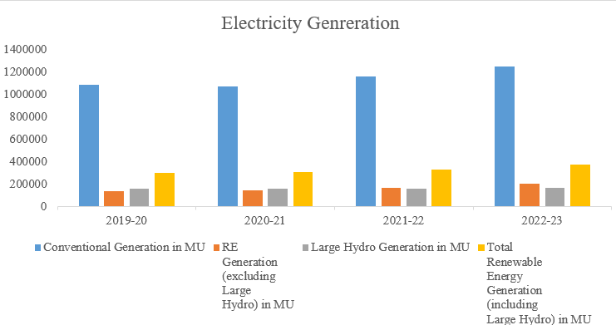
Fig. 1 All India electricity generation from 2019 to 2023.

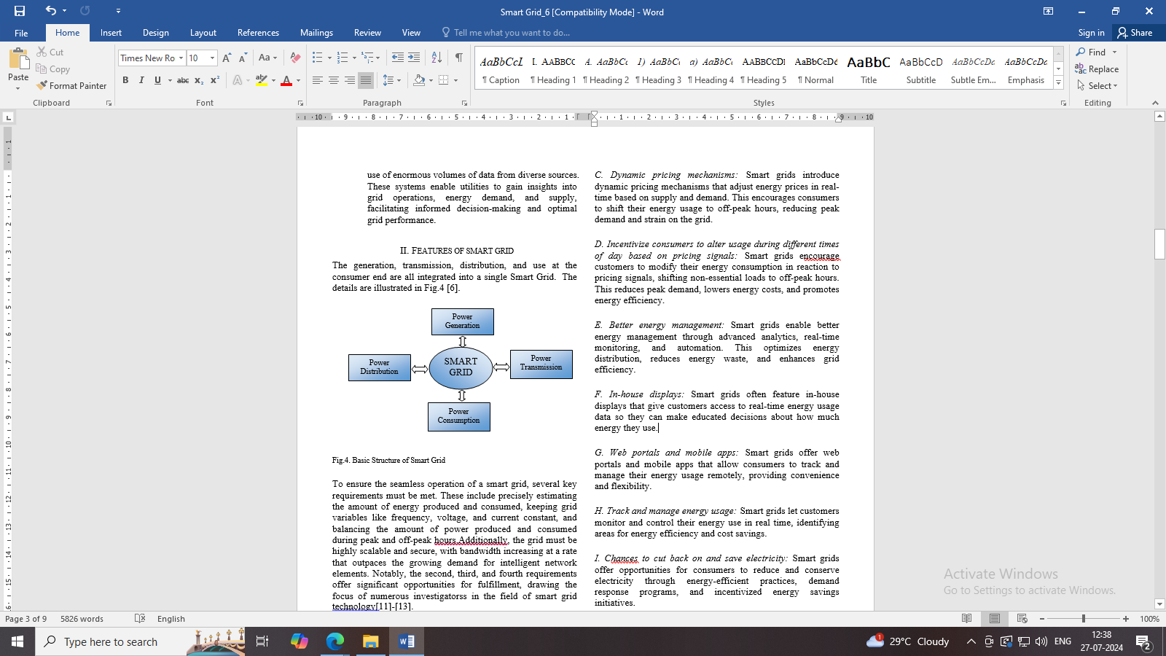
Fig.2. Basic Structure of Smart Grid

