Supplementary Material

# Supplementary Figures

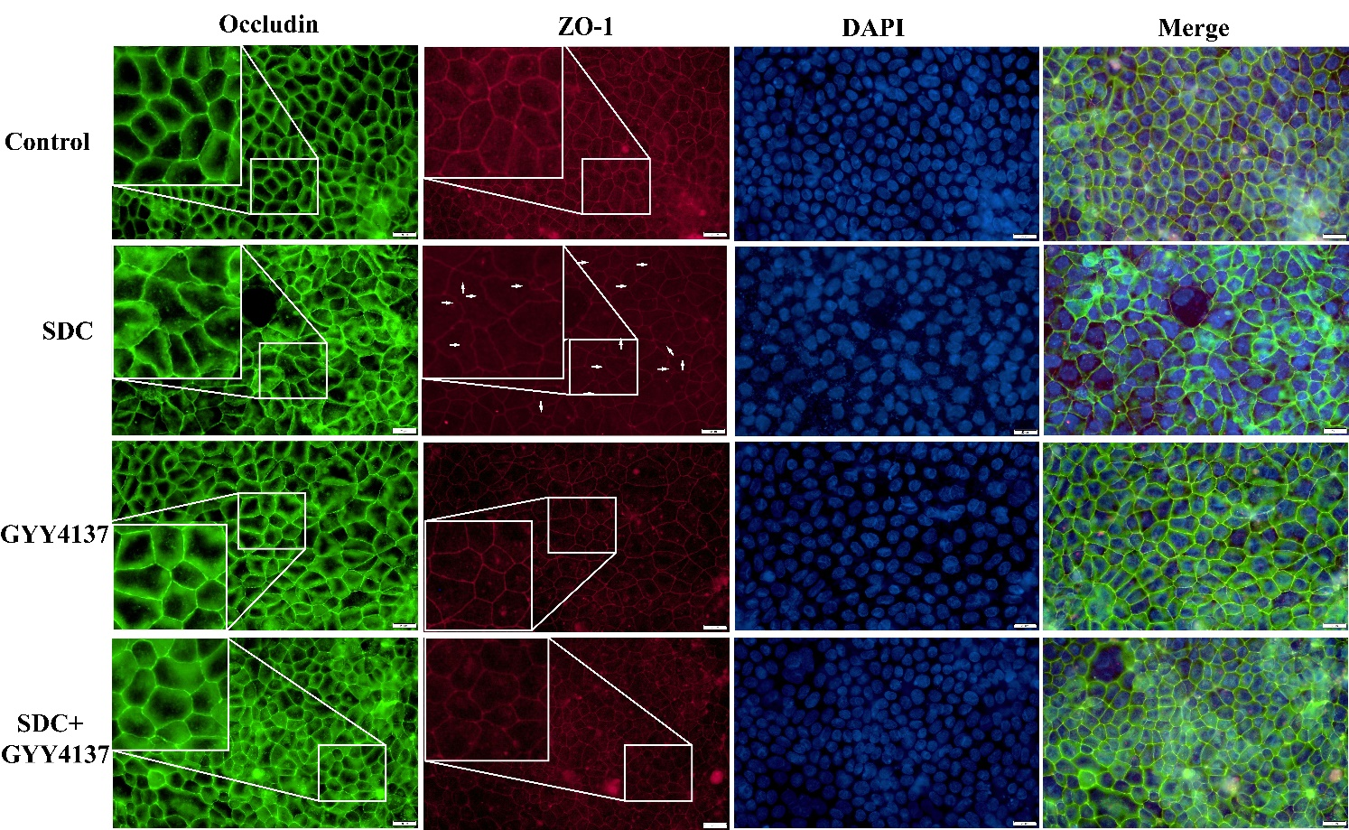**Supplementary Figure 1.** Occludin and ZO-1 were stained by immunofluorescence in Caco-2 monolayers.

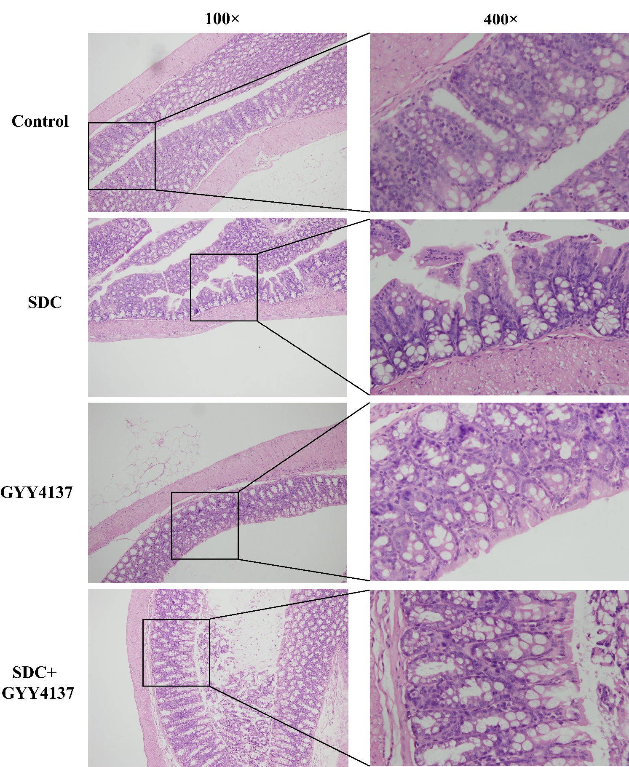

**Supplementary Figure 2.** GYY4137 remarkably attenuated the mucosal damage in mice treated with SDC.

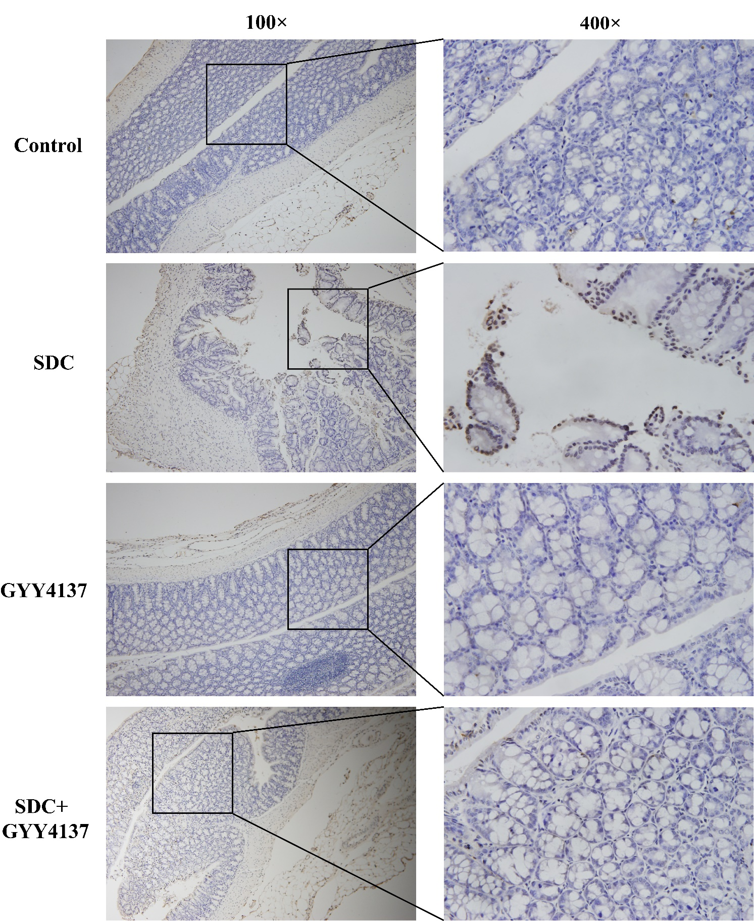

**Supplementary Figure 3.** Representative TUNEL images for cell apoptosis (brown signals) and GYY4137 significantly decreased the increased level of apoptosis in the colon epithelium in mice fed with SDC.

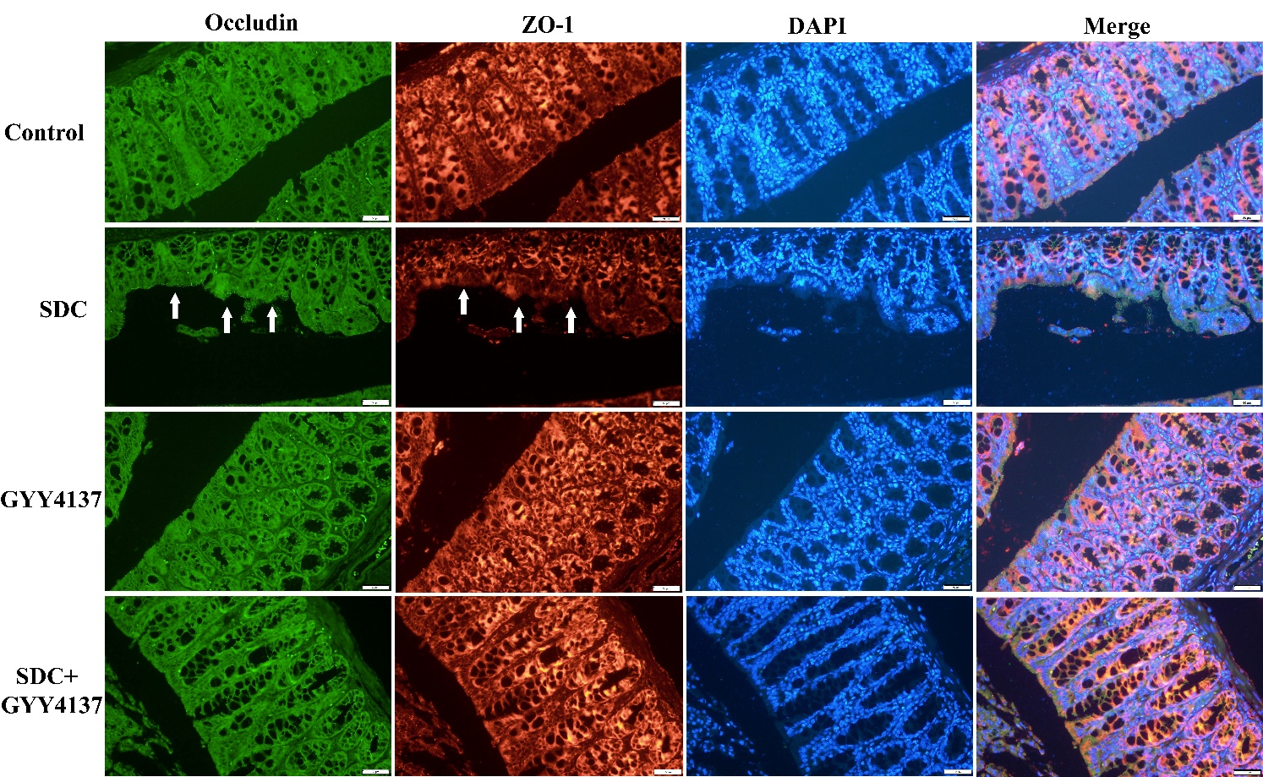

**Supplementary Figure 4.** Occludin and ZO-1 were stained by immunofluorescence. GYY4137 inhibited their decreased staining intensity and the damaged mucosal integrity in mice treated with SDC (White arrows were added to direct against distinct changes).