Standard substances | Supplier
2-Picoline, 2,6-lutidine, 3-picoline, 5-methylfurfural, furfuryl alcohol, 6-methyl-5-hepten-2-one, 2(5H)-furanone, 4'-methylacetophenone, ethyl phenylacetate, 3-acetylpyridine, β-ionone, acetophenone, β-damascone, (-)-ambroxide, sclareol, myristic acid, isoamyl acid, 3-methylvaleric acid, isophorone, sclareolide, 3,7,11,15-tetramethyl-2-hexadecen-1-ol, 2,6,6-trimethyl-2-cyclohexene-1,4-dione, isophytol, α-cyperone, 3-phenylpyridine, and (E)-2-hexenoic acid | Sigma-Aldrich (Shanghai, China)
2-Methoxy-4-vinylphenol, dihydroactinidiolide, indole, γ-butyrolactone, geranylacetone, pyridine, (+)-limonene, mesityl oxide, 6-methyl-3,5-heptadien-2-one, octanoic acid, vanillic acid, phenethyl alcohol, benzoic acid, 2-methyl-1H-pyrrole, and phenethyl acetate | Macklin (Shanghai, China)
6,10,14-Trimethyl-2-pentadecanone,  neophytadiene, 6-methyl-2-heptanone, and β-cyclocitral | J&K Scientific (Beijing, China)
Farnesylacetone (mixture of isomers), lactic acid, succinic acid, benzaldehyde, and guaiacol | Aladdin (Shanghai, China)
Table S1 Reagent Information
Note: The purity levels of the standard substances range from 80% to 99.5%.

Table S2 Qualitative analysis of aroma compounds
No. | Compounds | CAS | RIª | RI^{b} | RI^{c} | RI^{d} | Identification^{e}
1 | Pyridine | 110-86-1 |  |  | 730 | 736 | MS, Std, RI
2 | (+)-Limonene | 5989-27-5 | 1031 | 1035 |  |  | MS, Std, RI
3 | 2-Picoline | 109-06-8 |  |  | 819 | 821 | MS, Std, RI
4 | 6-Methyl-2-heptanone | 928-68-7 | 1216 | 1236 |  |  | MS, Std, RI
5 | 2,6-Lutidine | 108-48-5 | 1248 | 1267 |  |  | MS, Std, RI
6 | 3-Picoline | 108-99-6 |  |  | 847 | 861 | MS, Std
7 | 6-Methyl-5-hepten-2-one | 110-93-0 | 1333 | 1340 |  |  | MS, Std, RI
8 | Benzaldehyde | 100-52-7 | 1489 | 1502 |  |  | MS, Std, RI
9 | 2-Methyl-1H-pyrrole | 636-41-9 |  |  | 841 | 856 | MS, Std
10 | 5-Methylfurfural | 620-02-0 | 1594 | 1601 |  |  | MS, Std, RI
11 | β-Cyclocitral | 432-25-7 | 1587 | 1598 |  |  | MS, Std, RI
12 | Furfuryl alcohol | 98-00-0 | 1658 | 1666 |  |  | MS, Std, RI
13 | 2(5H)-Furanone | 497-23-4 | 1752 | 1767 |  |  | MS, Std, RI
14 | 4'-Methylacetophenone | 122-00-9 | 1780 | 1791 |  |  | MS, Std, RI
15 | Ethyl phenylacetate | 101-97-3 | 1765 | 1779 |  |  | MS, Std, RI
16 | 3-Acetylpyridine | 350-03-8 |  |  | 1109 | 1117 | MS, Std
17 | Guaiacol | 90-05-1 | 1854 | 1862 |  |  | MS, Std, RI
18 | Phenethyl alcohol | 60-12-8 | 1907 | 1922 |  |  | MS, Std, RI
19 | Neophytadiene | 504-96-1 |  |  | 1828 | 1836 | MS, Std
20 | β-Ionone | 14901-07-6 |  |  | 1483 | 1486 | MS, Std
21 | 3,7,11,15-Tetramethyl-2-hexadecen-1-ol | 102608-53-7 |  |  |  |  | MS, Std
22 | (-)-Ambroxide | 100679-85-4 |  |  |  |  | MS, Std
23 | 2-Methoxy-4-vinylphenol | 7786-61-0 | 2143 | 2156 |  |  | MS, Std, RI
24 | 3-Phenylpyridine | 1008-88-4 |  |  | 1461 | 1470 | MS, Std
25 | Isophytol | 505-32-8 | 2316 | 2327 |  |  | MS, Std, RI
26 | Dihydroactinidiolide | 17092-92-1 | 2341 | 2348 |  |  | MS, Std, RI
27 | Indole | 120-72-9 | 2437 | 2441 |  |  | MS, Std, RI
28 | Nicotine | 54-11-5 | 1859 | 1863 |  |  | MS, RI
29 | Mesityl oxide | 141-79-7 |  |  | 789 | 797 | MS, Std, RI
30 | γ-Butyrolactone | 96-48-0 |  |  | 905 | 908 | MS, Std, RI
31 | Acetophenone | 98-86-2 |  |  | 1072 | 1078 | MS, Std, RI
32 | 6-Methyl-3,5-heptadien-2-one | 1604-28-0 |  |  | 1084 | 1088 | MS, Std, RI
33 | Isophorone | 78-59-1 |  |  | 1118 | 1122 | MS, Std, RI
34 | 2,6,6-Trimethyl-2-cyclohexene-1,4-dione | 1125-21-9 |  |  | 1132 | 1139 | MS, Std, RI
35 | (E)-5-isopropyl-8-methylnona-6,8-dien-2-one | 54868-48-3 |  |  | 1297 |  | MS, RI
36 | β-Damascone | 35044-68-9 |  |  | 1406 | 1415 | MS, Std, RI
37 | Geranylacetone | 3796-70-1 |  |  | 1451 | 1452 | MS, Std, RI
38 | 4,7,9-Megastigmatrien-3-one II | 38818-55-2 |  |  | 1581 |  | MS, RI
39 | 3-Hydroxy-β-damascone | 102488-09-5 |  |  | 1612 |  | MS, RI
40 | 4,7,9-Megastigmatrien-3-one IV | 38818-55-2 |  |  | 1654 |  | MS, RI
41 | α-Cyperone | 473-08-5 |  |  | 1768 | 1771 | MS, Std, RI
42 | 2-Pentadecanone, 6,10,14-trimethyl- | 502-69-2 |  |  | 1841 | 1847 | MS, Std, RI
43 | Farnesylacetone | 762-29-8 |  |  | 1917 | 1921 | MS, Std, RI
44 | Cembrene | 1898-13-1 |  |  | 1930 | 1939 | MS, RI
45 | Thunbergol | 25269-17-4 |  |  | 1971 |  | MS, RI
46 | Sclareolide | 564-20-5 |  |  | 2069 |  | MS, Std
47 | Sclareol | 515-03-7 |  |  | 2081 |  | MS, Std
48 | Isoamyl acid | 503-74-2 |  |  | 861 | 867 | MS, Std, RI
49 | 3-Methylvaleric acid | 105-43-1 |  |  | 939 | 941 | MS, Std, RI
50 | Lactic acid | 50-21-5 |  |  |  |  | MS, Std
51 | Benzoic acid | 65-85-0 |  |  | 1159 | 1170 | MS, Std, RI
52 | Octanoic acid | 124-07-2 |  |  | 1167 | 1182 | MS, Std, RI
53 | Phenylacetic acid | 103-82-2 |  |  | 1254 | 1262 | MS, RI
54 | Succinic acid | 110-15-6 |  |  |  |  | MS, Std
55 | Vanillic acid | 121-34-6 |  |  | 1585 | 1592 | MS, Std, RI
56 | Myristic acid | 544-63-8 |  |  | 1759 | 1761 | MS, Std, RI
Notes: RIª: the linear retention indices calculated from a series of n-alkanes (C₇-C₃₀) with DB-WAX column; RI^{b}: retention indices referred to the literature value with DB-WAX column (http://webbook.nist.gov/chemistry/); RI^{c}: the linear retention indices calculated from a series of n-alkanes (C₇-C₃₀) with DB-5MS column; RI^{d}: retention indices referred to the literature value with DB-5MS column; Identification^{e}: MS referred to identification by comparison with the NIST17 mass spectrometry database, RI referred to identification by comparison RI calculated in this study with literature values, Std referred to determination by standards.

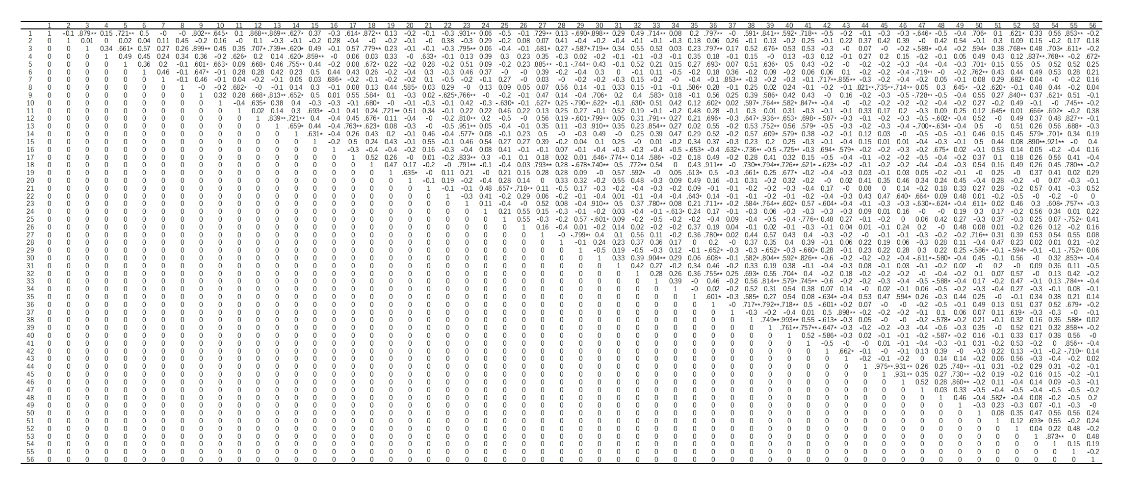
Table S3 Pearson correlation analysis of aroma compounds
Note: ‘*’ denotes differences were statistically significant at the 0.05 level; ‘**’ denotes differences were statistically significant at the 0.01 level.

