Supplementary Material

Techno-economic assessment of hydrogen application in cereal crop farming

Katumwesigye Anthony*, Magnus Hellstrom, Jonas Spor

**\* Correspondence:** Corresponding : email@uni.edu

# Supplementary Data

Supplementary Material should be uploaded separately on submission. Please include any supplementary data, figures and/or tables.

Supplementary material is not typeset so please ensure that all information is clearly presented, the appropriate caption is included in the file and not in the manuscript, and that the style conforms to the rest of the article.

# Supplementary Figures and Tables

## A diagram of a farm Description automatically generatedSupplementary Figures

Figure 1: Farm - gate system boundary

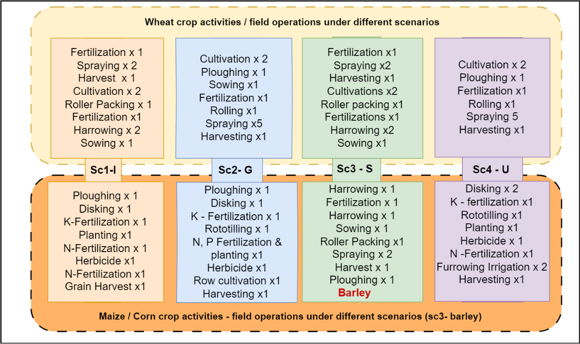Figure 2: Crop activities/field operations for each scenario (Sc1, Sc2, Sc3 and Sc4)

Figure 3: Schematic outline of a hydrogen component setting Sources : Micena et al., 2020

Figure 4: Annual farming calendars for Italy and USA farm structures that was a reference for hydrogen demand optimization

Figure 5:Annual farming calendars for Germany and Swedish farm structures that was a reference for hydrogen Demand optimisation.

Figure 6: Fuel usage by different cereal crop activities as a percentage of total annual fuel consumed under different scenarios

Figure 7: NPV results of both economic models

Figure 8: Levelized Cost of energy across both economic models under different load hours

## Supplementary Tables

This is Table 1: scenarios based on the selected farm geographical locations

|  |  |  |  |  |
| --- | --- | --- | --- | --- |
| Scenarios | Country | Crops | Farm structure | Farm machinery |
| Sc1-I | Italy | Wheat, Maize | Small holder | 2WD, 4WD |
| Sc2-G | Germany | Wheat, Maize | Medium Scale | 2WD, 4WD |
| Sc3-S | Sweden | Wheat, Barley | Medium Intensity | 2x2WD, 2x4WD |
| Sc4-U | USA | Wheat, Maize | Intensive (mechanized) | 3x2WD, 3x4WD |

This is Table 2: Economic data for the hydrogen fuel stations

|  |  |  |  |  |  |
| --- | --- | --- | --- | --- | --- |
| Plant Operation Parameter | Italy | Germany | Sweden | USA |  |
| Lifetime, n (Year) | 15 | 15 | 15 | 15 | years |
| Interest on Capital | 3 | 3 | 3 | 3 | % |
| Electrolyser Capacity | 50 | 170 | 110 | 350 | kW |
| Hydrogen Storage tanks size | 20 | 180 | 120 | 400 | kg |
| Target Annual hydrogen to be produced | 806 | 9716 | 6080 | 45518 | kg/yr |
| Targeted selling Price of H2 (6) | 3 | 3 | 3 | 3 | €/kg |
| Discounting rate | 4.09 (1) | 2.52(8,9) | 2.42(11) | 3.63(9,12) | % |

This is Table 3: Capital expenditure for hydrogen fuel stations investment requirements

|  |  |  |  |  |  |
| --- | --- | --- | --- | --- | --- |
| CAPEX for hydrogen system | Italy | Germany | Sweden | USA |  |
| Electrolyser (€) | 1100 (1) | 1000(9) | 970(11) | 1450(13) | €/kW |
| Stack replacement costs %age of elec. Capex (€) | 15 | 15 | 15 | 15 | % |
| Storage Tank (250bars) low Pressure tank | 200 (3) | 200 (3) | 200 (3) | 200 (3) | €/kg |
| Compressor | (<10kW) 6700(1) | 300000(10) | Scaled @ Factor 0.6 (10) | Scaled @ Factor 0.6 (10) | € |
| Dispenser +Chiller (€) | 170000(4) | 170000(4) | 170000(4) | Scaled @ Factor 0.6 (10) | € |
| Installation and Permitting | 15% of the capital equipment cost | | | Scaled @ Factor 0.6 (10) |  |

This is Table 4: Operational expenditure for hydrogen fuel systems in different scenarios

|  |  |  |  |  |  |
| --- | --- | --- | --- | --- | --- |
| OPEX for hydrogen system | Italy | Germany | Sweden | USA |  |
| Electricity Prices (Average Spot Prices 2023)[5] | 126.766 | 95.18 | 46.47 | 40 | €/MWh |
| Electrolyser | 50(3) | 50(3) | 50(3) | 50(3) | €/kW |
| Storage | 5(3) | 5(3) | 5(3) | 5(3) | €/kg |
| Dispenser + chiller (€) | 5350(4,7) | 5350(4,7) | 5350(4,7) | Based on scaled result | € |
| Compressor | 4 % of CAPEX | 15000(10) | Based on scaled result | Based on scaled result | € |

Unpublished table : Sources in the brackets for data in Table 2,Table 3, Table 4

|  |  |  |  |
| --- | --- | --- | --- |
| Sources |  | |  |
| 1 | DOI: 10.1016/j.prime.2023.100131 | | Economic assessment of hydrogen production in a Renewable Energy Community in Italy |
| 2 | https://doi.org/10.1016/j.ijhydene.2020.11.110 | | Analyzing the levelized cost of hydrogen in refueling stations with on-site hydrogen |
| 3 | https://doi.org/10.1016/j.ijhydene.2022.02.180 | | Analytical model for a techno-economic assessment of green hydrogen production in photovoltaic power station case study Salalah city-Oman |
| 4 | https://doi.org/10.1016/j.ijhydene.2019.11.092 | | Solar-powered Hydrogen Refueling Stations: A techno-economic analysis |
| 5 | https://www.energy-charts.info/charts/price_average_map/chart.htm?l=en&c=DE&interval=year&year=2023 | | Average Spot prices 2023 |
| 6 | https://www.clean-hydrogen.europa.eu/media/publications/hydrogen-roadmap-europe-sustainable-pathway-european-energy-transition_en | | Hydrogen Road Map |
| 7 | https://doi.org/10.1016/j.apenergy.2018.07.014 | | Carsharing with fuel cell vehicles: Sizing hydrogen refueling stations based on refueling behavior |
| 8 | | Interest Rates: Long-Term Government Bond Yields: 10-Year: Main (Including Benchmark) for Germany (IRLTLT01DEM156N) | FRED | St. Louis Fed (stlouisfed.org) | |
| 9 | https://doi.org/10.1016/j.renene.2021.05.149 | | Hydrogen as energy carrier: Techno-economic assessment of decentralized hydrogen production in Germany |
| 10 | | Hydrogen Fueling Station in Honolulu, Hawaii Feasibility Analysis | |
| 11 | https://www.frontiersin.org/articles/10.3389/fenrg.2020.595224/full | | Techno-Economic Assessment of Demand-Driven Small-Scale Green Hydrogen Production for Low Carbon Agriculture in Sweden |
| 12 | | https://www.treasurydirect.gov/savings-bonds/i-bonds/i-bonds-interest-rates/ | |
| 13 | IEA 2019 Report | | The Future of Hydrogen |

Sources in the brackets for data in Table 2,Table 3, Table 4

This is Table 5: Data used to study the best possible operational mode of these hydrogen systems

|  |  |  |  |  |
| --- | --- | --- | --- | --- |
|  | Utility rate (70%) | 2025-2030 | 2030-2035 | 2035-2040 |
| Country | **kgs H2** | **Projections (€/MWh)** | **Projections (€/MWh)** | **Projections (€/MWh)** |
| Italy | 7407 | 126.8 | 75 | 65 |
| Germany | 25295 | 95.2 | 65 | 55 |
| Sweden | 16354 | 46.5 | 45 | 40 |
| USA | 51864 | 42.5 | 40 | 37.5 |

This is Table 6: Results of Total Annual fuel consumption for farms under different scenarios because of growing two types of cereal crops.

|  |  |  |  |
| --- | --- | --- | --- |
|  | Diesel wheat | Diesel maize | Total fuel consumed |
|  | **Litres (l/ha)** | **Litres (l/ha)** | **Litres/yr.** |
| Sc1-I | 1,045 (104.5) | 1,640 (109.3) | 2,685 |
| Sc2-G | 24,196 (142.2) | 10,771 (134.6) | 34,967 |
| Sc3-S | 15,875 (80.6) | (barley)  4,389 (79.8) | 20,264 |
| Sc4-U | 80,000 (130.2) | 102,400 (108.3) | 182,400 |

This is Table 7: Results of the Electrolyser Optimizations and Tank sizing

|  |  |  |  |  |  |
| --- | --- | --- | --- | --- | --- |
| Country | Electrolyser Capacity (kW) | Electrolyser Daily Production (kg) | Max Daily H2 Demand (kg) | Electrolyser Size (units) | Tank Size (kg) |
| Italy | 50 | 29 | 3 | 1 | 7 |
| Germany | 170 | 99 | 86 | 1 | 173 |
| Sweden | 110 | 64 | 54 | 1 | 108 |
| USA | 350 | 203 | 196 | 1 | 392 |

This is Table 8: Capital requirement for the hydrogen fuel system setup across different scenarios

|  |  |  |  |  |
| --- | --- | --- | --- | --- |
| Equipment Capital costs (CAPEX) | Italy | Germany | Sweden | USA |
| Electrolyser (€) | 55000 | 170000 | 106700 | 507500.0 |
| Stack replacement costs 15% of elec. Capex (€) | 8250 | 25500 | 16005 | 76125.0 |
| Storage Tank (€) | 4000 | 36000 | 24000 | 80000.0 |
| Compressor (€) | 6700 | 300000 | 218199 | 436975.5 |
| Dispenser +Chiller (€) | 170000 | 170000 | 170000 | 509804.8 |
| Installation and Permitting (€) | 36592.5 | 105225 | 80236 | 538936.5 |
| Total Initial Capital costs (€) | **280542.5** | **806725.0** | **615139.1** | **2149341.8** |

This is table Table 9: Annual Fixed Costs of operations for the distinct hydrogen fuel system setups across different scenarios

|  |  |  |  |  |  |
| --- | --- | --- | --- | --- | --- |
| Annual Fixed Cost of Operation (FCOP) | | Italy | Germany | Sweden | USA |
| Electrolyser (€) | 2500 | | 8500 | 5500 | 17500.0 |
| Storage at 5€/KG (€) | 100 | | 900 | 600 | 2000.0 |
| Dispenser + chiller (€) | 5350 | | 5350 | 5350 | 32754.0 |
| Compressor (€) | 268 | | 15000 | 8727.9 | 28074.9 |
| Salary and overheads | 3000 | | 30000 | 30000 | 30000 |
| Maintenace | 281 | | 8067 | 615 | 21493 |
| Interest (3%) | 8416 | | 24202 | 18454 | 78021 |
| Fixed Cost of Operation (FCOP) (€) | **19915** | | **92019** | **69247** | **209843** |

This is Table 10: Results of the first economic model

|  |  |  |  |  |
| --- | --- | --- | --- | --- |
|  | Utilisation Rate (%) | Load hours (HDP) | NPV (HDP) (€) | LCOH (HDP) (€/kg) |
| Italy | 7.6 | 667 | -555575.0 | 57.4 |
| Germany | 26.9 | 2355 | -2415481.5 | 22.3 |
| Sweden | 26.0 | 2280 | -1521762.1 | 21.8 |
| USA | 61.4 | 5382 | -4525573.5 | 10.9 |



**Supplementary Figure 9.** The figure legends are required to have the same font as the main text, 12 point normal Times New Roman, single spaced. Please use a single paragraph for each legend and prepare the figures keeping in mind the PDF layout.