**Supplementary Figure**

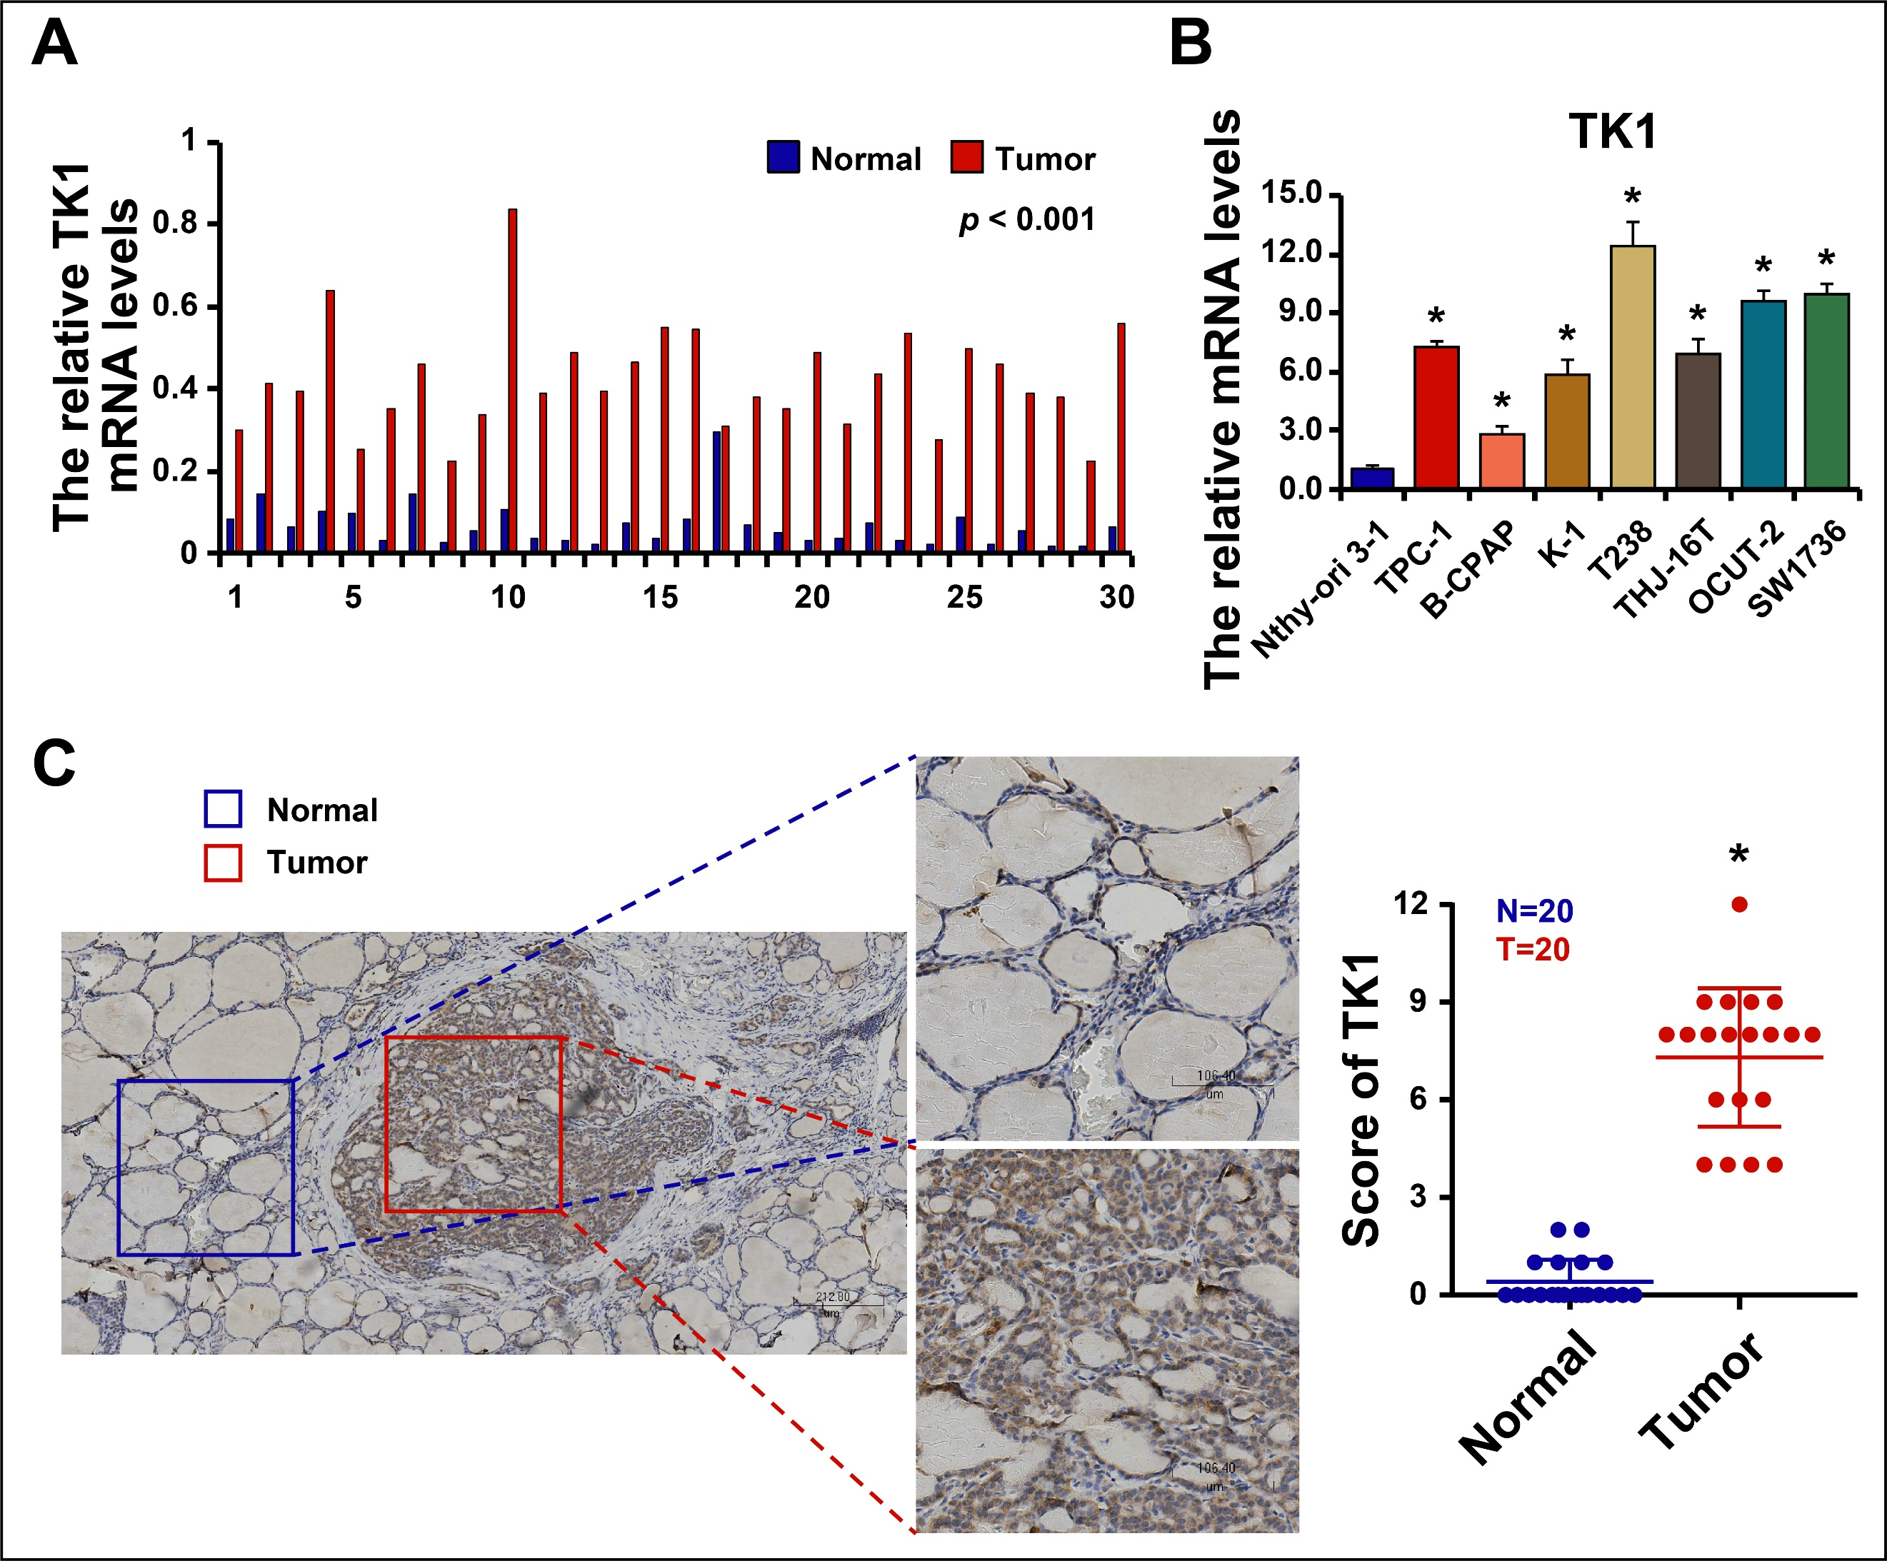

**Figure S1. The Expression Levels of TK1 in Tissues and Cell lines of Thyroid Cancer Patients.** (A) The mRNA level of TK1 in 30 paired cancer tissues and normal tissues of thyroid cancer patients detected by real-time quantitative PCR (RT-qPCR). (B) The mRNA level of TK1 in normal thyroid cells and thyroid cancer cell lines detected by RT-qPCR. (C) The protein level of TK1 from patients with thyroid cancer detected by immunohistochemistry. *\*P* <0.05.