**Supplementary information, Landquist et al.**

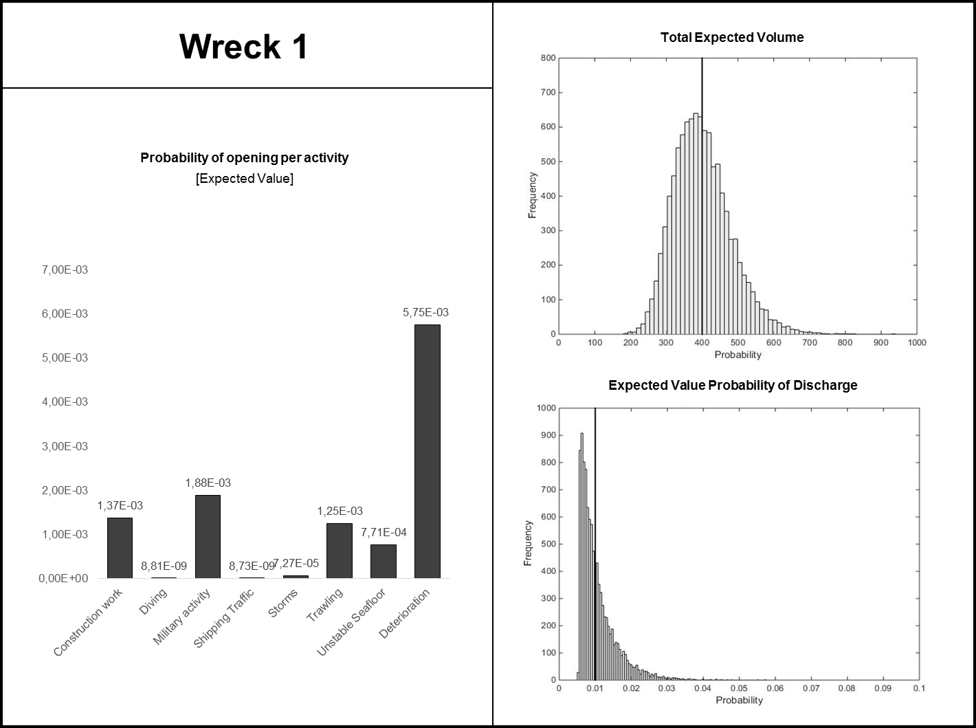

Figure S1. *Probability distribution for the total expected volume of the discharge. The solid line displays the expected (mean) value, 400 m3 of oil (upper right). Distribution of the probability of discharge (lower right). The solid line indicates the expected (mean) value, 0.01. The probability of opening per activity is also presented (left).*

*Table S1. Tier 2 consequence assessment of hypothetical wreck number 1.*

|  |  |  |  |
| --- | --- | --- | --- |
|  | **Low**  **severity** | **Moderate**  **severity** | **High**  **severity** |
| **Volume** | < 10 m3 | 10 – 500 m3 | > 500 m3 |
| **Distance to shore** | > 10 nautical miles | 1 – 10 nautical miles | < 1 nautical mile |
| **Sensitivity** | Nearest shore is: Sandy, steep cliffs or rock walls or facilities. | Nearest shore is:  Cliff beaches, pebble, boulder or gravel beaches. | Nearest shore is:  Reed beds, meadows, fine sediment beaches. or mixed beaches |

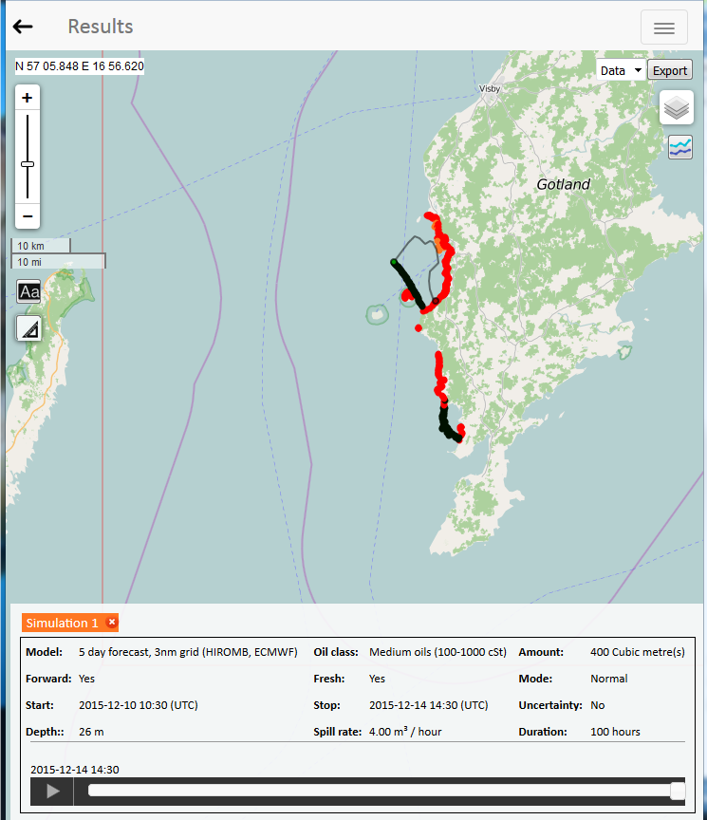

*Figure S2. Oil spill trajectory from Seatrack Web for wreck number 1. The black dots indicate oil on the surface, the red dots indicate oil on shore and the orange dots indicate oil on the seafloor. The green dot marks the location of the wreck.*

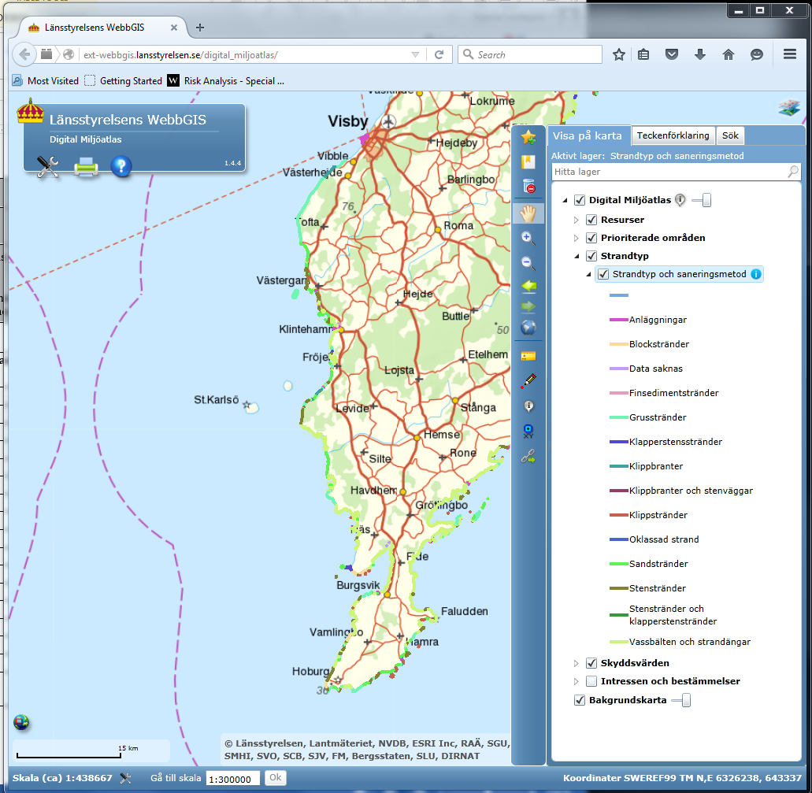

*Figure S3. Shore types in the Digital Environmental Atlas for the area of the discharge.*

*Table S2. Percentage of oil on the different types of shore, seafloor and water surface, as well as evaporated oil, based on information taken from Seatrack Web and the Digital Environmental Atlas.*

|  |  |  |  |
| --- | --- | --- | --- |
| Shore types in the Digital Environmental Atlas | Vulnerability ranking | Estimated percentage per shore type | Total |
|  |  |  |  |
| Plants | 0 | 0 |  |
| Steep cliffs | 1 | 0 |  |
| Steep cliffs and rock walls | 1 | 0 |  |
| Sandy beach | 2 | 50 | 2 x 0.5=1 |
| Gravel beach | 3 | 10 | 3 x 0.1=0.3 |
| Shingle beach | 4 | 0 |  |
| Boulder beach | 5 | 0 |  |
| Cliff shore | 6 | 0 |  |
| Cobble and shingle beach | 7 | 0 |  |
| Cobble beach | 7 | 0 |  |
| Fine sediment beach | 8 |  |  |
| Reed bead and sea meadow beach | 9 | 15 | 9 x 0.15 =1.35 |
| Data missing | 9 | 0 |  |
| Non-classified shore | 9 | 0 |  |
| Water surface | 4 | 20 | 4 x 0.2=0.8 |
| Seafloor | 8,**4**,4 (Depending on the type of seafloor) | 5 | 4 x 0.5=0.2 |
|  |  |  |  |
| Evaporated |  | 15 |  |

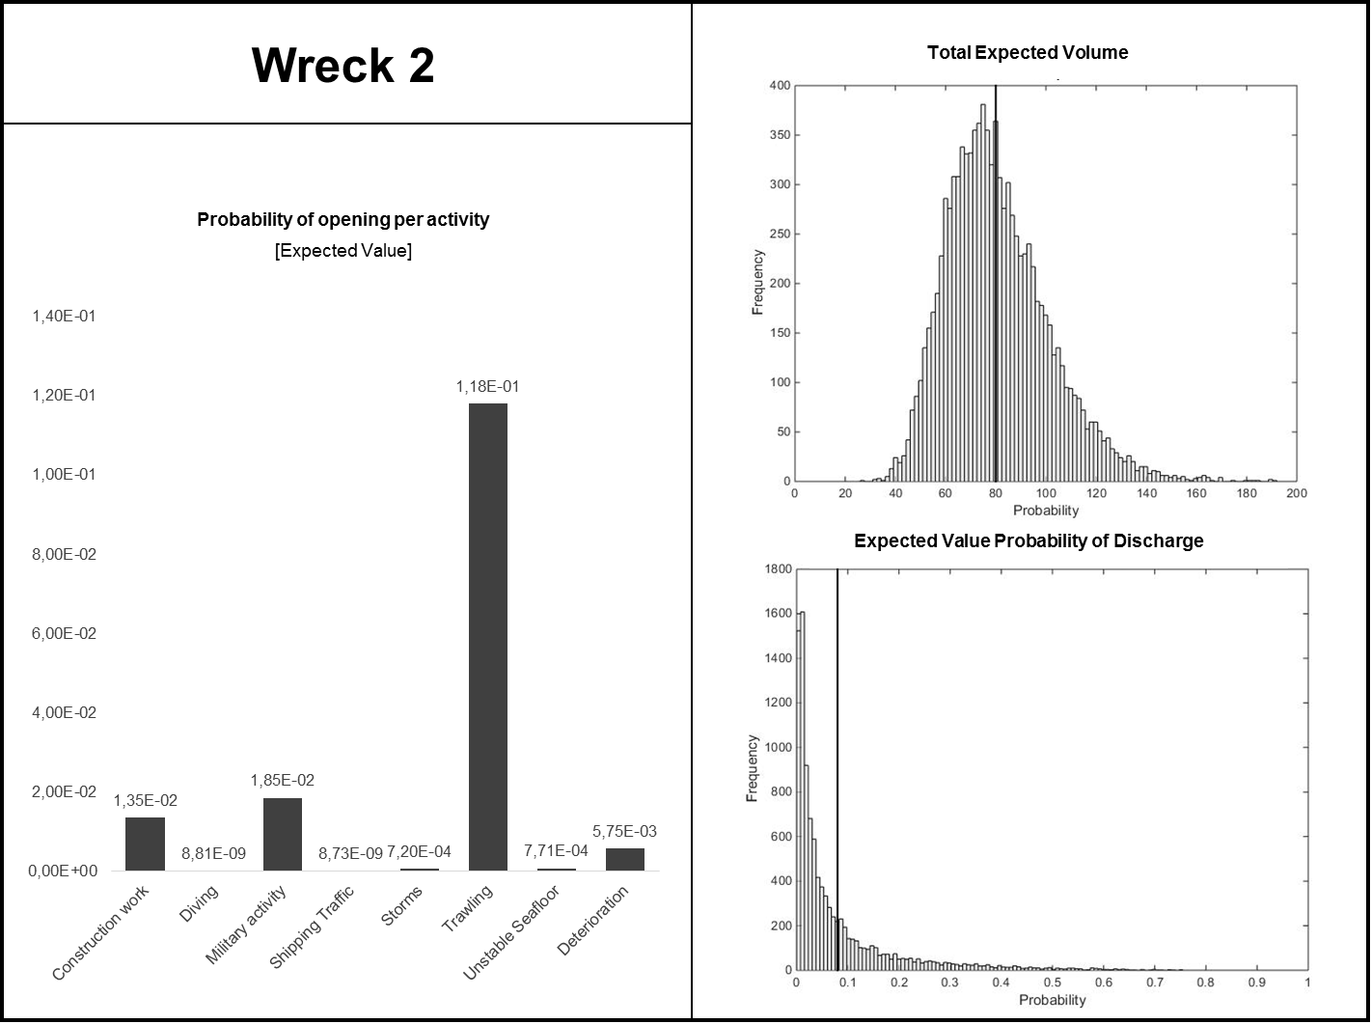

*Figure S4. Probability distribution for the total expected volume of the discharge. The solid line displays the expected (mean) value, 80 m3 of oil (upper right). Distribution of the probability of discharge (lower right). The solid line indicates the expected (mean) value, 0.08. The probability of opening per activity is also presented (left).*

*Table S3. Tier 2 consequence assessment of hypothetical wreck number 2.*

|  |  |  |  |
| --- | --- | --- | --- |
|  | **Low**  **severity** | **Moderate**  **severity** | **High**  **severity** |
| **Volume** | < 10 m3 | 10 – 500 m3 | > 500 m3 |
| **Distance to shore** | > 10 nautical miles | 1 – 10 nautical miles | < 1 nautical mile |
| **Sensitivity** | Nearest shore is: Sandy, steep cliffs or rock walls or facilities. | Nearest shore is:  Cliff beaches, pebble, boulder or gravel beaches. | Nearest shore is:  Reed beds, meadows, fine sediment beaches. or mixed beaches |

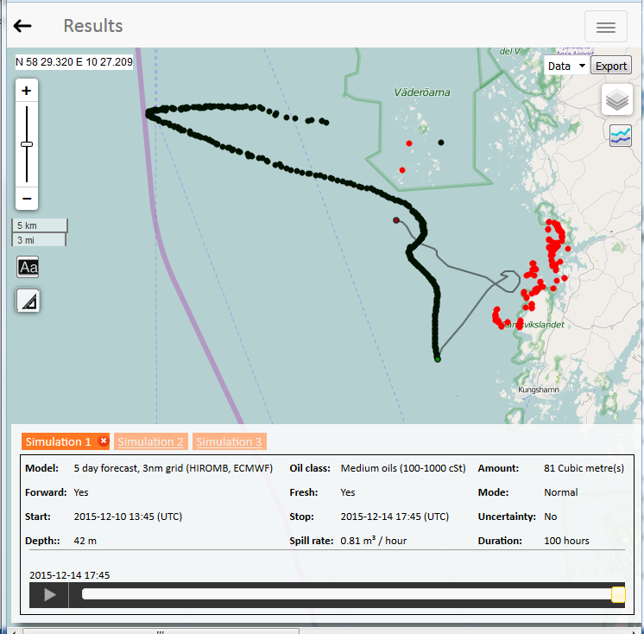

*Figure S5. Oil spill trajectory from Seatrack Web for wreck number 2. The black dots indicate oil on the surface and the red dots indicate oil on shore. The green dot marks the location of the wreck.*

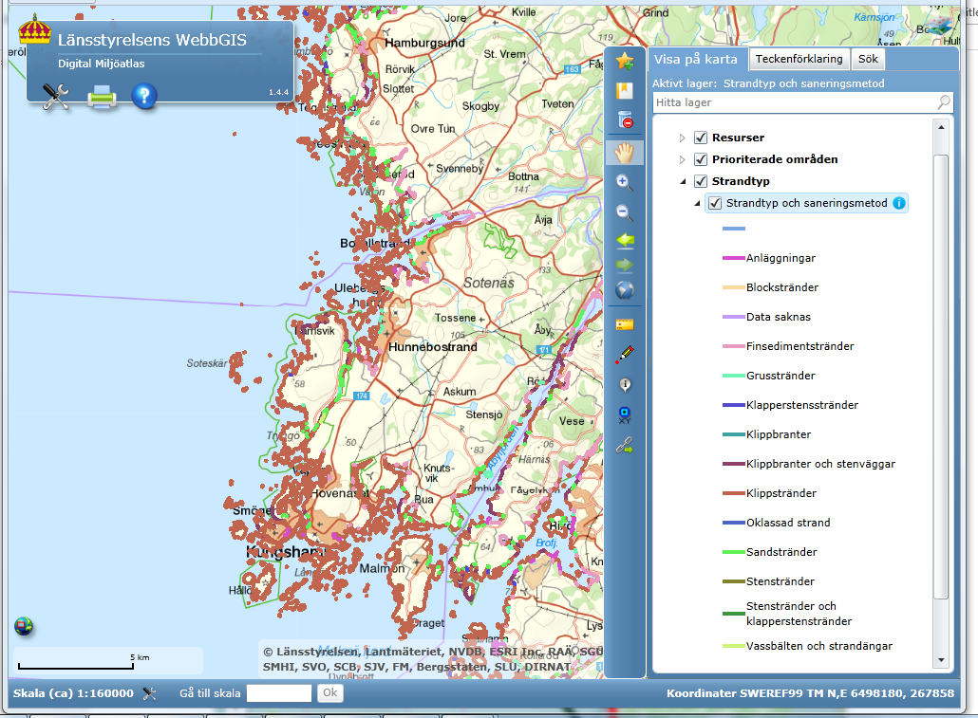

*Figure S6. Shore types in the Digital Environmental Atlas for the area of discharge.*

*Table S4. Percentage of oil on different types of shore, seafloor and water surface, as well as evaporated oil, based on information retrieved by Seatrack Web and the Digital Environmental Atlas.*

|  |  |  |  |
| --- | --- | --- | --- |
| Shore types in the Digital Environmental Atlas | Vulnerability ranking | Estimated percentage per shore type | Total |
|  |  |  |  |
| Plants | 0 | 0 |  |
| Steep cliffs | 1 | 0 |  |
| Steep cliffs and rock walls | 1 | 0 |  |
| Sandy beach | 2 | 0 |  |
| Gravel beach | 3 | 0 |  |
| Shingle beach | 4 | 0 |  |
| Boulder beach | 5 | 0 |  |
| Cliff shore | 6 | 70 | 6 x 0.7 = 4.2 |
| Cobble and shingle beach | 7 | 0 |  |
| Cobble beach | 7 | 0 |  |
| Fine sediment beach | 8 |  |  |
| Reed bead and sea meadow beach | 9 | 0 |  |
| Data missing | 9 | 0 |  |
| Non-classified shore | 9 | 0 |  |
| Water surface | 4 | 10 | 4 x 0.1 = 0.4 |
| Seafloor | 8,**4**,4 (Depending on the type of seafloor) | 0 |  |
|  |  |  |  |
| Evaporated |  | 20 |  |