Supplementary Figures

Supplementary Figure 1. The basic idea of our approach: The process of converting various medical data types–such as images, signals, and text–into a labeled training dataset, which is subsequently transformed into feature matrices where rows represent labeled samples and columns correspond to extracted features, organized by clarity for model development.

Supplementary Figure 2. Diagram of the basic approach to derive the transition matrix T from input matrices A and B, involving three main steps: visual analytics of the matrices, defining matrix A⁺, and establishing matrix T, which serves to interpret DL model outputs in terms of human-expert features.

Supplementary Figure 3. Diagram that outlines the proposed sequential approach to constructing matrix B from an initial dataset, through steps including compiling a feature list, defining numerical intervals, selecting techniques to extract features, validating feature selection, and ultimately constructing matrix B based on the defined transition matrix from the deep learning model to the feature model.

(a) | (b)
Supplementary Figure 4. This figure presents an ECG signal fragment displaying a triad of cardiac cycles, where (a) illustrates a heterogeneous appearance of the R peak, while (b) shows a homogeneous expression of the R peak across cycles.

Supplementary Figure 5. The results of applying PCA to classify data based on the "Absent P peak" feature, showing data points distributed across three principal components for visualization of feature separation.

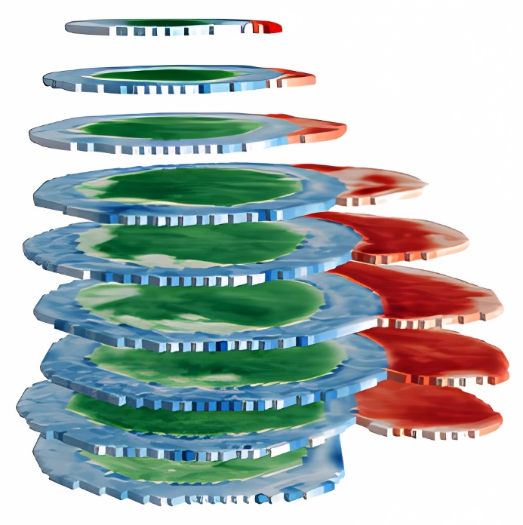 | 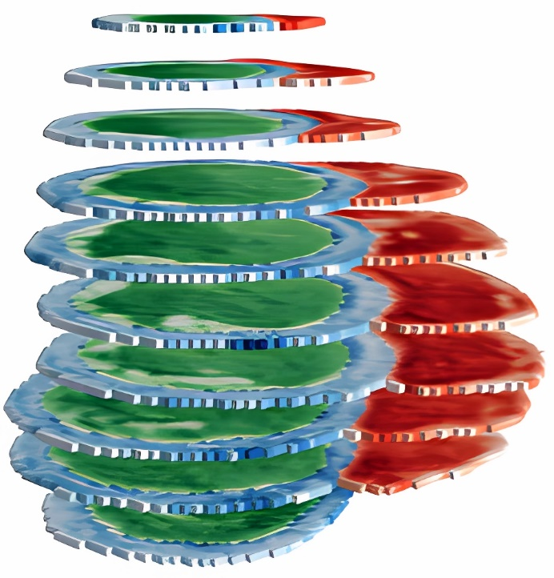
(a) | (b)
Supplementary Figure 6. A 3D visualization of segmented MRI data prepared for classification, with images from the ES phase in (a) and the ED phase in (b), while preserving MRI signal intensity values across layers for enhanced phase differentiation.

