**Appendix 1.** Supplementary material for:

Majer M, Svenning J and Bilde T (2015). Habitat productivity predicts the global distribution of social spiders. *Front. Ecol. Evol.* **3**:101. doi:10.3389/fevo.2015.00101

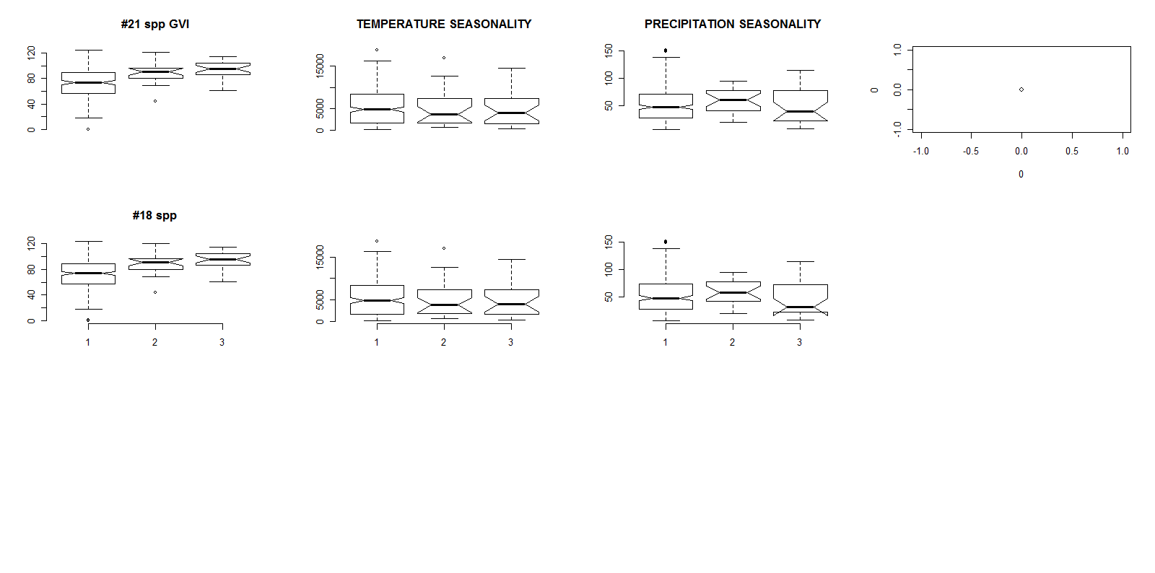

**Fig. S1.** Boxplots of environmental predictors (mean value computed for each botanical country) for social spiders’ richness equalling one, two, and three species. The data are shown for species richness of 21 social spider species (Table 1; upper panel); and for the reduced data set of 18 species (lower panel). The extremes, the inter-quartile range, and the median are shown.

**Table S1**. Binary logistic regression model summaries and performance across the dataset of presence vs. absence of social spiders (18spp. included, max SR=5 in 335 botanical countries). Abbreviations are: gviMedian, GVI Medians of botanical countries; sqrtSeaPrec, square rooted precipitation seasonality; sqrtSeaTemp, square rooted temperature seasonality. AIC scores, Akaike differences (∆AIC), relative weights (rel_w) and Akaike weights (*wi*), as well as model R2 are listed for each model. The set of models presented was chosen by stepwise selection.Bolded are the best supported models.

1. Non-spatial (*y=OldNew+log1p(areakm2)* as 0model)
2. Spatial (with autocovariate) (*y=OldNew+log1p(areakm2)+ac* as 0model)

|  |  |  |  |  |  |  |  |  |
| --- | --- | --- | --- | --- | --- | --- | --- | --- |
| Model | Predictors | AIC | ∆AIC | rel_w | wi | R2 |  |  |
|  | ***Non-spatial*** |  |  |  |  |  |  |  |
| 1 | OldNew+log1p(areakm2)+sqrtSeaTemp +sqrtSeaTemp*OldNew | 259.485 | 21.558 | 0.000 | 0.000 | 0.115 |  |
| 2 | OldNew+log1p(areakm2)+sqrtSeasp +sqrtSeasp*OldNew | 264.094 | 26.167 | 0.000 | 0.000 | 0.092 |  |
| 3 | OldNew+log1p(areakm2)+sqrtSeasp+sqrtSeaTemp sqrtSeaTemp*OldNew | 261.418 | 23.491 | 0.000 | 0.000 | 0.093 |  |
| 4 | **OldNew+log1p(areakm2)+GVI +GVI*OldNew** | **237.927** | **0.000** | **1.000** | **0.587** | **0.234** |  |
| 5 | OldNew+log1p(areakm2)+GVI+sqrtSeaTemp  + sqrtSeaTemp*OldNew | 240.046 | 2.119 | 0.347 | 0.204 | 0.208 |  |
| 6 | OldNew+log1p(areakm2)+GVI+sqrtSeasp | 240.644 | 2.717 | 0.257 | 0.151 | 0.208 |  |
| 7 | OldNew+log1p(areakm2)+GVI+sqrtSeasp+  sqrtSeaTemp+ sqrtSeaTemp*OldNew | 242.560 | 4.633 | 0.099 | 0.058 | 0.208 |  |
|  | ***Spatial*** |  |  |  |  |  |  |  |
| 1 | OldNew+log1p(areakm2 +sqrtSeaTemp +sqrtSeaTemp*OldNew +ac | 152.389 | 5.348 | 0.069 | 0.029 | 0.584 |  |  |
| 2 | OldNew+log1p(areakm2) +sqrtSeasp +sqrtSeasp*OldNew +ac | 154.041 | 7.000 | 0.030 | 0.013 | 0.578 |  |  |
| 3 | OldNew+log1p(areakm2) +sqrtSeasp+sqrtSeaTemp+ac | 153.967 | 6.927 | 0.031 | 0.013 | 0.578 |  |  |
| 4 | **OldNew+log1p(areakm2) +GVI +GVI*OldNew+ac** | **147.040** | **0.000** | **1.000** | **0.420** | **0.603** |  |  |
| 5 | OldNew+log1p(areakm2) +GVI+sqrtSeaTemp +GVI*OldNew+ac | 148.634 | 1.593 | 0.451 | 0.190 | 0.589 |  |  |
| 6 | OldNew+log1p(areakm2) +GVI+sqrtSeasp +GVI*OldNew+ac | 148.196 | 1.156 | 0.561 | 0.236 | 0.590 |  |  |
| 7 | OldNew+log1p(areakm2) +GVI+sqrtSeasp+  sqrtSeaTemp+ GVI*OldNew +ac | 149.928 | 2.887 | 0.236 | 0.099 | 0.592 |  |  |

**Table S2**. Binary logistic regression model summaries and model performance contrasting areas with one social spider spp. with those of two or more species (18 spp. included, maximum species richness =5 in 47 botanical countries). Species richness =1 is here modelled as 0. Abbreviations are: gviMedian, GVI Medians of botanical countries; sqrtSeaPrec, square rooted precipitation seasonality; sqrtSeaTemp, square rooted temperature seasonality. AIC scores, Akaike differences (∆AIC), relative weights (rel_w) and Akaike weights (*wi*), as well as model R2 are listed for each model. The set of models presented was chosen by stepwise selection.

1. Non-spatial (*y=OldNew+ Log area (km2)+*as 0model)
2. Spatial (with autocovariate) (*y=OldNew+ Log area (km2)++ac* as 0model)

|  |  |  |  |  |  |  |  |
| --- | --- | --- | --- | --- | --- | --- | --- |
| Model | Predictors | AIC | ∆AIC | rel_w | *wi* | R2 |  |
|  | ***Non-spatial*** |  |  |  |  |  |  |
| 1 | OldNew+log1p(areakm2)+sqrtSeaTemp +sqrtSeaTemp*OldNew | 65.910 | 5.170 | 0.075 | 0.022 | 0.227 |  |
| 2 | OldNew+log1p(areakm2)+sqrtSeasp +sqrtSeasp*OldNew | 60.740 | 0.000 | 1.000 | 0.294 | 0.353 |  |
| 3 | OldNew+log1p(areakm2)+sqrtSeasp+sqrtSeaTemp | 61.265 | 0.525 | 0.769 | 0.226 | 0.359 |  |
| 4 | OldNew+log1p(areakm2)+gviMedian +gviMedian*OldNew | 65.159 | 4.419 | 0.110 | 0.032 | 0.278 |  |
| 5 | OldNew+log1p(areakm2)+gviMedian+sqrtSeaTemp | 65.558 | 4.818 | 0.090 | 0.026 | 0.240 |  |
| 6 | OldNew+log1p(areakm2)+gviMedian+sqrtSeasp | 60.987 | 0.247 | 0.884 | 0.260 | 0.366 |  |
| 7 | OldNew+log1p(areakm2)+gviMedian+sqrtSeasp+sqrtSeaTemp | 62.254 | 1.514 | 0.469 | 0.138 | 0.384 |  |
|  | ***Spatial*** |  |  |  |  |  |  |
| 1 | OldNew+log1p(areakm2 +sqrtSeaTemp )+ac +sqrtSeaTemp*OldNew | 66.366 | 4.628 | 0.099 | 0.027 | 0.353 |  |
| 2 | OldNew+log1p(areakm2) +sqrtSeasp +ac +sqrtSea sp*OldNew | 61.873 | 0.135 | 0.935 | 0.252 | 0.436 |  |
| 3 | OldNew+log1p(areakm2) +sqrtSeasp+sqrtSeaTemp+ac | 62.193 | 0.455 | 0.796 | 0.215 | 0.440 |  |
| 4 | OldNew+log1p(areakm2) +gviMedian+ac +gviMedian*OldNew | 64.891 | 3.153 | 0.207 | 0.056 | 0.411 |  |
| 5 | OldNew+log1p(areakm2) +gviMedian+sqrtSeaTemp+ac | 65.776 | 4.038 | 0.133 | 0.036 | 0.363 |  |
| 6 | OldNew+log1p(areakm2) +gviMedian+sqrtSeasp+ac | 61.738 | 0.000 | 1.000 | 0.270 | 0.442 |  |
| 7 | OldNew+log1p(areakm2) +gviMedian+sqrtSeasp+sqrtSeaTemp+ac | 62.979 | 1.241 | 0.538 | 0.145 | 0.462 |  |

**Table S3.** Multi-model coefficient β, odds ratios and the coefficient support (*Wi* =sum of Akaike weights) of all the binary logistic models (Table S1&2 for the dataset with 18SS*) containing each of the three environmental variables representing our hypotheses for social spiders’ species richness (*H1, H2, H3*). The odds ratios show how much the probability of 1 (or binary presence/presence of 2+ species) change with one unit change of the variable for which each odds were calculated. Variables are ordered by their relative coefficient support throughout each set of models.

|  |  |  |  |  |  |  |
| --- | --- | --- | --- | --- | --- | --- |
| Predictor | *Spatial* | | | *Non-spatial* | | |
|  | **Multimodel β** | **Odds ratio** | ***Wi*** | **Multimodel β** | **Odds ratio** | ***Wi*** |
| 1. *Presence vs. absence* | | | | | | |
| GVI Old World | 3.466 | 32.017 | 0.945 | 3.674 | 39.425 | 1.000 |
| GVI New World | 0.211 | 1.235 | 0.945 | Non-significant! |  |  |
| SeaTemp | 0.175 | 1.191 | 0.331 | 0.097 | 1.101 | 0.262 |
| SeaPrec | -0.213 | 0.808 | 0.361 | 0.032 | 1.033 | 0.209 |
| 1. *≥2 species present vs. just 1 species present* | | | | | | |
| SeaPrec | -1.500 | 0.223 | 0.882 | -1.660 | 0.190 | 0.919 |
| GVI | 0.297 | 1.345 | 0.506 | 0.538 | 1.712 | 0.575 |
| SeaTemp | 0.275 | 1.317 | 0.422 | 0.257 | 1.293 | 0.413 |

*See Table 1 in the main manuscript file.

**Table S4.** Correlation of the environmental variables in Dataset 1 & 2 for 21 spp. Abbreviations are: GVI (GVI Means of botanical contries), sqrtSeaPrec is square rooted precipitation seasonality, sqrtSeaTemp is square rooted temperature seasonality.

|  |  |  |  |
| --- | --- | --- | --- |
| *a) Presence/absence (335 units)* | GVI | sqrtSeaPrec | sqrtSeaTemp |
| GVI | 1 | -0.013 | 0.016 |
| sqrtSeaPrec |  | 1 | -0.130 |
| sqrtSeaTemp |  |  | 1 |
| *b)Species richness (50 units)* |  |  |  |
| GVI | 1 | 0.115 | -0.095 |
| sqrtSeaPrec |  | 1 | -0.116 |
| sqrtSeaTemp |  |  | 1 |

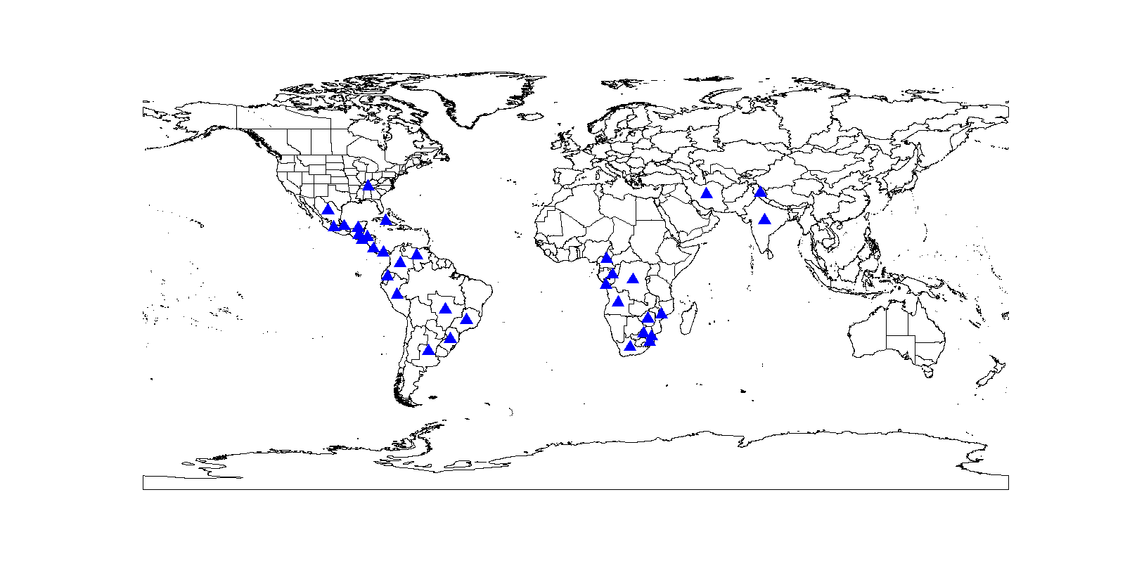**Fig. S2**. World map of botanical countries (see the Methods section in the main manuscript file), showing the occurrence of subsocial sister species (*Anelosimus* and *Stegodyphus spp.*) of the social spiders included in the main analyses. Points are the centroids of geographical coordinates of each botanical country.

**SUPPLEMENTARY ANALYSIS OF THE PRESENCE VS. ABSENCE OF SUBSOCIAL SISTER SPECIES OF THE SOCIAL SPIDERS INCLUDED IN THE MAIN ANALYSES**

We included the sister species of the social spiders in the genus *Anelosimus* and *Stegodyphus*, since these are the only genera where phylogenies (Agnarsson 2012; Settepani et al. 2015) and occurrence data for the species (Majer et al. 2013b; Majer et al. 2013a) are available. The species are listed in the table below. The analyses were performed in the same way as described in the Methods section of the main manuscript file.

**Table S5**. List of subsocial sister species (*Anelosimus* and *Stegodyphus spp.*) of the social spiders, on which the global occurrence analyses detailed below were performed.

|  |  |
| --- | --- |
| 1 | *Anelosimus baeza (sister to A. puravida)* |
| 2 | ***Anelosimus elegans*** *(sister to A. guacamayos)* |
| 3 | ***Anelosimus jabaquara*** *(sister to A. domingo)* |
| 4 | ***Anelosimus tosus*** *(sister to A. oritoyacu)* |
| 5 | ***Stegodyphus africanus*** *(sister to S. mimosarum)* |
| 6 | ***Stegodyphus tentoriicola*** *(sister to S. dumicola)* |
| 7 | ***Stegodyphus pacificus*** *(sister to S. sarasinorum)* |

**Table S6**. Binary logistic regression model summaries and model performance across the data set of presence vs. absence of subsocial spiders (7spp. in 335 botanical countries). Abbreviations are: GVI (GVI Means of botanical countries), sqrtSeaTemp (square rooted temperature seasonality); sqrtSeaPrec (square rooted precipitation seasonality), ac (spatial autocovariate; see Methods section for details). N countries = 335. AIC scores, Akaike differences (∆AIC), relative weights (relW) and Akaike weights (*wi*), as well as model R2 are listed for each model. The set of models presented was chosen by stepwise selection.

1. Non-spatial (*y=OldNew+ Log area (km2)+*as 0model)
2. Spatial (with autocovariate) (*y=OldNew+ Log area (km2)+ac* as 0model)

|  |  |  |  |  |  |  |  |  |
| --- | --- | --- | --- | --- | --- | --- | --- | --- |
| Model | Predictors | AIC | ∆AIC | rel_w | *wi* | R2 |  |  |
|  | *Non-spatial* |  |  |  |  |  |  |  |
| 1 | OldNew+logArea+sqrtSeaTemp | 201.936 | 20.278 | 0 | 0 | 0.132 |  |  |
| 2 | OldNew+logArea+sqrtSeasp | 202.344 | 20.686 | 0 | 0 | 0.13 |  |  |
| 3 | OldNew+logAreasqrt+SeaTemp+sqrtSeasp | 203.863 | 22.205 | 0 | 0 | 0.132 |  |  |
| 4 | OldNew+logArea+GVI | 181.658 | 0 | 1 | 0.519 | 0.235 |  |  |
| 5 | OldNew+logArea+GVI+sqrtSeaTemp | 183.586 | 1.928 | 0.381 | 0.198 | 0.235 |  |  |
| 6 | OldNew+logArea+sqrtSeasp+GVI | 183.535 | 1.877 | 0.391 | 0.203 | 0.236 |  |  |
| 7 | OldNew+logArea+sqrtSeasp+sqrtSeaTemp | 185.41 | 3.752 | 0.153 | 0.08 | 0.237 |  |  |
|  | *Spatial* |  |  |  |  |  |  |  |
| 1 | OldNew+logArea+sqrtSeaTemp+ac | 148.648 | 6.143 | 0.046 | 0.022 | 0.456 |  |  |
| 2 | OldNew+logArea+sqrtSeasp+ac | 148.552 | 6.047 | 0.049 | 0.023 | 0.458 |  |  |
| 3 | OldNew+logAreasqrt+SeaTemp+sqrtSeasp+ac | 150.49 | 7.986 | 0.018 | 0.009 | 0.459 |  |  |
| 4 | OldNew+logArea+GVI+ac | 142.505 | 0 | 1 | 0.475 | 0.484 |  |  |
| 5 | OldNew+logArea+GVI+sqrtSeaTemp+ac | 144.306 | 1.802 | 0.406 | 0.193 | 0.488 |  |  |
| 6 | OldNew+logArea+sqrtSeasp+GVI+ac | 144.229 | 1.724 | 0.422 | 0.200 | 0.488 |  |  |
| 7 | OldNew+logArea+sqrtSeasp+sqrtSeaTemp+GVI+ac | 146.112 | 3.608 | 0.165 | 0.078 | 0.491 |  |  |

**Table S7.** Multi-model coefficient estimates β, odds ratios and the coefficient support (*Wi*, sum of Akaike weights for models including this factor) of all the binary logistic models (Table S5) containing each of the three environmental variables representing our hypotheses for subsocial spiders’ occurence. The odds ratios show how much the probability of 1 (or binary presence/ presence) change with one unit change of the variable for which each odds were calculated. Variables are ordered by their relative coefficient support throughout each set of models. The most supported predictor (productivity) is bolded.

|  |  |  |  |  |  |  |
| --- | --- | --- | --- | --- | --- | --- |
| Predictor | *Spatial* | | | *Non-spatial* | | |
|  | **Multimodel β** | **Odds ratio** | ***Wi*** | **Multimodel β** | **Odds ratio** | ***Wi*** |
| *Presence vs. absence* | | | | | | |
| GVI | **2.438** | **11.447** | **0.946** | **4.086** | **59.515** | **1.000** |
| SeaPrec | -0.118 | 0.888 | 0.310 | -0.072 | 0.931 | 0.283 |
| SeaTemp | 0.098 | 1.103 | 0.302 | -0.054 | 0.947 | 0.278 |

**Table S8. Models of species richness excluding data from Ecuador**.

Binary logistic regression model summaries and model performance contrasting areas with one social spider spp. with those of two or more spp. (21 spp. included, maximum species richness =6). Species richness =1 is here modelled as 0. Abbreviations are: GVI (GVI Means of botanical countries), sqrtSeaPrec is square rooted precipitation seasonality; sqrtSeaTemp is square rooted temperature seasonality. N countries = 49. AIC scores, Akaike differences (∆AIC), relative weights (relW) and Akaike weights (*wi*), as well as model R2 are listed for each model. The set of models presented was chosen by stepwise selection.

1. Non-spatial (*y=OldNew+ Log area (km2)+*as 0model)
2. Spatial (with autocovariate) (*y=OldNew+ Log area (km2)+ac* as 0model)

|  |  |  |  |  |  |  |  |
| --- | --- | --- | --- | --- | --- | --- | --- |
| Model | Predictors | AIC | ∆AIC | rel_w | *wi* | R2 |  |
|  | *Non-spatial* |  |  |  |  |  |  |
| 1 | OldNew+logArea+sqrtSeaTemp | 66.218 | 1.84 | 0.398 | 0.126 | 0.239 |  |
| 2 | OldNew+logArea+sqrtSeasp | 64.378 | 0 | 1 | 0.316 | 0.28 |  |
| 3 | OldNew+logArea+sqrtSeasp+sqrtSeaTemp | 65.97 | 1.592 | 0.451 | 0.143 | 0.288 |  |
| 4 | OldNew+logArea+GVI | 66.582 | 2.204 | 0.332 | 0.105 | 0.231 |  |
| 5 | OldNew+logArea+GVI+sqrtSeaTemp | 67.682 | 3.305 | 0.192 | 0.061 | 0.251 |  |
| 6 | OldNew+logArea+GVI+sqrtSeasp | 65.623 | 1.245 | 0.537 | 0.17 | 0.296 |  |
| 7 | OldNew+logArea+GVI+sqrtSeasp+sqrtSeaTemp | 67.141 | 2.764 | 0.251 | 0.079 | 0.306 |  |
|  | *Spatial* |  |  |  |  |  |  |
| 1 | OldNew+logArea+sqrtSeaTemp + ac | 64.01 | 1.434 | 0.488 | 0.132 | 0.329 |  |
| 2 | OldNew+logArea+ sqrtSeasp +ac | 62.576 | 0 | 1 | 0.271 | 0.358 |  |
| 3 | OldNew+logArea+sqrtSeasp+sqrtSeaTemp+ac | 63.152 | 0.577 | 0.75 | 0.203 | 0.386 |  |
| 4 | OldNew+logArea +GVI +ac | 65.638 | 3.062 | 0.216 | 0.059 | 0.295 |  |
| 5 | OldNew+logArea+GVI+sqrtSeaTemp+ac | 65.392 | 2.817 | 0.245 | 0.066 | 0.342 |  |
| 6 | OldNew+logArea+GVI+sqrtSeasp+ac | 63.797 | 1.222 | 0.543 | 0.147 | 0.374 |  |
| 7 | OldNew+logArea+GVI+sqrtSeasp+sqrtSeaTemp+ac | 64.159 | 1.583 | 0.453 | 0.123 | 0.405 |  |