Supplementary Material

Supplementary Figures and Tables

Supplementary Figures
Supplementary Figure 1. Alignment of Pmk1 nucleotide sequences. The CDS sequence of Pmk1⁷⁰⁻¹⁵ gene was obtained from NCBI. Gene ID: 2680463. The genome sequence of Pmk1⁷⁰⁻¹⁵ was obtained from NCBI. GenBank: GCA_000002495.2. The genome sequences of Pmk1^{A7203-8} and Pmk1^{AM16} were sequenced by the laboratory itself. The genome sequence of Pmk1 ^{FJ81278} was obtained from NCBI. GenBank: GCA_002368475.1. The genome sequence of Pmk1 ^{Guy11} was obtained from NCBI. GenBank: GCA_002368485.1. "" represents a separator inserted every 20 bases.

Supplementary Figure 2. Alignment of Mac1 nucleotide sequences. The CDS sequence of Mac1⁷⁰⁻¹⁵ gene was obtained from NCBI. Gene ID: 2680463. The genome sequence of Mac1⁷⁰⁻¹⁵ was obtained from NCBI. GenBank: GCA_000002495.2. The genome sequences of Mac1^{A7203-8} and Mac1^{AM16} were sequenced by the laboratory itself. The genome sequence of Mac1 ^{FJ81278} was obtained from NCBI. GenBank: GCA_002368475.1. The genome sequence of Mac1 ^{Guy11} was obtained from NCBI. GenBank: GCA_002368485.1. "" represents a separator inserted every 20 bases.
Supplementary Figure 3. Identification of positive transformants overexpressing Pmk1. (A) Identification of positive transformants. (B) Colony morphology. (C) Colony size. (D) Conidiation. Error bars represent mean ± SD (n=3). "**" above the columns indicates significant differences at P<0.01 with Student’s t-test.
Supplementary Figure 4. Identification of positive transformants overexpressing Mac1. (A) Identification of positive transformants. (B) Colony morphology. (C) Colony size. (D) Conidiation. Error bars represent mean ± SD (n=3). "**" above the columns indicates significant differences at P<0.01 with Student’s t-test.
Supplementary Figure 5. Expression levels of Pmk1 and Mac1 genes in AM16 and its transformed strains. (A) The expression levels of Pmk1 gene in strains AM16 and Pmk1-ox. (B) The expression level of Mac1 gene in strains AM16 and Mac1-ox. (C) The expression level of Pmk1 and Mac1 in strains AM16 and Pmk1-Mac1-ox. The number of biological replicates for each experiment was n=3. Data were analyzed using ANOVA (P < 0.05) and Duncan's test. Different letters indicate the significance at p<0.05. Error bars represent the SD of three replicates (n = 3).
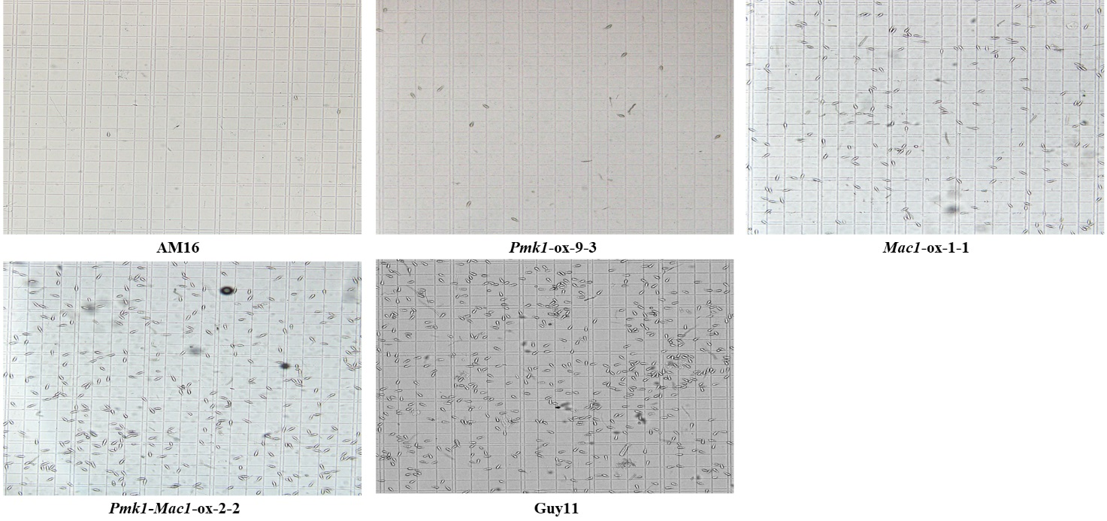
Supplementary Figure 6. Conidiation of five M. oryzae strains.

Supplementary Figure 7. Conidial germination and appressorium formation on hydrophobic surface. (A) Conidial germination of different strains on hydrophobic surfaces. (B) Conidial Germination rates (%) of Guy11 at 3 hpi and 8 hpi. (C) Appressorium formation rates (%) of Guy11 at 8 hpi and 12 hpi. Error bars represent mean ± SD (n=3). Scale bars, 10 µm.
Supplementary Figure 8. Pathogenicity of four M. oryzae isolates to rice. (A) Punch inoculation of JNXN plants. Two leaves each of AM16, Pmk1-ox-9-3, Mac1-ox-1-1 and Pmk1-Mac1-ox-2-2 are shown. Lesion length was measured. (B) Punch inoculation of Nip plants. Two leaves each of AM16, Pmk1-ox-9-3, Mac1-ox-1-1 and Pmk1-Mac1-ox-2-2 are shown. Lesion length was measured. Error bars represent mean ± SD (n=3). Asterisks indicate significant differences from AM16 strain according to Student's t-test (** p < 0.01). Jiangnan Xiangnuo (JNXN), Nipponbare (Nip).

Supplementary Figure 9. The expression of Pmk1 protein in different strains. Western blot using anti-Pmk1 antibody (top panel). Ponceau S staining of total proteins was shown as a loading control (lower panel).

Supplementary Table

