Supplementary data
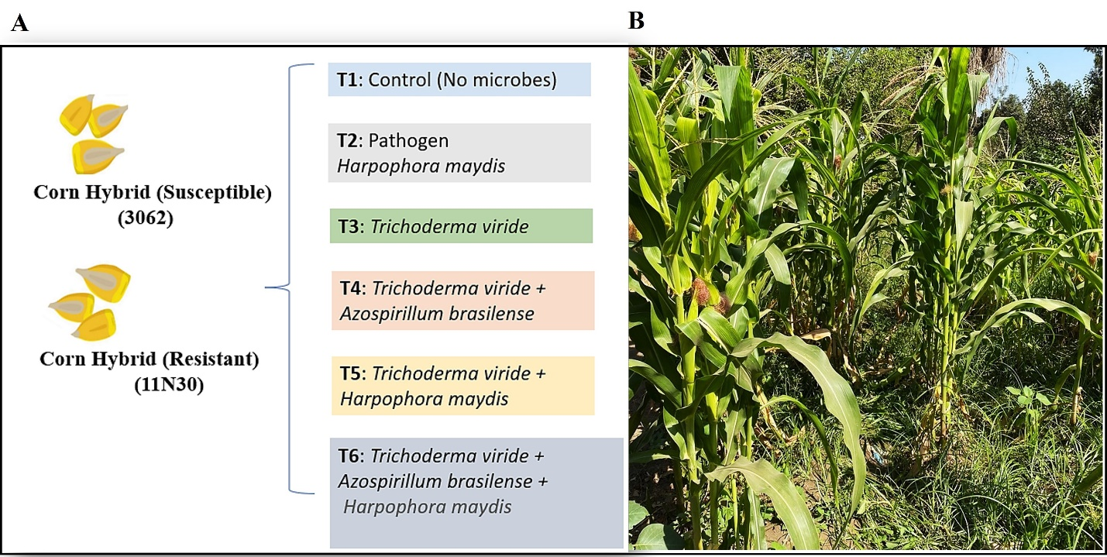
Figure S1: (A) Experimental field design showing various treatments with two maize hybrids. (B) Maize plants with cobs.

Table S1. Quantities of volatile compounds, siderophores, lytic enzymes, and growth hormones of T. viride (T27) and A. brasielence.
Microbes | Volatile compounds |  |  | Lytic enzymes (mg/mL) |  |  | Growth hormones  (mg/L)
 | HCN  (OD) | NH₄  (mg/L) | Siderophores  (%) | Chitinase | Cellulase | Amylase | IAA | GA₃
T. viride (T27) | 0.208 | 3.12 | 0.765 | 2.206 | 0.121 | 0.493 | 33.2 | 30.8
A. brasilense | - | - | - | - | - | - | 15.3 | 46.9

Table S2. The oxidative enzymes of two maize hybrids under different treatments.
Treatments |  | T1 | T2 | T3 | T4 | T5 | T6 | df | F | P
Oxidative enzymes
Polyphenol | Treatments | 0.93^{ab} | 0.79^{c} | 1.06^{ab} | 1.24^{ab} | 0.89^{c} | 1.35ª
 |  |  |  |  |  |  |  | 5 | 4.28 | .006
 | Corn | 1 |  |  |  |  |  |  | 8.95 | .006
 | Treatments × Corn | 5 |  |  |  |  |  |  | 3.43 | .017
Peroxidase | Treatments | 173.00ª | 179.00ª | 178.80ª | 172.36ª | 183.00ª | 178.58ª | 5 | 1.89 | .13
 | Corn | 1 |  |  |  |  |  |  | 13.65 | .001
 | Treatments × Corn | 5 |  |  |  |  |  |  | 4.05 | .008
Chitinase | Treatments | 30.47^{b} | 48.18ª | 39.59^{ab} | 36.02^{b} | 47.25ª | 29.64^{b} | 5 | 9.74 | .670
 | Corn | 1 |  |  |  |  |  |  | 4.86 | .169
 | Treatments × Corn | 5 |  |  |  |  |  |  | 19.21 | .800
Phenyl | Treatments | 94.78^{b} | 78.51^{cd} | 107.15ª | 72.06^{d} | 85.70^{bc} | 86.11^{bc} | 5 | 29.86 | <.001
 | Corn | 1 |  |  |  |  |  |  | 36.52 | <.001
 | Treatments × Corn | 5 |  |  |  |  |  |  | 14.93 | <.001
Catalase | Treatments | 12.14^{ab} | 13.93ª | 12.56^{ab} | 10.14^{c} | 13.25^{ab} | 11.45^{ab} | 5 | 2.98 | .031
 | Corn | 1 |  |  |  |  |  |  | 0.425 | .521
 | Treatments × Corn | 5 |  |  |  |  |  |  | 4.046 | .008
According to Duncan's multiple range test, values within a raw followed by the same letter (s) are not significantly different at the P = 0.05 level.

Table S3. Anatomical measurements in roots of two maize hybrids under different treatments.
Hybrids | Treatments | The whole thickness of the root (µ) | Cortex |  | Endodermis thickness (µ) | Pith thickness (µ) | Xylem |  | Phloem  Thickness (µ) | Aerenchyma
 |  |  | Thickness (µ) | Degradation area thickness (µ) |  |  | Thickness (µ) | Number of Vessels in rows |  | Thickness (µ) | Number
Susceptible | T1 | 1980 | 450 | -- | 45.0 | 720 | 18.0 | 2 | 22.0 | 55 | 24
 | T2 | 1170 | 315 | 360 | 18.0 | 270 | 45.0 | 3 | 18.0 | 42 | 14
 | T3 | 1198 | 360 | -- | 27.0 | 630 | 27.0 | 2 | 27.0 | 60 | 18
 | T4 | 2430 | 450 | -- | 28.0 | 1080 | 36.0 | 2 | 45.0 | 62 | 22
 | T5 | 1458 | 405 | 225 | 22.5 | 1107 | 9.00 | 2 | 31.5 | 72 | 24
 | T6 | 2178 | 203 | 225 | 27.0 | 900 | 18.0 | 2 | 40.5 | 81 | 20
Resistant | T1 | 2925 | 540 | -- | 24.0 | 1008 | 39.5 | 2 | 31.5 | 90 | 26
 | T2 | 1917 | 513 | 2881 | 18.1 | 1395 | 16.3 | 2 | 27.0 | 83 | 25
 | T3 | 2430 | 585 | 90.2 | 27.2 | 900 | 18.0 | 3 | 30.1 | 108 | 29
 | T4 | 3240 | 540 | -- | 27.0 | 765 | 22.1 | 3 | 27.0 | 90 | 26
 | T5 | 2163 | 378 | 360 | 27.1 | 821 | 23.2 | 3 | 38.7 | 90 | 25
 | T6 | 2718 | 450 | 252 | 28.8 | 1188 | 24.1 | 3 | 32.1 | 99 | 30

