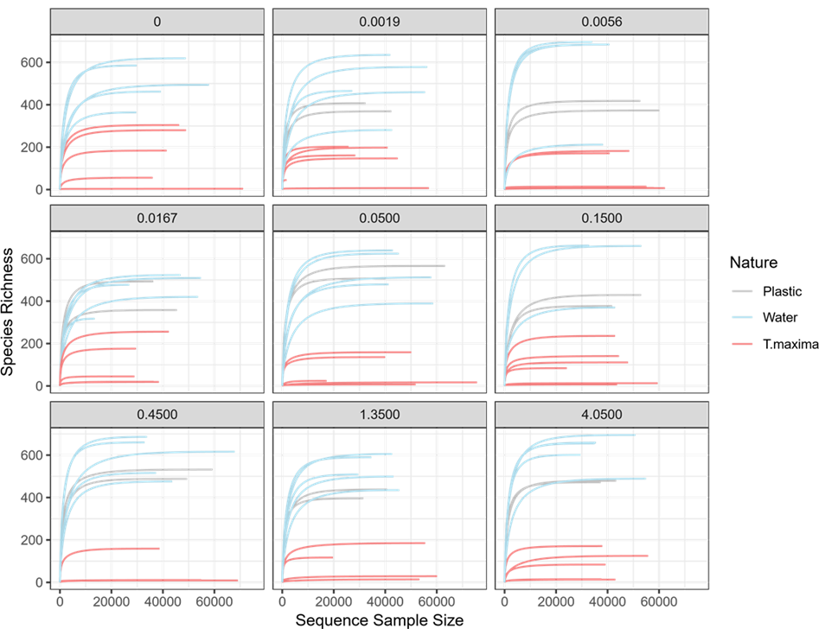
Figure S1. Rarefaction curves as a function of the concentration of plastic (grey: plastic, blue: water, pink: Tridacna maxima).

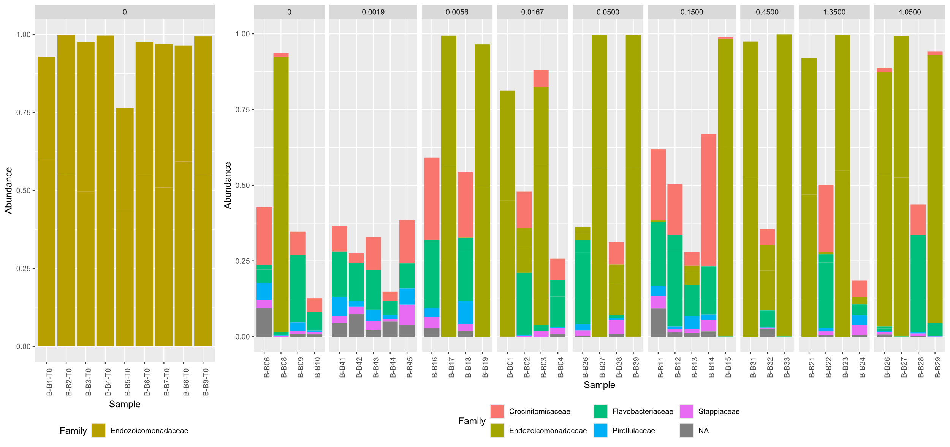
Figure S2. Compositional plot of the composition of T. maxima bacterial communities at family level. On the left, the composition of the bacterial communities of T. maxima sampled at t0 before immersion in plastics. On the right, the composition of the bacterial communities of T. maxima sampled after two months of exposure to different concentrations of pearl plastics.

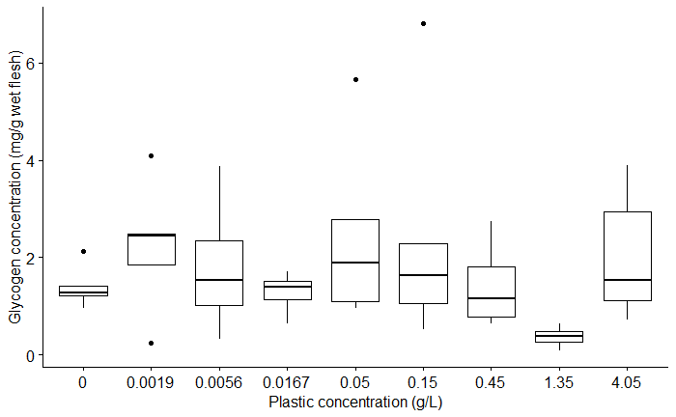
Figure S3. Muscle glycogen concentration per gram of wet weight of T. maxima as a function of pearl plastic concentration.

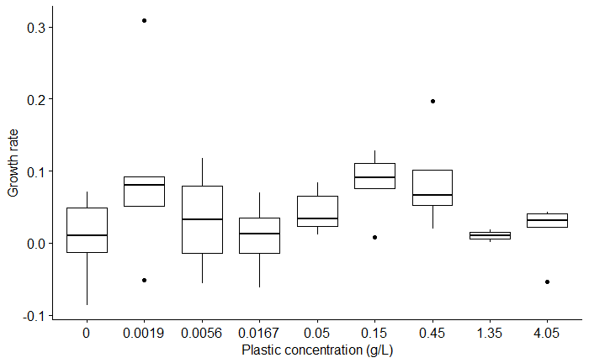
Figure S4. Shell growth rate of the T. maxima as a function of pearl plastic concentration.

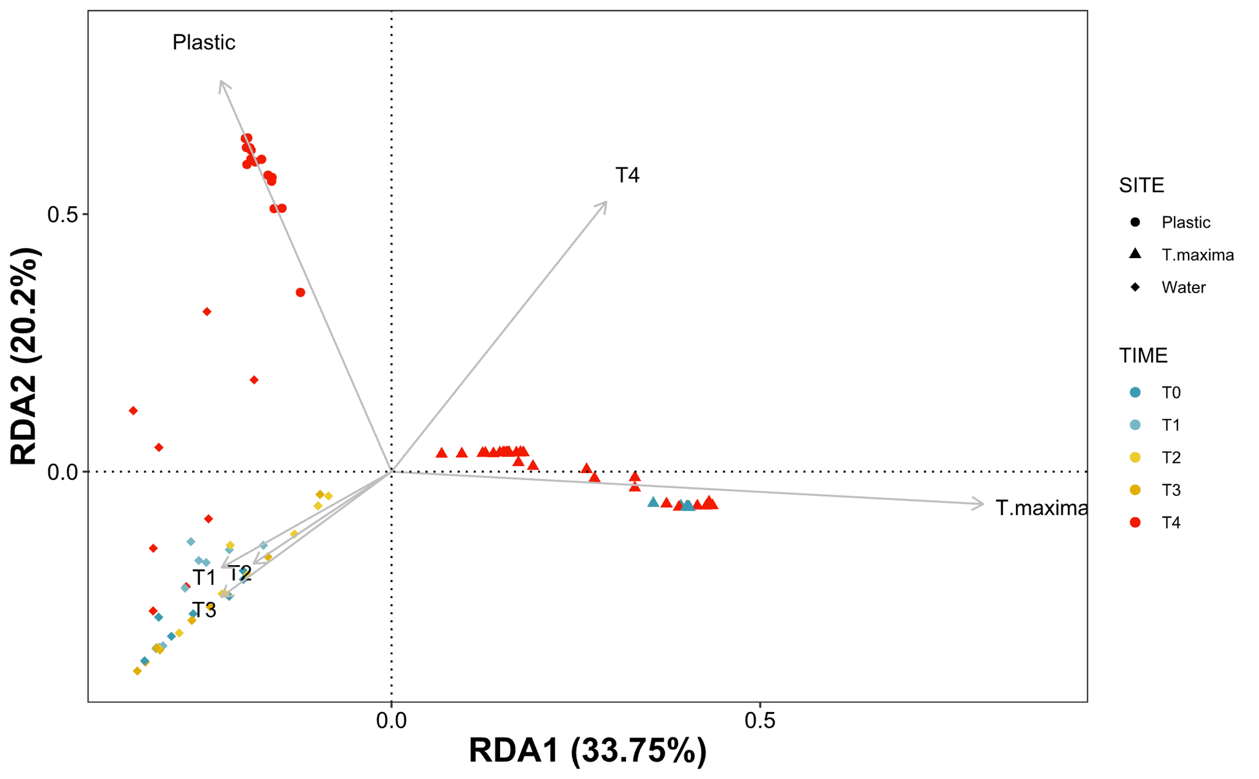
Figure S5. Distanced-based redundancy analysis on 104 samples that includes16, 42 and 46 samples of plastic, water and T. maxima respectively.

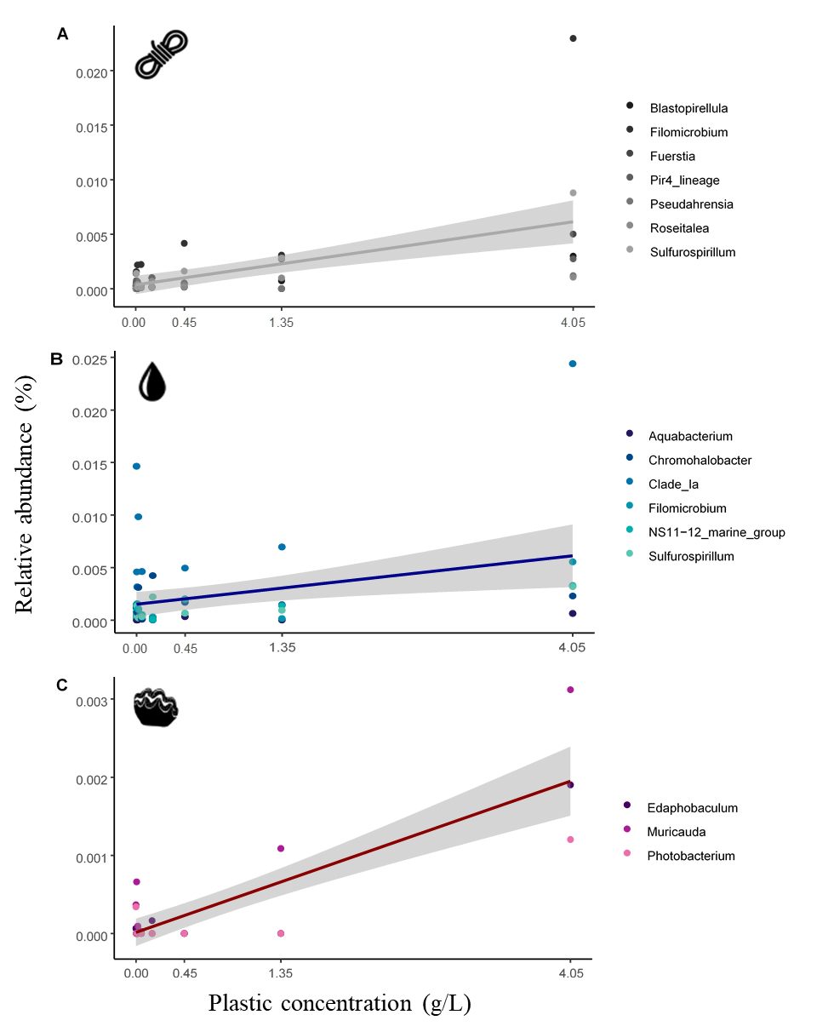

Figure S6. Percentage relative abundances of candidate ASVs as a function of plastic concentration (g/L) for each type of sample. Only ASVs identified up to genus have been represented (A: plastic, B: water, C: Tridacna maxima).

