Supplementary information
Exploring the Additive Compatibility and Tribological Behavior of Regular and High Oleic Soybean Oil
Piash Bhowmikª, Brajendra K. Sharma^{b}, Majher I. Sarker^{b}, Kalidas Mainali^{b}, Yachao Wangª, Clement Tangª, Sougata Roy^{c*}
ªDepartment of Mechanical Engineering, University of North Dakota, Grand Forks, ND, USA ​ ^{b}US Department of Agriculture**, Agricultural Research Service Eastern Regional Research Center, Sustainable Biofuels and Coproducts Research, Wyndmoor, PA, USA
^{c}Department of Mechanical Engineering, Iowa State University, Ames, IA, USA

*Corresponding author email: sroy@iastate.edu
**Mention of trade names or commercial products in this article is solely for the purpose of providing specific information and does not imply recommendation or endorsement by the U.S. Department of Agriculture (USDA). USDA is an equal opportunity provider and employer.
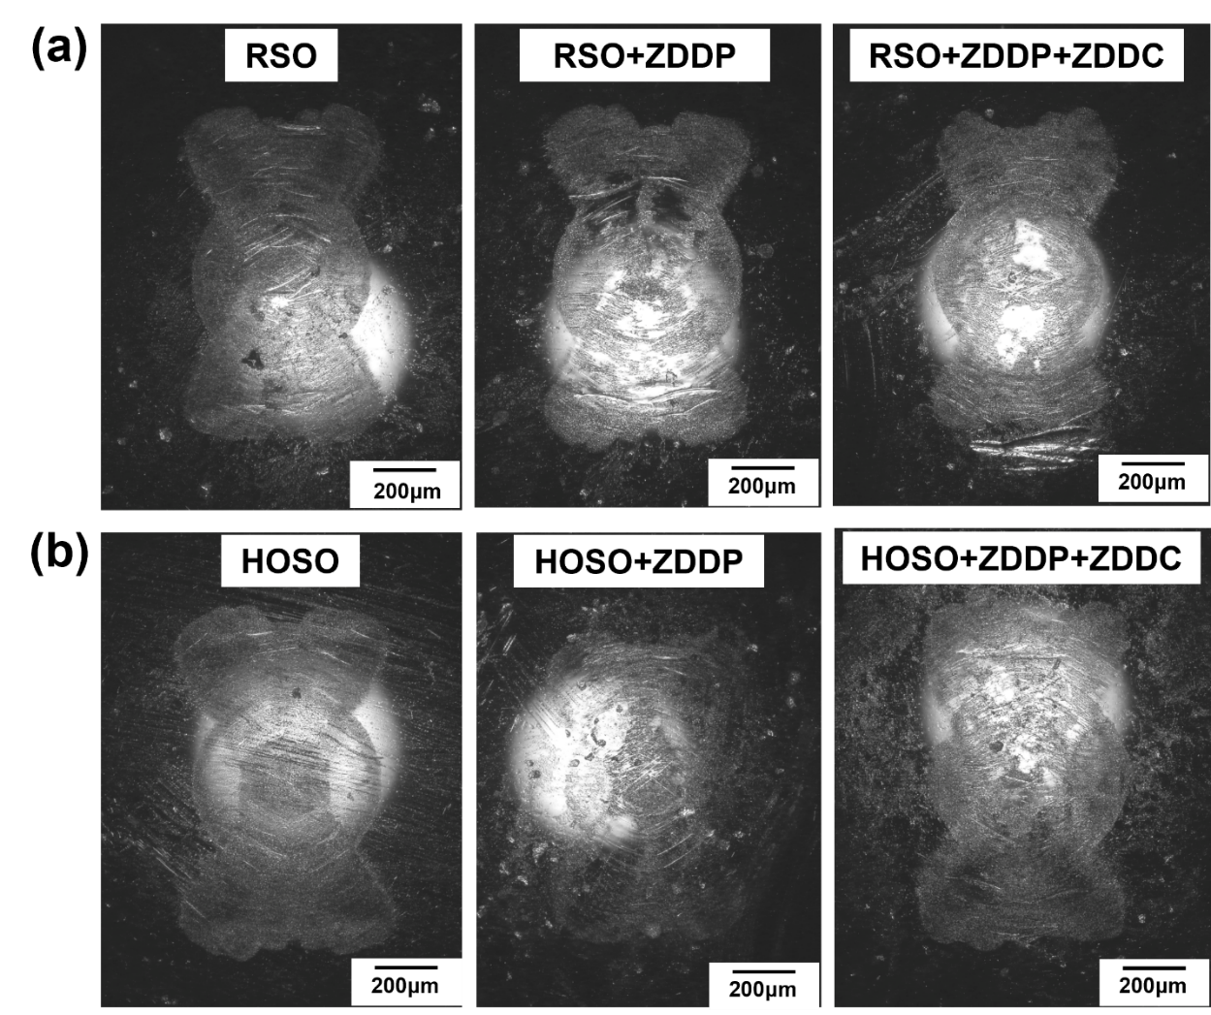
Figure S1. Optical microscopic images of balls wear (a) RSO and RSO with additives (b) HOSO and HOSO with additives

