Name | PubChem CID | Molecular Formula | Canonical SMILES | Structure
stepharine | 98455 | C₁₈H₁₉NO₃ | COC1=C(C2=C3C(CC24C=CC(=O)C=C4)NCCC3=C1)OC | 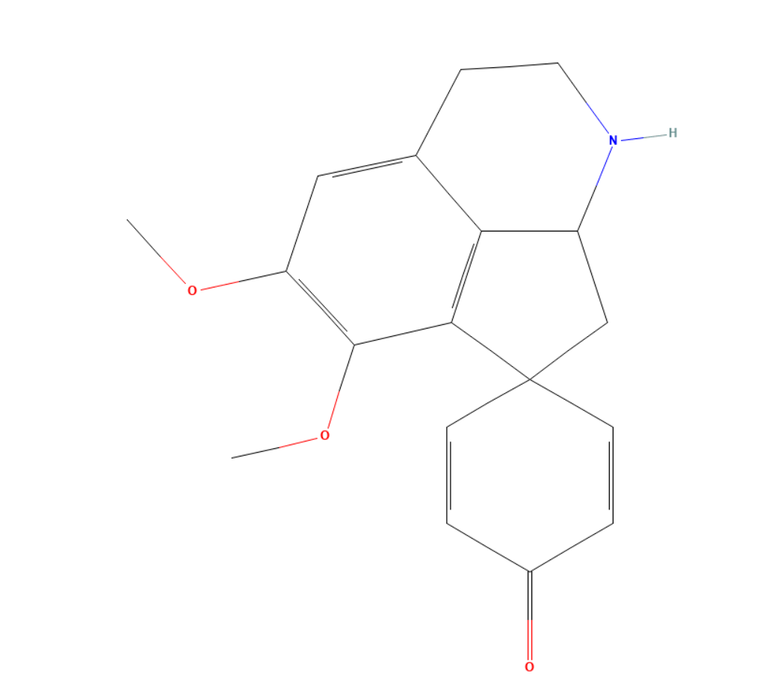
zizyphus saponin I_qt | 102475150 | C₅₁H₈₂O₂₂ | CC1CCC2(C(C3C(O2)CC4C3(CCC5C4CC=C6C5(CCC(C6)OC7C(C(C(C(O7)CO)OC8C(C(C(C(O8)CO)O)OC9C(C(C(C(O9)CO)O)O)O)O)O)OC2C(C(C(C(O2)C)O)O)O)C)C)C)OC1 | 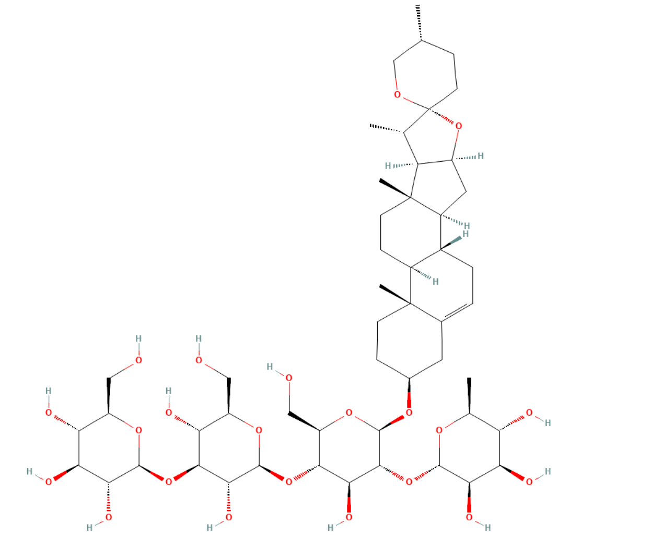
Jujubasaponin V_qt | 274197523 | C₄₈H₇₈O₁₈ | C[C@@H]1O[C@@H](O[C@H]2[C@H](OC3CC[C@@]4(C)[C@@H](CC[C@]5(C)[C@@H]4CC[C@@H]4[C@H]6[C@@](C)(O)[C@H](CC=C(C)C)O[C@]76C[C@@]54CO7)C3(C)C)O[C@H](CO)[C@@H](O)[C@@H]2O[C@@H]2O[C@H](CO)[C@@H](O)[C@H](O)[C@H]2O)[C@H](O)[C@H](O)[C@H]1O | 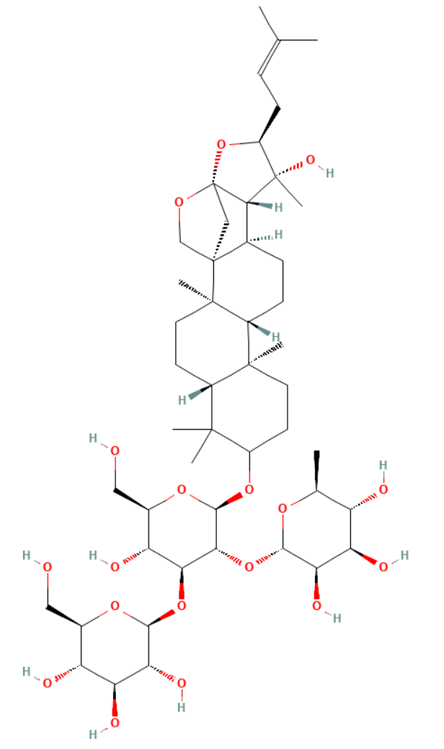
Mauritine D | 6443026 | C₃₃H₅₁NO₅ | CCC(C)C1C(=O)NC=CC2=CC=C(C=C2)OC3CCN(C3C(=O)N1)C(=O)C(CC(C)C)NC(=O)C(C(C)CC)N(C)C | 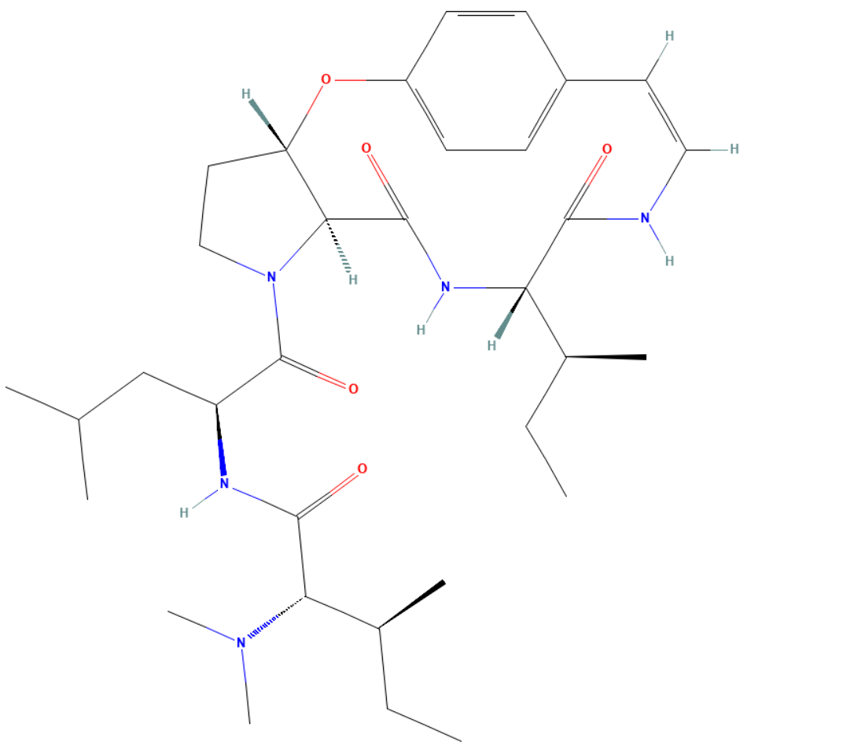
berberine | 2353 | C₂₀H₁₈NO₄ | COC1=C(C2=C[N+]3=C(C=C2C=C1)C4=CC5=C(C=C4CC3)OCO5)OC | 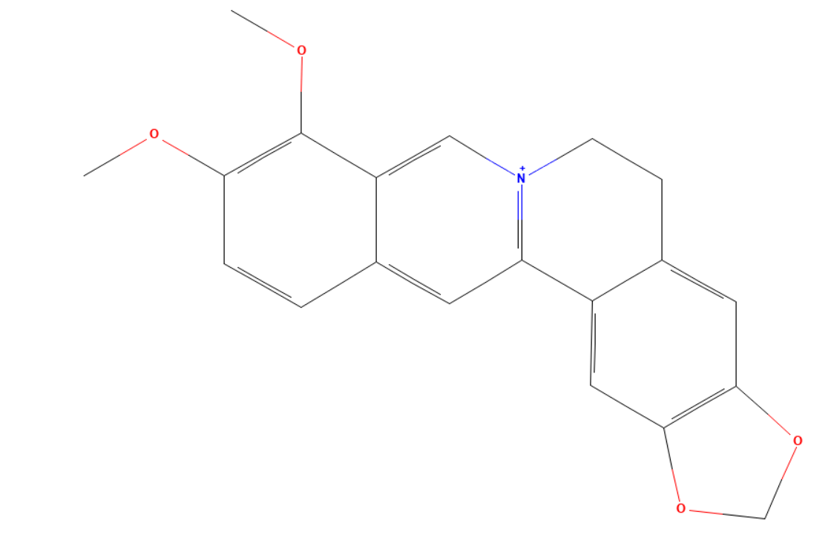
(S)-Coclaurine | 160487 | C₁₇H₁₉NO₃ | COC1=C(C=C2C(NCCC2=C1)CC3=CC=C(C=C3)O)O | 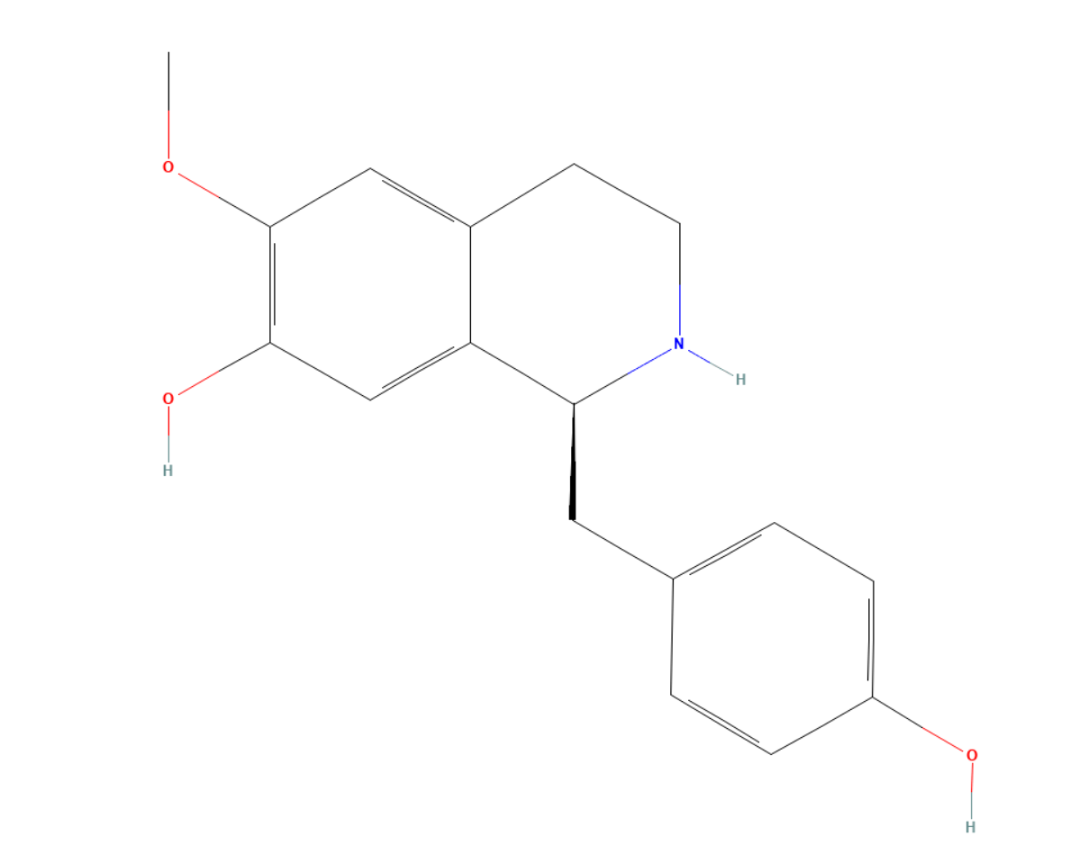
Mairin | 64971 | C₃₀H₄₈O₃ | CC(=C)C1CCC2(C1C3CCC4C5(CCC(C(C5CCC4(C3(CC2)C)C)(C)C)O)C)C(=O)O | 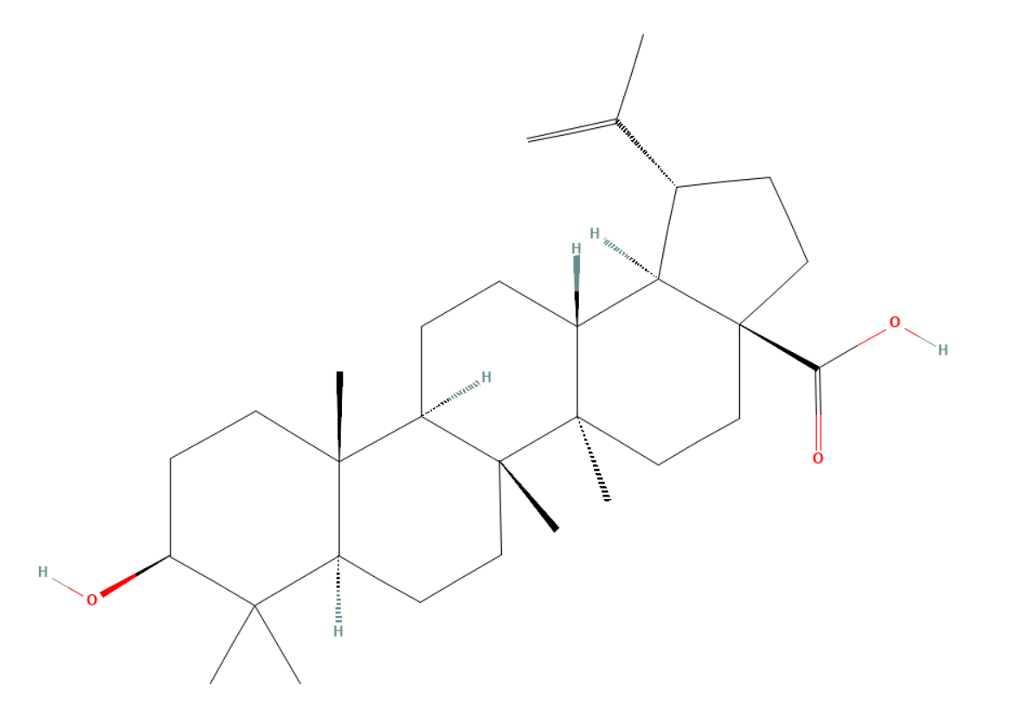
Stigmasterol | 5280794 | C₂₉H₄₈O | CCC(C=CC(C)C1CCC2C1(CCC3C2CC=C4C3(CCC(C4)O)C)C)C(C)C | 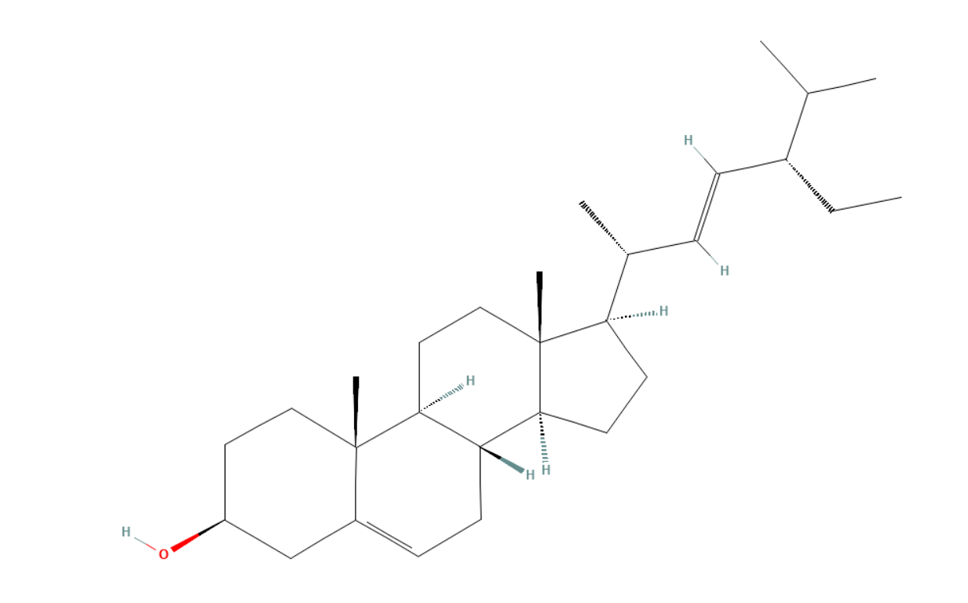
beta-sitosterol | 222284 | C₂₉H₅₀O | CCC(CCC(C)C1CCC2C1(CCC3C2CC=C4C3(CCC(C4)O)C)C)C(C)C | 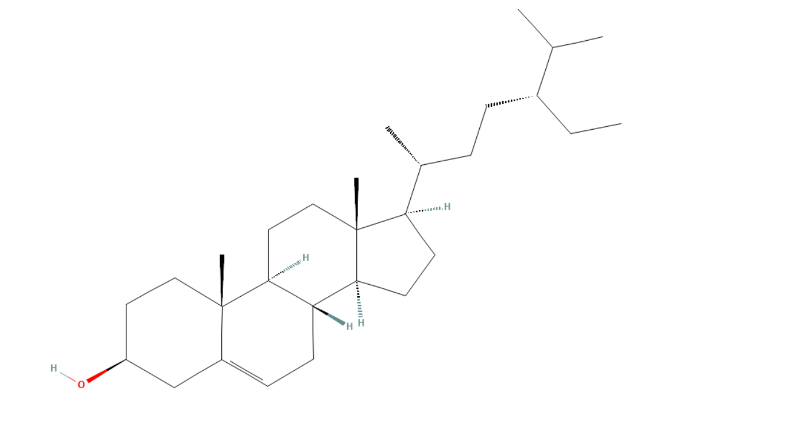
Ruvoside_qt | 101650325 | C₃₀H₄₆O₉ | CC1C(C(C(C(O1)OC2CCC3(C(C2)CCC4C3CCC5(C4(CCC5C6=CC(=O)OC6)O)C)CO)O)OC)O | 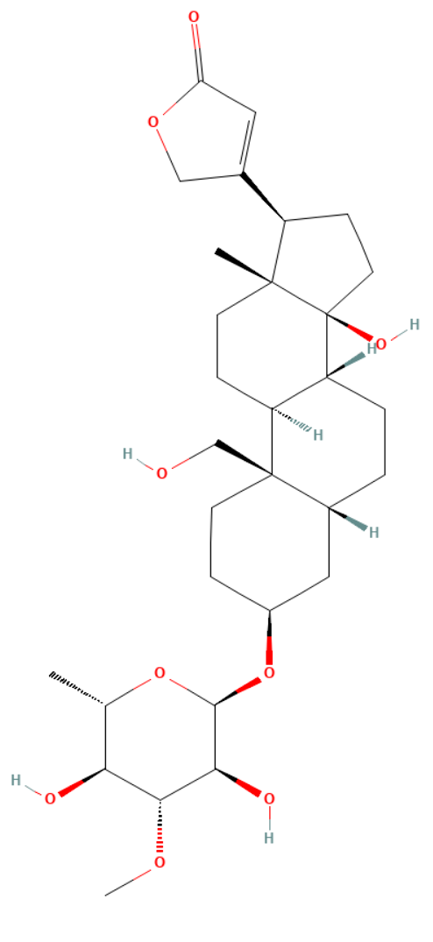
(+)-catechin | 9064 | C₁₅H₁₄O₆ | C1C(C(OC2=CC(=CC(=C21)O)O)C3=CC(=C(C=C3)O)O)O | 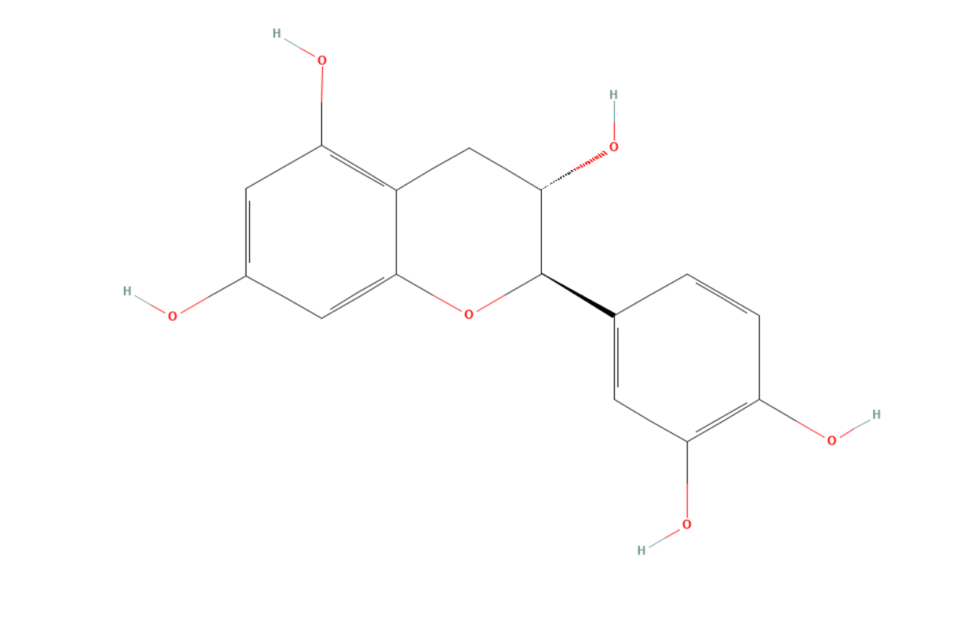
Stepholidine | 6917970 | C₁₉H₂₁NO₄ | COC1=C(C=C2C3CC4=C(CN3CCC2=C1)C(=C(C=C4)O)OC)O | 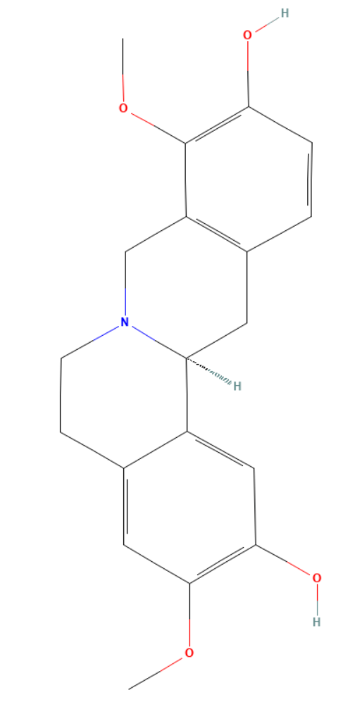
Nuciferin | 10146 | C₁₉H₂₁NO₂ | CN1CCC2=CC(=C(C3=C2C1CC4=CC=CC=C43)OC)OC | 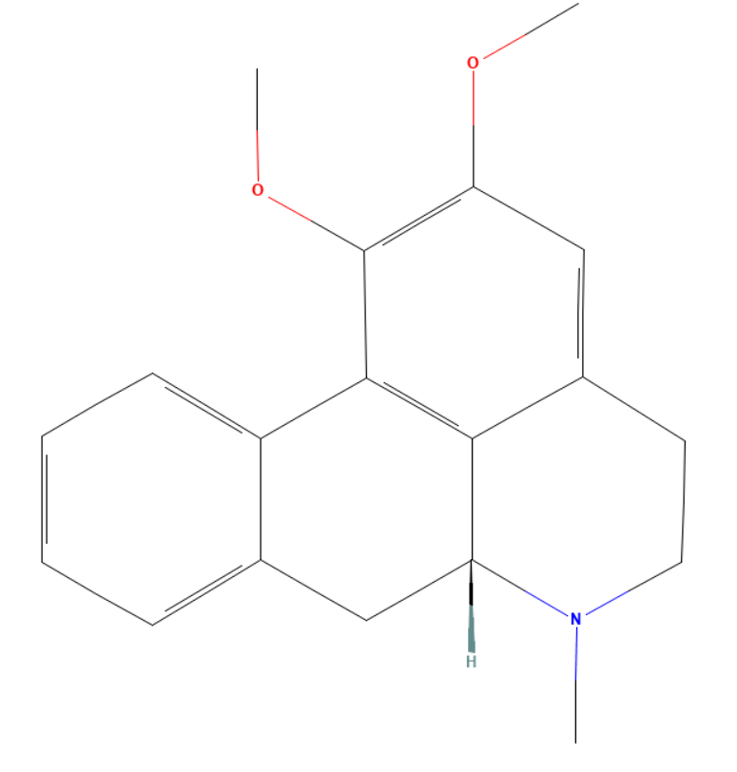
Fumarine | 4970 | C₂₀H₁₉NO₅ | CN1CCC2=CC3=C(C=C2C(=O)CC4=C(C1)C5=C(C=C4)OCO5)OCO3 | 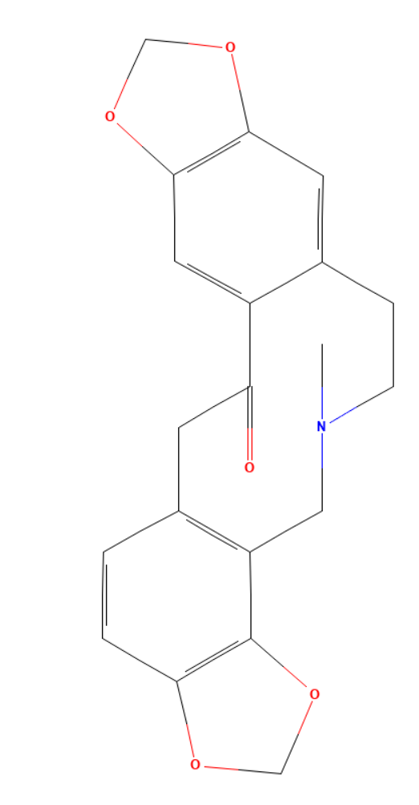
beta-carotene | 5280489 | C₄₀H₅₆ | CC1=C(C(CCC1)(C)C)C=CC(=CC=CC(=CC=CC=C(C)C=CC=C(C)C=CC2=C(CCCC2(C)C)C)C)C | 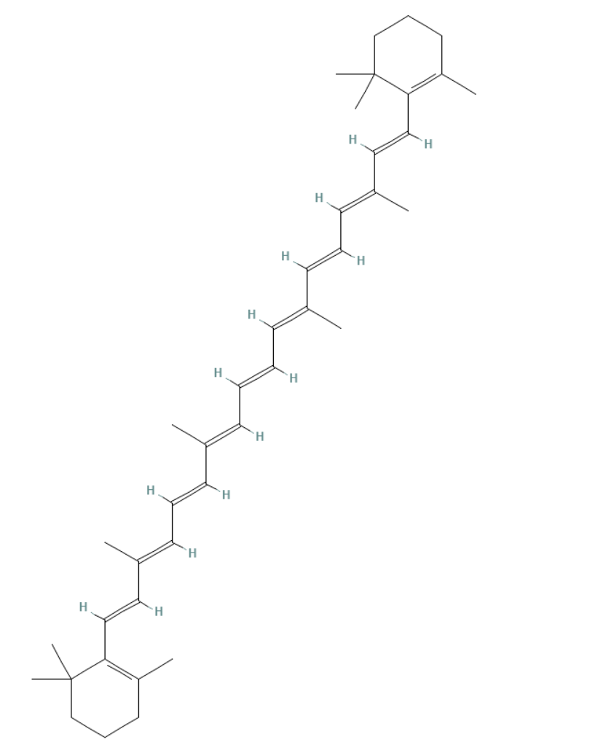
(-)-catechin | 73160 | C₁₅H₁₄O₆ | C1C(C(OC2=CC(=CC(=C21)O)O)C3=CC(=C(C=C3)O)O)O | 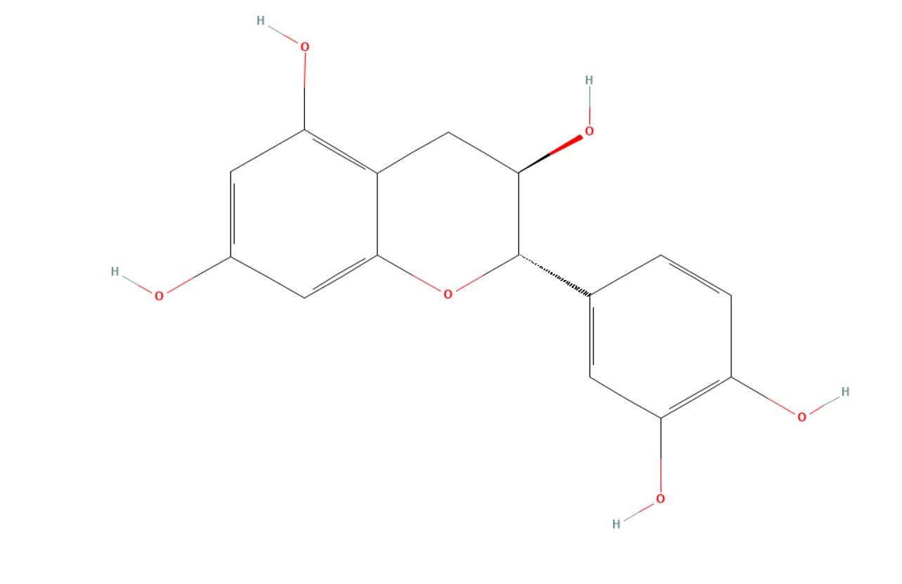
quercetin | 5280343 | C₁₅H₁₀O₇ | C1=CC(=C(C=C1C2=C(C(=O)C3=C(C=C(C=C3O2)O)O)O)O)O | 