Supplementary Material

## Supplementary Figures

## 

## Supplementary Figure 1. Rarefaction analysis of bacterial communities in gut of overwintering relict gulls based on Sobs index (a) and Shannon index (b)

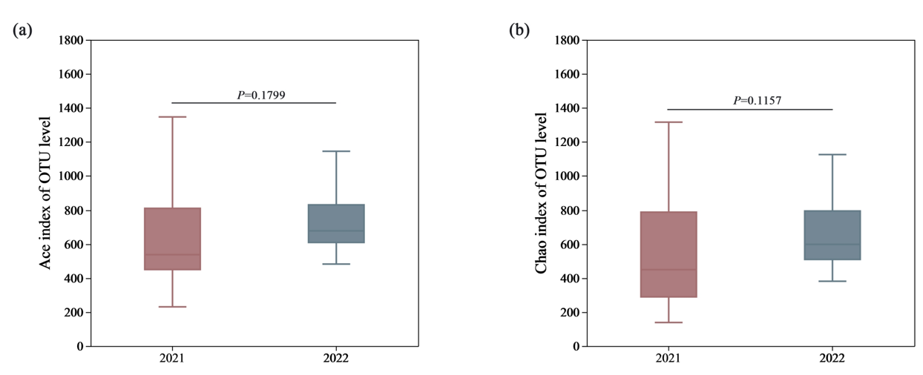

**Supplementary Figure 2.** The alpha diversity index of fecal microbial composition including Ace index (a) and Chao index (b)

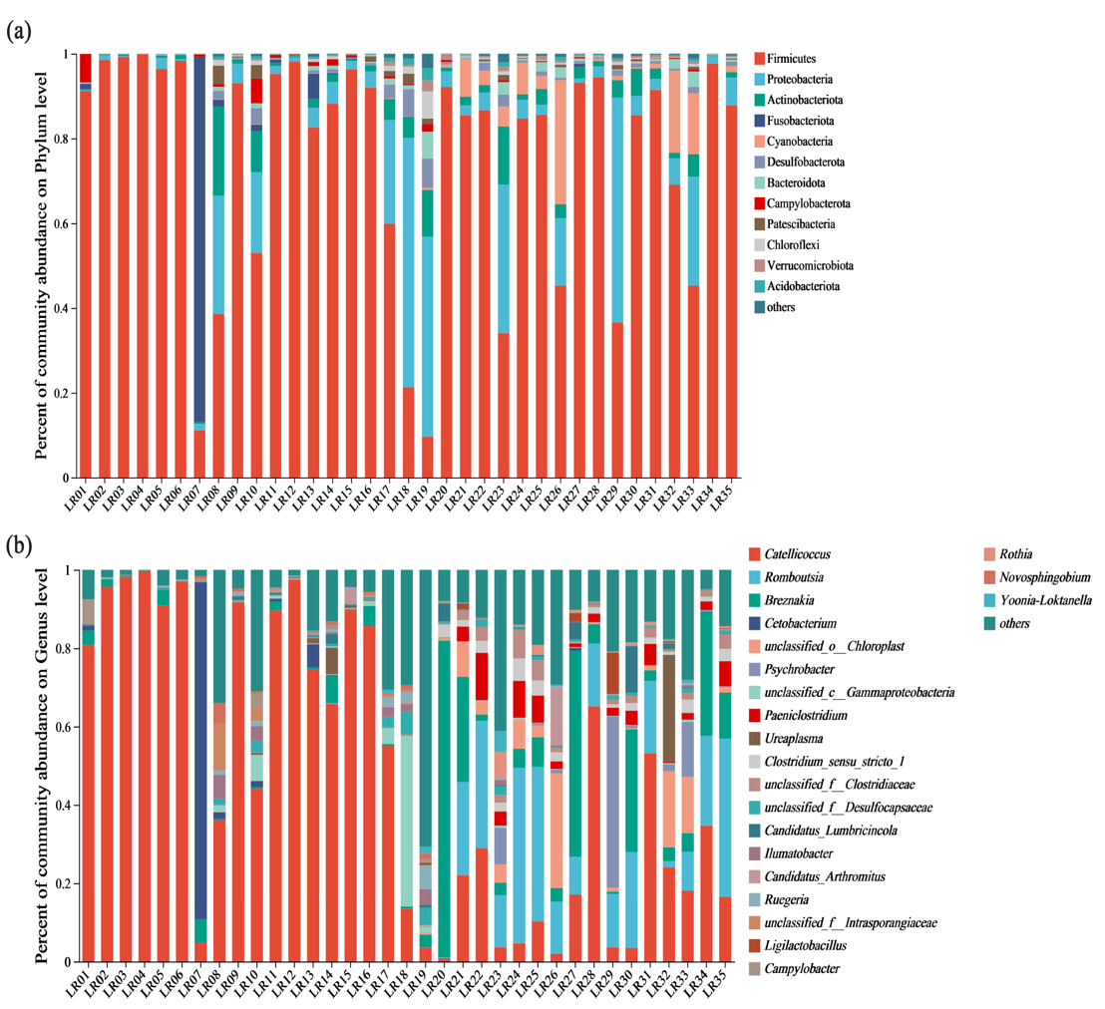

**Supplementary Figure 3.** Microbial composition of all fecal samples at the phylum (A), and genus(B) levels.

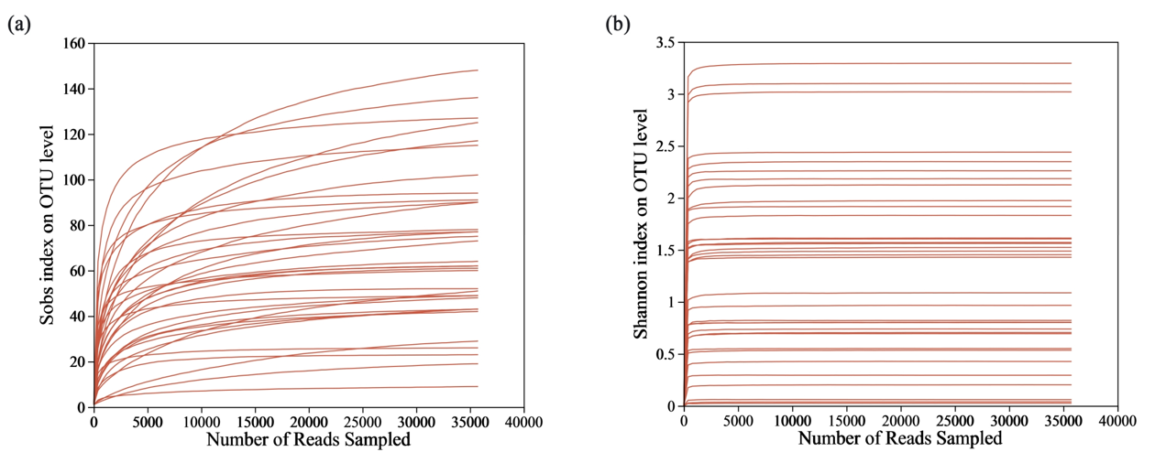

**Supplementary Figure4.** Rarefaction analysis of diet composition by high-throughput sequencing technology based on sobs index (a) and Shannon index (b)