**Supplementary Information**

**Phosphorus recovery as vivianite and amorphous calcium phosphate from high-load industrial wastewater**

**Dyllon Randalla,c,d, Justus Jalavab, Björn Vinneråsa, Prithvi Simhaa,[1],**

***a****Swedish University of Agricultural Sciences, Department of Energy and Technology, Box 7032, SE–750 07 Uppsala, Sweden*

**b***Tampere University of Applied Sciences, Kuntokatu 3, 33520 Tampere, Finland*

**c***Future Water Institute, University of Cape Town, 7700 Cape Town, South Africa*

**d***Civil Engineering Department, University of Cape Town, 7700 Cape Town, South Africa*

# **Thermodynamic modelling results**

To inform the study design, thermodynamic simulations were performed to estimate the dose of Ca(OH)2 and FeSO4.7H2O required to precipitate all the P present in the wastewater. In addition, the solubility of Ca(OH)2 and the concentration of the different solids formed at equilibrium was determined at different temperatures. The simulations were conducted using the Mixed Solvent Electrolyte model option of the software OLI Stream Analyzer (OLI Systems Inc., 2020).

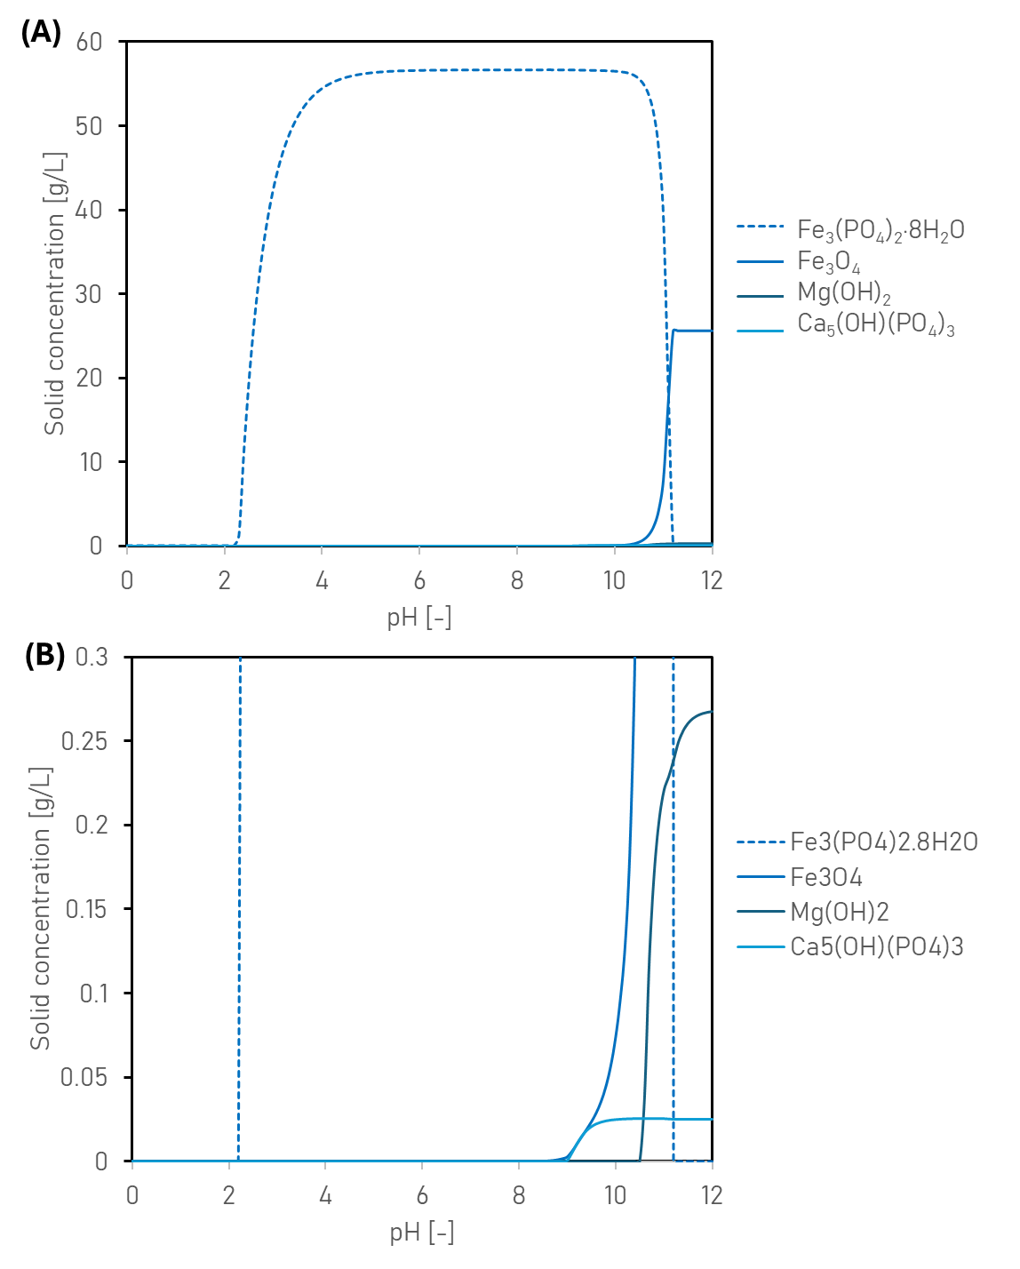

**Figure S1:** Thermodynamic modelling results for different solids that form for Ca(OH)2 and FeSO4·7H2O dosing of wastewater from toothpaste manufacturing. The top graph (A) illustrates the formation of major precipitates, whereas the bottom graph (B) focuses on minor precipitates forming at lower concentrations.

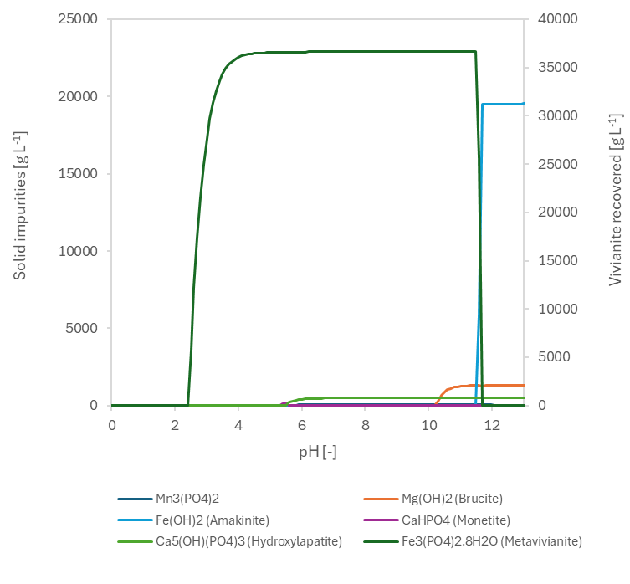

**Figure S2:** Thermodynamic modelling results for different solids that form when technical grade FeSO4·7H2O is dosed for treating wastewater from toothpaste manufacturing. According to the manufacturer (KRONOS ecochem, Germany), the FeSO4 (trade name Ferrogranul 20) used in the study typically contains 0.7% Mg, 0.3% Ca, 0.04% Mn and 0.6% insoluble impurities.

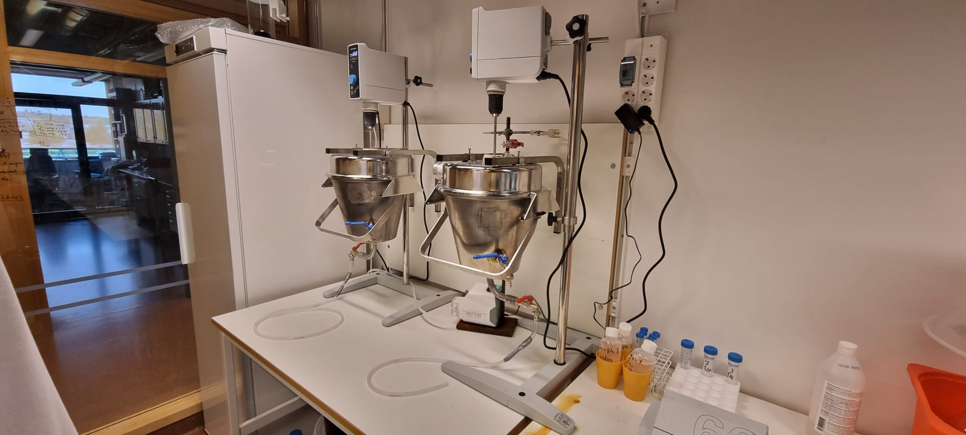

**Figure S3**. Setup used for pilot-scale experiments. Duplicate reactors were fed with 9 L wastewater d-1 and dosed with 60 g FeSO4.6-7H2O or 25 g Ca(OH)2 L-1. In total, 14 days of treatment were evaluated.

# **Preliminary economic analysis of the treatment options**

**Table S1:** Economic data for amorphous calcium phosphate and vivianite recovery

|  |  |  |  |  |
| --- | --- | --- | --- | --- |
| **Amorphous calcium phosphate** | **Unit** | **Value** | | **Reference** |
| Ca(OH)2 dosage required | kg/m3 | 24.5 | |  |
| Ca(OH)2 price | $/ton | 132 | | [1] |
| Ca(OH)2 cost | $/m3 | 3.23 | |  |
| Amorphous calcium phosphate production | kg/m3 | 16.10 | |  |
| Amorphous calcium phosphate price | $/ton | 1180 | | [2] |
| Amorphous calcium phosphate income | $/m3 | 19 | |  |
| **Vivianite** |  |  | |  |
| NaOH dosage required | kg/m3 | 6.76* | |  |
| NaOH price | $/ton | 363 | | [3] |
| NaOH cost | $/m3 | 4.89 | |  |
| FeSO4·7H2O dosage required | kg/m3 | 45 | |  |
| FeSO4·7H2O price | $/ton | 80 | | [4] |
| FeSO4·7H2O cost | $/m3 | 3.60 | |  |
| Vivianite production | kg/m3 | 24.1 | |  |
| Amorphous calcium phosphate price | $/ton | 10 700 | | [5] |
| Amorphous calcium phosphate income | $/m3 | 258 |  | |

*\*Double dosage to account for 50% purity*

**References**

[1] Calcium hydroxide price trend and forecast. <https://www.chemanalyst.com/Pricing-data/calcium-hydroxide-1204>, 2024 (accessed 17 July 2024).

[2] Tricalcium phosphate price trend and forecast. <https://www.chemanalyst.com/Pricing-data/tricalcium-phosphate-tcp-1188>, 2024 (accessed 17 July 2024).

[3] Caustic soda price trend and forecast. <https://www.chemanalyst.com/Pricing-data/caustic-soda-3>, 2024 (accessed 17 July 2024).

[4] Water treatment ferrous sulfate heptahydrate. <https://hbpusuo.en.made-in-china.com/product/QaCRSfqlgJhd/China-Water-Treatment-Ferrous-Sulfate-Heptahydrate-98-99-Feso4-Chemical-Formula-Iron-Sulfate-Ferrous-Sulphate-Price-CAS-7782-63-0.html>, 2024 (accessed 17 July 2024).

[5] Wu, Y., Luo, J., Zhang, Q., Aleem, M., Fang, F., Xue, Z. and Cao, J. 2019. Potentials and challenges of phosphorus recovery as vivianite from wastewater: A review. Chemosphere 226, 246-258.

1. *Corresponding Author*: Department of Energy and Technology, Swedish University of Agricultural Sciences, P.O. Box 7032, SE–75007, Uppsala, Sweden. Ph: +46 790 544 594; E–mail: [Prithvi.Simha@slu.se](mailto:Prithvi.Simha@slu.se) / [Prithvi.Simha@mespom.eu](mailto:Prithvi.Simha@mespom.eu) (Prithvi Simha)