Supplemental Tables
Table S1: Table containing the Silva taxonomic classification for each ASV identified as a potentially cyanobacterial which were present in more than 10% of samples. All ASVs are in the phylum Cyanobacteria and class Cyanobacteriia. None were classified to the species level. Also included are the top BLAST hits against Symbiodiniaceae genomes.
ASV ID | Order | Family | Genus | Top Symbiodiniaceae BLAST hits | Symbiodiniaceae Accession Number
ASV29 | Synechococcales | Cyanobiaceae |  | Symbiodinium sp. CCMP2592 | CAJNDT010005913.1
ASV102 | Cyanobacteriales | Cyanobacteriaceae | Symphothece PCC-7002 | Symbiodinium microadriaticum | CAJNJV010044445.1
ASV130 | Synechococcales | Cyanobiaceae | Cyanobium PCC-6307 | Symbiodinium sp. CCMP2592 | CAJNDT010005913.1
ASV155 | Synechococcales | Cyanobiaceae | Synechococcus CC9902 | Symbiodinium sp. CCMP2592 | CAJNDT010005913.1
ASV221 | Synechococcales | Cyanobiaceae | Synechococcus CC9902 | Symbiodinium sp. CCMP2592 | CAJNDT010005913.1
ASV399 | Synechococcales | Cyanobiaceae |  | Symbiodinium sp. CCMP2592 | CAJNDT010005913.1
ASV465 | Cyanobacteriales | Cyanobacteriaceae | Symphothece PCC-7002 | Symbiodinium sp. clade C Y103 | BGPT01000001.1
ASV473 | Synechococcales | Synechococcales Incertae Sedis | Schizothrix LEGE 07164 | Symbiodinium sp. clade C Y103 | BGPT01000001.1
ASV580 | Synechococcales | Cyanobiaceae | Synechococcus CC9902 | Symbiodinium sp. CCMP2592 | CAJNDT010005913.1
ASV611 | Synechococcales | Synechococcales Incertae Sedis | Schizothrix LEGE 07164 | Symbiodinium sp. clade C Y103 | BGPT01000001.1
ASV612 | Cyanobacteriales | Cyanobacteriaceae | Symphothece PCC-7002 | Symbiodinium sp. clade A Y106 | BGNK01000001.1
ASV711 | Cyanobacteriales | Cyanobacteriaceae | Symphothece PCC-7002 | Symbiodinium microadriaticum | CAJNJV010044445.1
ASV741 | Cyanobacteriales | Cyanobacteriaceae | Symphothece PCC-7002 | Symbiodinium microadriaticum | CAJNJV010044445.1
ASV807 | Cyanobacteriales | Cyanobacteriaceae | Symphothece PCC-7002 | Symbiodinium microadriaticum | CAJNJV010044445.1
ASV1971 | Cyanobacteriales | Cyanobacteriaceae | Symphothece PCC-7002 | Symbiodinium microadriaticum | CAJNJV010044445.1
ASV2471 | Synechococcales | Cyanobiaceae | Synechococcus CC9902 | Symbiodinium sp. CCMP2592 | CAJNDT010005913.1
ASV3309 | Cyanobacteriales | Cyanobacteriaceae | Symphothece PCC-7002 | Symbiodinium sp. clade C Y103 | BGPT01000001.1

Table S2: In file: TableS2_ASVmainEffects.csv. Table containing the taxonomy for each ASV as well as the main effect tests for variability based on any of the treatment combinations including numerator degrees of freedom (ndf) denominator degrees of freedom (ddf), F statistic (f.value), p-value (p.value), and FDR adjusted p-value (fdr.bh).

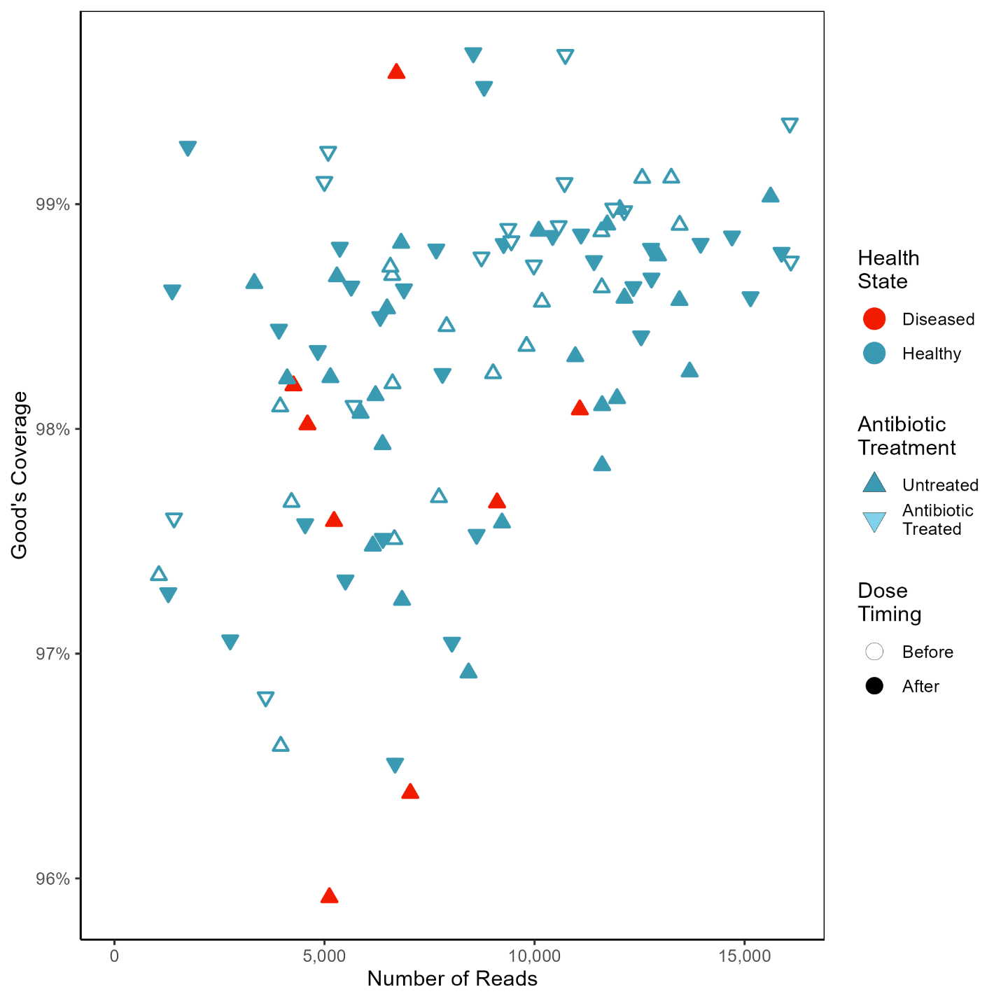
Figure S1: Plot of Good’s coverage compared with the number of sequenced reads of each coral fragment. Some coral fragments were previously treated with antibiotics (inverted triangle) while others were left untreated (triangle). Samples taken prior to dosage with disease homogenate are open while those take after disease dosage are filled. Those corals which develop disease symptoms are marked in red while healthy corals are blue.

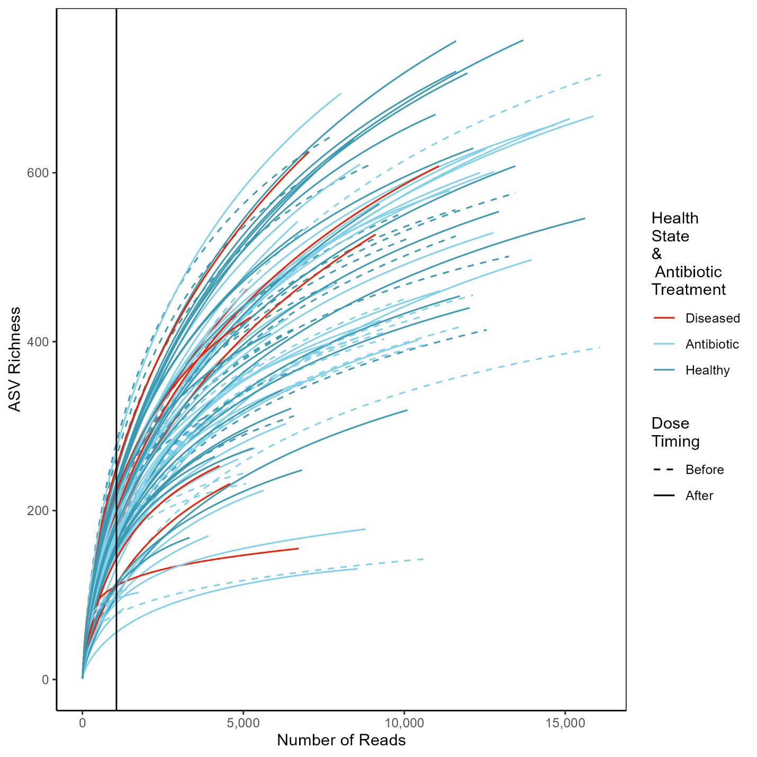
Figure S2: Plot of the rarefaction curves for all coral fragments showing the number of unique ASVs compared with the number of sequenced reads. Corals which develop disease symptoms are marked in red while healthy corals are dark blue and antibiotic treated healthy corals are light blue. Samples taken prior to dosage with disease homogenate are dashed lines while those take after disease dosage are solid lines. The vertical black line shows the number of reads samples were rarified to for subsequent alpha diversity analyses.

