**Supplementary data**

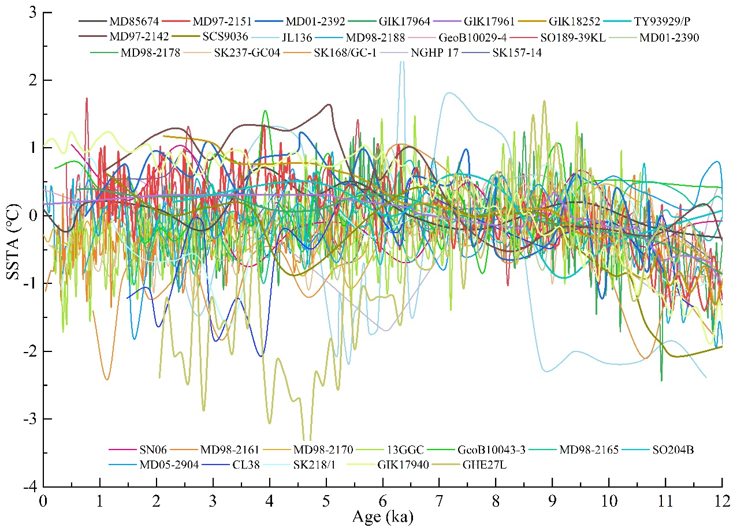

**Fig. S1.** Comparison of sea surface temperature anomaly records in the Asian monsoon regions. Anomalies are calculated as departures relative to the average of the past 4 ka (6−10 ka).

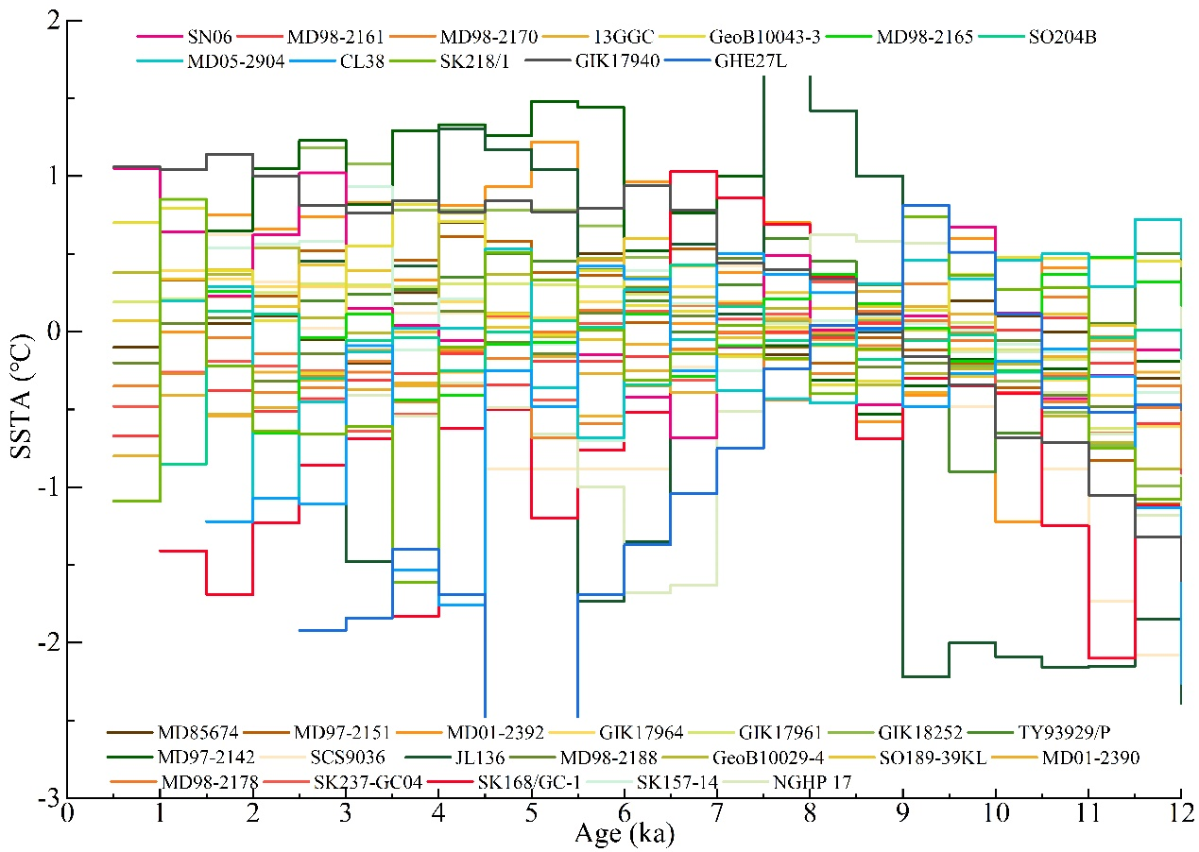

**Fig. S2.** Comparison of sea surface temperature anomaly records in the Asian monsoon regions with 500 yr non-overlapping binning.

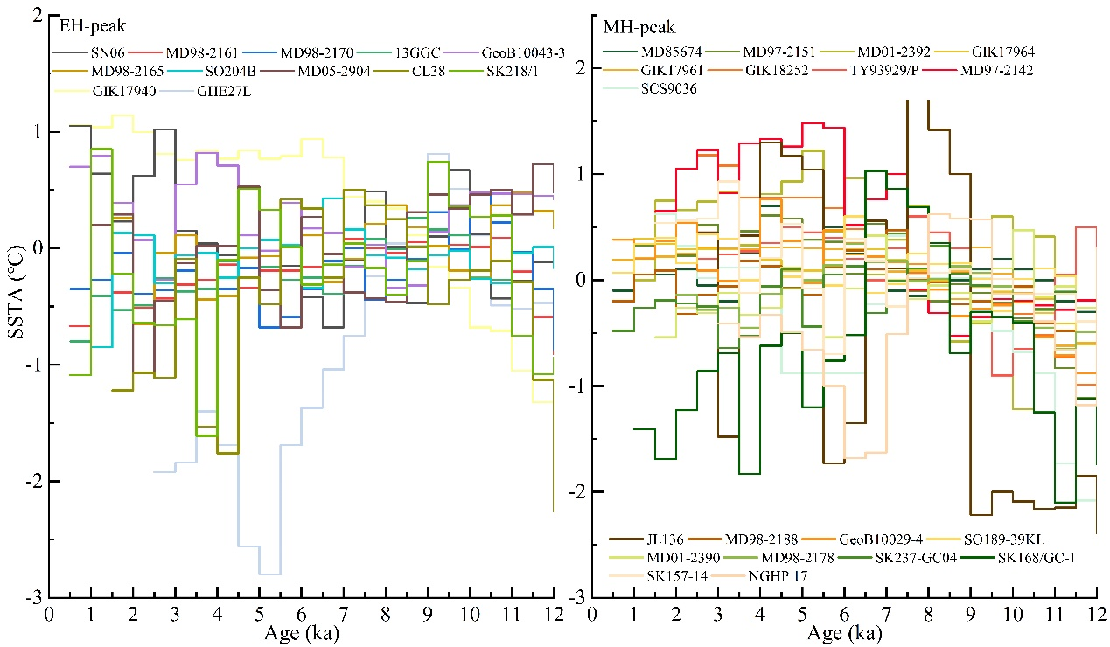

**Fig. S3.** Peak identification was performed on the data from each site, and the SSTA was simply divided into two modes, the Early Holocene (EH-peak) and the Middle Holocene (MH-peak), based on the timing the first maximum peak, using 9 ka as the boundary.

**Table S1** Mg/Ca ratios of *G. ruber* (s.s.) and Mg/Ca-SST of cores SH-CL38 and JL136-pushcore6

|  |  |  |  |  |  |  |  |
| --- | --- | --- | --- | --- | --- | --- | --- |
| SH-CL38 | | | | JL136-pushcore6 | | | |
| Age  (ka) | Mg/Ca  (mmol/mol) | SST (℃) | Depth (cm) | Age (ka) | Mg/Ca (mmol/mol) | SST (℃) | Depth (cm) |
| 1.48 | 4.08 | 26.7 | 5 | 2.14 | 4.32 | 27.0 | 0 |
| 1.86 | 4.06 | 26.6 | 9 | 2.74 | 3.62 | 25.1 | 1 |
| 2.06 | 4.16 | 26.9 | 11 | 3.35 | 4.30 | 27.0 | 2 |
| 2.44 | 4.32 | 27.3 | 15 | 3.96 | 4.66 | 27.8 | 3 |
| 2.63 | 4.53 | 27.8 | 17 | 4.56 | 4.55 | 27.6 | 4 |
| 2.83 | 4.64 | 28.1 | 19 | 5.17 | 3.46 | 24.5 | 5 |
| 3.02 | 4.48 | 27.7 | 21 | 5.25 | 3.74 | 25.4 | 6 |
| 3.40 | 4.28 | 27.2 | 25 | 5.33 | 3.51 | 24.7 | 7 |
| 3.60 | 4.17 | 26.9 | 27 | 5.42 | 3.40 | 24.4 | 8 |
| 3.89 | 4.43 | 27.6 | 29 | 5.49 | 3.63 | 25.1 | 9 |
| 4.19 | 4.79 | 28.5 | 31 | 5.58 | 3.68 | 25.2 | 10 |
| 4.78 | 4.50 | 27.8 | 35 | 5.66 | 3.90 | 25.8 | 11 |
| 5.37 | 4.69 | 28.2 | 39 | 5.74 | 3.55 | 24.8 | 12 |
| 5.67 | 4.84 | 28.6 | 41 | 5.89 | 3.57 | 24.9 | 13 |
| 6.26 | 4.62 | 28.1 | 45 | 6.04 | 4.46 | 27.4 | 14 |
| 6.56 | 4.77 | 28.4 | 47 | 6.19 | 4.34 | 27.1 | 15 |
| 6.86 | 4.80 | 28.5 | 49 | 6.34 | 5.16 | 28.9 | 16 |
| 8.90 | 4.84 | 28.6 | 63 | 6.49 | 3.62 | 25.0 | 17 |
| 9.19 | 4.87 | 28.7 | 65 | 7.06 | 4.84 | 28.3 | 18 |
| 10.07 | 4.53 | 27.8 | 71 | 7.64 | 4.71 | 28.0 | 19 |
| 10.66 | 4.64 | 28.1 | 75 | 8.22 | 4.53 | 27.5 | 20 |
| 10.95 | 4.56 | 27.9 | 77 | 8.79 | 3.39 | 24.3 | 21 |
| 11.23 | 4.26 | 27.2 | 79 | 9.37 | 3.46 | 24.5 | 22 |
| 11.52 | 4.08 | 26.7 | 81 | 9.94 | 3.41 | 24.4 | 23 |
| 12.08 | 3.93 | 26.2 | 85 | 10.51 | 3.42 | 24.4 | 24 |
|  |  |  |  | 11.09 | 3.51 | 24.7 | 25 |
|  |  |  |  | 11.66 | 3.34 | 24.1 | 26 |