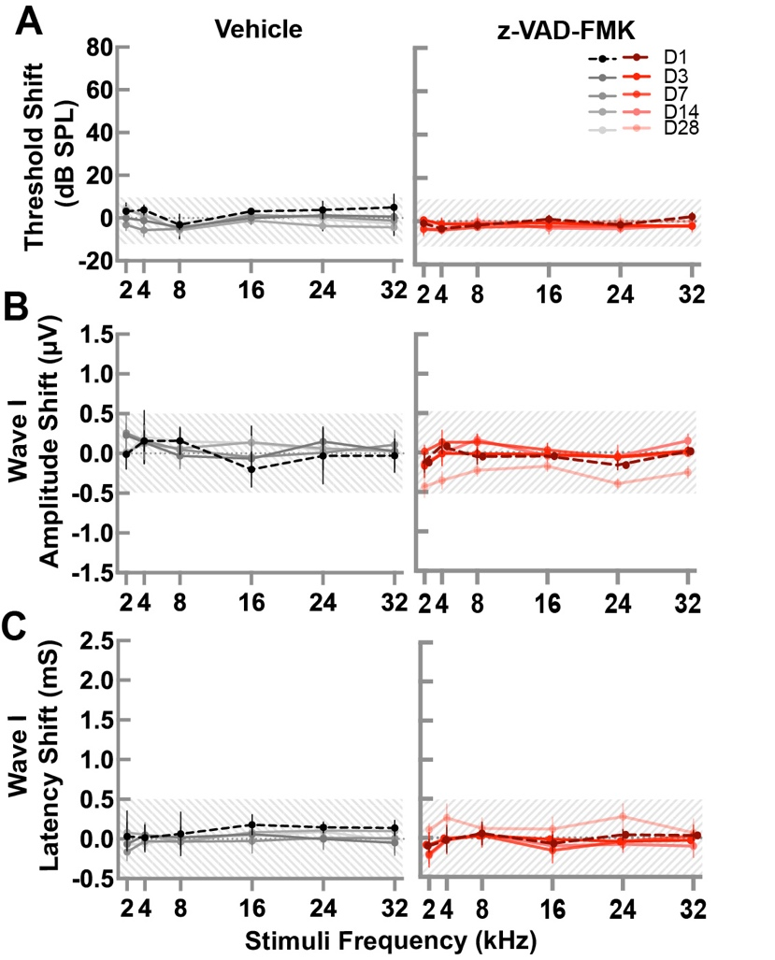

Figure 1. Delivery of z-VAD-FMK and Vehicle Does Not Impact ABR Outcomes. ABR threshold shifts (A), amplitude shifts (B) and latency shifts (C) data from the vehicle-only (n=4, gray lines) and z-VAD-FMK-only (n=4, red lines) groups measured at 1, 3-, 7-, 14-, and 28-days post-exposure for frequency stimuli at 2, 4, 8, 16, and 24 kHz. Data is presented as mean ± SE. The shaded gray area represents the range within which all recorded outcomes were recorded.

