Supplementary Material

# Tables.

|  |  |  |  |  |  |  |  |  |
| --- | --- | --- | --- | --- | --- | --- | --- | --- |
| **Publication** | **Publishing organisation** | **Title** | **Year** | **Org. type** | **Percent grey refs** | **Refs grey** | **Refs academic** | **Refs total** |
| **BFC, 2021** | British Fashion Council Institute for Positive Fashion (BFC) | The Circular fashion system: A blueprint for the future | 2021 | Trade org. | **82%** | 49 | 11 | 60 |
| **BFC, 2022** | British Fashion Council Institute for Positive Fashion (BFC) | THE CIRCULAR FASHION ECOSYSTEM PROJECT: Phase 2 Developing the Roadmap for Change | 2022 | Trade org. | **73%** | 8 | 3 | 11 |
| **BOF, 2017** | The Business of Fashion (BOF), McKinsey & Co. | The State of Fashion 2018 | 2017 | Trade journalism | **100%** | 2 | 0 | 2 |
| **CE, 2020** | Circle Economy (CEc) | AVOIDING BLIND SPOTS:  Promoting circular fashion and fair business models | 2020 | Advocacy | **71%** | 114 | 47 | 161 |
| **UK EAC, 2019** | UK House of Parliament Environmental Audit Committee (UK EAC) | FIXING FASHION: clothing consumption and sustainability | 2019 | Policy | **94%** | 83 | 5 | 88 |
| **EC, 2022** | European Commission (EC) | EU strategy for sustainable and circular textiles | 2022 | Policy | **98%** | 62 | 1 | 63 |
| **EEA, 2021** | European Environment Agency: European Topic Centre on Waste and Materials in a Green Economy (EEA) | Business Models in a Circular Economy | 2021 | Policy | **61%** | 95 | 60 | 155 |
| **EMF 2013** | Ellen MacArthur Foundation (EMF) | TOWARDS THE CIRCULAR ECONOMY: Economic and business rationale for an accelerated transition | 2015 | Advocacy | **88%** | 80 | 11 | 91 |
| **EMF, 2017** | Ellen MacArthur Foundation (EMF) | A NEW TEXTILES ECONOMY: Redesigning Fashion’s Future | 2017 | Advocacy | **85%** | 387 | 68 | 455 |
| **EMF, 2021** | Ellen MacArthur Foundation (EMF) | The Jeans Redesign Guidelines | 2021 | Advocacy | **83%** | 24 | 5 | 29 |
| **GFA, 2020** | Global Fashion Agenda (GFA) | 2020 Circular Fashion System Commitment: Final report | 2020 | Advocacy | **97%** | 30 | 1 | 31 |
| **ILO, 2019** | International Labour Organisation (ILO) | The future of work in textiles, clothing, leather and footwear | 2019 | Policy | **98%** | 46 | 1 | 47 |
| **ILO, 2022** | International Labour Organisation (ILO) | Opportunities for a Just Transition to environmental sustainability and COVID-19 recovery in the textile and garment sector in Asia | 2022 | Policy | **56%** | 30 | 24 | 54 |
| **EURATEX, 2019** | European Commission European Apparel and Textiles Organisation (EURATEX) | Support report mapping sustainable fashion opportunities for SMES | 2019 | Policy | **48%** | 42 | 46 | 88 |
| **EU JRC, 2021** | European Union Joint Research Council (EU JRC) | Circular economy perspectives in the EU textile sector | 2021 | Policy | **86%** | 136 | 22 | 158 |
| **PwC, 2024** | PwC | Circular fashion: Making resale a reality | 2024 | Consulting | **100%** | 8 | 0 | 8 |
| **UNECE, 2019** | United Nations Economic Commission for Europe (UNECE) | Accelerating action for a sustainable and circular garment and footwear industry, through transparency and traceability of value chains (ECE/TRADE/449) | 2019 | Policy | **79%** | 37 | 10 | 47 |
| **UNEP, 2021** | United Nations Environment Programme (UNEP) | CATALYSING SCIENCE-BASED POLICY ACTION ON SUSTAINABLE CONSUMPTION AND PRODUCTION: The value-chain approach & its application to food, construction and textiles | 2021 | Policy | **100%** | 45 | 0 | 45 |
| **WRAP, 2020** | Waste and Resources Action Plan (WRAP) | Changing our clothes: Why the clothing sector should adopt new business models | 2020 | Advocacy | **100%** | 16 | 0 | 16 |
| **WRAP, 2021** | Waste and Resources Action Plan (WRAP) | Textiles 2030 Circularity Pathway | 2021 | Advocacy | **–** | 0 | 0 | 0 |

Table 1. Grey literature documents in review sample

|  |  |  |  |
| --- | --- | --- | --- |
|  | Author/ Publishing organisation | Citations | Journal/GL |
| 1 | EC | 58 | GL |
| 2 | EMF | 43 | GL |
| 3 | WRAP | 30 | GL |
| 4 | ILO | 22 | GL |
| 5 | Mistra Fashion Futures | 21 | GL |
| 6 | Greenpeace | 19 | GL |
| 7 | GFA | 18 | GL |
| 8 | McKinsey & Co | 17 | GL |
| 9 | Nordic Council of Ministers | 14 | GL |
| EEA | 14 | GL |
| 10 | UNEP | 13 | GL |
| 11 | UK Parliament EAC | 12 | GL |
| Circle Economy | 12 | GL |
| 12 | Eurostat | 11 | GL |
| European Parliament | 11 | GL |
| European Commission decision | 11 | GL |
| 13 | OECD | 10 | GL |
| 14 | IRP | 9 | GL |
| 15 | WEF | 8 | GL |
| Euromonitor | 8 | GL |
| ECAP | 8 | GL |
| DEFRA | 8 | GL |
| 16 | Policy Hub | 7 | GL |
| Bocken | 7 | GL |
| 17 | Rreuse | 6 | GL |
| EU JRC | 6 | GL |
| Black | 6 | Academic |
| Fletcher | 6 | Academic |
| Kant Hvass | 6 | Academic |
| 18 | World Bank | 5 | GL |
| US EPA | 5 | GL |
| UN SDG | 5 | GL |
| IPCC | 5 | GL |
| BOF | 5 | GL |
| Kirchher | 5 | Academic |
| Laitala | 5 | Academic |
| Bakker | 5 | Academic |
| Niinimäki | 5 | Academic |
| 19 | WTO | 4 | GL |
| UNECE | 4 | GL |
| UN comtrade | 4 | GL |
| UK DLME | 4 | GL |
| GS1 | 4 | GL |
| Gartner | 4 | GL |
| Fashion For Good | 4 | GL |
| Clean Clothes Campaign | 4 | GL |
| Changing markets foundation | 4 | GL |
| Accenture | 4 | GL |
| Dahlbo | 4 | Academic |
| 20 | Kirchain | 3 | Academic |
| UN Population Division | 3 | GL |
| UKFT | 3 | GL |
| Roadmap to zero | 3 | GL |
| Rijkswaterstaat | 3 | GL |
| Chemsec | 3 | GL |
| Bukhari et al 2018 | 3 | GL |
| Browne et al 2011 | 3 | GL |
| BFC | 3 | GL |
| BCG | 3 | GL |

Table 2. Top twenty grey publishing organisations and academic journal authors in the sample, but citation count.

Note: A full list of all citations was produced. Duplicate citations within individual documents were removed. The list was sorted by publishing organisation and a count of citations produced. A separate list of individual authors and citation count was produced. The two lists are merged above.

|  |  |  |  |  |
| --- | --- | --- | --- | --- |
| **Article** | **Includes GL in review** | **Cites GL in references** | **Cites EMF** | **Cites EMF 2017** |
| Abbate et al., 2024 |  | Y | Y | Y |
| Abdelmeguid et al., 2022 | Y | Y | Y |  |
| De Ponte et al., 2023 |  | Y | Y | Y |
| Dissanayake & Weerasinghe, 2021 | Y | Y | Y | Y |
| Galatt & Baruque-Ramos, 2022 | Y | Y | Y | Y |
| Hugo et al., 2021 |  | Y | Y | Y |
| Hultberg & Pal, 2021 | Y | Y | Y | Y |
| Ki et al., 2020 |  | Y | Y | Y |
| Kim, 2024 |  | Y | Y | Y |
| Kongelf & Camacho-Otero, 2020 |  | Y | Y | Y |
| Nosratabadi et al., 2019 |  |  |  |  |
| Pal et al., 2021 |  | Y |  |  |
| Saha et al., 2024 |  | Y | Y | Y |
| Shirvanimoghadda et al., 2020 |  | Y | Y |  |
| Valencia et al., 2023 |  | Y | Y |  |
| Vanacker et al., 2023 | Y | Y | Y |  |
| Yiyan et al., 2023 |  | Y | Y |  |
| Yriberry et al., 2023 |  | Y | Y | Y |
| Total | 5 | 17 | 16 | 11 |
| Percent | 28% | 94% | 89% | 61% |

Table 3: Recent literature reviews on circular fashion. Authors frequently cite grey literature in background information, but exclude it from analysis.

|  |  |  |  |
| --- | --- | --- | --- |
| **Article** | **Includes GL in review** | **Cites GL in references** | **Cites EMF** |
| Ghisellini et al., 2016 |  | Y | Y |
| Tukker, 2015 |  | Y | Y |
| Geissdoerfer et al., 2017 |  | Y | Y |
| Kirchherr et al., 2017 | Y | Y | Y |
| Lieder and Rashid, 2016 |  | Y | Y |
| Total | 1 (20%) | 5 (100%) | 5 (100%) |

Table 4: Influential literature reviews on circular economy and inclusion of grey literature.

|  |  |  |  |  |  |
| --- | --- | --- | --- | --- | --- |
| Observer | Year of observation | Observed price | USD / tonne (calculated conversion) | Market price of 16.6 million tonnes in USD | Market price as a percent of USD 460 billion |
| Charity Retail Association, n.d. | 2017 | GBP 470 per tonne | 619 | 10,275,400,000 | 2.2% |
| [letsrecycle.com](http://letsrecycle.com/), n.d. | 2017 | GBP 560 per tonne | 738 | 12,250,800,000 | 2.7% |
| EU JRC, 2021 | 2013 | 95 Eurocents/kg | 1056 | 17,529,600,000 | 3.8% |
| EU JRC, 2021 | 2019 | 76 Eurocents/kg | 845 | 14,027,000,000 | 3.0% |

Table 5: Observed market prices of used textiles, and realisable market value of 16.6 million tonnes of used textiles.

# Figures.

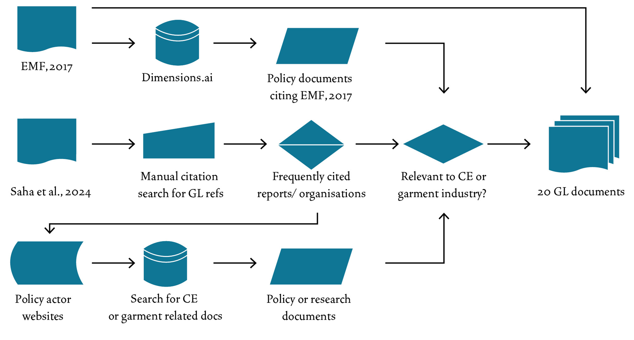

**Figure 1:** Selection process for literature review.

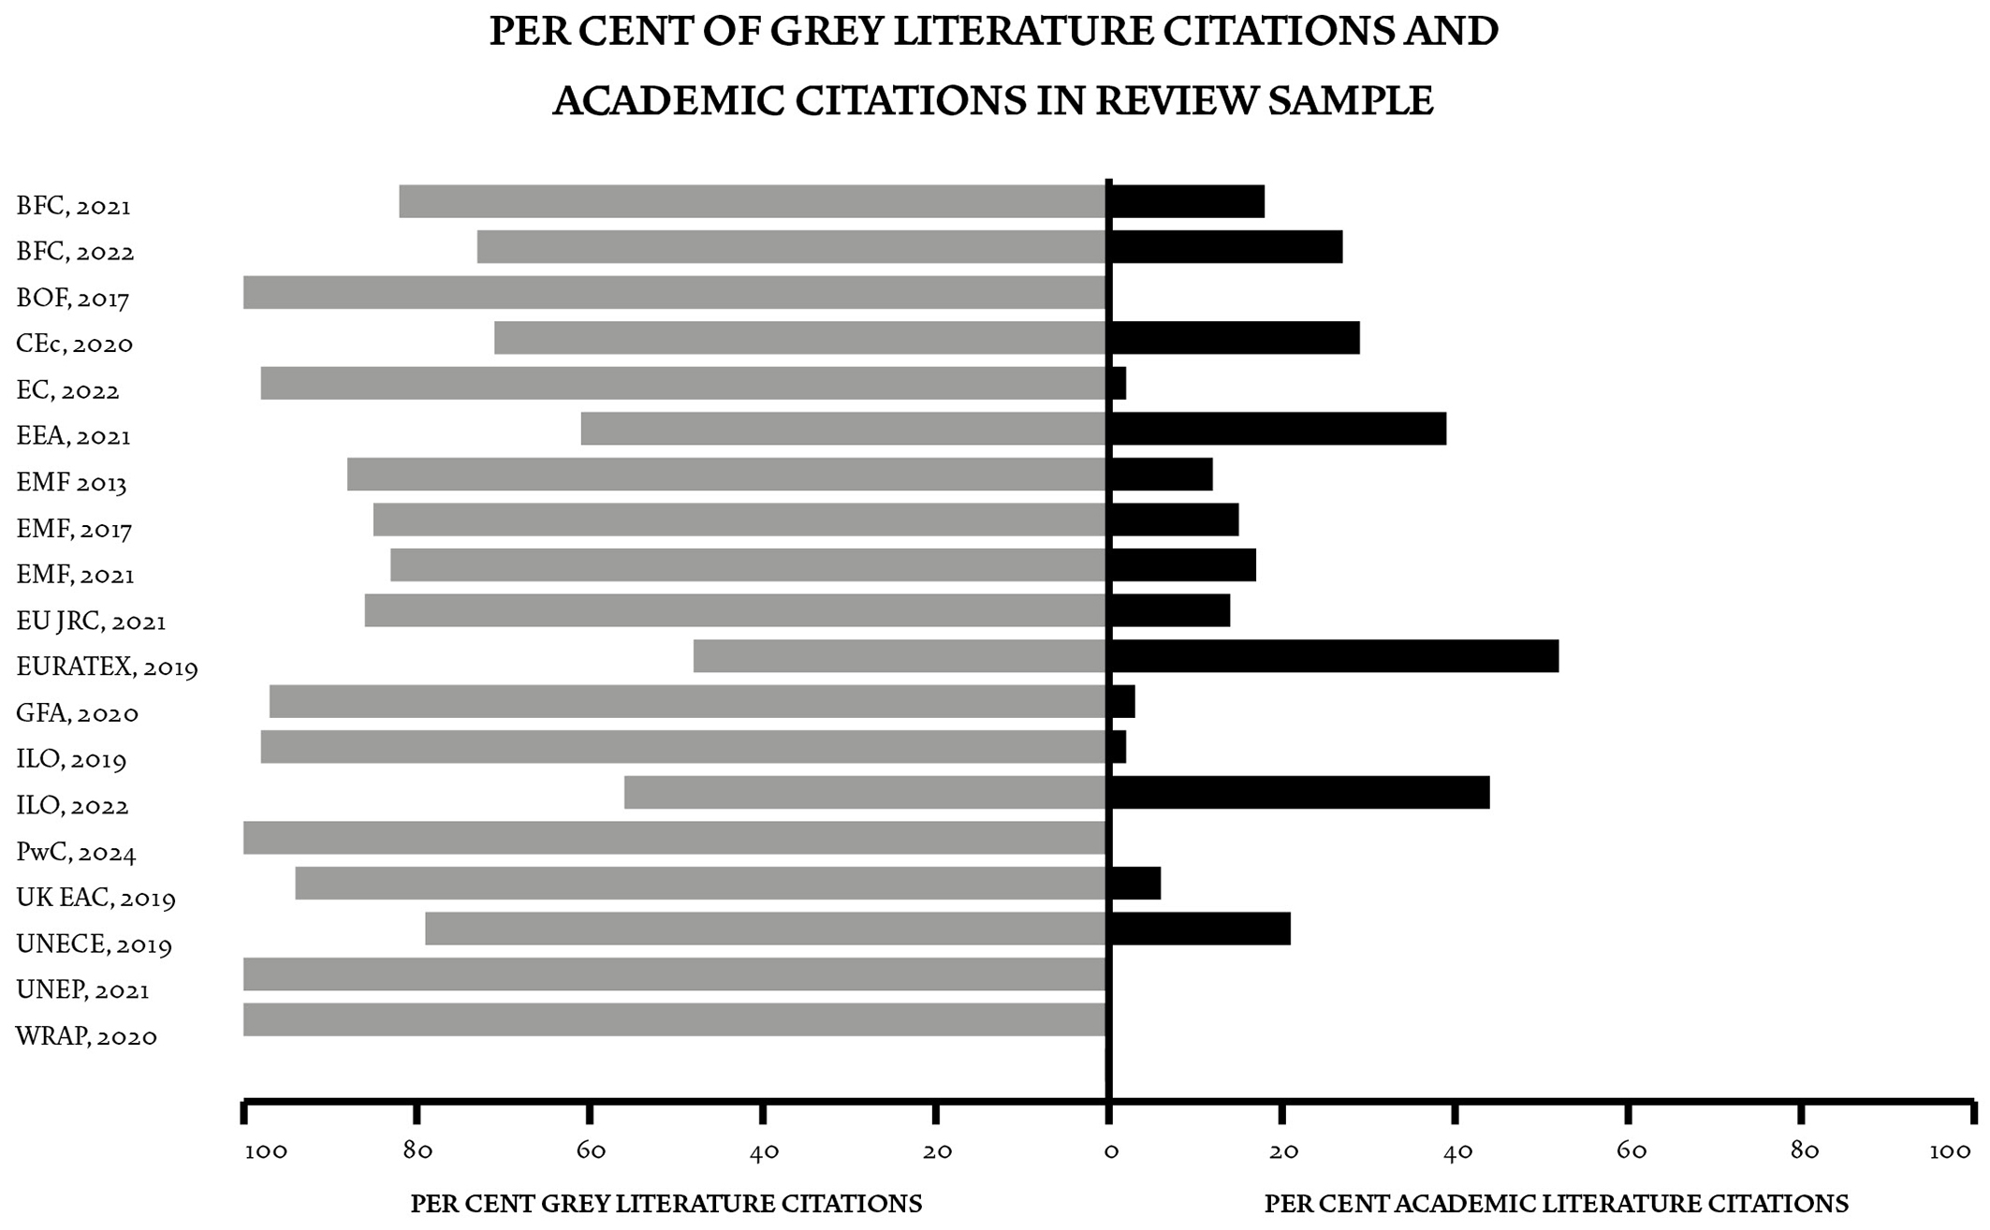

**Figure 2.** Grey literature heavily cites other grey literature. Note: GL publications analysed in this paper are referenced by publishing organisation and not individual authors.

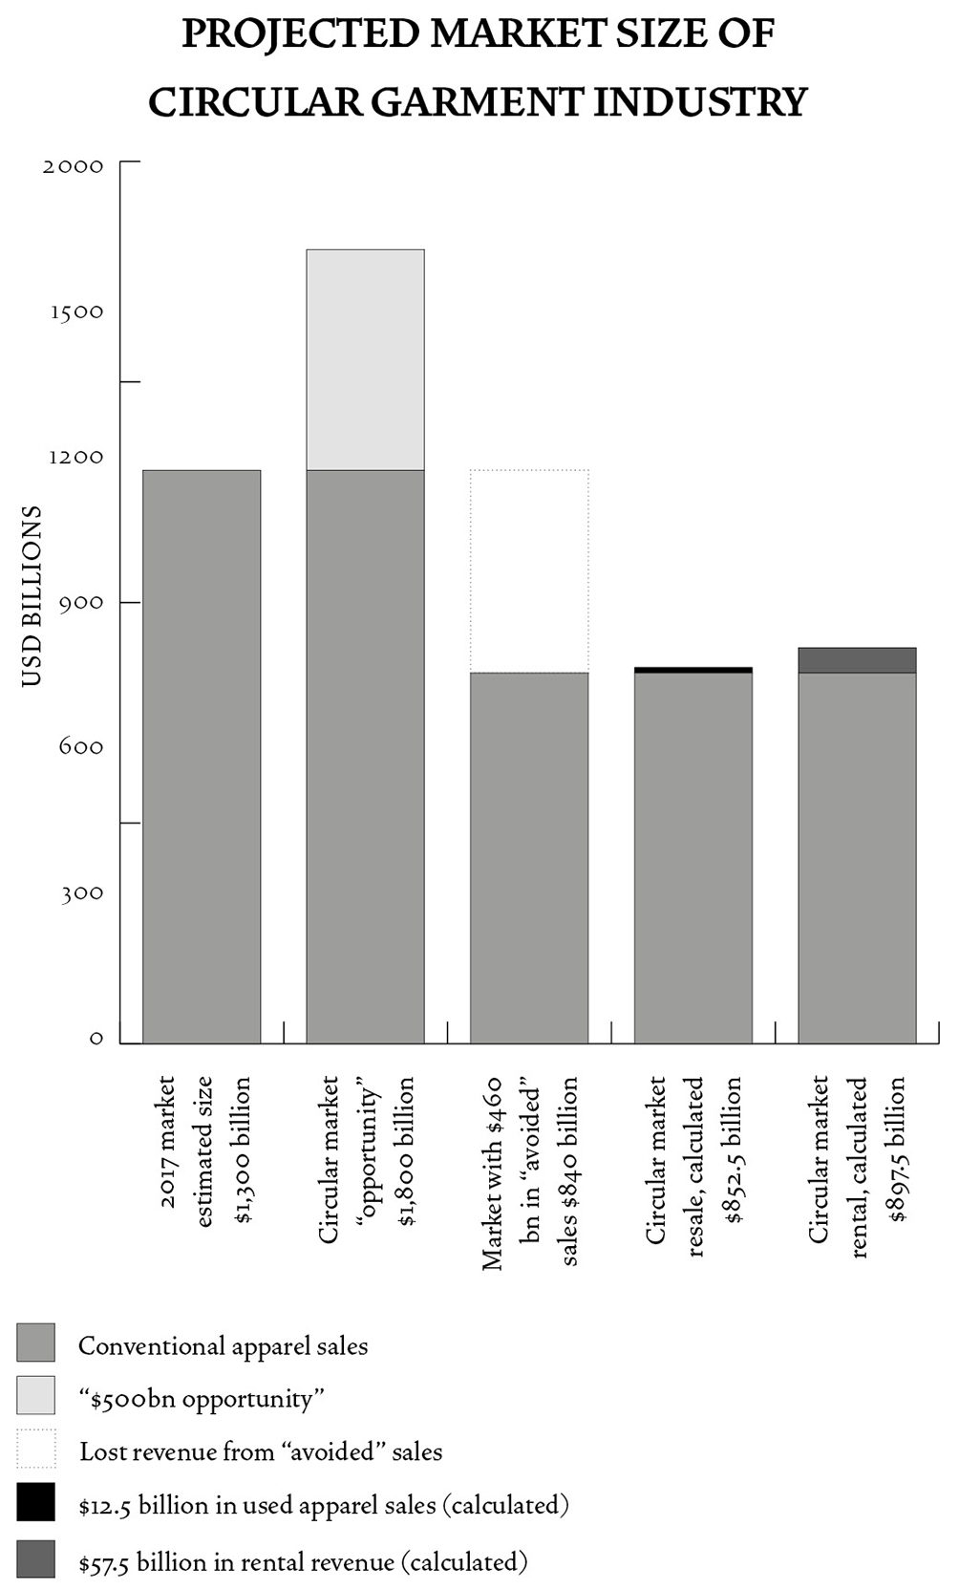

**Figure 3.** Figure 3. Estimated size of the garment industry. Based on figures provided in EMF 2017 and author’s calculations.