**Supplementary material**

Dosing chart for bedinvetmab (Librela, Zoetis) supplied to all investigators on the Castor EDC platform

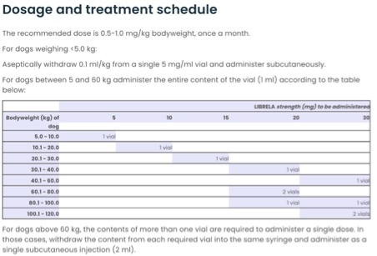

* Chart used with permission from Zoetis