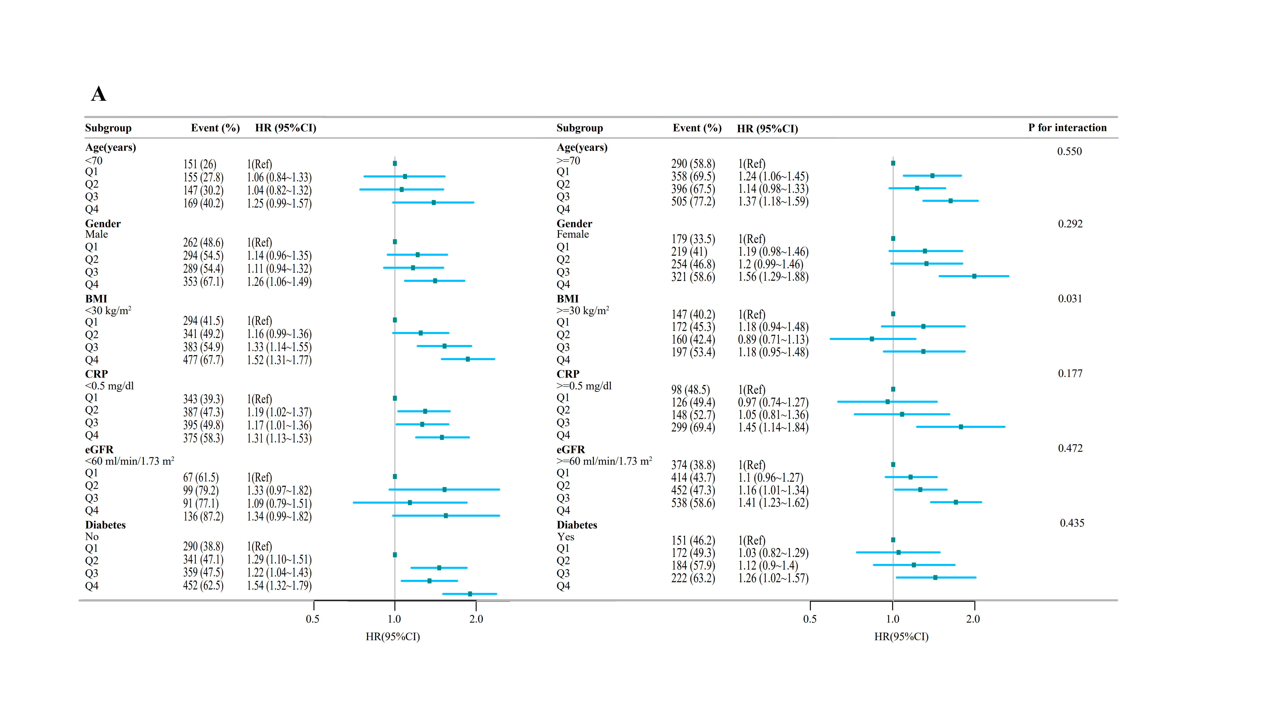

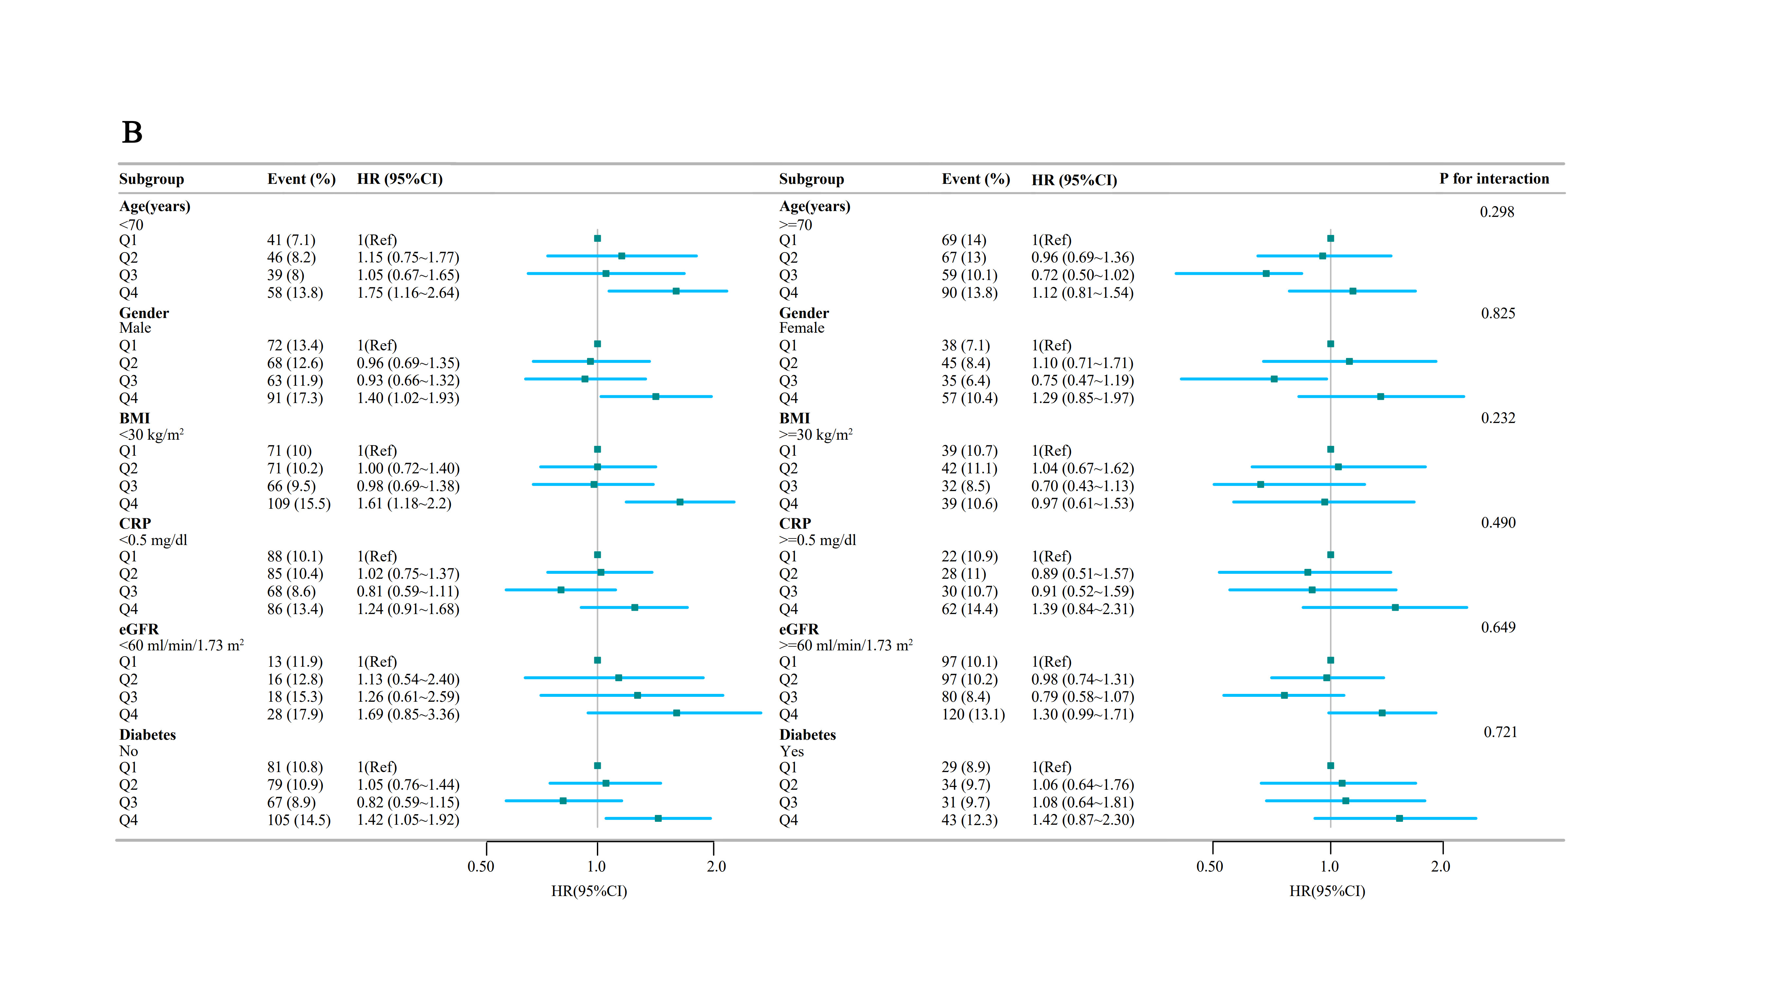

Forest plot of subgroup analyses of the association of SII with all-cause mortality（A） and cancer mortality(B).

Mortality. Hazard ratios (HRs) were calculated from multivariate Cox regression models adjusted for the variables listed in the fully adjusted model, except for those used for stratification.