Supplementary Material

# Supplementary Data

The data and commands are attached.

# Supplementary Figures and Tables

## Supplementary Figures

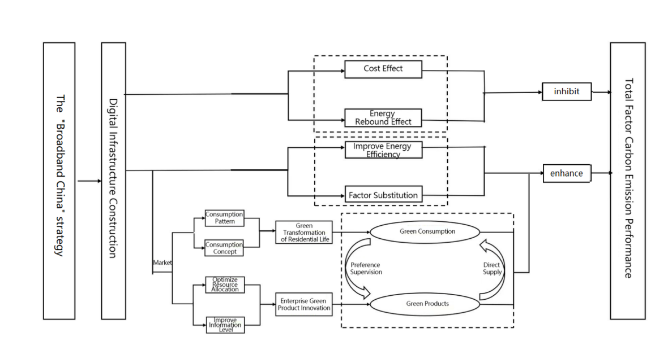

**FIGURE1** Theoretical framework diagram

图片1

**FIGURE2** Parallel Trend Test

图片2

**FIGURE 3** Placebo Test

## Supplementary Tables

**TABLE 1 Descriptive Statistics of Key Variables**

|  |  |  |  |  |  |  |
| --- | --- | --- | --- | --- | --- | --- |
| **Variable** | **Description** | **Observations** | **Mean** | **Std. Dev.** | **Min** | **Max** |
| UEI | Total factor carbon emission performance | 1850 | 0.267 | 0.160 | 0.043 | 1 |
| DID | “Broadband China” pilot dummy | 1850 | 0.227 | 0.419 | 0 | 1 |
| dop | City size | 1850 | 502.861 | 330.097 | 18.46 | 2005.91 |
| gov | Government size | 1850 | 0.170 | 0.069 | 0.0734 | 0.4507 |
| ui | Industrial structure | 1850 | 2.316 | 0.139 | 2.0277 | 2.6949 |
| lnprgdp | Economic development level | 1850 | 10.774 | 0.582 | 9.436 | 12.0684 |

**TABLE 2. Baseline Regression Results**

|  |  |  |  |  |  |
| --- | --- | --- | --- | --- | --- |
| **Variable** | **(1)** | **(2)** | **(3)** | **(4)** | **(5)** |
| DID | 0.017***  (3.59) | 0.017***  (3.60) | 0.010**  (2.20) | 0.010**  (2.25) | 0.023***  (2.76) |
| dop |  | 0.0001***  (3.95) | 0.0001***  (4.02) | 0.0001***  (4.17) | 0.0001  (1.11) |
| gov |  |  | -0.734***  (-12.80) | -0.740***  (-12.91) | -0.215**  (-2.61) |
| ui |  |  |  | 0.094**  (2.13) | 0.060  (0.93) |
| lnprgdp |  |  |  |  | 0.224***  (13.72) |
| Constant | 0.186***  (47.30) | 0.122***  (7.38) | 0.229***  (12.83) | 0.017  (0.17) | -2.314***  (-9.44) |
| City FE | Yes | Yes | Yes | Yes | Yes |
| Year FE | Yes | Yes | Yes | Yes | Yes |
| Observations | 1850 | 1850 | 1850 | 1850 | 1850 |
| R2 | 0.531 | 0.535 | 0.577 | 0.578 | 0.691 |

P < 0.05, *P < 0.01; Values in parentheses are t-statistics.

**TABLE 3. Robustness Test Regression Results**

|  |  |  |  |  |
| --- | --- | --- | --- | --- |
| **Variable** | **PSM-DID** | **Changed Policy Time** | **Excluded Other Policies** | **Excluded Extreme Values** |
| **(1)** | **(2)** | **(3)** | **(4)** |
| DID | 0.017***  (2.10) | 0.0107  (1.22) | 0.023***  (2.78) | 0.013**  (2.37) |
| Smart City Dummy |  |  | -0.008  (-1.08) |  |
| Constant | -2.344***  (-10.05) | -2.239***  (-9.18) | -2.323***  (-9.48) | -1.711***  (-9.79) |
| Control Variables | Yes | Yes | Yes | Yes |
| City FE | Yes | Yes | Yes | Yes |
| Year FE | Yes | Yes | Yes | Yes |
| Observations | 1795 | 1850 | 1850 | 1850 |
| R2 | 0.701 | 0.686 | 0.692 | 0.776 |

P < 0.05, *P < 0.01; Values in parentheses are t-statistics.

**TABLE 4. Digital Infrastructure Evaluation Index System**

|  |  |  |  |
| --- | --- | --- | --- |
| **Subsystem** | **Indicator Level** | **Indicator Calculation** | **Indicator Attribute** |
| Digital Infrastructure Input | Optical Fiber Length | Length of long-distance optical fiber cables (10,000 km) | Positive |
| Internet Broadband Access Ports | Number of internet broadband access ports (10,000 ports) | Positive |
| Related Employees | Number of employees in information transmission, computer services, and software industries (10,000 people) | Positive |
| Digital Infrastructure Output | Telecom Business Volume Per Capita | Total telecom business income / total population | Positive |
| Mobile Phone Penetration Rate | Number of mobile phone users / total population | Positive |
| Internet Penetration Rate | Number of internet broadband access users / total population | Positive |

**TABLE 5. Regression Results after Replacing the Core Explanatory Variable**

|  |  |  |  |  |  |
| --- | --- | --- | --- | --- | --- |
| **Variable** | **(1)** | **(2)** | **(3)** | **(4)** | **(5)** |
| *dig* | 0.550**  (2.32) | 0.511**  (2.41) | 0.451**  (2.39) | 0.502***  (2.66) | 0.450**  (2.51) |
| *dop* |  | 0.407  (0.83) | 0.0001  (0.77) | 0.0001  (0.80) | 0.0001  (0.99) |
| *gov* |  |  | -0.732***  (-6.76) | -0.741***  (-6.71) | -0.255***  (-3.16) |
| *ui* |  |  |  | 0.140*  (1.82) | 0.101  (1.54) |
| *lnprgdp* |  |  |  |  | 0.216***  (13.01) |
| Constant term | 0.175***  (24.55) | 0.125**  (2.02) | 0.232***  (3.26) | -0.086  (-0.46) | -2.309***  (-9.48) |
| City FE | Yes | Yes | Yes | Yes | Yes |
| Year FE | Yes | Yes | Yes | Yes | Yes |
| Observations | 1850 | 1850 | 1850 | 1850 | 1850 |
| *R2* | 0.538 | 0.541 | 0.583 | 0.586 | 0.692 |

*P<0.10,**P<0.05,***P<0.01；Values in parentheses are t-statistics.

**TABLE 6. Regression Results of Endogeneity Treatment**

|  |  |  |
| --- | --- | --- |
| **Variable** | **First Stage** | **Second Stage** |
| **DID** | **UEI** |
| **(1)** | **(2)** |
| DID |  | 0.106**  (2.30) |
| iv | -110.420***  (-4.48) |  |
| Control Variables | Yes | Yes |
| City FE | Yes | Yes |
| Year FE | Yes | Yes |
| Observations | 1850 | 1850 |
| Non-identification Test | 13.58  [0.000 2] |  |
| Weak Identification Test | 20.09  [16.38] |  |

*P<0.05,***P<0.01；Values in parentheses are t-statistics.In column (1) of Table 4, for the test of the null hypothesis "the instrumental variable is not identifiable," the P-value of the Kleibergen-Paap rk LM statistic is 0.00, significantly rejecting the null hypothesis. In the weak identification test of the instrumental variable, the Kleibergen-Paap rk Wald F statistic is greater than the critical value of 16.38 at the 10% level of the Stock-Yogo weak identification test.

**TABLE 7. Mechanism Test Regression Results**

|  |  |  |  |  |
| --- | --- | --- | --- | --- |
| **Variable** | **elc** | **UEI** | **gp** | **UEI** |
| **(1)** | **(2)** | **(3)** | **(4)** |
| DID | 2.816***  (3.03) | 0.011**  (2.05) | 0.042**  (2.04) | 0.042***  (32.42) |
| elc |  | 0.001***  (3.15) |  |  |
| gp |  |  |  | 0.002***  (3.46) |
| Control Vars | Yes | Yes | Yes | Yes |
| City FE | Yes | Yes | Yes | Yes |
| Year FE | Yes | Yes | Yes | Yes |
| Constant | -6.057  (-0.24) | -1.706***  (-9.86) | 0.866  (1.08) | -2.079***  (-41.19) |
| Observations | 1850 | 1850 | 23620 | 23620 |
| R2 | 0.410 | 0.779 | 0.075 | 0.809 |

P < 0.05, *P < 0.01; Values in parentheses are t-statistics.

**TABLE 8. Heterogeneity Analysis Regression Results**

|  |  |  |  |  |
| --- | --- | --- | --- | --- |
| **Variable** | **Income Level**  **Heterogeneity** | **Education Level Heterogeneity** | **Ownership Heterogeneity** | **Technology Level Heterogeneity** |
| **(1)** | **(2)** | **(3)** | **(4)** |
| DID*×*dpi | 0.034***  (4.61) |  |  |  |
| DID×learn |  | 0.028**  (2.05) |  |  |
| DID×soe |  |  | -0.007*  (-1.82) |  |
| DID×hte |  |  |  | 0.010**  (2.57) |
| Control Vars | Yes | Yes | Yes | Yes |
| City FE | Yes | Yes | Yes | Yes |
| Year FE | Yes | Yes | Yes | Yes |
| Constant | -2.407  (-9.87) | -2.343***  (-9.65) | -0.671  (-4.18) | -0.675  (-4.19) |
| Observations | 1850 | 1850 | 23620 | 23620 |
| R2 | 0.697 | 0.696 | 0.721 | 0.722 |

*P < 0.10, **P < 0.05, ***P < 0.01; Values in parentheses are t-statistics.