**Supplement information**

**Characterization of the salivary microbiome in healthy individuals under fatigue status**

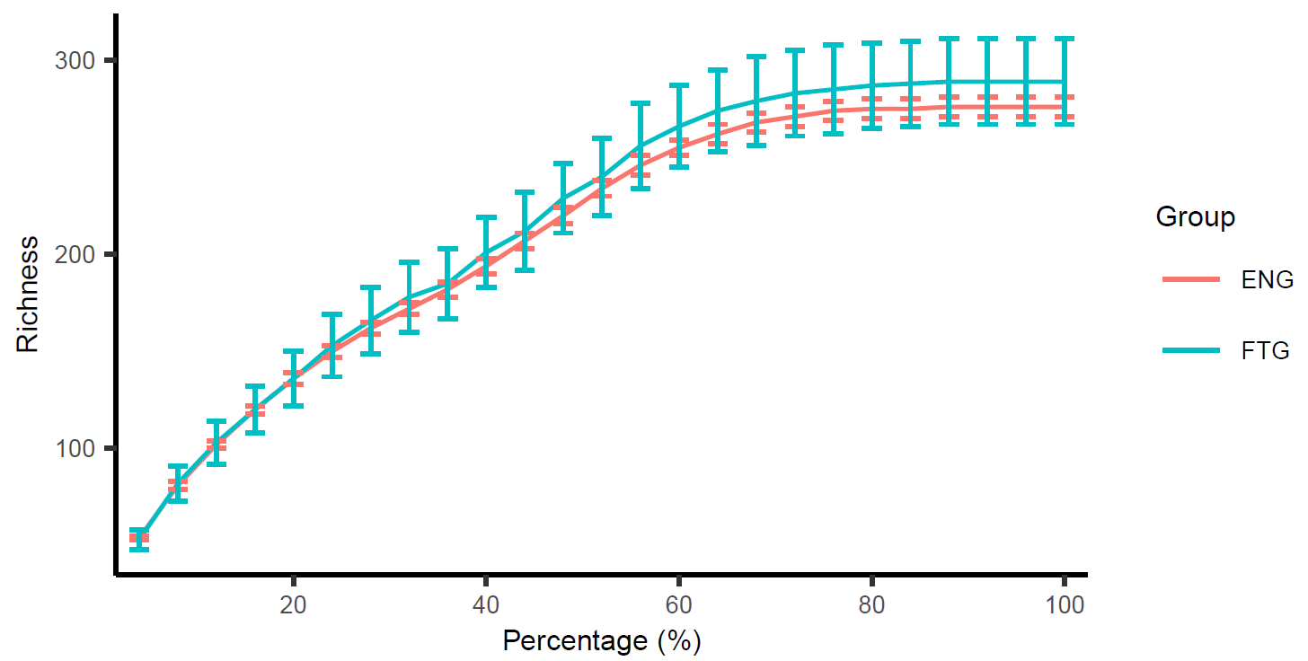

Figure S1. The distinction between species accumulation curves and rarefaction curves in the FTG and ENG groups.