Supplementary information:
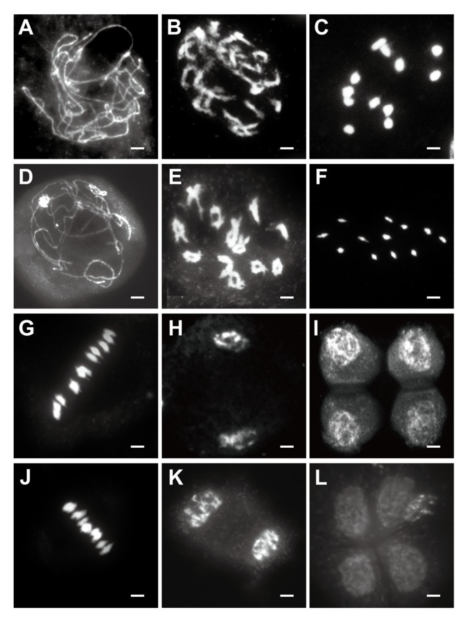
Figure S1. Chromosome behavior of male meiocytes of wild type ZH8015 and lap3 at different stages by DAPI staining.
(A) and (D) ZH8015 and lap3 meiocytes at pachytene;(B) and (E) ZH8015 and lap3 meiocytes at diplotene;(C) and (F) ZH8015 and lap3 meiocytes at diakinesis;(G) and (J) ZH8015 and lap3 meiocytes at metaphase I ;(H) and (K) ZH8015 and lap3 meiocytes at dyad stage;(I) and (L) ZH8015 and lap3 meiocytes at tetrad stage .Bars=5 μm.

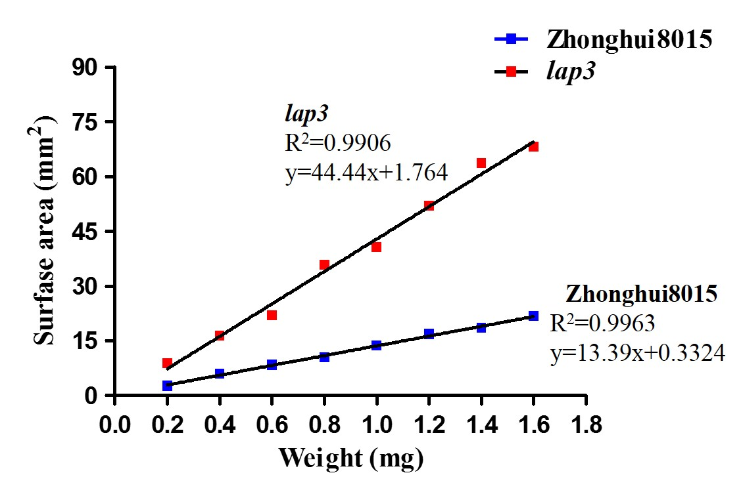
Figure S2. The ratio of weight/surface area of the anthers in the wild type Zhonghui8015 and the lap3 mutant.

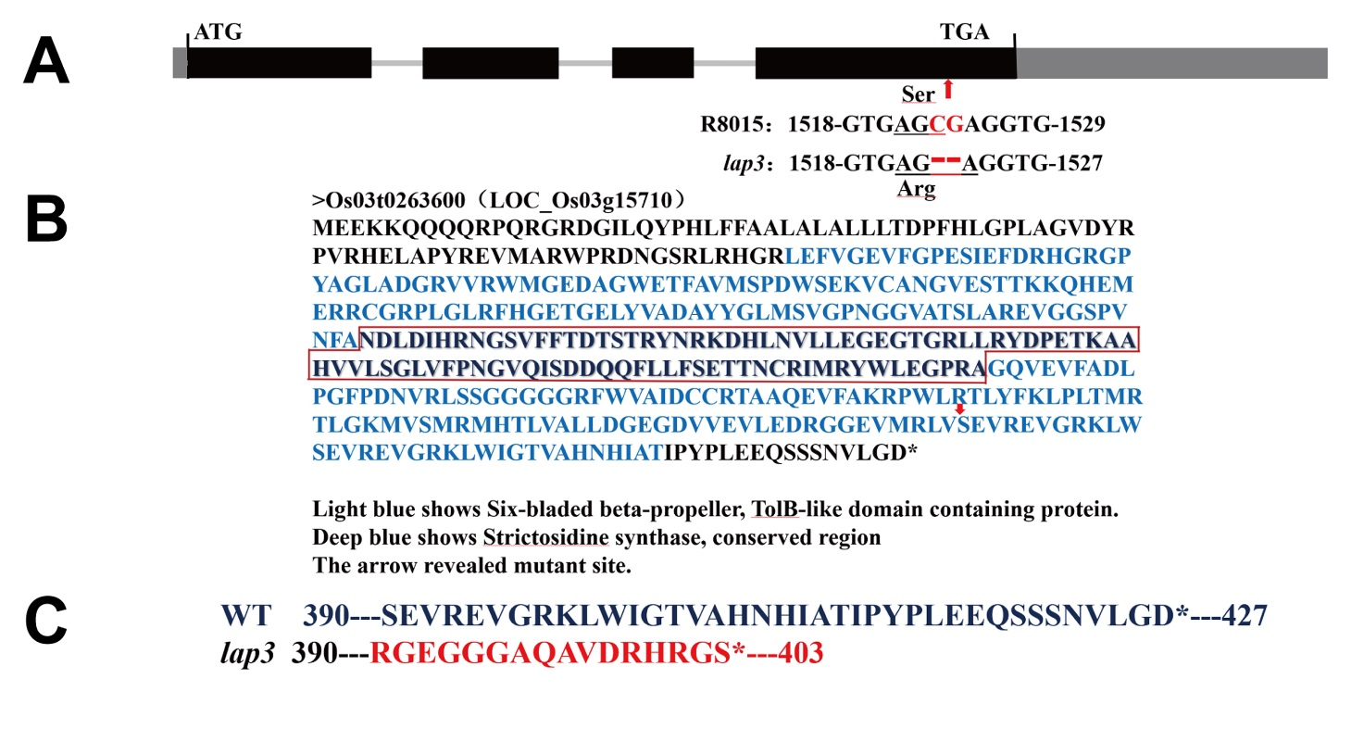
Figure S3. Sequence analysis of the lap3 mutation site.

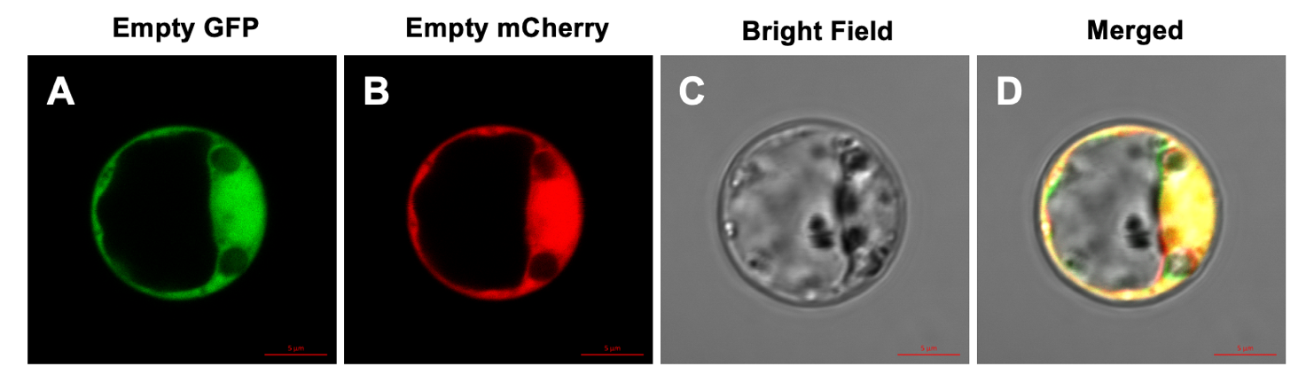
Figure S4. Negative control for subcellular localization of LAP3 protein
Table S1. Comparison of agronomic traits between ZH8015 and lap3
Agronomic Traits | ZH8015 | lap3 | P
Plant height(cm) | 108.0±2.7 | 104.5±1.9 | 0.0002
Tiller number | 9.0±0.7 | 8.8±0.4 | 0.6075
Days to heading | 98.2±2.7 | 101.2±2.8 | 0.0005
Spikelet Count | 125.7±6.4 | 126.8±5.2 | 0.4039
Seed setting rate(%) | 84.3±1.6 | 0 | <0.0001

Table S2. Segregation analysis of the lap3 allele
Combination | Seed-setting  rate of F₁ | F₂ |  | χ²(3:1) | χ²_{0.05}
Combination | Seed-setting  rate of F₁ | No. of wild type plants | No. of mutant plants | χ²(3:1) | χ²_{0.05}
lap3/Zh8015 | 88.21 | 385 | 123 | 0.17 | 3.84
lap3/02428 | 85.78 | 3904 | 1256 | 1.19 | 3.84

Table S3. Primer sequences used in this study
Primer | Forward primer (5′-3′) | Reverse primer (5′-3′) | Purpose
RD0304 | GGCGTCACTGCTCGTA | GCCTGAAGCGTCCACA | Linkage analysis
RM1338 | TGCAAGTTGGACTTCAAAGAGG | TGGATTCCTTCTTCCTTTCTCTCC | Linkage analysis
RM14723 | GCAAAGTCCTTTGGACAGGTAGC | CGTCCCAGATCAAAGTACACTCTTCC | Linkage analysis
RM7 | TTCGCCATGAAGTCTCTCG | CCTCCCATCATTTCGTTGTT | Linkage analysis
JS-1 | GGCCTCTGATACTACTCGATCTCG | TGCTCGACCAAATGCTCACG | Fine mapping
JS-2 | GAGGCAATAGCAGCGGACG | GCCAACGGCAGAGGTCTTC | Fine mapping
JS-3 | CTGTGCAACTAGTCCGTTAAGAC | CTACTTAAATGTATAGATTAGGG | Fine mapping
JS-4 | ATACAAGCAATGTGGCGTGGA | CAAACACGGGTCACATCCACT | Fine mapping
JS-5 | TCTAACCGGTGTATTTCGTGT | CCGTCAGAAGTTTTGACAATG | Fine mapping
JS-6 | TCAAGGCAATGCACTTACTAAC | AATCGTATTTTCTCAGGAACGA | Fine mapping
JS-7 | CGGCCGGATTACGGACATT | TCTGCCGTTTCCTCACCAAT | Fine mapping
JS-8 | AAATAAGACTGACGGTTAAACG | AAGTTCTAGAGGGAATGAGCAT | Fine mapping
JS-9 | TTCTTGGTCTGGATTGGAGTG | TTTGTCATCTGTTCCATAGGC | Fine mapping
LAP3-1 | TAATGCGGTACTGGCTGGAA | TAATGCGGTACTGGCTGGAA | Sequencing
LAP3-COM-BamHⅠ | CGGTACCCGGGGATCCCCTCCCTCGATTTGTACACGG | CGACTCTAGAGGATCCTTTCCTCGAAAAGGTCGGTAACT | Complementation vector construction
GP-Cas-AarⅠ | AGATGATCCGTGGCAgctcgtgtcggtgaagaacacggGTTTTAGAGCTATGC |  | CRISPR/Cas9 vector construction and Sequencing
Cas-Seq | CTCTCGTAGCAGTGTACAAT | GTCATATCTGAGCAGCCTC | CRISPR/Cas9 vector construction and Sequencing
OsLAP3-ISH-Anti Sense | CGAGAGAAGTCGGCGGGAG | TAATACGACTCACTATAGGGTCCAGCCAGTACCGCATTATC | In situ hybridization
OsLAP3-ISH-Sense | TAATACGACTCACTATAGGGCGAGAGAAGTCGGCGGGAG | TCCAGCCAGTACCGCATTATC | In situ hybridization
OsLAP3-GUS | GGACTCTTGACCATGGGAATTTGCACGCAGAGGAAAGA | TACCGAGCTCGAATTCCGGGTAGGCCAACGAATTCAC | GUS vector construction  (NcoⅠ/EcoRⅠ)
OsLAP3-GFP | GCCCAGATCAACTAGTCAATTCCGTCTTTCCTCTGC | TGCTCACCATGGATCCATCACCAAGCACGTTGCTGCTAC | GFP vector construction  (SpeⅠ/ BamHⅠ)
OsLAP3 | CGACACGAGCACGAGATA | ACGCCATTCGGGAAGACCA | qPCR

