Supplementary Material

# Supplementary File: Scoping Review Protocol

**Best Practices in Public Risk Communications during Multi-jurisdictional Enteric Illness Outbreak Investigations: A Scoping Review Protocol**

# Abstract

**Objective:** The objective of this scoping review is to understand the extent and type of evidence for best practices in public risk communication strategies used during enteric illness outbreak investigations.

**Introduction:** Public risk communication is a key intervention to inform Canadians about ongoing enteric illness outbreak investigations. Previous research has broadly examined best practices in health and food safety communication, leaving a critical knowledge gap in how to communicate risk information to Canadians specifically during active enteric illness outbreaks using best practices and available platforms and tools.

**Inclusion criteria:** Academic and grey literature that describes public risk communication during human disease outbreaks will be included. The investigated literature must describe food-borne, water-borne or enteric zoonotic illness outbreaks.

**Methods:** The search databases include Ovid MEDLINE, CAB Direct, Web of Science, PsycInfo, and Communication and Mass Media Complete as well as Google Scholar as a source of grey literature. A search strategy will be employed by two reviewers to identify relevant studies. A data extraction tool will extract necessary information from identified studies and results will be presented in a descriptive manner.

# Introduction

In Canada, the investigation of multi-jurisdictional enteric illness outbreaks are coordinated at the federal level by the Public Health Agency of Canada. During investigations, public risk communication is a key public health intervention used by PHAC to notify Canadians about an ongoing outbreak and advise them about measures they can take to protect their health. Although a significant number of resources are dedicated to public risk communication during these investigations, a formal evaluation has not been conducted to determine if these communications are reaching targeted populations and impacting their behaviours.

The goal of this scoping review is to identify and consolidate best practices that can be used to optimize public risk communication during enteric illness outbreak investigations. A preliminary search of PROSPERO, PubMed, and Google Scholar was conducted and no published systematic reviews, scoping reviews, protocols, or registrations on the topic were identified. Previous, related reviews have either broadly focused on best practices in health communication (Lipkus, 2007; Im & Anderson, 2020) or the use of media platforms for public risk communication (Overby, *et. al.;* Ntshoe, *et. al.,* 2021). Others have been more narrowly focused, such as a 2022 review on prevention of food-borne illness through food safety communication (Zanetta *et. al.*, 2022). Thus, there is a gap in the literature with respect to best practices for public risk communication during enteric illness outbreak investigations. A scoping review is useful in assessing the current state of knowledge for a given topic by systematically mapping a variety of information sources and can be used to identify best practices as well as knowledge gaps. The objective of this scoping review is to assess the body of knowledge on public risk communication during enteric illness outbreak investigations.

# Review questions

During an enteric illness outbreak:

1. What are the best practices for public risk communication?
2. What other types of communication channels could be used to reach the public?

# Keywords

Key words: Best practices; Risk communication; Enteric illness; Food-borne diseases; Water-borne diseases; Enteric zoonotic diseases; Outbreaks; Public

# Eligibility criteria

Inclusion criteria are:

1. Academic or grey literature that describes public risk communication practices during human disease outbreak investigations.
2. Outbreak investigations are related to food-borne, water-borne, or enteric zoonotic diseases.

Exclusion criteria:

1. Outbreaks in animal populations with no transmission to humans.
2. Articles written in a language other than English or French.
3. Articles without full text available.

This scoping review will consider both experimental and quasi-experimental study designs including randomized controlled trials, non-randomized controlled trials, before and after studies, and interrupted time-series studies. In addition, analytical observational studies including prospective and retrospective cohort studies, case-control studies, and analytical cross-sectional studies will be considered for inclusion. This review will also consider descriptive observational study designs including case series, individual case reports, and descriptive cross-sectional studies for inclusion. Qualitative studies will also be considered that focus on qualitative data including, but not limited to, designs such as phenomenology, grounded theory, ethnography, qualitative description, action research and feminist research. In addition, systematic and other scoping reviews that meet the inclusion criteria as well as text and opinion papers will also be considered.

# Methods

The proposed scoping review will be conducted in accordance with the JBI methodology for scoping reviews.

### Search strategy

The search strategy will aim to locate published studies. An initial limited search of PubMed and Google Scholar was undertaken to identify articles on the topic. The text words contained in the titles and abstracts of relevant articles, and the index terms used to describe the articles were used to develop a full search strategy. The search strategy will be adapted for each included database and/or information source. The reference list of all included sources of evidence will be screened for additional studies.

Searches will be limited to title, abstract, and keywords using the following search strategy:

1. ((media and communicat*) or social media or Facebook or YouTube or Instagram or TikTok or snapchat or twitter or LinkedIn or "mobile adj5 application" or online or on-line or digital or digitally or digitalize* or digitalizing or digitalization or virtual or virtually or web-based or website* or web-site* or mobile* or "web page*" or internet or news* or magazine* or radio or television or dashboard*).ab,kw,ti.
2. (social media or mobile applications or web browser).sh.
3. Exp Mass Media/
4. Exp Publication Components/
5. Exp Publication Formats/
6. Exp Internet/
7. 1 or 2 or 3 or 4 or 5 or 6 [Communication Platforms]
8. ((health or illness* or disease* or risk* or crisis or crises or public) adj10 (communicat* or campaign* or promotion* or media or message*)).ab,kw,ti.
9. Exp Communications Media/
10. Exp Communication/
11. 8 or 9 or 10 [Risk communication]
12. ((foodborne or food-borne or (food adj1 borne)) adj10 (disease* or illness* or infection* or outbreak* or investigat* or pathoge* or bacterium or bacteria or virus or viruses or parasite* or cluster)).ab,kw,ti.
13. (food adj10 (safety or poison* or contamina* or quality)).ab,kw,ti.
14. (food contamination).sh.
15. Exp Foodborne Diseases/
16. Exp Food Quality/
17. 12 or 13 or 14 or 15 or 16 [Foodborne diseases]
18. (zoonoses or (zoonotic adj10 (disease* or illness* or infection* or outbreak* or investigat* or pathogen* or bacterium or bacteria or virus or viruses or parasite* or cluster))).ab,kw,ti.
19. Exp zoonoses/
20. 18 or 19 [Zoonotic diseases]
21. ((waterborne or water-borne or water-related or (water adj1 borne)) adj10 (disease* or illness* or infection* or outbreak* or investigat* or pathogen* or bacterium or bacteria or virus or viruses or parasite* or cluster)).ab,kw,ti.
22. (waterborne diseases).sh.
23. 21 or 22 [Waterborne diseases]
24. (enteric adj10 (disease* or illness* or infection* or outbreak* or investigat* or pathogen* or bacterium or bacteria or virus or viruses or parasite* or cluster)).ab,kw,ti.
25. (gastroenteritis or gastro or “stomach flu” or diarrhea or diarrhoea).ab,kw,ti.
26. (transmissible gastroenteritis virus).sh
27. Exp Gastrointestinal Disease/
28. 24 or 25 or 26 or 27 [Enteric diseases]
29. (Disease Transmission, infectious).sh.
30. Exp Disease Outbreaks/
31. Exp Public Health Practice/
32. Exp Epidemiologic Methods/
33. Exp Communicable Disease Control/
34. Exp Population Surveillance/
35. Exp Communicable Diseases/
36. Exp Infections/
37. 29 or 30 or 31 or 32 or 33 or 34 or 35 or 36 [Outbreaks]
38. 17 or 20 or 23 or 28 [Foodborne, waterborne, zoonotic or enteric diseases]
39. 7 and 11 and 37 and 38 [Communication Platform + Risk Communication + Disease Outbreak]

**Table 1. Summary of search terms by concept area**

|  |  |
| --- | --- |
| **Concept Area** | **Search Terms** |
| Communication Platforms | media communicat* or social media or Facebook or YouTube or Instagram or TikTok or snapchat or twitter or LinkedIn or mobile application or online or on-line or digital or digitally or digitalize* or digitalizing or digitalization or virtual or virtually or web-based or website* or web-site* or mobile* or web page* or internet or news* or magazine* or radio or television or dashboard*  MeSH: social media or mobile applications or web browser or mass media or publication components or publication formats or internet |
| Risk Communication | health communicat* or health campaign* or health promotion* or health media or health message or illness* communicat* or illness* campaign* or illness* promotion* or illness* message* or disease* communicat* or disease* campaign* or disease* promotion* or disease* media or disease* message* or risk* communicat* or risk* campaign* or risk* promotion* or risk* media* or public communicat* or public campaign* or public promotion* or public media or public message  MeSH: communications or communications media |
| Foodborne Diseases | (Foodborne / food-borne / food borne)  disease* or (Foodborne / food-borne / food borne) illness* or (Foodborne / food-borne / food borne) infection* or (Foodborne / food-borne / food borne) outbreak* or (Foodborne / food-borne / food borne) pathog* or (Foodborne / food-borne / food borne) bacterium/bacteria or (Foodborne / food-borne / food borne) virus/viruses or (Foodborne / food-borne / food borne) parasite* or (Foodborne / food-borne / food borne) cluster or food safety or food poison or food contamina* or food quality  MeSH: foodborne disease or food contamination or food quality |
| Waterborne Diseases | (waterborne/ water-borne/ water borne/ water-related) disease* or (waterborne/ water-borne/ water borne/ water-related) illness* or (waterborne/ water-borne/ water borne/ water-related) infection* or (waterborne/ water-borne/ water borne/ water-related) outbreak* or (waterborne/ water-borne/ water borne/ water-related) pathog* or (waterborne/ water-borne/ water borne/ water-related) bacterium/bacteria or (waterborne/ water-borne/ water borne/ water-related) virus/viruses or (waterborne/ water-borne/ water borne/ water-related) parasite* or (waterborne/ water-borne/ water borne/ water-related) cluster  MeSH: waterborne diseases |
| Zoonotic Diseases | zoonotic disease* or zoonotic illness* or zoonotic infection* or zoonotic outbreak* or zoonotic pathog* or zoonotic bacterium/bacteria or zoonotic virus/viruses or zoonotic parasite* or zoonotic cluster*  MeSH: zoonoses |
| Enteric Diseases | enteric disease* or enteric illness* or enteric infection* or enteric outbreak* or enteric pathog* or enteric bacterium/bacteria or enteric virus/viruses or zoonotic parasite* or enteric cluster or gastroenteritis or gastro or stomach flu or diarrhea or diarrhoea  MeSH: transmissible gastrointestinal virus or gastrointestinal disease |
| Outbreaks | MeSH: disease transmission, infectious or disease outbreaks or public health practice or communicable disease control or population surveillance or epidemiological methods or communicable diseases or infections |

The databases to be searched include Ovid MEDLINE, CAB Direct, Web of Science, PsycInfo, and Communication and Mass Media Complete. Sources of grey literature to be searched include Google Scholar, and ProQuest Theses and Dissertations. A full search strategy for Ovid MEDLINE can be found in Appendix 1.

### Study/Source of Evidence selection

Following the search, all identified citations will be collated and uploaded into Covidenceand duplicates removed. Following a pilot test, titles and abstracts will then be screened by two independent reviewers for assessment against the inclusion criteria for the review. Potentially relevant sources will be retrieved in full text and imported into Covidence.The full text of selected citations will be assessed in detail against the inclusion criteria by two or more independent reviewers. References of the included full-text studies will also be reviewed for potentially relevant literature. Any disagreements that arise between the reviewers at each stage of the selection process will be resolved through discussion, or with an additional reviewer/s. The results of the search and the study inclusion process, including reasons for full-text exclusion, will be reported in full in the final scoping review and presented in a Preferred Reporting Items for Systematic Reviews and Meta-analyses extension for scoping review (PRISMA-ScR) flow diagram.

### Data Extraction

Data will be extracted from papers included in the scoping review by two or more independent reviewers using a data extraction tool developed by the reviewers. The data extracted will include specific details about the study population, inclusion criteria, methodology/methods, type of outbreak investigation, and key findings related to public risk communication practices. A draft extraction form is provided in Appendix 2. The draft data extraction tool will be modified and revised as necessary during the process of extracting data from each included evidence source. Modifications will be detailed in the final scoping review document. Any disagreements that arise between the reviewers will be resolved through discussion, or with an additional reviewer/s. If appropriate, authors of papers will be contacted to request missing or additional data, where required.

### Data Analysis and Presentation

A basic frequency analysis will be conducted on the extracted data to identify relevant public risk communication practices during enteric illness outbreak investigations. Similar communication practices will be identified amongst the data and grouped together. The data will be presented in a descriptive manner using tabular or graphical formats. A narrative summary will accompany the tabulated and/or charted results and will describe how the results relate to the review objective and questions. Relevant excerpts from included studies will also be presented as examples of identified public risk communication practices during enteric illness outbreak investigations.

# References

Im, D. & Aaronson, E. (2020). Best Practices in Patient Safety and Communication. Emerg *Med Clin North Am, 38*(3):693-703. DOI: 10.1016/j.emc.2020.04.007.

Lipkus, I.M. (2007). “Numeric, verbal, and visual formats of conveying health risks: suggest best practices and future recommendations.” *Med Decis Making,* *27*(5):696-713. DOI: 10.1177/0272989X07307271.

Ntshoe, G*. et. al.* (2021). A systematic review on mobile health applications for foodborne outbreak management. *BMC Public Health, 21*:2228. DOI: https://doi.org/10.1186/s12889-021-12283-6

Overby, K. *et. al.* (2017). A Systematic Review of the Use of Social Media for Food Safety Risk Communication. *J of Food Protec, 80*(9):1537-1549. DOI: 10.4315/0362-028X.JFP-16- 345

Zanetta, L.D. *et. al*. (2022). What Motivates Consumer Food Safety Perceptions and Beliefs? A Scoping Review in BRICS Countries. *Foods, 11*(3):432. DOI: 10.3390/foods11030432.

# Appendix 1: Search strategy

*For Ovid Medline: 7113 results*

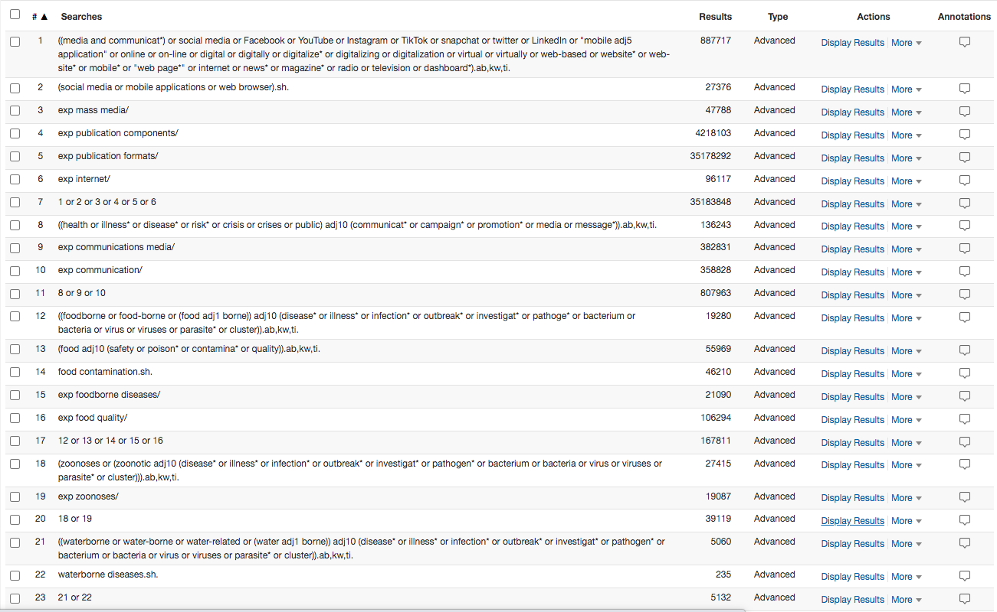

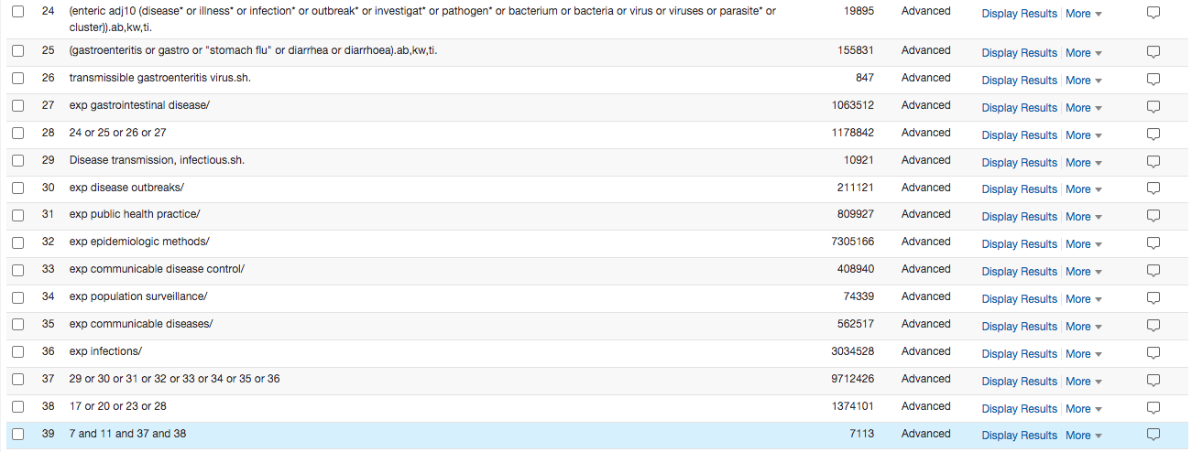

# Appendix II: Data extraction instrument

The following variables are included in our initial data extraction instrument:

1. Author(s)
2. Year of Publication
3. Country of Origin (where the study was conducted)
4. Study Aim
5. Study Population
6. Sample Size (if applicable)
7. Methods
8. Inclusion Criteria: Context
9. Exclusion Criteria
10. Study Design
11. Type of Outbreak / Outbreak Category Identified (if applicable)
12. Type of Pathogen
13. Communication Framework or Model (if applicable)
14. Type of Communication
15. Communication Practices Identified
16. Evaluation of Communication Initiatives
17. Bias and Limitations
18. Future Directions

# Supplementary Tables

**2.1** Supplementary Table 1. Controlled Vocabulary and Keywords Used in Ovid via MEDLINE

|  |  |
| --- | --- |
| **Concept Area** | **Search Terms** |
| Communication Platforms | media communicat* or social media or Facebook or YouTube or Instagram or TikTok or snapchat or twitter or LinkedIn or mobile application or online or on-line or digital or digitally or digitalize* or digitalizing or digitalization or virtual or virtually or web-based or website* or web-site* or mobile* or web page* or internet or news* or magazine* or radio or television or dashboard*  MeSH: social media or mobile applications or web browser or mass media or publication components or publication formats or internet |
| Risk Communication | health communicat* or health campaign* or health promotion* or health media or health message or illness* communicat* or illness* campaign* or illness* promotion* or illness* message* or disease* communicat* or disease* campaign* or disease* promotion* or disease* media or disease* message* or risk* communicat* or risk* campaign* or risk* promotion* or risk* media* or public communicat* or public campaign* or public promotion* or public media or public message  MeSH: communications or communications media |
| Foodborne Diseases | (Foodborne / food-borne / food borne)  disease* or (Foodborne / food-borne / food borne) illness* or (Foodborne / food-borne / food borne) infection* or (Foodborne / food-borne / food borne) outbreak* or (Foodborne / food-borne / food borne) pathog* or (Foodborne / food-borne / food borne) bacterium/bacteria or (Foodborne / food-borne / food borne) virus/viruses or (Foodborne / food-borne / food borne) parasite* or (Foodborne / food-borne / food borne) cluster or food safety or food poison or food contamina* or food quality  MeSH: foodborne disease or food contamination or food quality |
| Waterborne Diseases | (waterborne/ water-borne/ water borne/ water-related) disease* or (waterborne/ water-borne/ water borne/ water-related) illness* or (waterborne/ water-borne/ water borne/ water-related) infection* or (waterborne/ water-borne/ water borne/ water-related) outbreak* or (waterborne/ water-borne/ water borne/ water-related) pathog* or (waterborne/ water-borne/ water borne/ water-related) bacterium/bacteria or (waterborne/ water-borne/ water borne/ water-related) virus/viruses or (waterborne/ water-borne/ water borne/ water-related) parasite* or (waterborne/ water-borne/ water borne/ water-related) cluster  MeSH: waterborne diseases |
| Zoonotic Diseases | zoonotic disease* or zoonotic illness* or zoonotic infection* or zoonotic outbreak* or zoonotic pathog* or zoonotic bacterium/bacteria or zoonotic virus/viruses or zoonotic parasite* or zoonotic cluster*  MeSH: zoonoses |
| Enteric Illnesses | enteric disease* or enteric illness* or enteric infection* or enteric outbreak* or enteric pathog* or enteric bacterium/bacteria or enteric virus/viruses or zoonotic parasite* or enteric cluster or gastroenteritis or gastro or stomach flu or diarrhea or diarrhoea  MeSH: transmissible gastrointestinal virus or gastrointestinal disease |
| Outbreaks | MeSH: disease transmission, infectious or disease outbreaks or public health practice or communicable disease control or population surveillance or epidemiological methods or communicable diseases or infections |

**2.2** Supplementary Table 2. Keywords Used in Google Scholar and ProQuest Thesis and Dissertations

|  |  |
| --- | --- |
| **Keywords for Risk Communication** | **Keywords for Enteric illness Outbreaks** |
| Communication, Risk | Outbreak, Food |
| Media, Risk | Outbreak, Escherichia coli |
| Outbreak, Salmonella |
| Outbreak, (listeria or listeriosis) |

**2.3** Supplementary Table 3. Evaluation of Level of Confidence

|  |  |  |  |
| --- | --- | --- | --- |
| **Construct** | **High (3 points)** | **Moderate (2 points)** | **Low (1 point)** |
| **Evidence Adequacy** | | | |
| Type | Quantitative observational or experimental studies | Descriptive or qualitative studies | Text or opinion papers |
| Generalizability | Evidence can be applied to risk communication in most outbreaks. | Evidence is more specific to risk communication during outbreaks of a specific pathogen or in a specific location but can be adapted. | Evidence is very specific to risk communication during outbreaks of a specific pathogen or in a specific location and cannot easily be adapted. |
| Weight of evidence | 7-9 studies | 4-6 studies | 1-3 studies |
| **Evidence Agreement** | | | |
| Agreement | 75-100% of studies are in agreement. | 25-74% of studies are in agreement. | 0-24% of studies are in agreement. |

**2.4** Supplementary Table 4. Determining Confidence from Evidence Adequacy and Agreement

|  |  |  |
| --- | --- | --- |
| **Evidence Adequacy** | **Evidence Agreement** | **Confidence** |
| Low | Low | Low |
| Low | Moderate | Low |
| Low | High | Moderate |
| Moderate | Low | Moderate |
| Moderate | Moderate | Moderate |
| Moderate | High | High |
| High | Low | Moderate |
| High | Moderate | High |
| High | High | High |