Supplementary Material

1. **Appendix A**

The color composite mosaics covering the entire study area over the years are displayed here. For 1972, the bands are assigned as follows: (red: NIR2 band, green: red band, blue: green band). For the other years, the bands are assigned as follows: (red: NIR band, green: red band, blue: green band).

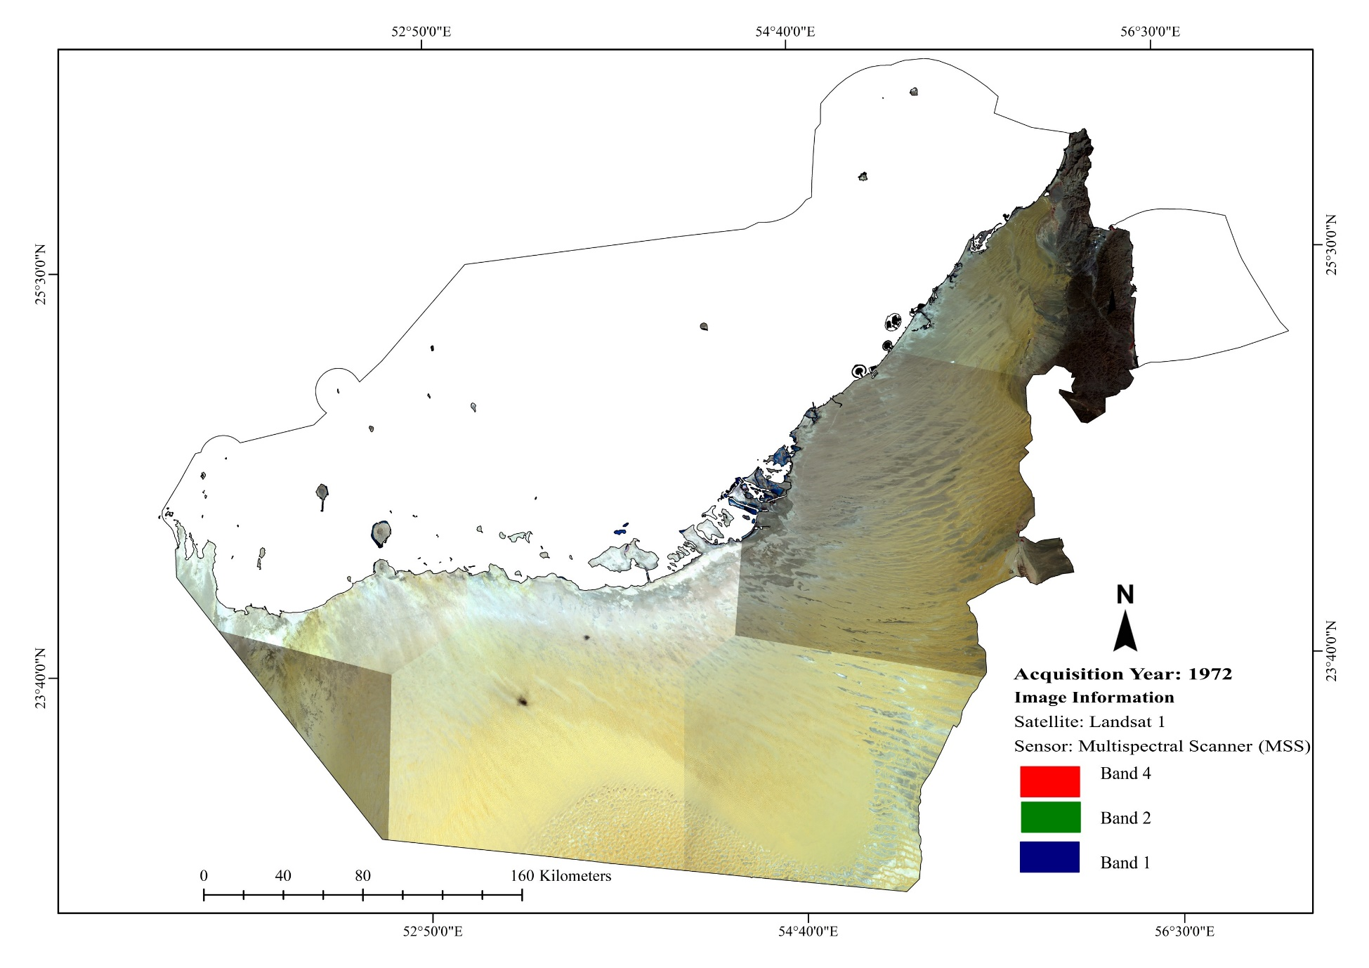

1. **Appendix B**

The training and testing samples used for the classification of the Landsat scenes into four main classes: Built areas, Vegetation, Water and Desert and Mountainous areas.

|  |  |  |  |  |  |  |  |
| --- | --- | --- | --- | --- | --- | --- | --- |
| Dataset | Scene (Path/Row) | Sample | Class | | | | Total |
| Desert and Mountainous areas | Built areas | Vegetation | Water |
| 2021 | 159/42 | Training | 134 | 71 | 67 | 98 | 370 |
| Testing | 25 | 18 | 25 | 25 | 93 |
| 159/43 | Training | 122 | 110 | 96 | 42 | 370 |
| Testing | 24 | 37 | 21 | 10 | 92 |
| 160/42 | Training | 358 | 149 | 152 | 135 | 794 |
| Testing | 91 | 44 | 36 | 27 | 198 |
| 160/43 | Training | 348 | 196 | 181 | 157 | 882 |
| Testing | 91 | 54 | 44 | 32 | 221 |
| 160/44 | Training | 271 | 46 | 46 | 3 | 366 |
| Testing | 67 | 6 | 17 | 1 | 91 |
| 161/43 | Training | 252 | 183 | 184 | 199 | 818 |
| Testing | 60 | 42 | 57 | 46 | 205 |
| 161/44 | Training | 228 | 128 | 137 | 17 | 510 |
| Testing | 53 | 35 | 37 | 3 | 128 |
| 162/43 | Training | 263 | 129 | 165 | 195 | 752 |
| Testing | 60 | 23 | 53 | 52 | 188 |
| 162/44 | Training | 120 | 15 | 42 | 39 | 216 |
| Testing | 32 | 3 | 10 | 9 | 54 |
| 2017 | 159/42 | Training | 143 | 79 | 71 | 95 | 388 |
| Testing | 33 | 16 | 20 | 28 | 97 |
| 159/43 | Training | 110 | 113 | 100 | 46 | 369 |
| Testing | 36 | 30 | 20 | 6 | 92 |
| 160/42 | Training | 362 | 150 | 155 | 125 | 792 |
| Testing | 87 | 43 | 34 | 34 | 198 |
| 160/43 | Training | 344 | 193 | 170 | 145 | 852 |
| Testing | 95 | 39 | 40 | 39 | 213 |
| 160/44 | Training | 295 | 82 | 75 | 3 | 455 |
| Testing | 65 | 20 | 28 | 1 | 114 |
| 161/43 | Training | 296 | 12 | 191 | 197 | 696 |
| Testing | 72 | 43 | 51 | 51 | 217 |
| 161/44 | Training | 230 | 131 | 136 | 14 | 511 |
| Testing | 51 | 31 | 43 | 3 | 128 |
| 162/43 | Training | 261 | 125 | 166 | 198 | 750 |
| Testing | 62 | 28 | 49 | 49 | 188 |
| 162/44 | Training | 174 | 48 | 51 | 36 | 309 |
| Testing | 48 | 9 | 8 | 12 | 77 |
| 2013 | 159/42 | Training | 129 | 81 | 82 | 86 | 378 |
| Testing | 30 | 15 | 14 | 36 | 95 |
| 159/43 | Training | 113 | 138 | 100 | 38 | 389 |
| Testing | 33 | 33 | 18 | 13 | 97 |
| 160/42 | Training | 358 | 173 | 152 | 147 | 830 |
| Testing | 81 | 49 | 42 | 35 | 207 |
| 160/43 | Training | 368 | 183 | 162 | 157 | 870 |
| Testing | 83 | 51 | 44 | 38 | 216 |
| 160/44 | Training | 261 | 93 | 87 | 2 | 443 |
| Testing | 59 | 22 | 30 | 0 | 111 |
| 161/43 | Training | 248 | 164 | 185 | 201 | 798 |
| Testing | 63 | 41 | 52 | 43 | 199 |
| 161/44 | Training | 225 | 118 | 145 | 7 | 495 |
| Testing | 53 | 34 | 34 | 3 | 124 |
| 162/43 | Training | 253 | 117 | 170 | 186 | 726 |
| Testing | 70 | 22 | 29 | 60 | 181 |
| 162/44 | Training | 174 | 32 | 50 | 40 | 296 |
| Testing | 45 | 12 | 10 | 7 | 74 |
| 2002 | 159/42 | Training | 127 | 62 | 84 | 95 | 368 |
| Testing | 32 | 23 | 14 | 23 | 92 |
| 159/43 | Training | 88 | 138 | 125 | 42 | 393 |
| Testing | 26 | 39 | 24 | 9 | 98 |
| 160/42 | Training | 291 | 111 | 123 | 101 | 626 |
| Testing | 63 | 35 | 33 | 25 | 156 |
| 160/43 | Training | 347 | 152 | 163 | 130 | 792 |
| Testing | 87 | 46 | 32 | 33 | 198 |
| 160/44 | Training | 261 | 52 | 134 | 0 | 447 |
| Testing | 65 | 15 | 32 | 0 | 112 |
| 161/43 | Training | 245 | 106 | 172 | 191 | 714 |
| Testing | 61 | 21 | 46 | 50 | 178 |
| 161/44 | Training | 175 | 72 | 119 | 0 | 366 |
| Testing | 45 | 15 | 32 | 0 | 92 |
| 162/43 | Training | 249 | 53 | 128 | 207 | 637 |
| Testing | 62 | 17 | 41 | 39 | 159 |
| 162/44 | Training | 203 | 23 | 50 | 0 | 276 |
| Testing | 53 | 2 | 14 | 0 | 69 |
| 1997 | 159/42 | Training | 104 | 45 | 73 | 96 | 318 |
| Testing | 32 | 15 | 11 | 22 | 80 |
| 159/43 | Training | 79 | 105 | 134 | 40 | 358 |
| Testing | 19 | 31 | 28 | 11 | 89 |
| 160/42 | Training | 279 | 101 | 122 | 104 | 606 |
| Testing | 75 | 22 | 33 | 22 | 152 |
| 160/43 | Training | 345 | 171 | 214 | 132 | 862 |
| Testing | 90 | 42 | 56 | 27 | 215 |
| 160/44 | Training | 257 | 57 | 122 | 0 | 436 |
| Testing | 67 | 13 | 29 | 0 | 109 |
| 161/43 | Training | 235 | 111 | 161 | 187 | 694 |
| Testing | 71 | 18 | 31 | 53 | 173 |
| 161/44 | Training | 178 | 62 | 128 | 0 | 368 |
| Testing | 42 | 16 | 34 | 0 | 92 |
| 162/43 | Training | 238 | 45 | 120 | 205 | 608 |
| Testing | 73 | 10 | 28 | 41 | 152 |
| 162/44 | Training | 225 | 10 | 47 | 0 | 282 |
| Testing | 62 | 2 | 7 | 0 | 71 |
| 1992 | 159/42 | Training | 128 | 60 | 98 | 84 | 370 |
| Testing | 31 | 14 | 14 | 34 | 93 |
| 159/43 | Training | 82 | 93 | 118 | 44 | 337 |
| Testing | 32 | 26 | 19 | 7 | 84 |
| 160/42 | Training | 280 | 89 | 127 | 97 | 593 |
| Testing | 72 | 19 | 29 | 28 | 148 |
| 160/43 | Training | 350 | 144 | 239 | 125 | 858 |
| Testing | 84 | 39 | 61 | 31 | 215 |
| 160/44 | Training | 263 | 43 | 116 | 0 | 422 |
| Testing | 61 | 12 | 32 | 0 | 105 |
| 161/43 | Training | 248 | 75 | 151 | 184 | 658 |
| Testing | 58 | 18 | 33 | 56 | 165 |
| 161/44 | Training | 180 | 56 | 119 | 0 | 355 |
| Testing | 40 | 13 | 36 | 0 | 89 |
| 162/43 | Training | 258 | 36 | 110 | 190 | 594 |
| Testing | 53 | 13 | 26 | 56 | 148 |
| 162/44 | Training | 228 | 10 | 34 | 0 | 272 |
| Testing | 59 | 2 | 7 | 0 | 68 |
| 1986 | 159/42 | Training | 121 | 57 | 100 | 96 | 374 |
| Testing | 38 | 10 | 23 | 22 | 93 |
| 159/43 | Training | 165 | 106 | 150 | 40 | 461 |
| Testing | 36 | 29 | 39 | 11 | 115 |
| 160/42 | Training | 268 | 90 | 129 | 102 | 589 |
| Testing | 71 | 20 | 34 | 22 | 147 |
| 160/43 | Training | 351 | 139 | 242 | 118 | 850 |
| Testing | 83 | 41 | 51 | 38 | 213 |
| 160/44 | Training | 269 | 20 | 104 | 0 | 393 |
| Testing | 55 | 8 | 35 | 0 | 98 |
| 161/43 | Training | 251 | 76 | 125 | 182 | 634 |
| Testing | 55 | 17 | 29 | 58 | 159 |
| 161/44 | Training | 173 | 43 | 105 | 0 | 321 |
| Testing | 47 | 8 | 25 | 0 | 80 |
| 162/43 | Training | 255 | 38 | 95 | 193 | 581 |
| Testing | 56 | 11 | 25 | 53 | 145 |
| 162/44 | Training | 230 | 8 | 21 | 0 | 259 |
| Testing | 57 | 2 | 6 | 0 | 65 |
| 1972 | 171/42 | Training | 140 | 7 | 53 | 93 | 293 |
| Testing | 43 | 1 | 8 | 21 | 73 |
| 171/43 | Training | 54 | 26 | 76 | 34 | 190 |
| Testing | 19 | 5 | 14 | 9 | 47 |
| 172/42 | Training | 281 | 8 | 63 | 98 | 450 |
| Testing | 76 | 3 | 18 | 16 | 113 |
| 172/43 | Training | 458 | 12 | 76 | 115 | 661 |
| Testing | 104 | 2 | 29 | 30 | 165 |
| 172/44 | Training | 287 | 8 | 30 | 0 | 325 |
| Testing | 75 | 2 | 4 | 0 | 81 |
| 173/43 | Training | 276 | 8 | 90 | 187 | 561 |
| Testing | 74 | 3 | 17 | 46 | 140 |
| 173/44 | Training | 165 | 5 | 32 | 0 | 202 |
| Testing | 42 | 0 | 8 | 0 | 50 |
| 174/43 | Training | 273 | 0 | 36 | 183 | 492 |
| Testing | 62 | 0 | 11 | 50 | 123 |
| 174/44 | Training | 226 | 0 | 3 | 0 | 229 |
| Testing | 56 | 0 | 1 | 0 | 57 |

1. **Appendix C**

Accuracy assessment report of the eight LULC maps between 1972 and 2021.

|  |  |  |  |  |  |
| --- | --- | --- | --- | --- | --- |
| LULC Year | LULC Class | Producer’ Accuracy  Range (%)  (min - max) | User’ Accuracy  Range (%)  (min - max) | Overall Accuracy  Range (%)  (min - max) | Kappa Statistic Range (min -max ) |
| 1972  (9 scenes) | Desert and mountainous areas | 88 – 100 | 78-93 | 85-92 | 0.24-0.88 |
| Built areas | 15 – 50 | 50-80 |
| Vegetation | 80 – 100 | 75-100 |
| Water | 100 | 87.5-98 |
| 1986  (9 scenes) | Desert and mountainous areas | 86 – 100 | 75-100 | 89 to 98 | 0.85-0.92 |
| Built areas | 50 – 100 | 75 – 100 |
| Vegetation | 95 – 100 | 75 – 100 |
| Water | 100 – 100 | 83 – 100 |
| 1992  (9 scenes) | Desert and mountainous areas | 89 – 100 | 87– 100) | 88-98 | 0.58-0.96 |
| Built areas | 69 – 100 | 75– 100 |
| Vegetation | 94– 100 | 84– 100 |
| Water | 100 | 89– 100 |
| 1997  (9 scenes) | Desert and mountainous areas | 88 – 100 | 90 – 100 | 91-96 | 0.87-0.95 |
| Built areas | 69 – 100 | 70– 100 |
| Vegetation | 95 – 100 | 80– 100 |
| Water | 100 | 90– 100 |
| 2002  (9 scenes) | Desert and mountainous areas | 77– 100 | 88– 100 | 89-95 | 0.85-0.93 |
| Built areas | 66– 100 | 76– 100 |
| Vegetation | 92– 100 | 85– 100 |
| Water | 100 | 92– 100 |
| 2013  (9 scenes) | Desert and mountainous areas | 85 – 100 | 94– 100 | 94-99 | 0.85-0.97 |
| Built areas | 77– 100 | 70– 100 |
| Vegetation | 90 – 100 | 96– 100 |
| Water | 97-100 | 90 – 100 |
| 2017  (9 scenes) | Desert and mountainous areas | 87– 92 | 94– 100 | 92-97 | 0.89-0.97 |
| Built areas | 85– 100 | 74– 93 |
| Vegetation | 90– 100 | 90– 100 |
| Water | 94-100 | 100 |
| 2021  (9 scenes) | Desert and mountainous areas | 86– 92 | 91– 100 | 88-97 | 0.83-0.97 |
| Built areas | 82– 100 | 70– 93 |
| Vegetation | 88– 100 | 80– 100 |
| Water | 90-100 | 100 |



**Supplementary Figure 1.** The figure legends are required to have the same font as the main text, 12 point normal Times New Roman, single spaced. Please use a single paragraph for each legend and prepare the figures keeping in mind the PDF layout.