Supplementary Information

Computational Molecular Insights into Ibrutinib as a Potent Inhibitor of HER2-L755S Mutant in Breast Cancer: Gene Expression Studies, Virtual Screening, Docking, and Molecular Dynamics Analysis

Supplementary Table 1. Summary of gene expression datasets of Breast Cancer

Geo_accession | Experiment | Total_samples (available in the dataset) | Total_samples (Used in this study) | No of controls | No of cases | Tissue_type | Platform | Possible combination | Treatment_type (Yes/No)
GSE3744 | Expression profiling by array | 47 | 47 | 7 | 40 | Breast_tissue | GPL570 [HG-U133_Plus_2] Affymetrix Human Genome U133 Plus 2.0 Array | Control: bulk normal breast or normal breast organoid; Case: breast tumor | No
GSE20711 | Expression profiling by array | 90 | 90 | 2 | 88 | Breast_tissue | GPL570 [HG-U133_Plus_2] Affymetrix Human Genome U133 Plus 2.0 Array | Control: Normal breast tissue; Case: Breast tumor | No
GSE5364 | Expression profiling by array | 341 | 196 | 13 | 183 | Breast_tissue | GPL96[HG-U133A] Affymetrix Human Genome U133A Array | Control: Breast Normal sample; Case: Breast tumor sample | No
GSE10780 | Expression profiling by array | 185 | 185 | 143 | 42 | Breast_tissue | GPL570 [HG-U133_Plus_2] Affymetrix Human Genome U133 Plus 2.0 Array | Control: Unremarkable breast ducts (Normal); Case: Invasive ductal carcinoma (IDC) | No
GSE15852 | Expression profiling by array | 86 | 86 | 43 | 43 | Breast_tissue | GPL96[HG-U133A] Affymetrix Human Genome U133A Array | Control: normal breast tissue; Case: breast tumor tissue | No
GSE17907 | Expression profiling by array | 109 | 55 | 4 | 51 | Breast_tissue | GPL570 [HG-U133_Plus_2] Affymetrix Human Genome U133 Plus 2.0 Array | Control: normal breast tissue; Case: breast tumor tissue | No
GSE42568 | Expression profiling by array | 121 | 121 | 17 | 104 | Breast_tissue | GPL570 [HG-U133_Plus_2] Affymetrix Human Genome U133 Plus 2.0 Array | Control: normal breast tissue; Case: breast tumor tissue | No
GSE36295 | Expression profiling by array | 50 | 50 | 5 | 45 | Breast_tissue | GPL6244[HuGene-1_0-st] Affymetrix Human Gene 1.0 ST Array [transcript (gene) version] | Control: normal breast tissue; Case: breast tumor tissue | No
GSE37751 | Expression profiling by array | 108 | 108 | 47 | 61 | Breast_tissue | GPL6244 [HuGene-1_0-st] Affymetrix Human Gene 1.0 ST Array [transcript (gene) version] | Control: normal breast tissue; Case: breast tumor tissue | No

Supplementary Table 2. Virtual Screening and ADMET profiling of ibrutinib drug

Virtual Screening results
Mutation | L755S
Drug library | Tyrosine kinase library
XP G-score | -11.864
Glide evdw | -55.231
Glide ecoul | -6.934
Glide energy | -62.255
Glide emodel | -86.096
MM-GBSA ΔG bind | -69.206
ADMET results
Characteristics | Values
Molecule | Ibrutinib
Canonical SMILES | C=CC(=O)N1CCC[C@H](C1)n1nc(c2c1ncnc2N)c1ccc(cc1)Oc1ccccc1
Formula | C25H24N6O2
MW | 440.5
#Heavy atoms | 33
#Aromatic heavy atoms | 21
Fraction Csp3 | 0.2
#Rotatable bonds | 6
#H-bond acceptors | 5
#H-bond donors | 1
MR | 131.01
TPSA | 99.16
iLOGP | 3.8
XLOGP3 | 3.57
WLOGP | 3.84
MLOGP | 2.84
Silicos-IT Log P | 2.59
Consensus Log P | 3.33
ESOL Log S | -4.9
ESOL Solubility (mg/ml) | 5.61E-03
ESOL Solubility (mol/l) | 1.27E-05
ESOL Class | Moderately soluble
Ali Log S | -5.34
Ali Solubility (mg/ml) | 2.02E-03
Ali Solubility (mol/l) | 4.59E-06
Ali Class | Moderately soluble
Silicos-IT LogSw | -6.53
Silicos-IT Solubility (mg/ml) | 1.30E-04
Silicos-IT Solubility (mol/l) | 2.95E-07
Silicos-IT class | Poorly soluble
GI absorption | High
BBB permeant | No
Pgp substrate | Yes
CYP1A2 inhibitor | No
CYP2C19 inhibitor | Yes
CYP2C9 inhibitor | Yes
CYP2D6 inhibitor | Yes
CYP3A4 inhibitor | Yes
log Kp (cm/s) | -6.45
Lipinski #violations | 0
Ghose #violations | 1
Veber #violations | 0
Egan #violations | 0
Muegge #violations | 0
Bioavailability Score | 0.55
PAINS #alerts | 0
Brenk #alerts | 1
Leadlikeness #violations | 2
Synthetic Accessibility | 3.94

Supplementary Table 3. Molecular docking results of triplicates in four HER2-L755S-ligand complexes.

Runs | Compound | Docking Score | Hydrogen Bonds
afatinib
1 | afatinib | -8.4 | 3
2 | afatinib | -8.5 | 1
3 | afatinib* | -7.7 | 5
lapatinib
1 | lapatinib | -10.1 | 3
2 | lapatinib | -8.9 | 3
3 | lapatinib* | -9.7 | 5
neratinib
1 | neratinib | -7.7 | 4
2 | neratinib* | -9 | 5
3 | neratinib | -8.9 | 4
ibrutinib
1 | ibrutinib* | -10.4 | 2
2 | ibrutinib | -10.3 | 1
3 | ibrutinib | -9 | 2
*indicates that these complex runs chosen for further analysis

Supplementary Table 4. Average values of RMSD, RMSF, Rg, SASA over 1000 ns of Apo and holo forms.

Name | RMSD (nm) |  |  | RMSF(nm) |  |  | Rg(nm) |  |  | SASA(nm)
 | Run1 | Run2 | Run3 | Run1 | Run2 | Run3 | Run1 | Run2 | Run3 | Run1 | Run2 | Run3
Apo (HER2-WT) | 0.308 ± 0.03 | 0.284± 0.03 | 0.287± 0.03 | 0.151 ± 0.109 | 0.127 ± 0.103 | 0.133 ± 0.121 | 1.992 ± 0.02 | 1.984 ± 0.01 | 2.000 ± 0.01 | 150.020 ± 3.51 | 151.557± 3.01 | 149.000 ± 3.16
Apo (HER2-MT) | 0.267 ± 0.02 | 0.284 ± 0.02 | 0.251 ± 0.02 | 0.121 ± 0.09 | 0.125 ± 0.09 | 0.138± 0.11 | 1.965 ± 0.01 | 1.982 ± 0.01 | 1.967 ± 0.01 | 147.72 ± 3.51 | 151.44 ± 2.73 | 149.08 ± 3.11
Holo (HER2-afatinib) | 0.258 ± 0.02 | 0.245 ± 0.02 | 0.254 ± 0.05 | 0.114 ± 0.08 | 0.111 ± 0.06 | 0.126 ± 0.11 | 2.015 ± 0.01 | 2.008 ± 0.01 | 2.022 ± 0.01 | 154.31 ± 2.91 | 151.51 ± 2.83 | 151.94 ± 2.59
Holo (HER2-ibrutinib) | 0.377 ± 0.04 | 0.324 ± 0.03 | 0.269 ± 0.06 | 0.139 ± 0.07 | 0.128 ± 0.11 | 0.160 ± 0.10 | 2.057 ± 0.01 | 2.014 ± 0.01 | 2.040 ± 0.03 | 155.053 ± 2.78 | 151.419 ± 2.78 | 153.33 ± 3.35
Holo (HER2-lapatinib) | 0.252 ± 0.02 | 0.272 ± 0.04 | 0.171 ± 0.03 | 0.107 ± 0.09 | 0.116 ± 0.09 | 0.103 ± 0.10 | 2.005 ± 0.01 | 2.008 ± 0.01 | 2.021 ± 0.01 | 149.723 ±2.72 | 151.840 ± 2.650 | 152.47 ± 2.455
Holo (HER2-neratinib) | 0.277 ± 0.03 | 0.277 ± 0.04 | 0.168 ± 0.02 | 0.121 ± 0.10 | 0.121 ± 0.10 | 0.104 ± 0.07 | 1.998 ± 0.01 | 2.020 ± 0.01 | 2.004 ± 0.01 | 152.012 ± 2.91 | 152.231 ± 2.63 | 153.353 ± 2.40

Supplementary Table 5. Hydrogen Bond occupancy analysis of four complexes
HER2-afatinib (Found 5 h-bonds)
Donor | Acceptor | Occupancy
LIG994-Side | ASP808-Side | 72.69%
CYS 805-Main | LIG994-Main | 22.67%
MET801-Main | LIG994-Main | 8.84%
LYS736-Side | LIG994-Main | 0.38%
LIG994-Side | LEU726-Main | 0.20%
HER2-ibrutunib (Found 9 h-bonds)
Donor | Acceptor | Occupancy
LYS736-Side | LIG994-Side | 34.23%
LYS736-Side | LIG994-Main | 31.59%
LIG994-Side | ASP863-Side | 1.04%
MET801-Main | LIG994-Side | 4.74%
ARG849-Side | LIG994-Side | 1.02%
LIG994-Side | THR862-Side | 0.54%
LIG994-Side | GLN799-Main | 0.72%
ASN850-Side | LIG994-Side | 4.78%
THR862-Side | LIG994Side | 0.02%
HER2-lapatinib (Found 7 h-bonds)
Donor | Acceptor | Occupancy
PHE731-Main | LIG994-Side | 54.30%
LIG994-Side | ARG849-Main | 9.36%
LIG994-Side | SER728-Side | 1.38%
GLY732-Main | LIG994-Side | 0.28%
SER728-Main | LIG994-Side | 0.04%
SER728-Side | LIG994-Side | 0.02%
LYS883-Side | LIG994-Side | 0.02%
HER2-neratinib(Found 14 h-bonds)
Donor | Acceptor | Occupancy
THR862-Side | LIG994-Side | 0.02%
LIG994-Side | LEU726-Main | 0.04%
LIG994-Side | VAL725-Main | 0.02%
SER728-Side | LIG994-Side | 0.10%
LIG994-Side | SER728-Side | 0.04%
MET801-Main | LIG994-Side | 0.02%
LIG994-Side | ARG849-Main | 20.63%
LIG994-Side | ASP845-Side | 48.90%
ARG849-Side | LIG994-Side | 1.40%
LIG994-Side | ASN850-Side | 15.13%
CYS805-Main | LIG994-Side | 0.02%
LYS753-Side | LIG994-Side | 0.18%
LYS736-Side | LIG994-Side | 0.06%
SER728-Side | LIG994-Main | 0.14%

Cluster-ID | Area | Number of contacts | Contacts/Residue | Area/Residue (Å)
1(HER2-WT) | 1714.08 | 38 | 3.8 | 45.11
1(HER2-MT) | 1358.81 | 32 | 3.56 | 42.46
Supplementary Table 6. Hydrophobic contact analysis of HER2-WT and HER2-MT.

Supplementary Figures

Figure S1. HER2 frequency mutation analysis using cosmic database. A) A top 20 most gene mutation frequency in breast cancer. B) The top most prevalent mutation in breast cancer.

Figure S2.The structure Assessment analysis
- The modeled structure was validated using Ramachandran Plot B) The modeled and original structures' aligned structures were visualized using PyMOL.

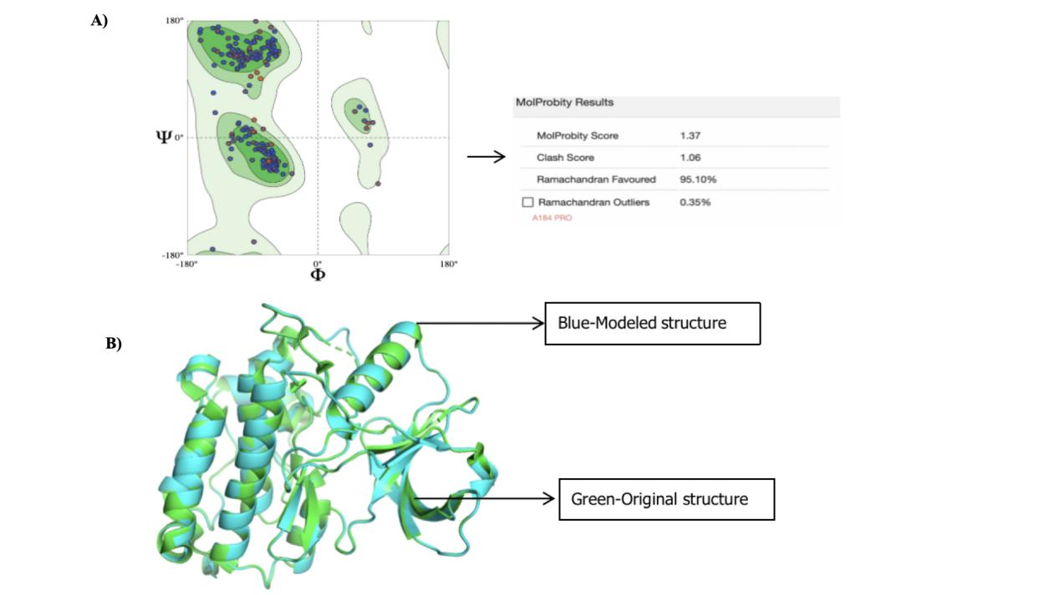

Figure S3. The boxplots of different expression datasets were analyzed. A) GSE3744 B) GSE20711 C) GSE5364 D) GSE10780 E) GSE15852 F) GSE17907

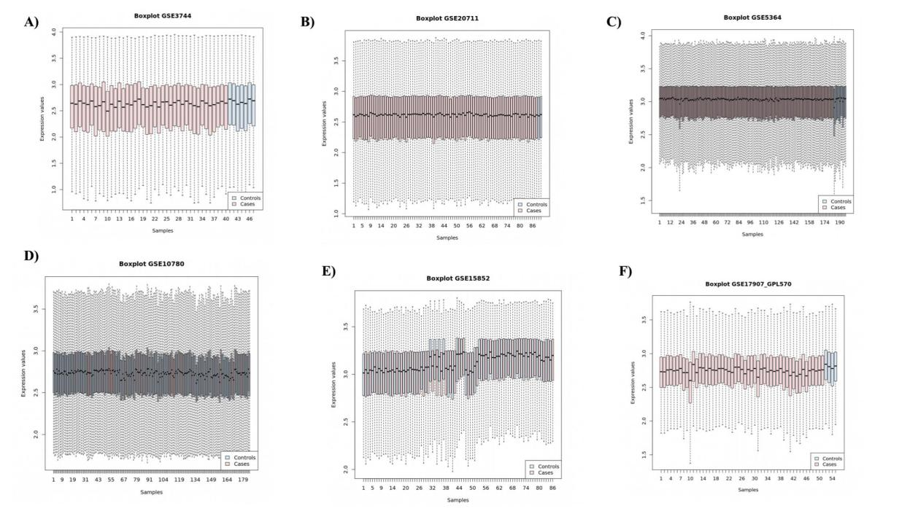

Figure S4. The boxplots different expression datasets and respective data quality were analyzed. A) GSE42568 B) GSE36295 C) GSE37751.
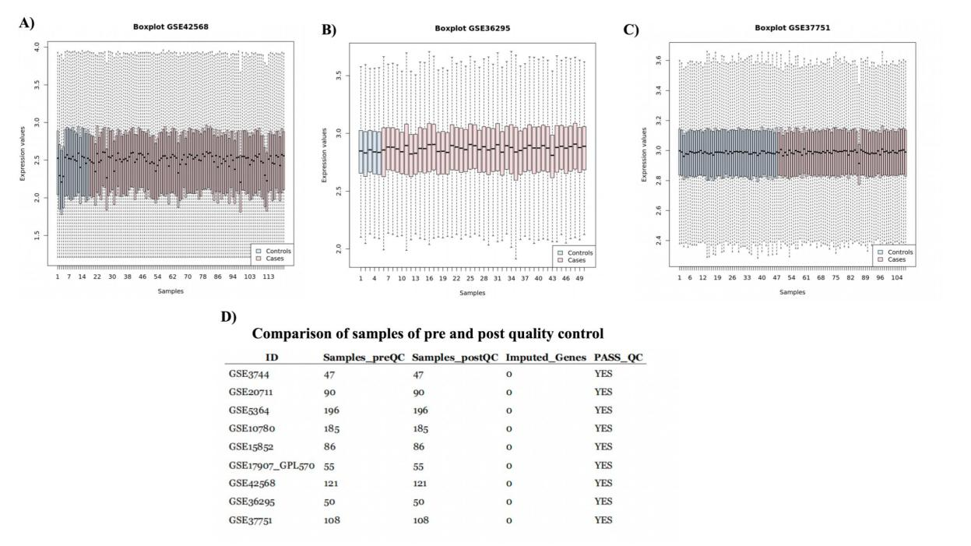

Figure S5. Validation on top five hub genes. The expression boxplot of all cancer expression and survival plot in five hub genes. A) MYC B) EGFR C) CDKN2A D) ERBB2 (HER2) E) CDK1.

Figure S6. The structural effects of wild-type (HER2-WT) and mutant-type (HER2-L755S) were examined over 1000 ns (triplicates). Color Scheme is as follows: Run1-black, Run2-yellow, and Run3-brown. A) Time plot of RMSD values for HER2-WT backbone atoms, with the X-axis representing time in ns and the Y-axis representing RMSD in nm. B) Boxplot showing the RMSD values; the X-axis denotes model types, and the Y-axis denotes RMSD values. C) Time plot of RMSD values for HER2-MT backbone atoms, with the X-axis representing time in ns and the Y-axis representing RMSD in nm. D) Boxplot showing the RMSD values; the X-axis denotes model types, and the Y-axis denotes RMSD values
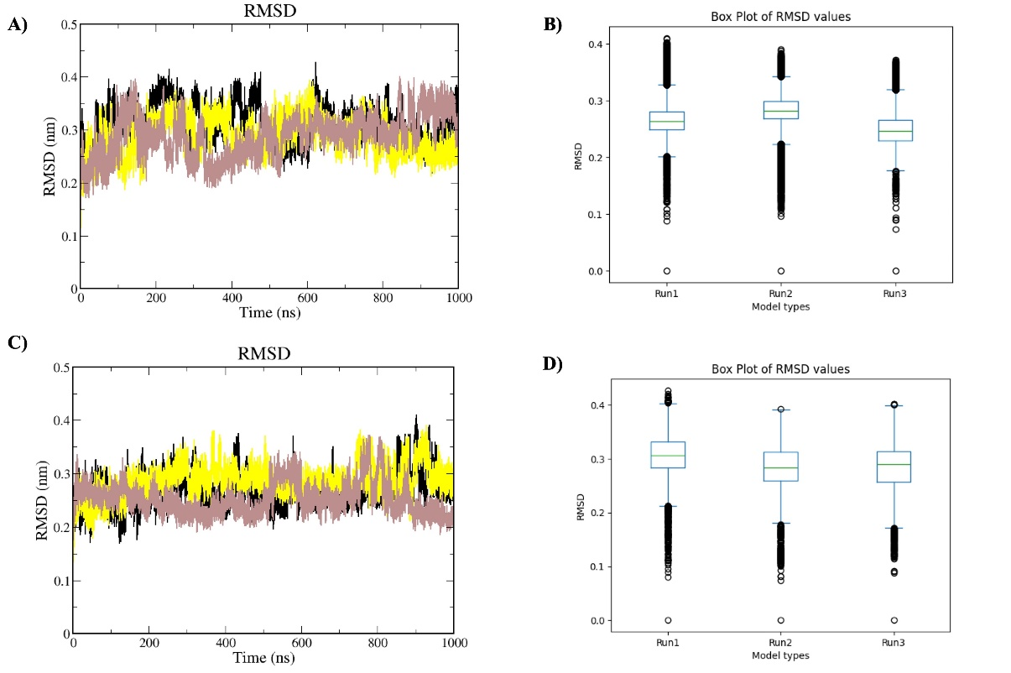

Figure S7. The structural effects of various complexes were analyzed over 1000 ns (triplicates). Color Scheme is as follows: Run1-black, Run2-yellow, and Run3-brown. A) Time plot of RMSD values for HER2-afatinib backbone atoms, with the X-axis representing time in ns and the Y-axis representing RMSD in nm. B) Boxplot showing the RMSD values; the X-axis denotes model types, and the Y-axis denotes RMSD values. C) Time plot of RMSD values for HER2-ibrutinib backbone atoms, with the X-axis representing time in ns and the Y-axis representing RMSD in nm. D) Boxplot showing the RMSD values; the X-axis denotes model types, and the Y-axis denotes RMSD values.
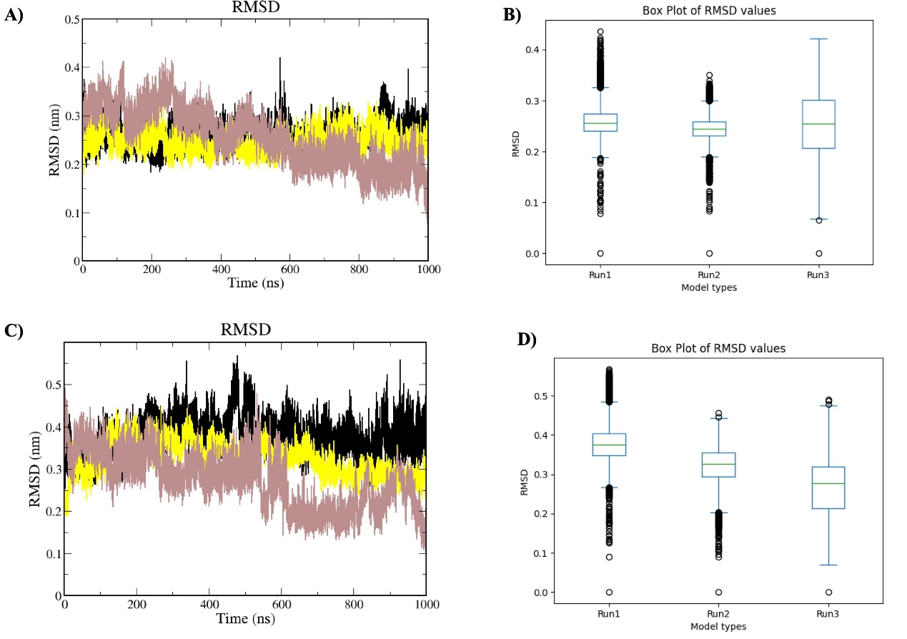

Figure S8. The structural effects of various complexes were analyzed over 1000 ns (triplicates). Color Scheme is as follows: Run1-black, Run2-yellow, and Run3-brown. A) Time plot of RMSD values for HER2-lapatinib backbone atoms, with the X-axis representing time in ns and the Y-axis representing RMSD in nm. B) Boxplot showing the RMSD values; the X-axis denotes model types, and the Y-axis denotes RMSD values. C) Time plot of RMSD values for HER2-neratinib backbone atoms, with the X-axis representing time in ns and the Y-axis representing RMSD in nm. D) Boxplot showing the RMSD values; the X-axis denotes model types, and the Y-axis denotes RMSD values.
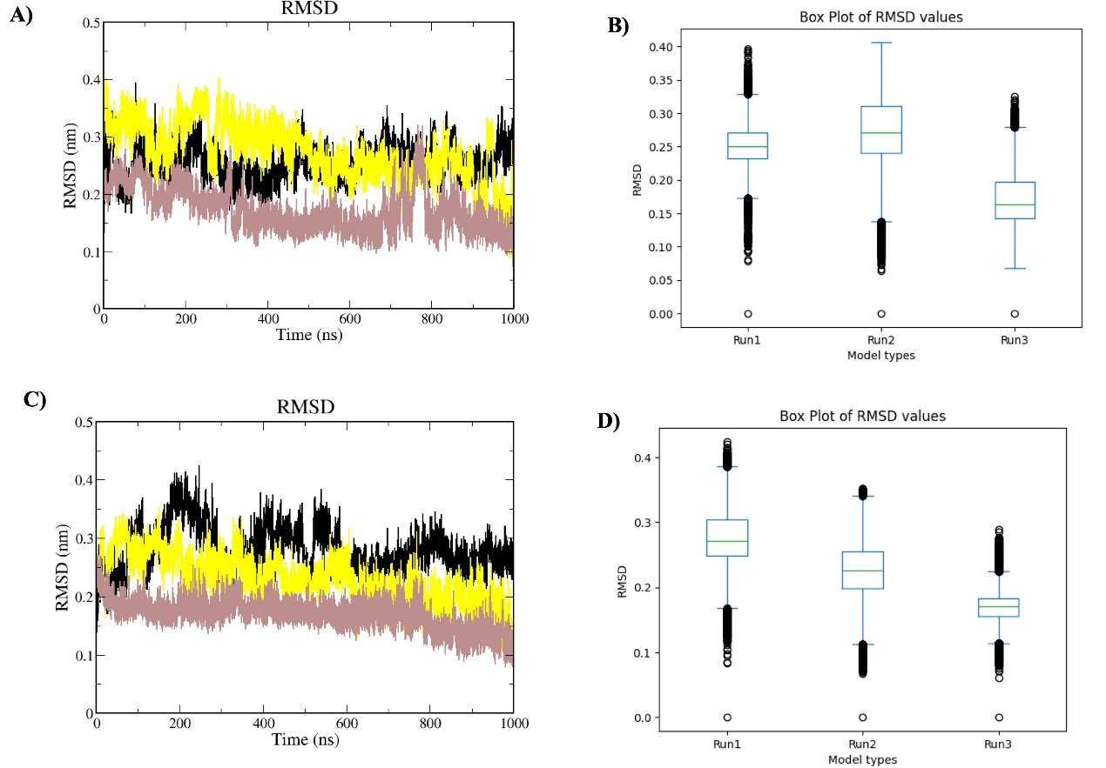

Figure S9. Molecular Dynamics simulations (structural parameters) were used to analyze the protein-ligand complexes over 1000 ns. Color Scheme is as follows: HER2-L755S-afatinib-black, HER2-L755S-ibrutinib-yellow, HER2-L755S-lapatinib-magenta, and HER2-L755S-neratinib-brown. A) RMSF plot, with the X-axis representing time in ns and the Y-axis representing RMSF in nm. B) Boxplot showing the RMSF values; the X-axis denotes ligand types, and the Y-axis denotes RMSF values. C) Rg plot, with the X-axis representing time in ps and the Y-axis representing Rg in nm. D) SASA plot, with the X-axis representing time in ns and the Y-axis representing SASA in nm².
