# SUPPLEMENTARY INFORMATION

# Characterization of the fate of primary and re-precipitated silver nanoparticles in lake water microcosms

Sarayu Rao1, Xiaoyu Gao1,2, Subhasis Ghoshal1,\*

1: Department of Civil Engineering, McGill University, Montreal, Quebec H3A 0C3, Canada

2: Department of Environmental Science, Baylor University, Waco, Texas 76798, USA

This Supplementary Information consists of the following figures and text:

* spICP-MS conditions
* Mass balances of silver
* Lake water analysis
* All Supplementary Figures (13) and Tables (2)

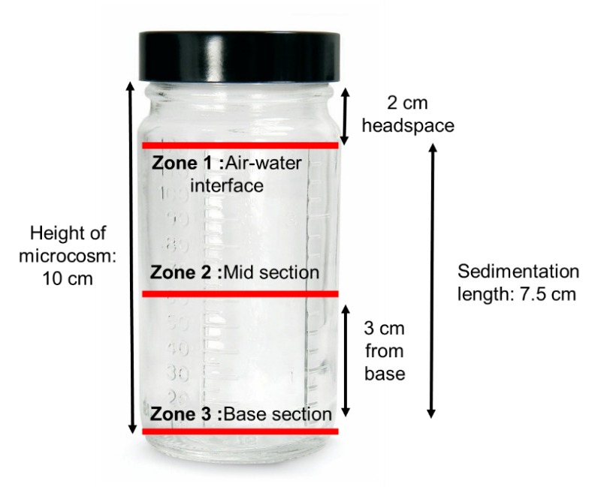

**Figure S1:** Fate experiment microcosm set-up

## spICP-MS Conditions

The integration dwell time of 100 μs was used throughout all experiments. Sampling time was set to 100 s and a wash time of 90 s between samples. Duplicate samples were collected at every time point, and each sample was measured three times. Transport efficiency was calculated using 57.1 nm ultra-uniform nAu stabilized with PEG-COOH (nanoComposix) with a mass concentration of 170 ng/L. Transport efficiency values were between 6 and 8% for all time points measured. Silver calibration curve was made using dissolved silver standards (SCP Science) between 10 ng/L and 1000 ng/L in 1% ICP grade nitric acid.

**Table S1:** Instrument operating parameters of NexION 300X spICP-MS

**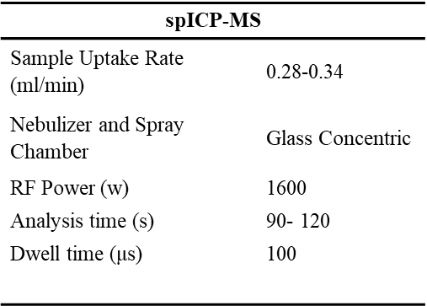**

## Mass balances of Silver

Mass balances of nAg were done using a method previously established in our lab(Azodi, Sultan et al. 2016). The total mass measured using spICP-MS (sum of dissolved and particle mass) should compare with total acid digested silver in the same sample at the same time point. A method was developed by spiking nAg in LW, FLW and DI water and measured total mass in single particle mode as well as total metals analysis by digesting nAg with 67% ICP grade nitric acid on a hot-block for 60 minutes at 900C. Samples from mixed filtered LW systems at different time points were also analysed for mass balances.

**Figure S2**: Silver mass balance (Time: mixed systems in FLW) digested versus spICP-MS

We observed lower masses in spICP-MS, this may be because of adsorption of nAg particles to centrifuge tubes or tubing in the instrument. All samples were vortexed between measurements.

It should be noted that the 75%-90% total Ag recovery from digestion data suggests that ~10%-25% Ag could be lost due to sorption to the flasks used in this study.

## Lake water Analysis:

Lac Hertel has an area of 0.3 km2 with maximum depth of 9 m. The lake is fed by at least three permanent streams and drained by only one. All anthropogenic activities like bathing, fishing, and swimming are forbidden and there is no agricultural or urban runoff that enters the lake. We determined the elemental composition of the filtrate of ultrafiltered (3 kDa, Millipore) lake water (which should only consist of dissolved ions that pass through the filter). Our results indicated the presence of Cu, Zn, Al, Si in the dissolved form. The exact elemental composition is reported in Table S2.

**Table S2:** Characteristics of lake water used in study (n =3 for anions and cations)

|  |  |  |  |  |  |
| --- | --- | --- | --- | --- | --- |
| **Characteristics of lake water from Mont-Saint-Hilaire** | | | | | |
| pH | 7.5 | Calcium, mg/L | 9.44 ± 0.06 | Iron, mg/L | 0.0015 ± 0.001 |
| Conductivity , μs/cm | 93.4 | Magnesium, mg/L | 1.20 ± 0.01 | Fluoride, mg/L | 0.18 ± 0.01 |
| TSS, mg/L | 2.7 | Potassium, mg/L | 0.056 ± 0.001 | Chloride, mg/L | 1.07 ± 0.06 |
| DOC, mg/L (n=6) | 3.5 ± 0.1 | Zinc, mg/L | 0.0 | Nitrate, mg/L | 1.12 ± 0.04 |
| Zeta potential of LW colloids, mV (n=3) | -17.7± 1.9 | Sodium, mg/L | 1.89 ± 0.02 | Sulfate, mg/L | 5.52 ± 0.27 |
| DO, mg/L | 10.4 | Silicon, mg/L | 1.45 ± 0.01 | Total Sulfur, mg/L | 2.68 ± 0.21 |

Colloidal size analysis of lake water was performed by concentrating lake water colloids by centrifugation at 4500g for 30 minutes and measured using Horiba Laser Scattering Particle Size Analyzer, all samples were sonicated before analysis (Figure S2).

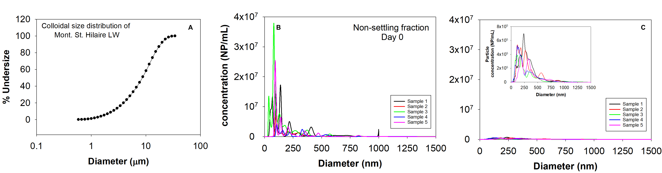

**Figure S3:** (A) Colloidal size distribution of lake water measured using laser light scattering. Size distribution of natural colloids obtained using NTA on (B) Day 0 (C) ~ 6 months

The lake water was also characterized for pH, conductivity, zeta potential, total suspended solids, total ions (anion and cation analysis), dissolved organic carbon and size distribution of colloids. For FLW, lake water was centrifuged at 4500g for 30 min and the supernatant was collected. The supernatant was filtered through 0.1 μm (cellulose acetate membrane) filter and stored at 4 oC until further use.

**Zeta Potential:** The zeta potential and conductivity were determined using DLS (ZetaSizer Nano ZS, Malvern). . PVP-nAg in UFLW had a negative zeta potential of (- 14.3 ± 0.6 mV). There was a decrease in the negative zeta potential of nAg in FLW (-11.5 ± 0.9 mV).

**Total suspended solids:** Whatman™ 934-AH™ Glass Microfiber filters were carefully placed in aluminum weigh boats and dried overnight in an over at 1050C. Total weight of filter plus boat were noted before filtering 100 mL of lake water through vaccum filtration. Filters with solids were dried for 24 hours at 1050C and weighed. TSS was calculated as follows:

$$\frac{Final weight-Initial weight (mg)}{Volume (L)}$$

**Dissolved organic carbon (DOC):** Lake water samples were filtered through 0.45 micron PTFE syringe filters and analysed for DOC using TOC analyser.

**Elemental analysis:** Total metal ions were determined using ICP-OES (Perkin Elmer Optima 8300) by digesting lake water in aqua regia (HNO3:HCl, 1:3) on a hot block (Perkin Elmer) at 900 C for 45 min. Water was added to these samples to reduce the acid content to <5% and measured using ICP-OES. IC analysis (ICS-5000 ThermoFisher) was done with a Dionex IonPac AS18-4 µm, 2×150 mm , mobile phase 32 mM KOH and flow rate: 0.25 mL/min. The suppressor was Dionex ERS 500 Suppressor (2 mm) and a conductivity detector was used.

Colloidal size analysis of lake water was performed by concentrating natural lake water colloids by centrifugation at 4500g for 30 minutes and measured using Horiba Laser Scattering Particle Size Analyzer.

C:\Users\srao16\Google Drive\RESEARCH\ALL DATA\TEM\2018-03-12\Ag80PVP_1ppm\17.tif

**Figure S4:** TEM image of pristine nAg-PVP 80 nm

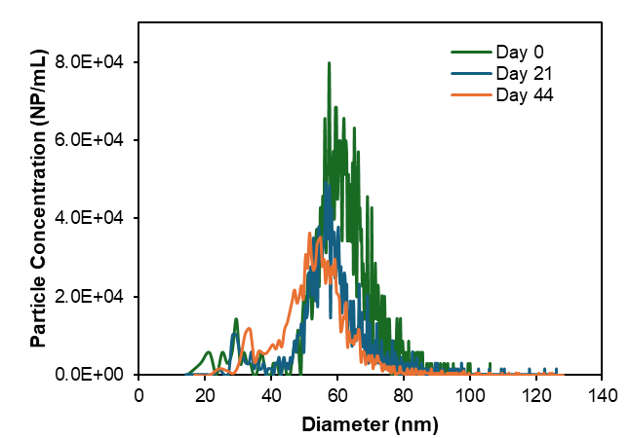

**Figure S5:** Particle size distribution of nAg in DI water on day 0, day 21 and day 44 under quiescent conditions

**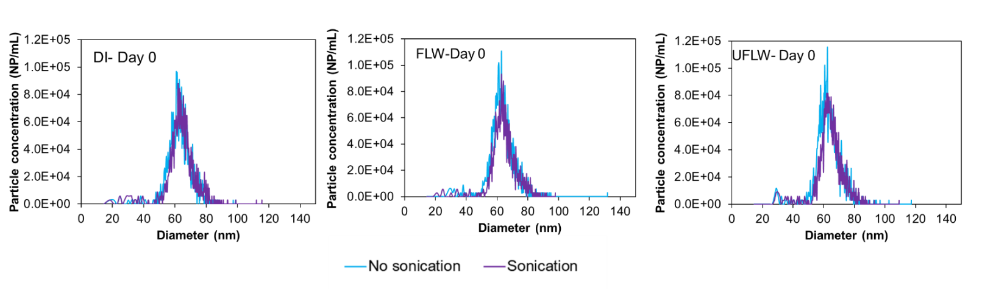**

**Figure S6:** Effect of sonication on spiked nAg in DI, FLW and UFLW systems

**Figure S7:** (A) Frequency of precipitated nAg on Day 0 spiked with 10 μg/L Ag+. TEM size distribution of precipitated nAg from spiked Ag+ ions in (B) UFLW and FLW. Diameter of naturally formed nAg in (C) Quiescent (D) Mixed. (E)TEM image of nAg cluster in DOM in FLW from spiking with 1000 μg/L Ag+. (F) TEM image of precipitated nAg in FLW from spiking with 1000 μg/L Ag+. TEM images of precipitated nAg from spiking with 1000 μg/L Ag+ in (G) UFLW (H) EDS of precipitated nAg in UFLW

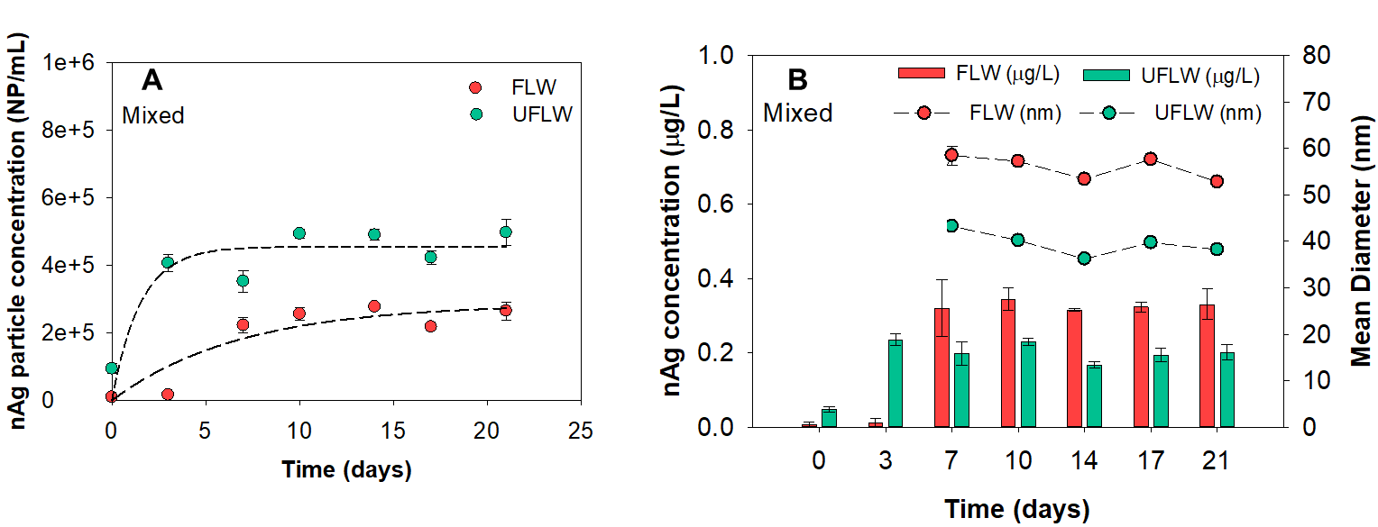

**Figure S8:** (A) Change in nAg particle concentration due to reformation from 10 μg/L spiked Ag+. Dashed line represents non-linear regression of experimental data (UFLW: 0.66 day-1, FLW: 0.15 day-1) (B) Change in mean diameters and mass concentration of re-precipitated nAg over time.

**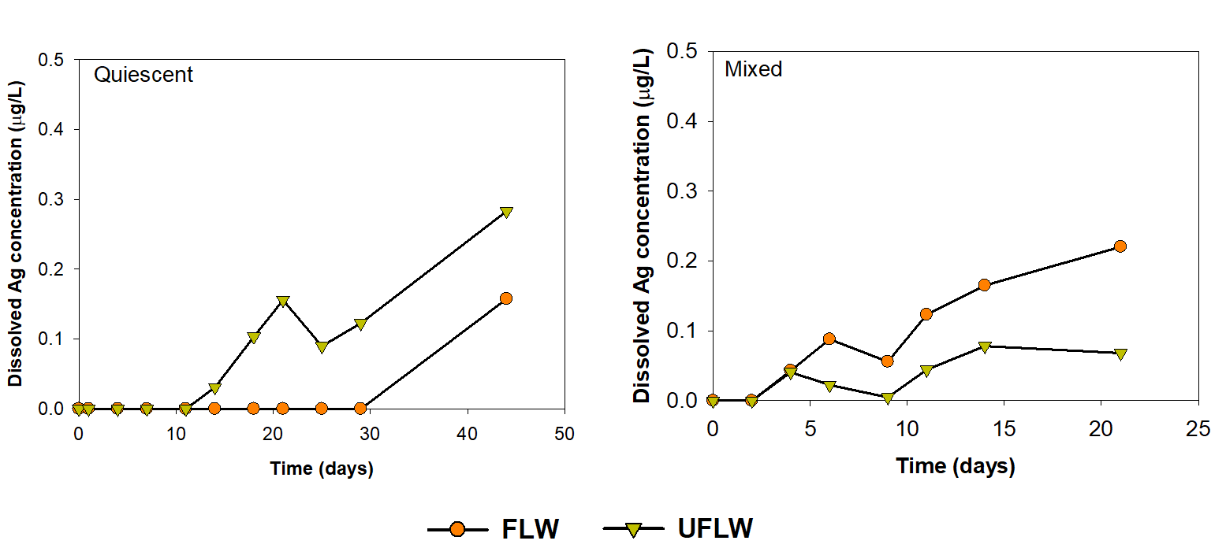**

**Figure S9:** Dissolved silver concentrations in filtered LW and LW systems over time under both quiescent and mixed conditions.

**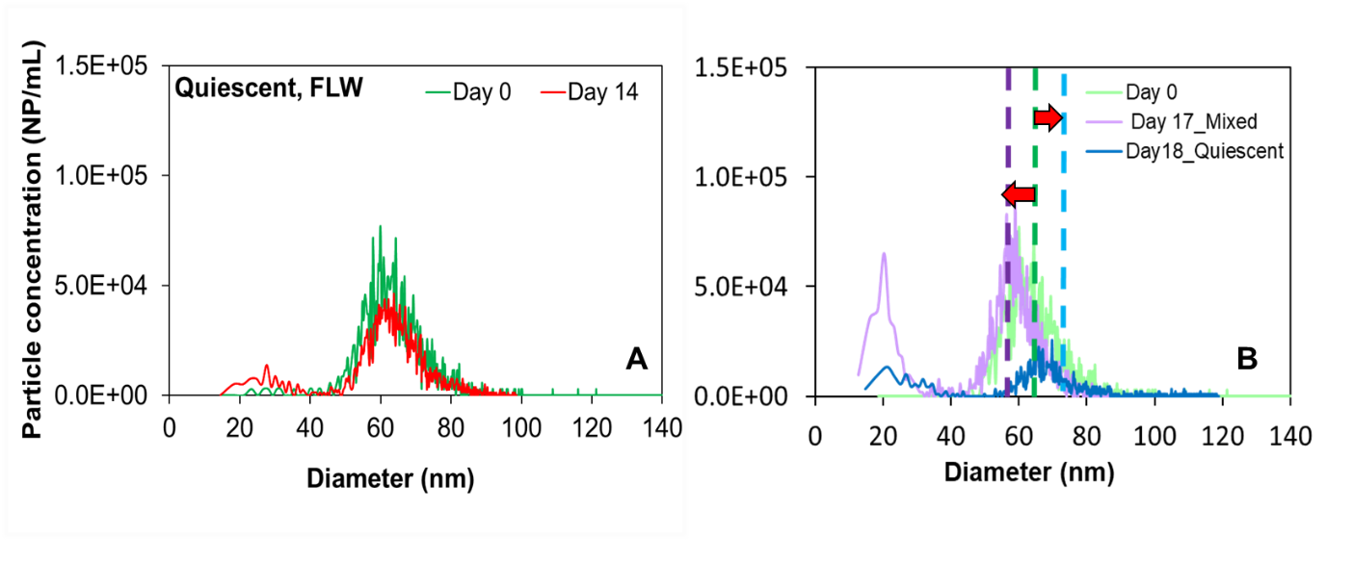**

**Figure S10: (**A) Particle size distribution of nAg in suspension on day 0 and day 14 (B) Particle size distributions of nAg in FLW under mixed and quiescent conditions.

****

**Figure S11:** Mass concentration of nAg in suspension over time due to homoagglomeration induced sedimentation of nAg in FLW under quiescent conditions.

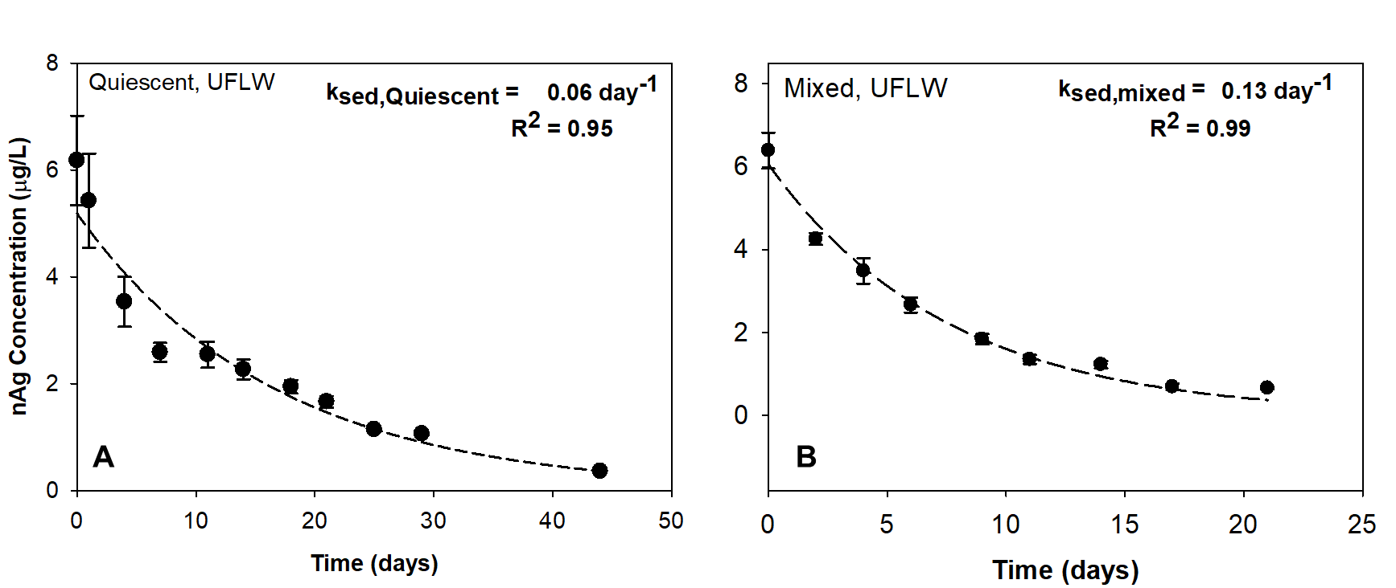

**Figure S12:** Decrease in nAg mass concentration in the water column over time in UFLW systems

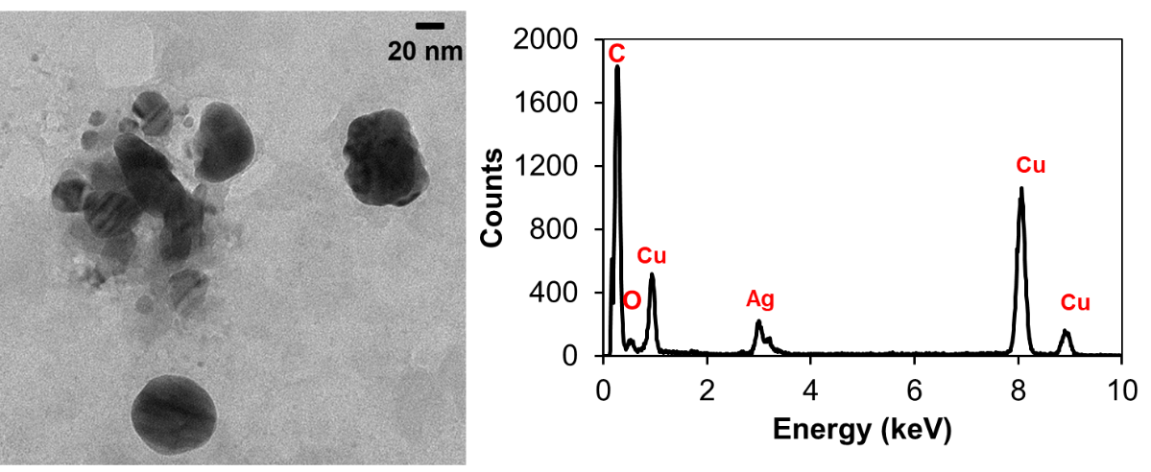

**Figure S13:** TEM image of nAg in FLW and EDS of the imaged area



**Figure S14:** Experimental replicates of 80 nm PVP-nAg spiked in UFLW at 6 µg/L

**REFERENCES**

1. Azodi, M., et al. (2016). "Dissolution Behavior of Silver Nanoparticles and Formation of Secondary Silver Nanoparticles in Municipal Wastewater by Single-Particle ICP-MS." Environmental Science & Technology 50(24): 13318-13327.

2. Goswami, S. R. (1962). Hydrologic regime of Lake Hertel, Mont St. Hilaire, P. Q. Department of Engineering., McGill University. Department of Civil Engineering.

3. Low-Décarie, E., et al. (2016). "Communities that thrive in extreme conditions captured from a freshwater lake." Biology letters 12(9): 20160562.