**Supplementary Materials**

**Appendix I**

**List of Sources for Empires**

1. **Empire Start Year**

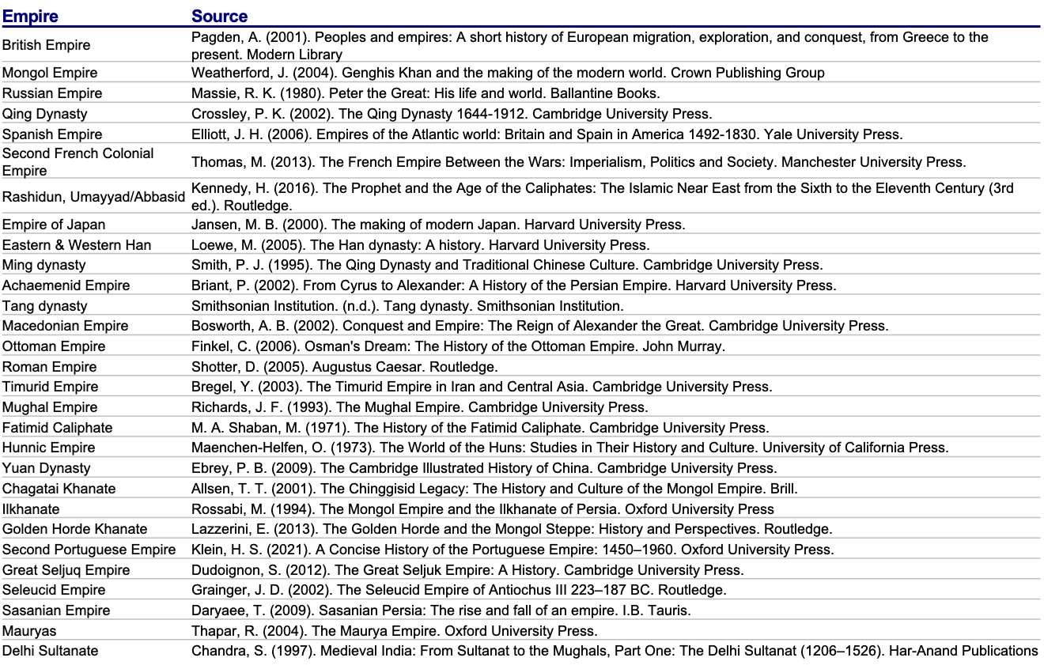

1. **Empire End Year**

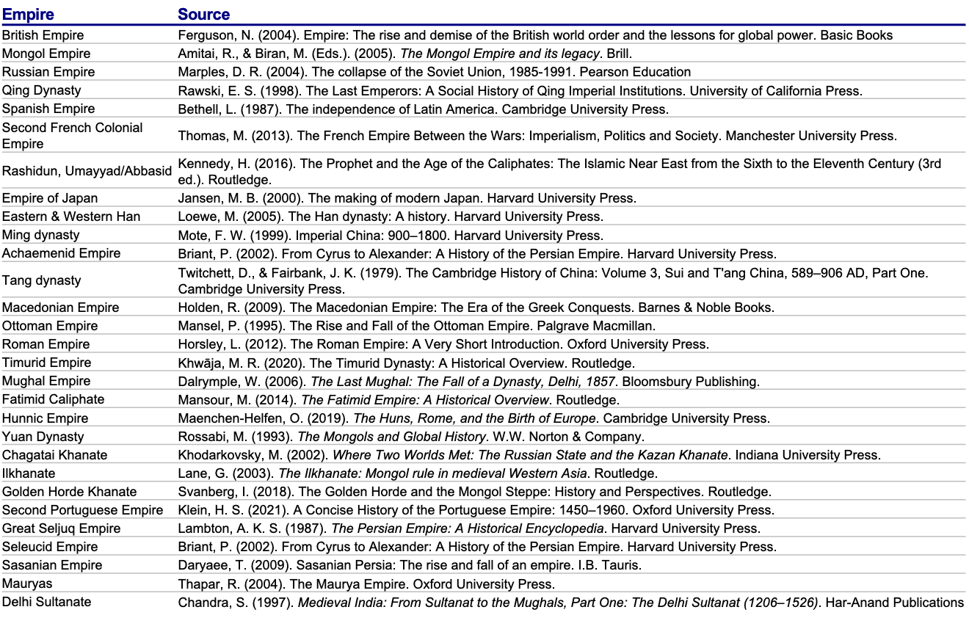

Note: Sensitivity Analysis was conducted on the Spanish Empire specifically for 1898 as the end year, briefly described in the Results section.

1. **Empire Peak Year**

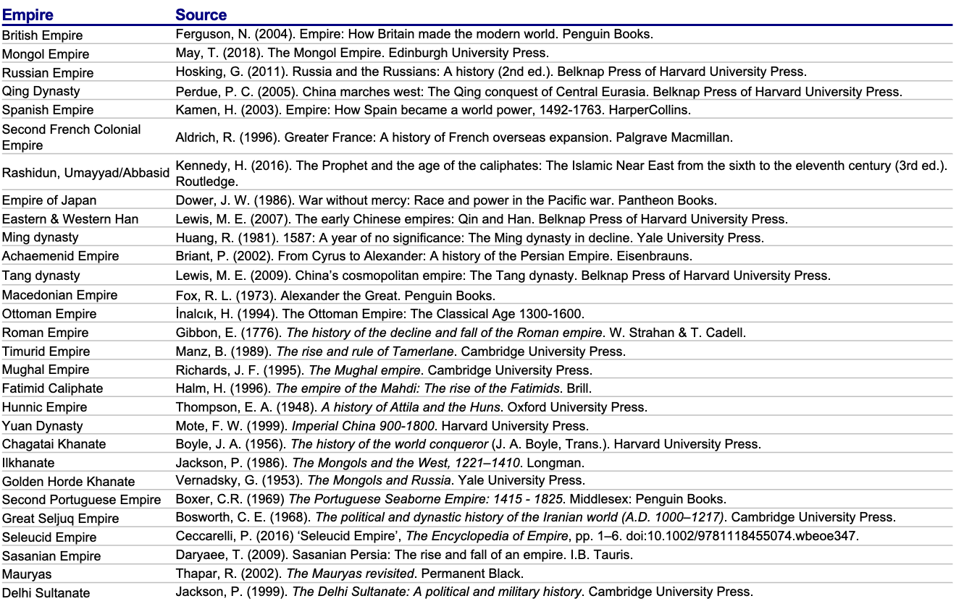

1. **Empire Peak Land Area (In Million Sq. Miles)**

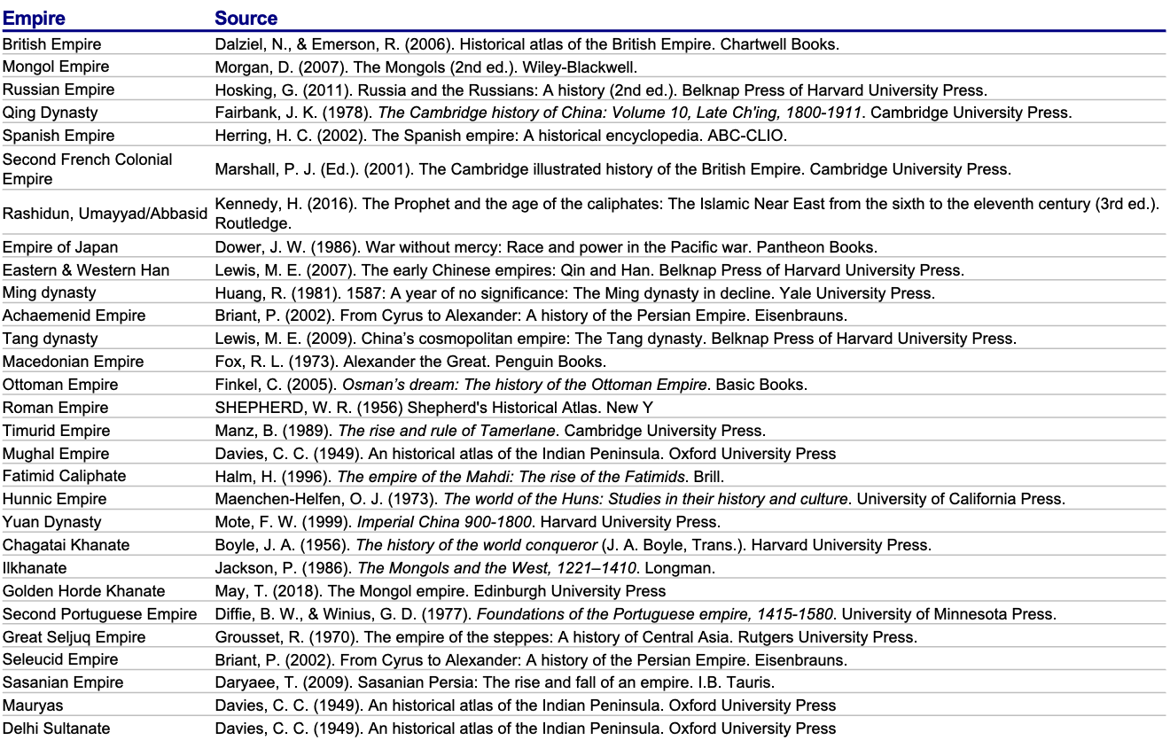

**Appendix II**

**Results of Analysis**

*1. Pattern of Power Life Cycle*

The results of the polynomial trendline analysis support the hypothesis that empires follow a predictable cycle of rise, peak, and decline. The key factors considered to build the trendline for US power projection are as follows

**Average Empire Duration**: The analysis shows that the average duration of the 29 studied empires is approximately 240 years.

**Time to Peak**: On average, empires peak in the middle of the period of their empire lifecycle to control their total landmass or power during their lifecycle.

Based on the historical model, the U.S. is estimated to be in a plateau phase, with potential signs of entering a decline depending on how internal and external pressures are managed.

#### 2. Projection of US Power

Using the historical trajectories of other empires, the study models three potential scenarios for the U.S. trajectory. The study has taken the starting point of U.S. global power in 1898, following the Spanish-American War, where the U.S. emerged as a colonial power and its peak post-World War II, when the U.S. controlled approximately 40% of the global GDP. A turning point in U.S. power occurred in 2001 after the events of 9/11, marking a shift in America's perception of its global role, though not immediately affecting its GDP.

**The Fall:** To estimate the decline of U.S. power, the study considered the decline periods of the 6 largest empires, as well as the 29 largest modern industrial-age empires. These comparisons provide a range for the U.S.'s potential future trajectory.

**GDP at End Year:** The U.S. GDP at the estimated "end year" of the decline is projected to return to around 15% of global GDP—roughly the same share it held in 1898.

The fall of the different set of empires have been considered to get an estimate of the date of fall of the US’ power trajectory

* 1. **Scenario 1 (Modern Industrial Age Empires):** Based on the average rise and fall trajectory of the Modern Industrial Age Empires, the U.S. could reach its end by 2032

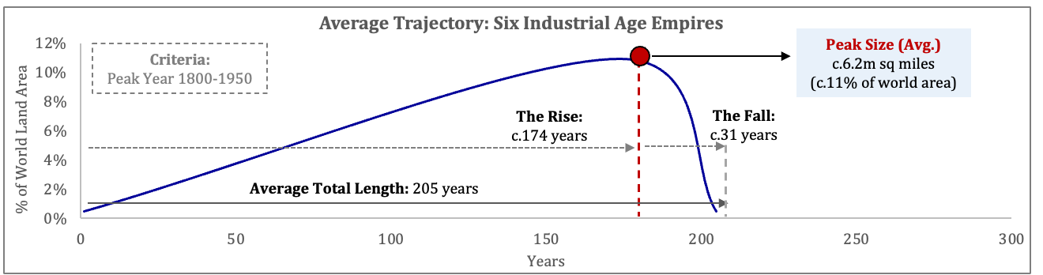

**Trajectory: Average of Six Industrial Age Empires; US Power ‘Ends’: 2032**

% of World GDP

* 1. **Scenario 2 (Largest Empires):** Based on the average rise and fall trajectory of the six Largest Empires, U.S. global dominance might last until 2067

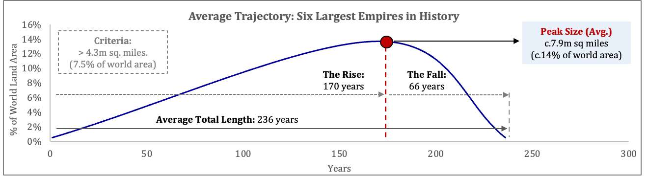

**Trajectory: Average of Six Largest Empires; US Power ‘Ends’: 2067**

% of World GDP

* 1. **Scenario 3 (Average of All Empires):** Using the overall average of all 29 empires, U.S. power might extend until 2122, suggesting a long and gradual decline

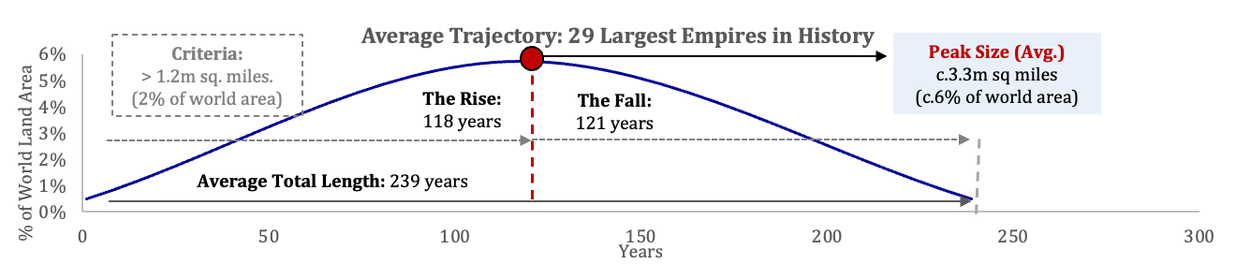

% of World GDP

**References**

Achs, J., Lafortune, G., & Fuller, G. (2024). The SDGs and the UN Summit of the Future. Sustainable Development Report 2024. Dublin University Press. <https://s3.amazonaws.com/sustainabledevelopment.report/2024/sustainable-development-report-2024.pdf>.

Afrobarometer. (2021). *Africans Welcome China’s Influence but Maintain Democratic Aspirations (Dispatch No. 489).* By J. Appiah-Nyamekye Sanny and E. Selormey, November 15, 2021. <https://www.afrobarometer.org/wp-content/uploads/2022/02/ad489-pap3-africans_welcome_chinas_influence_maintain_democratic_aspirations-afrobarometer_dispatch-15nov21.pdf>.

Ahuja, R. (2008). *Pathways of empire: Circulation, "public works" and social space in colonial Orissa (c. 1780–1914)*. Orient Longman Private Limited. ISBN 978-81-250-3527-5.

Akande, A., & Kellner, D. (2023). Donald Trump, populism, and the struggle to save democracy. In A. Akande (Ed.), *U.S. democracy in danger*. *Springer Studies on Populism, Identity Politics and Social Justice*. Springer, Cham. <https://doi.org/10.1007/978-3-031-36099-2_1>.

Akram, S., & Akbar, M. (2023). US withdrawal from Afghanistan: emerging challenges and future prospects. *Glob. Foreign Policies Rev*, *6*, 97-111.

Aldrich, R. (1996). *Greater France: A History of French Overseas Expansion.* Palgrave Macmillan.

Alliance of Democracies Foundation, & Latana. (2024). *Democracy Perception Index 2024*. Alliance of Democracies. <https://allianceofdemocracies.org/democracy-perception-index>

Allison, G. (2015, September 24). The Thucydides trap: Are the US and China headed for war? *The Atlantic.* <https://www.theatlantic.com/international/archive/2015/09/united-states-china-war-thucydides-trap/406756/>.

Altbach, P. G. (2004). Globalization and the university: Myths and realities in an unequal world. Tertiary Education and Management, 10(1), 3–25. https://doi.org/10.1080/13583883.2004.9967114

Anna, T. E. (1983). *Spain and the loss of America*. University of Nebraska Press. ISBN 978-0803210141.

Aron, R. (1966). *Peace and war: A theory of international relations* (R. Howard & A. B. Fox, Trans.). Doubleday & Company. (Original work published 1962)

Bacevich A. (2021). *After the Apocalypse: America's Role in a World Transformed.* Metropolitan Books.  [ISBN](https://en.wikipedia.org/wiki/ISBN_(identifier)) [978-1-2507-9599-1](https://en.wikipedia.org/wiki/Special:BookSources/978-1-2507-9599-1).

Bajpaee, C. (2024, April). *How India’s democracy shapes its global role and relations with the West.* Chatham House. <https://www.chathamhouse.org/sites/default/files/2024-04/2024-04-15-how-indias-democracy-shapes-its-global-role-and-relations-west-bajpaee.pdf>.

Balfour, S. (1997). 'Prologue', *The End of the Spanish Empire, 1898–1923* (Oxford, 1997; online edn, Oxford Academic, 3 Oct. 2011), <https://doi.org/10.1093/acprof:oso/9780198205074.003.0001>, accessed 8 Dec. 2024.

Ballard-Rosa, C., Jensen, A., & Scheve, K. (2021). Economic Decline, Social Identity, and Authoritarian Values in the United States. *International Studies Quarterly*, 65(3), 743–757. <https://doi.org/10.1093/isq/sqab027>

Bar-Yam, Y. (2002). Complexity rising: From human beings to human civilization, a complexity profile. In *Encyclopedia of Life Support Systems* (United Nations, Oxford, UK); also NECSI Report 1997-12-01 (December 1997). Retrieved from <https://www.researchgate.net/publication/250082400_Complexity_Rising_From_Human_Beings_to_Human_Civilization_a_Complexity_Profile>.

Barkey, K. (2008). Empire of difference: The Ottomans in comparative perspective. Cambridge University Press.

Barnett, T. P. (2021). The rise of the liberal world order. War Room. *U.S. Army War College.* <https://warroom.armywarcollege.edu/articles/liberal-world-order/the-rise-of-the-liberal-world-order>.

Barnett, M., & Duvall, R. (2005). Power in international politics. *International Organization, 59*(1), 39–75. <https://doi.org/10.1017/S0020818305050010>

Bello, W. (2024). Overextension and Globalization: The Dynamics of Hegemonic Decline. *Critical Sociology, 0(0).* <https://doi.org/10.1177/08969205241266982>.

Body-Gendrot, S. (2012). *The turning point of 9/11. In Globalization, fear and insecurity: Transnational crime, crime control and security* (pp. 36–47). Palgrave Macmillan.

Burbank, J., & Cooper, F. (2010). *Empires in world history: Power and the politics of difference.* Princeton University Press.

Brands, H., & Feaver, P. (2017). Was the Rise of ISIS Inevitable? *Survival*, *59*(3), 7–54. <https://doi.org/10.1080/00396338.2017.1325595>.

Brattberg, E., & Rome, N. (2018, November 28). The limitations of the U.S. approach to Brexit. *Carnegie Endowment for International Peace*. <https://carnegieendowment.org/2018/11/28/limitations-of-u.s.-approach-to-brexit-pub-77803>

Breslin, S. (2023). China and global governance. In R. Xiao (Ed.), International organization and global governance (3rd ed.). *Routledge.* <https://doi.org/10.4324/9781003266365>

Briant, P. (2002). *From Cyrus to Alexander: A history of the Persian Empire* (P. T. Daniels, Trans.). Eisenbrauns.

Brooks, S. G., & Wohlforth, W. C. (2023). The myth of multipolarity: American power's staying power. *Foreign Affairs,* 102(3), 76-91.

Brown, M. (2006). "Not Forging Nations but Foraging for Them: Uncertain Collective Identities in Gran Colombia." *Nations and Nationalism*, vol. 12, no. 2, 2006, pp. 223–240. <https://doi.org/10.1111/j.1469-8129.2006.00238.x>.

Brzezinski, Z. (1997). *The grand chessboard: American primacy and its geostrategic imperatives*. Basic Books.

Bunyavejchewin, P., Thavornyutikarn, S., Faugchun, P., & Kamonpetch, P. (2024). Measuring the concentration of military power in the international geopolitical system: Singer’s methodology using only military indicators. *Frontiers in Political Science, 6,* 1412260. <https://doi.org/10.3389/fpos.2024.1412260>.

Cato Institute. (2021, October 4). 750 bases in 80 countries is too many for any nation: Time for the US to bring its troops home. <https://www.cato.org/commentary/750-bases-80-countries-too-many-any-nation-time-us-bring-its-troops-home>.

Centre for Economics and Business Research (CEBR). (2024, August 15). China's economic future: Forecasts and implications. *Centre for Economics and Business Research.* <https://cebr.com/reports/we-forecast-that-china-will-be-the-worlds-largest-economy-for-only-21-years-before-the-us-overtakes-again-in-2057-and-by-2081-india-will-have-overtaken-the-us-how-does-this-affect-geopoliti/>.

Centre for Economic Policy Research (CEPR). (2023, October 30). Reassessing the fall in US public debt after World War II. By J. Acalin & L. Ball. *VoxEU*. <https://cepr.org/voxeu/columns/reassessing-fall-us-public-debt-after-world-war-ii>.

Center for Strategic and International Studies (CSIS). (2024, November 18). How Trump sees allies and partners. *CSIS*. <https://www.csis.org/analysis/how-trump-sees-allies-and-partners>.

Chan, S., Feng, H., He, K., & Hu, W. (2021). *Contesting revisionism: China, the United States, and the transformation of international order.* Oxford University Press.

Chancel, L., Piketty, T., Saez, E., Zucman, G., & Bauluz, L. (2022). World inequality report 2022. *World Inequality Lab.* <https://wir2022.wid.world>.

Chase-Dunn, C., Álvarez, A., & Pasciuti, D. (2005). Power and size: Urbanization and empire formation in world-systems since the Bronze Age. In C. Chase-Dunn & E. N. Anderson (Eds.), *The historical evolution of world-systems*. Palgrave Macmillan. <https://doi.org/10.1057/9781403980526_5>.

Chin, W. (2019). Technology, war and the state: Past, present and future. International Affairs, 95(4), 765–783. <https://doi.org/10.1093/ia/iiz106>.

Chivvis, C. S. (2011). Emerging powers and the international system. *Carnegie Endowment for International Peace*. <https://carnegie-production-assets.s3.amazonaws.com/static/files/Chivvis_Emerging-Powers_11-1.pdf>.

Chow, D. C. (2010). China's response to the global financial crisis: Implications for U.S.-China economic relations. *Global Business Law Review, 1*(1), 47–65.

Chrimes, T., Gootjes, B., Kose, M. A., & Wheeler, C. (2024). The great reversal: Prospects, risks, and policies in International Development Association (IDA) countries. *World Bank.* <https://doi.org/10.1596/978-1-4648-2145-5>.

Clarke, M., & Ricketts, A. (2017). Donald Trump and American foreign policy: The return of the Jacksonian tradition. *The International Journal of Human Rights,* 21(3), 366-379; <https://doi.org/10.1080/01495933.2017.1361210>.

Climate Action Tracker (November 2024). Warming Projections Global Update. <https://climateactiontracker.org/documents/1277/CAT_2024-11-14_GlobalUpdate_COP29.pdf>.

Collyns, C. (2008). The crisis through the lens of history. *Finance & Development, 45*(4). International Monetary Fund. <https://www.imf.org/external/pubs/ft/fandd/2008/12/collyns.htm>.

Congressional Budget Office (September 2022). Estimated Budgetary Effects of Public Law 117-169, to Provide for Reconciliation Pursuant to Title II of S. Con. Res. 14. <https://www.cbo.gov/publication/58455>.

Congressional Research Service (CRS). (2019, August 7). *U.S. overseas diplomatic presence: Background and issues for Congress.* Congressional Research Service. Retrieved December 11, 2024, from <https://crsreports.congress.gov/product/pdf/IF/IF11242/4?utm_source=chatgpt.com>.

Conteduca, F. P., Mancini, M., & Borin, A. (2025, May 6). *Roaring tariffs: The global impact of the 2025 US trade war.* CEPR’s VoxEU. <https://cepr.org/voxeu/columns/roaring-tariffs-global-impact-2025-us-trade-war>

Courtois, S., Werth, N., Panne, J.-L., Bartoloni, J.-L., & Margolin, C. (1999). The black book of communism: Crimes, terror, repression. *Harvard University Press.*

Cox, R. W. (1987). Production, power, and world order: Social forces in the making of history. Columbia University Press.

Cox, M. (2023, September 15). Tipped power balance: China’s peak and the U.S. resilience. *Council on Foreign Relations.* <https://www.cfr.org/blog/tipped-power-balance-chinas-peak-and-us-resilience>.

Crippa, M., Guizzardi, D., Pagani, F., Banja, M., Muntean, M., Schaaf, E., Becker, W., Monforti-Ferrario, F., Quadrelli, R., Risquez Martin, A., Taghavi-Moharamli, P., Köykkä, J., Grassi, G., Rossi, S., Brandao De Melo, J., Oom, D., Branco, A., San-Miguel, J., & Vignati, E. (2021). Emissions database for global atmospheric research (*JRC/IEA Report*). Publications Office of the European Union. <https://doi.org/10.2760/953322>.

Crystal, D. (2003). *English as a global language (2nd ed.).* Cambridge University Press

Darwin, J. (1999). A third British empire? The dominion idea in imperial politics. In W. R. Louis (Ed.), *The Oxford history of the British Empire: Volume IV: The twentieth century* (pp. [specific page range if known]). Oxford University Press. ISBN 0-19-820564-3.

De Spiegeleire, S., Skinner, C., & Sweijs, T. (2018). *The rise of populist sovereignism: What it is, where it comes from, and what it means.* Routledge.

DeNardis, L. (2014). *The global war for internet governance.* Yale University Press

Devji, S. (2024, February). Ukraine, Gaza and the International Order (Quincy Brief No. 52). *Quincy Institute*. <https://quincyinst.s3.amazonaws.com/wp-content/uploads/2024/02/17204724/QUINCY-BRIEF-NO.-52-FEBRUARY-2024-DEVJI-1.pdf>.

Dimant, E., Hegre, H., Nygård, H. M., & Rønning, H. A. (2024, February 6). *Anti-American terrorism: When US military aid has unintended consequences*. VoxDev. <https://voxdev.org/topic/institutions-political-economy/anti-american-terrorism-when-us-military-aid-has-unintended>

Donnan, H., & Wilson, T. M. (Eds.). (1999). *Borders: Frontiers of identity, nation and state.* Routledge.

Doran, C. F. (2012). "Power Cycle Theory and the Ascendance of China: Peaceful or Stormy?" *SAIS Review of International Affairs*, vol. 32, no. 1, Winter-Spring 2012, pp. 73–87. https://doi.org/10.1353/sais.2012.0016.

Doyle, M. W. (1986). *Empire.* Cornell University Press.

El-Erian, M. A. (2008). A crisis to remember. *Finance & Development, 45*(4). International Monetary Fund. <https://www.imf.org/external/pubs/ft/fandd/2008/12/elerian.htm>.Engler, S., & Weisstanner, D. (2020). The threat of social decline: Income inequality and radical right support. *Journal of Political Ideologies*, 25(2), 153-173. <https://doi.org/10.1080/13501763.2020.1733636>.

Eurasian Research Journal. (2023). Vol. 5, No. 4, 27-44. <https://doi.org/10.53277/2519-2442-2023.4-02>.

Fallows J (2004) The hollow army. *The Atlantic Monthly*, March. Available at: <https://www.theatlantic.com/magazine/archive/2004/03/the-hollow-army/302891/> (accessed 14 April 2024).

Federal Register. (n.d.). *Executive orders. U.S. National Archives and Records Administration.* Retrieved May 26, 2025, from <https://www.federalregister.gov/presidential-documents/executive-orders>

Fehl, C., & Thimm, J. (2019). Dispensing with the indispensable nation?: Multilateralism minus one in the Trump era. *Global Governance: A Review of Multilateralism and International Organizations, 25*(1), 23–46.

Ferguson, N. (2004). *Colossus: The price of America’s empire.* Penguin Press.

Financial Times. (2024, November 13). Donald Trump chooses Elon Musk and Vivek Ramaswamy to lead government efficiency effort. By A. Rogers & S. Palma. *Financial Times*. *(Add URL if available online)*.

Financial Times. (2025, April 4). *US stocks shed $5.4tn in two days as Trump's tariffs stoke recession fears*. <https://www.ft.com/content/b1eda0a8-6449-4fe5-b8c6-a2afebadc823>

Finkel, C. (2005). *Osman's Dream: The History of the Ottoman Empire.* New York: Basic Books.

Foner, P. S. (1972). *The Spanish-Cuban-American War and the birth of American imperialism (Vol. 2).* Monthly Review Press.

Food and Agricultural Organization of the United Nations (FAO) (2022). *FAOSTAT Analytical Brief 71,* Land statistics and indicators 2020-21, Global regional and country trends. <https://openknowledge.fao.org/server/api/core/bitstreams/0c372c04-8b29-4093-bba6-8674b1d237c7/content>.

Force for Good (2024, January). *Technology as a Force for Good. Technology Driving the Transition to a Superior Future*. <https://www.forcegood.org/report-2024>.

Gellner, E. (1983). *Nations and nationalism*. Cornell University Press.

Gibbon, E. (1776-1789). *The History of the Decline and Fall of the Roman Empire.* Strahan & Cadell.

Gilpin, R. (1981). War and change in world politics. Cambridge University Press.

Goldberg, J. (2020, June 3). James Mattis denounces President Trump, describes him as a threat to the Constitution. *The Atlantic*. <https://www.theatlantic.com/politics/archive/2020/06/james-mattis-denounces-trump-protests-militarization/>.

Goldman, D. P. (2023, December 19). Israel in the shadow of American decline. *The American Mind.* <https://americanmind.org/features/warfare-by-immigration/israel-in-the-shadow-of-american-decline/>.

Greater Pacific Capital (GPC). (2019, August). *National Populism and the New World Order.* Sign of the Times. <https://www.greaterpacificcapital.com/thought-leadership/national-populism-and-the-new-world-order>.

Greater Pacific Capital (GPC). (2020, August). Sign of the Times. *American Power: Mapping its Rise and Calculating its Fall (and Return).* https://www.greaterpacificcapital.com/thought-leadership/american-power-mapping-its-rise-and-calculating-its-fall-and-return - presented as opinion paper, preliminary to original publication.

Greater Pacific Capital (GPC). (2020, December). Sign of the Times. *The Quadrilateral Power Blocs Shaping the World: Will Democracy Prevail?.* <https://www.greaterpacificcapital.com/thought-leadership/the-quadrilateral-power-blocs-shaping-the-world-will-democracy-prevail>.

Greater Pacific Capital (GPC). (2023, November). Sign of the Times. *The Consequences of Local Conflicts on Global Stability.* <https://www.greaterpacificcapital.com/thought-leadership/the-consequences-of-local-conflicts-on-global-stability>.

Greater Pacific Capital (GPC). (2024, May). Sign of the Times. *Global Champions Critical to Long Term Growth, Focus on India.* <https://www.greaterpacificcapital.com/thought-leadership/global-champions-critical-to-long-term-growth-focus-on-india>.

Greater Pacific Capital (GPC). (2025, May). Sign of the Times. *The strength of America’s economic foundations*. <https://www.greaterpacificcapital.com/thought-leadership/the-strength-of-americas-economic-foundations>

Güney, I., & Kurnaz, M. (2023). The global polycrisis: The causal mechanisms of crisis entanglement. *Global Sustainability*, 6, Article e23. <https://doi.org/10.1017/sus.2023.16>.

Haas, M. (2023). *Beyond polarized American democracy: From mass society to coups and civil war.* Routledge. ISBN 978-1032474144.

Hameleers, M. (2024). The visual nature of information warfare: The construction of partisan claims on truth and evidence in the context of wars in Ukraine and Israel/Palestine. *Journal of Communication*. <https://doi.org/10.1093/joc/jqae045>.

Han, Z., & Paul, T. V. (2020). China’s rise and balance of power politics. *The Chinese Journal of International Politics*, 13(1), 1–26. <https://doi.org/10.1093/cjip/poz018>.

Hargreaves, A. (1981). *The Colonial Experience in French Fiction. A Study of Pierre Loti, Ernest Psichari and Pierre Mille* (London: Macmillan, 1981), 121–2.

Harman, S. (2001). American power and the empire of capitalist democracy. *Review of International Studies,* 27(2), 191–212. <https://doi.org/10.1017/S0260210501008087>.

Hebron, L., & James, P. (2008) "Great Powers, Cycles of Relative Capability and Crises in World Politics." *International Interactions*, vol. 23, no. 2, 2008, pp. 145–173. <https://doi.org/10.1080/03050629708434905>.

Hirsh, M. (2024, October 2). Can the U.S. still prevent an all-out Middle East war? As Israel plans its response to Iran, Biden is attempting a diplomatic Hail Mary. *Foreign Policy.* <https://foreignpolicy.com/2024/10/02/israel-iran-hezbollah-war-us-leverage-biden/>.

Hobsbawm, E. J. (1990). *Nations and nationalism since 1780: Programme, myth, reality*. Cambridge University Press.

Hoffman, J. (2023, September 20). Pariah or partner? Reevaluating the U.S.-Saudi relationship (*Policy Analysis No. 961*). *Cato Institute.*<https://www.cato.org/sites/cato.org/files/2023-09/PA%20961_update.pdf>.

Hyam, R. (1999). "Bureaucracy and 'Trusteeship' in the Colonial Empire." In *The Oxford History of the British Empire: Volume IV: The Twentieth Century*, edited by W. R. Louis & J. M. Brown. Oxford University Press, 1999.

International Energy Agency (IEA). (2024, October 9). *Renewables 2024: Massive global growth of renewables to 2030 is set to match entire power capacity of major economies today, moving world closer to tripling goal*. <https://www.iea.org/news/massive-global-growth-of-renewables-to-2030-is-set-to-match-entire-power-capacity-of-major-economies-today>

Ikenberry, G. J., & Kupchan, C. A. (1990). Socialization and hegemonic power*. International Organization, 44(3),* 283–315. <https://doi.org/10.1017/S002081830003530X>

Ikenberry, G. J. (2001). *After victory: Institutions, strategic restraint, and the rebuilding of order after major wars.* Princeton University Press.

Ikenberry, G. J. (2011). The future of the liberal world order: Internationalism after America. *Foreign Affairs,* 90(3), 56–68.

Ikenberry, G. J. (2018). The end of liberal international order? *International Affairs, 94(1), 7–23.* <https://doi.org/10.1093/ia/iix241>.

Imperial War Museums. (n.d.). *How Britain hoped to avoid war with Germany in the 1930s*. Imperial War Museums. <https://www.iwm.org.uk/history/how-britain-hoped-to-avoid-war-with-germany-in-the-1930s>.

Institute for Global Change (IGC). (2024, January 11). *Divisiveness or delivery: Populism and the primacy of policy responsiveness.* Institute for Global Change. <https://www.institute.global/insights/politics-and-governance/divisiveness-or-delivery-populism-and-the-primacy-of-policy-responsiveness>.

Intergovernmental Panel on Climate Change (IPCC). (2023). *Summary for Policymakers: Climate Change 2023: Synthesis Report. Contribution of Working Groups I, II and III to the Sixth Assessment Report of the Intergovernmental Panel on Climate Change* [Core Writing Team, H. Lee and J. Romero (eds.)]., IPCC, Geneva, Switzerland, pp. 1-34, doi: 10.59327/IPCC/AR6-9789291691647.001.

International Peace Institute & Institute for Economics and Peace (IPI & IEP). (2024, October). Multilateralism Index 2024. New York, NY: *International Peace Institute*. <https://www.ipinst.org/wp-content/uploads/2024/10/2024-Multilateralism-index.pdf>.

International Monetary Fund (IMF) (2024, April). *World Economic Outlook.* <https://www.imf.org/en/Publications/WEO/weo-database/2024/April>.

Jackson, P. (1978). The dissolution of the Mongol Empire. *Central Asiatic Journal, 22*(3/4), 186–244. Harrassowitz Verlag. <https://www.jstor.org/stable/41927240>.

Jansen, M. B. (2000). *The making of modern Japan*. The Belknap Press of Harvard University Press. ISBN 0-674-00334-9 (cloth), ISBN 0-674-00991-6.

Jervis, R. (2018). Theories of international politics and the problem of the international system. *International Affairs, 94(1), 7–24.* <https://doi.org/10.1093/ia/iix200>.

Kagan, R. (2002, June 1). *Power and weakness: Why the United States and Europe see the world differently.* Hoover Institution. <https://www.hoover.org/research/power-and-weakness>.

Kagan, R. (2006, October 23). Against the myth of American innocence: Cowboy nation. *The New Republic*. <https://newrepublic.com/article/against-myth-american-innocence>.

Kang, D. C. (2010). *East Asia before the West: Five centuries of trade and tribute.* Columbia University Press.

Kemp J (2019) China has replaced U.S. as locomotive of global economy. *Reuters*, 5 November. Available at: <https://www.reuters.com/article/us-economy-global-kemp-column-idUSKBN1XF211/> (accessed 15 April 2024).

Kennedy, P. (1987). *The Rise and Fall of the Great Powers: Economic Change and Military Conflict from 1500 to 2000.* Random House.

Khanal, S., Zhang, H., & Taeihagh, A. (2024). *Why and how is the power of Big Tech increasing in the policy process? The case of generative AI.* Policy and Society. <https://doi.org/10.1093/polsoc/puae012>.

Kim, W. (1992). Power Transitions and Great Power War from Westphalia to Waterloo. *World Politics*, *45*(1), 153–172. doi:10.2307/2010522.

Kortunov, A. (2022). International multilateralism in a non-hegemonic world. In S. Chaturvedi, T. Fues, & E. Sidiropoulos (Eds.), *COVID-19 and foreign aid* (1st ed., pp. 18-35). Routledge. <https://doi.org/10.4324/9781003273844>.

Krauthammer, C. (1990). The unipolar moment. *Foreign Aff.*, *70*, 23.

Krauthammer, C. (2002). The unipolar moment revisited. *The National Interest*, (70), 5–18. <https://www.jstor.org/stable/42897438>.

Lake, D. A., Martin, L. L., & Risse, T. (2021). Challenges to the liberal order: Reflections on international organization. *International Organization,* 75(2), 225–257. https://doi.org/10.1017/S0020818320000636

Layne, C. (1993). The unipolar illusion: Why new great powers will rise. *International Security, 17*(4), 5–51.

Lederer, E. (2024 April 19). US vetoes widely supported resolution backing full UN membership for Palestine. *Associated Press*. <https://apnews.com/article/un-vote-palestinian-membership-us-veto-8d8ad60d8576b5ab9e70d2f8bf7e2881>.

Lobell, S. E., Jesse, N. G., & Williams, K. P. (2015). Why do secondary states choose to support, follow, or challenge? *International Politics,* 52(2), 146–162. https://doi.org/10.1057/ip.2014.50.

Louis, W. R. (1999). The dissolution of the British Empire. In W. R. Louis (Ed.), *The Oxford history of the British Empire: Volume IV: The twentieth century.* Oxford University Press. ISBN 0-19-820564-3.

Lowy Institute. (2024, August). *Revisionist powers would gain from Trump’s challenge to the rules-based order.* By R. Neelam. <https://interactives.lowyinstitute.org/features/2024-us-presidential-election/donald-trump/article/trump-and-the-multilateral-system/>.

MacGeorge, G. W. (2007). *Ways and works in India* (Import ed.). Read Books. <https://doi.org/> (if applicable; omit if not available). ISBN 978-1406775334.

Magalhães, P. T. (2022). Beyond the reactionary sea change: Antimodern thought, American politics and political science. *Frontiers in Political Science, 4*, 954668. <https://doi.org/10.3389/fpos.2022.954668>.

Malkasian, C. (2021). *The American war in Afghanistan: a history.* New York, NY, Oxford University Press.

Marples, D. R. (2004). *The collapse of the Soviet Union, 1985–1991*. Pearson Education Limited. ISBN 978-0-582-50599-5. Reissued in 2013 by Routledge.

Mathur-Ashton, A. (2024, October 23). *The list of high-profile military leaders slamming Trump: Former Chief of Staff John Kelly is one of several high-profile military leaders to denounce the former president. Here are some notable others.*U.S. News & World Report. <https://www.usnews.com/news/national-news/articles/2024-10-23/the-high-profile-military-leaders-who-have-come-out-against-donald-trump>.

McKercher, B. J. (1999). *Transition of Power: Britain's Loss of Global Pre-eminence to the United States, 1930–1945*. Cambridge University Press.

McMichael, P. (1990). Incorporating comparison within a world-historical perspective: An alternative comparative method. *American Sociological Review, 55*(3), 385-397. <https://doi.org/10.2307/2095763>.

Mearsheimer, J. J. (2001). *The tragedy of great power politics.* W. W. Norton & Company.

Mearsheimer, J. J. (2018). [*The Great Delusion: Liberal Dreams and International Realities*](https://books.google.com/books?id=9zdsDwAAQBAJ)*.*[Yale University Press](https://en.wikipedia.org/wiki/Yale_University_Press).[ISBN](https://en.wikipedia.org/wiki/ISBN_(identifier)) [978-0300234190](https://en.wikipedia.org/wiki/Special:BookSources/978-0300234190).

Mendes, P. E. (2023). The dynamics of change in United States foreign policy: Contexts, leadership, and hegemonic legitimacy. *Social Sciences, 12*(10), 560. <https://doi.org/10.3390/socsci12100560>

Modelski, G., & Thompson, W. R. (1996). *Leading sectors and world powers: The coevolution of global politics and economics.* University of South Carolina Press.

Mommsen W. J. (1990), *Der autoritäre Nationalstaat. Verfassung, Gesellschaft und Kultur im deutschen Kaiserreich,* Fischer Verlag.

Motyl, A. J. (2001). Imperial ends: *The decay, collapse, and revival of empires*. Columbia University Press.

Munger, M., & Klein, D. B. (2022, September 18). *The descent into tyranny.* The American Institute for Economic Research. <https://www.aier.org/article/the-descent-into-tyranny/>.

National Science Foundation (NSF) (2024, March 12*). The State of U.S. Science and Engineering 2024.* <https://ncses.nsf.gov/pubs/nsb20243>.

Nichols, T. (2025, March 24). *The Judiciary’s last stand: Trump’s campaign against the rule of law has ratcheted up dramatically. The Atlantic*. <https://www.theatlantic.com/ideas/archive/2025/03/judiciarys-last-stand/682149/>

Nye, J. S. Jr. (2004). *Soft power: The means to success in world politics*. PublicAffairs.

Nye, J. S. (2019). The rise and fall of American hegemony from Wilson to Trump. *International Affairs, 95*(1), 63–80. <https://doi.org/10.1093/ia/iiy254>

Oliphant, J. (2024, November 26). Trump 2.0: What it could mean for trade, migrants, climate change and electric cars. *Reuters*. [https://www.reuters.com](https://www.reuters.com/).

Organski, A. F. K. (1958). *World politics.* Alfred A. Knopf.

Organski, A. F. K., & Kugler, J. (1980). *The war ledger.* University of Chicago Press.

Orlandi, G., Hoyer, D., Zhao, H., Bennett, J. S., Benam, M., Kohn, K., et al. (2023). Structural-demographic analysis of the Qing Dynasty (1644–1912) collapse in China. *PLoS ONE, 18*(8), e0289748. <https://doi.org/10.1371/journal.pone.0289748>.

Owen, N. (1999). Critics of empire in Britain. In W. R. Louis (Ed.), *The Oxford history of the British Empire: Volume IV: The twentieth century* (pp. [specific page range if known]). Oxford University Press. ISBN 0-19-820564-3.

Patel, K., & Hansmeyer, C. (2024). COP28 and its impact on the shared socioeconomic pathways. *Frontiers in Environmental Economics, 3*, Article 1315159. <https://doi.org/10.3389/frevc.2024.1315159>.

Paquette, G. (2009). The dissolution of the Spanish Atlantic monarchy. *The Historical Journal, 52*(1), 175–212. <https://doi.org/10.1017/S0018246X0800736X>,

Pearson, M. M. (2015). Entrepreneurs and democratization in China's foreign sector. In *The new entrepreneurs of Europe and Asia* (pp. 130–156). Routledge.

Pedreira, J. (2000). From growth to collapse: Portugal, Brazil, and the breakdown of the old colonial system (1760–1830). *Hispanic American Historical Review, 80*(4), 839–864. <https://doi.org/10.1215/00182168-80-4-839>.

Peter G. Peterson Foundation. (2024, April 22). The United States spends more on defense than the next 9 countries combined. <https://www.pgpf.org/article/the-united-states-spends-more-on-defense-than-the-next-9-countries-combined/>.

Pitts, L., & Versluys, M. J. (2014). *Globalisation and the Roman world: World history, connectivity and material culture.* Cambridge University Press.

Politico. (2024, August 12). Musk might be the only person Trump listens to on climate. *Politico*. <https://www.politico.com/news/2024/08/12/musk-trump-advice-climate-change-00173411>.

Prasad, E. S. (2023, December). China stumbles but is unlikely to fall. *Finance & Development.* <https://www.imf.org/en/Publications/fandd/issues/2023/12/China-bumpy-path-Eswar-Prasad>.

Pew Research Center. (2023, September 13). Congress has long struggled to pass spending bills on time. *Pew Research Center*. <https://www.pewresearch.org/short-reads/2023/09/13/congress-has-long-struggled-to-pass-spending-bills-on-time/>.

Pew Research Center. (2023, June 27). Views of American soft power: Spring 2023 global attitudes survey. *Pew Research Center.* Written by R. Wike, J. Fetterolf, M. Fagan, S. Austin, & J. Lippert. <https://www.pewresearch.org/global/2023/06/27/views-of-american-soft-power/>.

Pew Research Center (2024). Globally, Biden Receives Higher Ratings Than Trump. *Pew Research Center*. <https://www.pewresearch.org/global/2024/06/11/globally-biden-receives-higher-ratings-than-trump/>.

Pew Research Center. (2024, February 28). Democracy in the balance: How democratic values and support for democracy are evolving globally. *Pew Research Center*. <https://www.pewresearch.org/global/wp-content/uploads/sites/2/2024/02/gap_2024.02.28_democracy-closed-end_report.pdf>.

Pew Research Center. (2024, July 10). 72% of Americans say the U.S. used to be a good example of democracy, but isn’t anymore. Based on 35 countries. *Pew Research Center*. <https://www.pewresearch.org/short-reads/2024/07/10/72-of-americans-say-the-us-used-to-be-a-good-example-of-democracy-but-isnt-anymore/>.

Powers, M. (2019). *Zero-sum climate and energy politics under the Trump administration.* Environmental Law Reporter News & Analysis, 49, 10870-10882. SSRN. <https://ssrn.com/abstract=3376207>.

Price, R. (2020). *Sovereignty: The history of a political idea.* Polity Press.

Rajah, R., & Leng, A. (2022). *Revising down the rise of China*. Lowy Institute for International Policy. <https://www.jstor.org/stable/resrep40116>

Rapp-Hooper, M. (2020, February 10). Saving America’s alliances: The United States still needs the system that put it on top. *Foreign Affairs*. <https://www.foreignaffairs.com/articles/united-states/2020-02-10/saving-americas-alliances>.

Rawski, E. S. (1998). *The last emperors: A social history of Qing imperial institutions.* University of California Press. ISBN 0-520-21289-4.

Repnikova, M. (2022). *Chinese Soft Power*. Cambridge University Press, 2022. <https://doi.org/10.1017/9781108874700>.

Rogelj, J., Popp, A., Calvin, K.V. et al (2018). Scenarios towards limiting global mean temperature increase below 1.5 °C. *Nature Climate Change 8,* 325–332. <https://doi.org/10.1038/s41558-018-0091-3>.

Ruggie, J. G. (1994). Third try at world order? America and multilateralism after the Cold War. *Political Science Quarterly, 109*(4), 553-570. <https://doi.org/10.2307/2151838>.

Saez, E., & Zucman, G. (2020). The rise of income and wealth inequality in America: Evidence from distributional macroeconomic accounts. *Journal of Economic Perspectives, 34*(4), 3–26.

Schäfer, M., & Stadelmann, D. (2015). Political economy of environmental policy: A review*. Journal of Environmental Policy and Planning, 17*(2), 226-246. <https://doi.org/10.17104/1611-8944-2015-2-226>.

Scissors, D. (2023). "China’s (Rough) Economic Trajectory to 2050." *American Enterprise Institute*, April 2023. <https://www.aei.org/wp-content/uploads/2023/04/Chinas-Rough-Economic-Trajectory-to-2050.pdf?x85095>.

Schere, Elizabeth. (2021). Soft power the underestimated strategy for global influence. *Fletcher Forum of World Affairs, 45*(2), 41-64.

Seeley, J. (1883). *The Expansion of England*. Edited by J. Gross, Chicago: University of Chicago Press, 1971 (originally published 1883), p. 141.

Shaw S. J. & Shaw E. S. (1976) *History of the Ottoman Empire and Modern Turkey: Reform, revolution, and republic: the rise of modern Turkey, 1808-1975,* Cambridge University Press.

Shepherd, C. & Northrop, K. (23 November 2024). *China looks to step into global vacuum as Trump vows to pull U.S. back*. Washington Post. <https://www.washingtonpost.com/world/2024/11/23/china-climate-leadership-cop29/>.

Sirota, D. (2024, August 14). Project 2025: *How Trump loyalists and right-wing leaders are paving a fast road to fascism.* Religion Dispatches. <https://religiondispatches.org/project-2025-how-trump-loyalists-and-right-wing-leaders-are-paving-a-fast-road-to-fascism/?utm_source=newsletter&utm_medium=email&utm_content=Project%202025%3A%20How%20Trump%20loyalists%20and%20right-wing%20leaders%20are%20>.

Starcevic, S. (2025, March 17). *Trump stacks military academy boards with MAGA loyalists.* Politico. <https://www.politico.com/news/2025/03/17/michael-flynn-charlie-kirk-trump-appointments-00234637>

Stern P. J. (2011). *The Company-State: Corporate Sovereignty and the Early Modern Foundations of the British Empire in India*, Oxford University Press.

Stirling, D. (2025, March 4). Trump’s firing of Brown puts Joint Chiefs chairman position in spotlight. *The Conversation*. <https://theconversation.com/trumps-firing-of-brown-puts-joint-chiefs-chairman-position-in-spotlight>

Stockholm International Peace Research Institute. (2013). SIPRI Yearbook 2013: Chapter 6. World nuclear forces. https://www.sipri.org/yearbook/2013/06; *World Nuclear Association. (*2024, May 3). Country profiles: Nuclear power in Iran. <https://world-nuclear.org/information-library/country-profiles/countries-g-n/iran>.

Stockholm International Peace Research Institute (SIPRI) (2024, April 22). *Global military spending surges amid war, rising tensions and insecurity.* <https://www.sipri.org/media/press-release/2024/global-military-spending-surges-amid-war-rising-tensions-and-insecurity>.

Stockwell, A. J. (1988). The war and the British Empire. In J. Turner (Ed.), *Britain and the First World War (RLE The First World War)* (1st ed., pp. 17). Routledge. https://doi.org/10.4324/9781315776996.

Stuenkel, O. (2023, November 2). *Why the Global South is accusing America of hypocrisy: Many countries perceive a double standard in the West’s contrasting responses to Gaza and Ukraine.* Foreign Policy. <https://foreignpolicy.com/2023/11/02/israel-palestine-hamas-gaza-war-russia-ukraine-occupation-west-hypocrisy/>.

Strange, S. (1988). *States and markets.* Pinter.

Sweijs, T. (2010). *The role of small powers.* The Hague Centre for Strategic Studies. <https://hcss.nl/wp-content/uploads/2010/12/Sweijs-The-Role-of-Small-Powers-Sept-2010-1_0.pdf>.

The Atlantic. (2024, November). The cases against Trump: A guide. By D. A. Graham. *The Atlantic.* <https://www.theatlantic.com/ideas/archive/2024/11/donald-trump-legal-cases-charges/675531/>.

The Diplomat. (2016, September 21). China’s Wukan democracy experiment comes to a violent end. By C. Wong. *The Diplomat*. <https://thediplomat.com/2016/09/chinas-wukan-democracy-experiment-comes-to-a-violent-end/>.

The White House Press. (2024, May 30). *Fact sheet: Biden-Harris administration takes action to expand access to capital for small- and medium-sized climate businesses.* The White House. Retrieved from <https://www.whitehouse.gov/briefing-room/statements-releases/2024/05/30/fact-sheet-biden-harris-administration-takes-action-to-expand-access-to-capital-for-small-and-medium-sized-climate-businesses/#:~:text=Since%20the%20start%20of%20the,Biden's%20economic%20and%20climate%20agenda>.

Thomas, M. (2005). *The French empire between the wars: Imperialism, politics and society*. Manchester University Press. [https://www.manchesteruniversitypress.co.uk](https://www.manchesteruniversitypress.co.uk/).

Toffler, A. (1980). *The third wave.* William Morrow and Company. ISBN 9780688035976; Toffler, A. (1986). Beyond the break-up of industrial society: Political and economic strategies in the context of upheaval. The leader-manager, 9-28.

Tomlinson, B. R. (1999). "Imperialism and After: The Economy of the Empire on the Periphery." In *The Oxford History of the British Empire: Volume IV: The Twentieth Century*, edited by W. R. Louis & J. M. Brown, [insert page range]. Oxford University Press, 1999.

Tooze, A. (2018). *Crashed: How a decade of financial crises changed the world*. Viking.

U.S. Bureau of Labor Statistics (2024) All employees, manufacturing. *FRED, Federal Reserve Bank of St. Louis*. Available at: <https://fred.stlouisfed.org/series/MANEMP> (accessed 13 April 2024).

UNRIC. (2024, September 30). "A Third World War is possible,” says Charles Michel at the UN General Assembly. *United Nations Regional Information Centre*. <https://unric.org/en/eu-a-third-world-war-is-possible-says-charles-michel-at-the-un-general-assembly/>.

United Nations (2022, February 3). *Aggression against Ukraine: resolution adopted by General Assembly.* <https://documents.un.org/doc/undoc/gen/n22/293/36/pdf/n2229336.pdf>.

United Nations (2023, October 27). *Illegal Israeli actions in Occupied East Jarusalem and the rest of the Occupied Palestinian Territory: resolution adopted by General Assembly.* <https://documents.un.org/doc/undoc/ltd/n23/319/20/pdf/n2331920.pdf>.

United Nations. (2024, February 15). Stories from the UN archive: The presentation that launched a war. *UN News*. <https://news.un.org/en/story/2024/02/1146332>.

United Nations Security Council (UNSC). (2003, March 26). *Security Council holds first debate on Iraq since start of military action; speakers call for halt to aggression, immediate withdrawal* (Press Release No. SC/7705). United Nations. <https://press.un.org/en/2003/sc7705.doc.htm>.

United Nations Security Council (UNSC). (2024, February 13). *UN Security Council Working Methods: The Veto.* <https://www.securitycouncilreport.org/un-security-council-working-methods/the-veto.php>.

Wallerstein, I. (1974). *The modern world-system I: Capitalist agriculture and the origins of the European world-economy in the sixteenth century.* Academic Press

Wallerstein, I. (2011). Structural crisis in the world-system: Where do we go from here? *Monthly Review, 62*(10), 31–38. <https://doi.org/10.14452/MR-062-10-2011-03_3>.

Walt, S. M. (2017, December 8). *Who’s afraid of a balance of power?* Foreign Policy. <https://foreignpolicy.com/2017/12/08/whos-afraid-of-a-balance-of-power/>

Walt, S. M. (2024, March 21). *The United States has less leverage over Israel than you think: A close look at the foundations of U.S. influence—and the lack of it.* Foreign Policy. <https://foreignpolicy.com/2024/03/21/us-israel-leverage-biden-netanyahu/>.

Weber, M. (1978). *Economy and society: An outline of interpretive sociology* (Vol. 1). University of California Press.

West, D. M. (2024, November 7). *How disinformation defined the 2024 election narrative*. Brookings. <https://www.brookings.edu/articles/how-disinformation-defined-the-2024-election-narrative/>.

Wojczewski, T. (2020). Trump, populism, and American foreign policy. *Foreign Policy Analysis, 16*(3), 292–311. <https://doi.org/10.1093/fpa/orz021>.

World Bank. (2024, August 5). *The middle-income trap: Economic growth strategies.* <https://www.worldbank.org/en/news/video/2024/08/05/the-middle-income-trap-economic-growth-strategies-expert-answers>.

World Federation of Exchanges (2023). *Annual Statistics.* <https://www.world-exchanges.org/our-work/statistics>.

World Trade Organization (WTO) (2023). *World Trade Statistical Review 2023.* <https://www.wto.org/english/res_e/publications_e/wtsr_2023_e.htm>.

Zhang, D. D., Brecke, P., Lee, H. F., & Zhang, J. (2007). Global climate change, war, and population decline in recent human history*. Proceedings of the National Academy of Sciences, 104*(49), 19214–19219. <https://doi.org/10.1073/pnas.0703073104>.

Zogby, J. J. (2024, March 18). *Ukraine and Gaza threaten US leadership and politics.* Arab American Institute. <https://www.aaiusa.org/library/ukraine-and-gaza-threaten-us-leadership-and-politics>.

Żuk & Pacześniak (2022): Żuk, P., & Pacześniak, A. (2022). Is it possible to defeat right-wing populist authorities by winning elections? The erosion of democracy and the system of the triple-masters class in Poland. *Frontiers in Political Science, 4*, 1040616. <https://doi.org/10.3389/fpos.2022.1040616>.