**Support Information**

**Title**: Exploring electrochemical impedance spectroscopy for the early diagnosis of *Mycobacterium tuberculosis* using CFP10:ESAT6 protein detection

**Authors**: Luisa Vogado Ribeiro1, Juliana Cancino-Bernardi1,2*, Claudia do Amaral Razzino1, Thales Rafael Machado1, Marco A. M. Tuesta1, Valtencir Zucolotto1

**Affiliations**.: 1 – Nanomedicine and Nanotoxicology Group (GNano), Physics Institute of São Carlos, University of São Paulo, São Carlos, SP, Brazil. 2 – Laboratory in Bioanalytical of Nanosystems (LBioNano), Chemistry Department - Faculty of Philosophy, Sciences and Letters of Ribeirão Preto – FFCLRP, University of São Paulo, Ribeirão Preto, SP, Brazil.

**\*Corresponding authors**: jucancino@usp.br (Juliana Cancino-Bernardi)

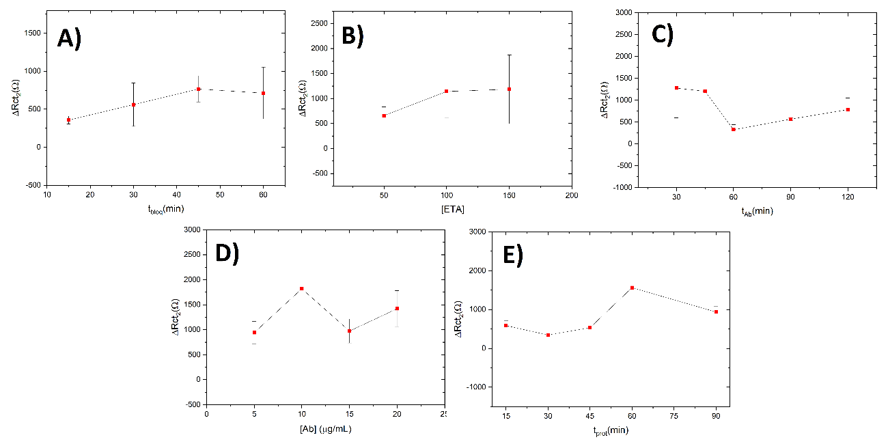

**Fig.SI-1**. Immunosensor optimization studies. A) Blocking time with ETA. B) ETA concentration in blocking stage. C) Anti-CFP10 concentration. D) Immobilization time of anti-CFP10. E) Interaction of the immunosensor with pCFP10:ESAT6.

**Table SI-1**. RMS roughness extracted from the AFM corresponding profiles of the electrode surfaces

|  |  |
| --- | --- |
| **Electrode surfaces** | **RMS (nm)** |
| **ITO** | 3.61 |
| **ITO/APTES** | 14.47 |
| **ITO/APTES/anti-CFP10** | 16.75 |
| **ITO/APTES/anti-CFP10/pCFP10:ESAT6** | 18.93 |



**Fig. SI-2.** A) Cyclic Voltammogram and B) Nyquist plot to repeatability immunosensor study [pCFP10:ESAT6] = 4 ng mL-1.

**Table SI-2**. Results of repeatability experiments.

|  |  |  |  |  |  |  |  |
| --- | --- | --- | --- | --- | --- | --- | --- |
| **Immunosensor** | **Rtc1 (Ω)** | **Rtc2 (Ω)** | **Rtc3 (Ω)** | **Rtc4 (Ω)** | **Mean** | **SD** | **RSD (%)** |
| **1** | 2881 | 3152 | 4155 | 4529 | 3679 | 788 | 21 |
| **2** | 3591 | 4385 | 4387 | 4321 | 4171 | 388 | 9 |
| **3** | 3701 | 3745 | 4753 | 3770 | 3992 | 508 | 13 |

**Table SI-3**. Results of reproducibility experiments.

|  |  |  |  |  |  |  |  |
| --- | --- | --- | --- | --- | --- | --- | --- |
| **Immunossensor** | **1** | **2** | **3** | **4** | **Mean** | **SD** | **RSD (%)** |
| **ΔR*tc* (Ω)** | 432 | 1732 | 432 | 639 | 809 | 623 | 77 |
| 432 | - | 432 | 639 | 501 | 120 | 24 |