Supplemental data
The supplemental materials in the paper are as follows:

Table S1 Primer sequence of RT-qPCR
Gene | Primer sequence (5'-3') | fragment length（bp）
OPG | Upstream: GTGGAATAGATGTCACCCTGTGC | 165
 | Downstream: TTTGCTCTTGCGAGCTGTGT
RANKL | Upstream: CATCGGGTTCCCATAAAGTCAGT | 137
 | Downstream: GCAAATGTTGGCGTACAGGTAAT
GAPDH | Upstream: CTGGAGAAACCTGCCAAGTATG | 138
 | Downstream: GGTGGAAGAATGGGAGTTGCT

Table S2 The first step of PCR amplification reaction
Name | Volume
2×Gflex PCR Buffer | 15μL
5 pmol/μl primer F | 1μL
5 pmol/μl primer R | 1μL
Template DNA | ≥ 1μL (50 ng)
Tks Gflex DNA Polymerase (1.25U/μL) | 0.6μL
H2O | A 30μL supplement was made
Total amount | 30μL

Table S3 The first step of PCR amplification reaction program
Temperature | Time | Number of cycles
94℃ | 5min | 1
94℃ | 30s | 26
56℃ | 30s
72℃ | 20s
72℃ | 5min | 1
4℃ | hold | -

Table S4 The second step of PCR amplification reaction
Name | Volume
2×Gflex PCR Buffer | 15μL
Tks Gflex DNA Polymerase (1.25U/μL) | 0.6μL
Adapter I5 | 1μL
Adapter I7 | 1μL
H2O | A 30μL supplement was made
Total amount | 30μL
First step product | Take 50ng

Table S5 The second step of PCR amplification reaction program
Temperature | Time | Number of cycles
94℃ | 5min | 1
94℃ | 30s | 7
56℃ | 30s
72℃ | 20s
72℃ | 5min | 1
4℃ | hold | -

Table S6 Sample tags distribution table
Sample ID | Clean tags | Valid tags | Valid percent | valid mean Length | OUT counts
Sham.1 | 75114 | 68913 | 91.74% | 420.2 | 1789
Sham.2 | 76778 | 67032 | 87.31% | 413.99 | 2442
Sham.3 | 77004 | 64752 | 84.09% | 411.57 | 2743
OVX.1 | 74631 | 64991 | 87.08% | 413.63 | 2077
OVX.2 | 77021 | 66361 | 86.16% | 416.3 | 1798
OVX.3 | 76749 | 67918 | 88.49% | 416.36 | 2061
E2.1 | 74341 | 65097 | 87.57% | 412.21 | 2692
E2.2 | 74376 | 63873 | 85.88% | 413.23 | 2411
E2.3 | 76689 | 67169 | 87.59% | 414.35 | 2548
TFEL-L.1 | 75909 | 67277 | 88.63% | 414.14 | 2197
TFEL-L.2 | 74573 | 65504 | 87.84% | 413.97 | 2089
TFEL-L.3 | 77125 | 68389 | 88.67% | 414.13 | 2176
TFEL-M.1 | 75333 | 65017 | 86.31% | 415.48 | 2343
TFEL-M.2 | 75403 | 64368 | 85.37% | 410.38 | 2170
TFEL-M.3 | 75046 | 65273 | 86.98% | 414.67 | 2634
TFEL-H.1 | 75482 | 67485 | 89.41% | 417.12 | 2083
TFEL-H.2 | 77055 | 67212 | 87.23% | 410.42 | 2683
TFEL-H.3 | 76951 | 67382 | 87.56% | 412.77 | 2798

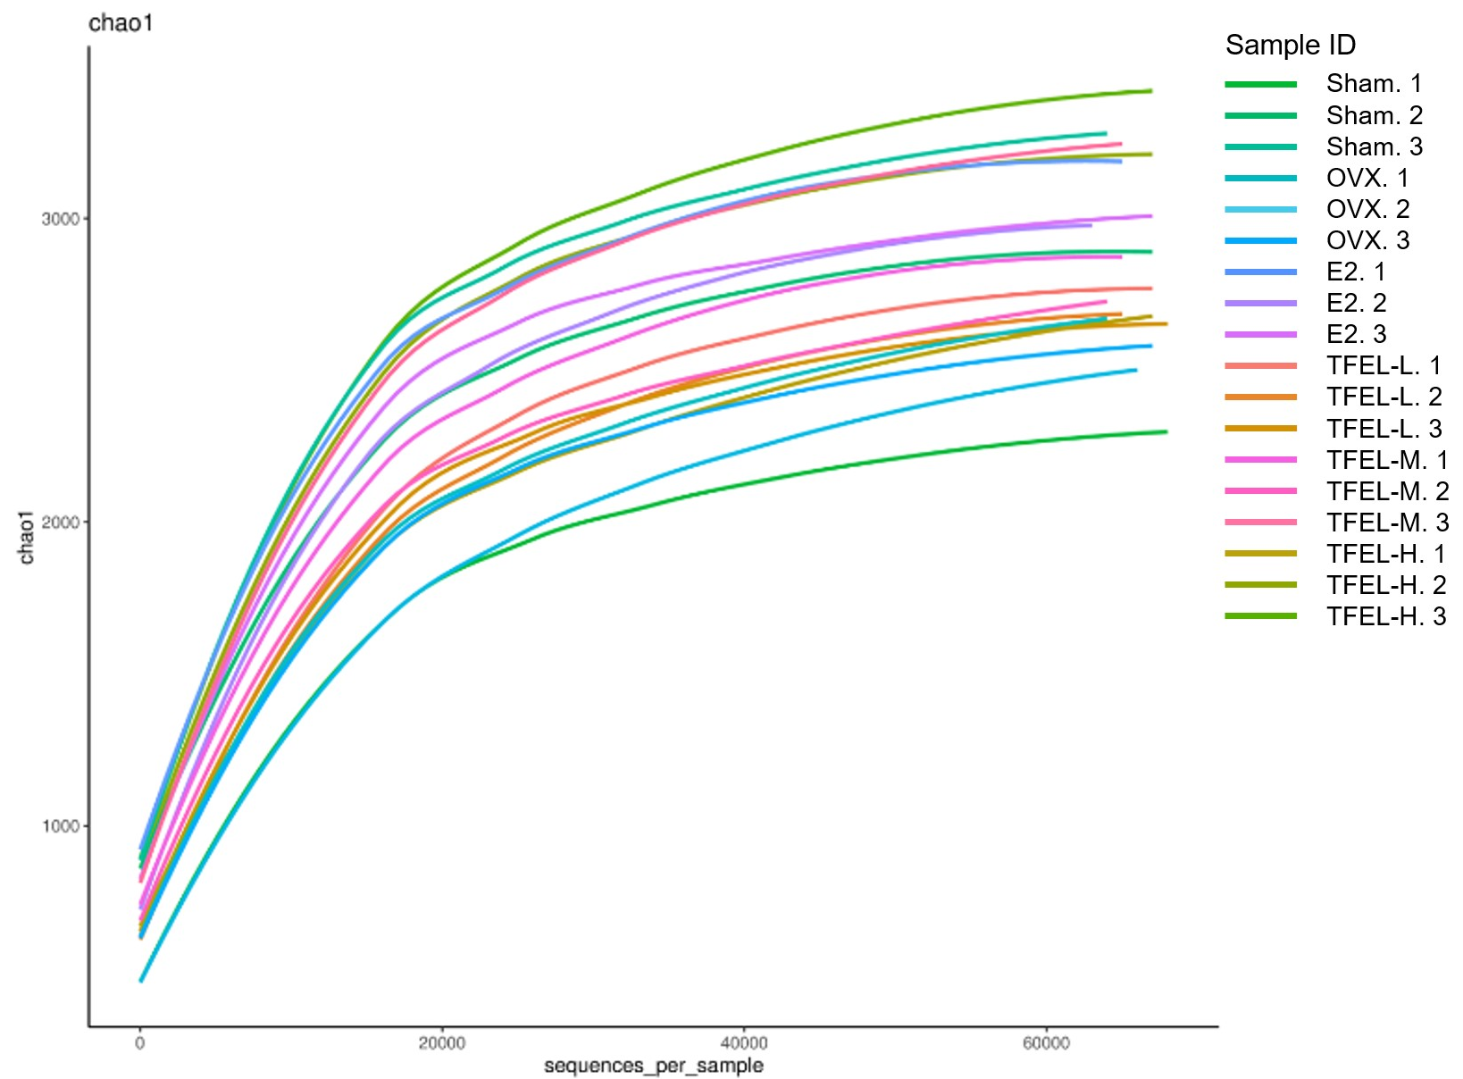
Figure S1 Dilution curve

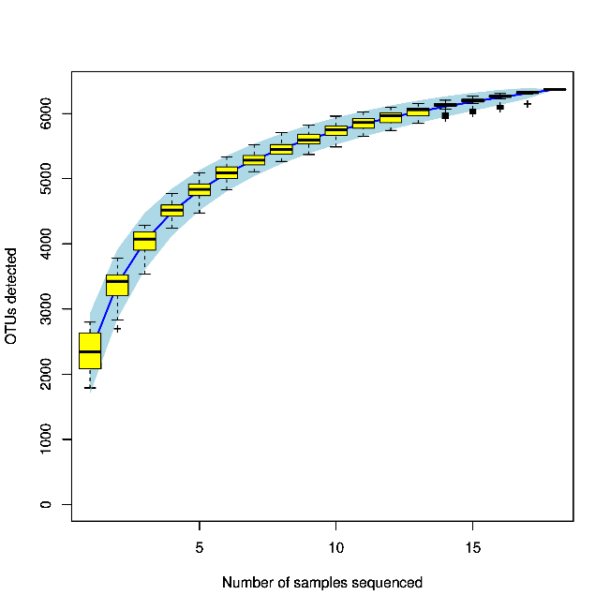
Figure S2 Cumulative curve of species

