**Supplemental Materials**

Table of Contents

**Supplemental Figure 1. Association between 2009 CKD-EPI race-included donor eGFR and kidney graft loss, overall and by DR mismatch** 2

**Supplemental Figure 2. Association between 2009 CKD-EPI race-included donor eGFR and kidney graft loss by recipient age group, overall and by DR mismatch** 3

**Supplemental Figure 3. Association between donor 2009 CKD-EPI race-included eGFR and patient death, overall and by DR mismatch** 4

**Supplemental Figure 4. Association between donor 2009 CKD-EPI race-included eGFR and patient death by recipient age group, overall and by DR mismatch** 5

# **Supplemental Figure 1. Association between 2009 CKD-EPI race-included donor eGFR and kidney graft loss, overall and by DR mismatch**

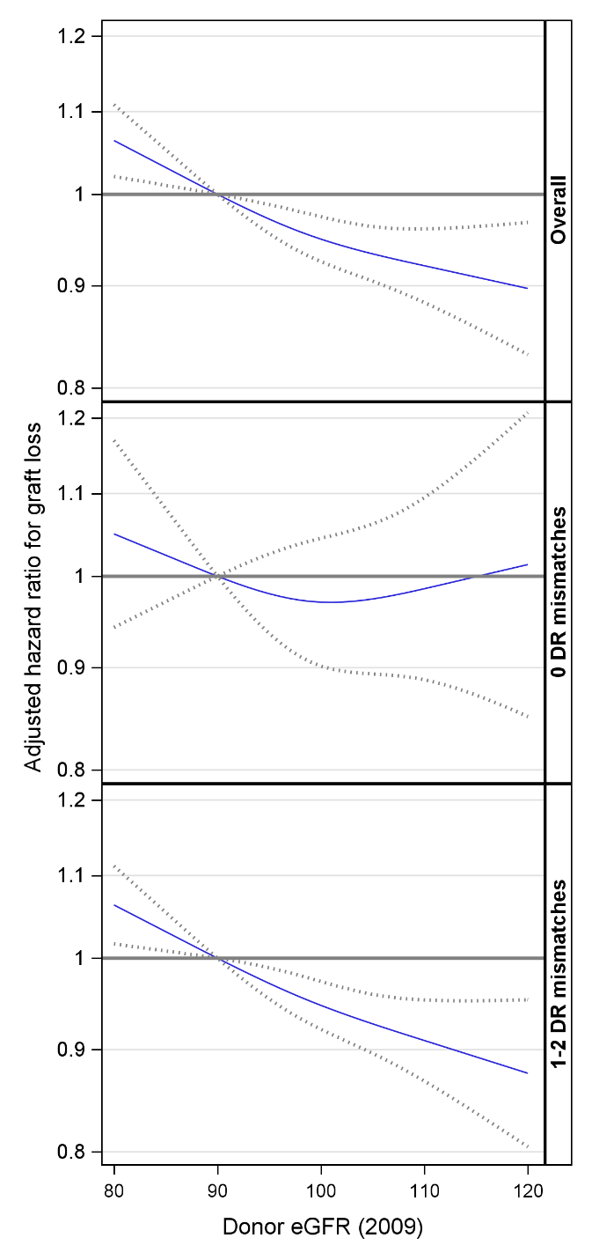

Models adjusted for recipient age, race/ethnicity, BMI, education, insurance, primary diagnosis, peak cPRA, time on dialysis, donor/recipient weight ratio, donor and recipient both male, donor and recipient of same race, ABOi, and donor and recipient related.

CKD-EPI: chronic kidney disease epidemiology collaboration; eGFR: estimated glomerular filtration rate

# **Supplemental Figure 2. Association between 2009 CKD-EPI race-included donor eGFR and kidney graft loss by recipient age group, overall and by DR mismatch**

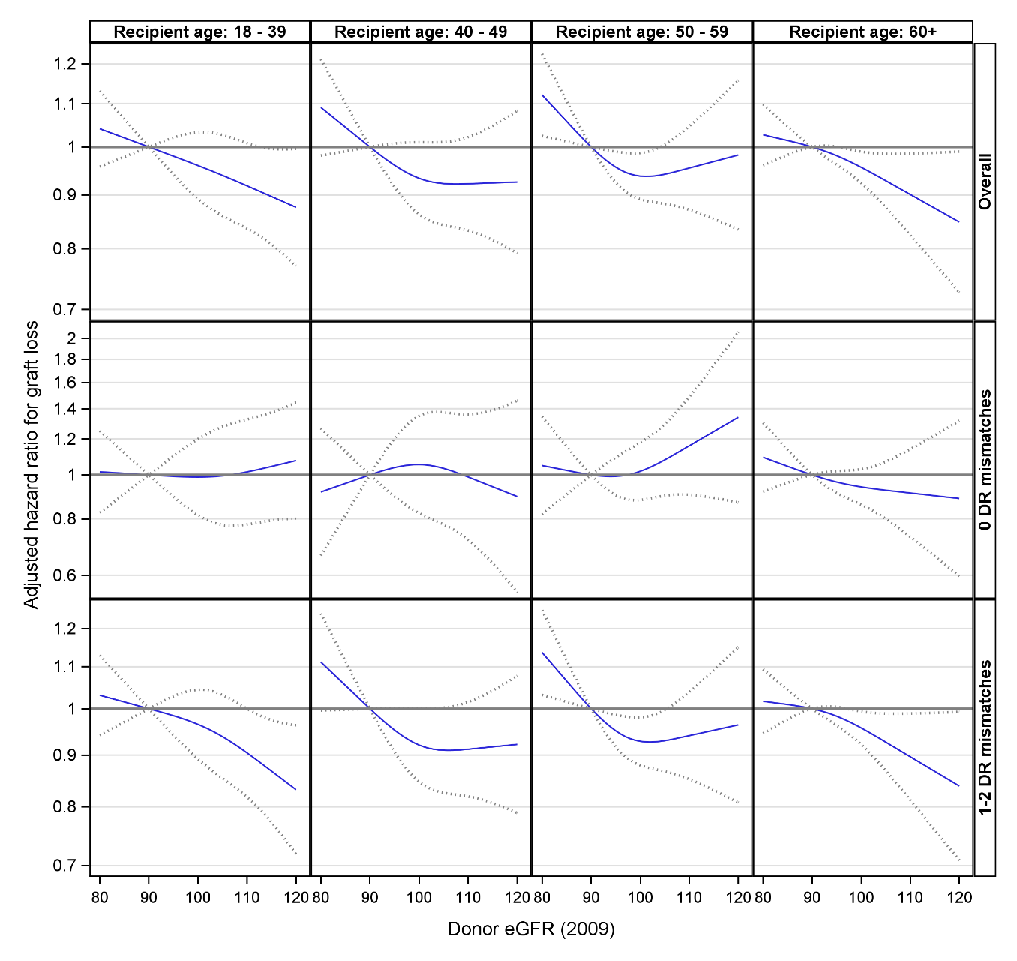

Models adjusted for recipient age, race/ethnicity, BMI, education, insurance, primary diagnosis, peak cPRA, time on dialysis, donor/recipient weight ratio, donor and recipient both male, donor and recipient of same race, ABOi, and donor and recipient related.

CKD-EPI: chronic kidney disease epidemiology collaboration; eGFR: estimated glomerular filtration rate

# **Supplemental Figure 3. Association between donor 2009 CKD-EPI race-included eGFR and patient death, overall and by DR mismatch**

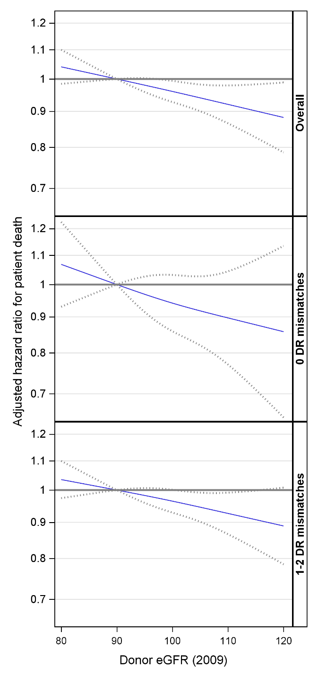

Models adjusted for recipient age, race/ethnicity, BMI, education, insurance, primary diagnosis, peak cPRA, time on dialysis, donor/recipient weight ratio, donor and recipient both male, donor and recipient of same race, ABOi, and donor and recipient related.

CKD-EPI: chronic kidney disease epidemiology collaboration; eGFR: estimated glomerular filtration rate

# **Supplemental Figure 4. Association between donor 2009 CKD-EPI race-included eGFR and patient death by recipient age group, overall and by DR mismatch**

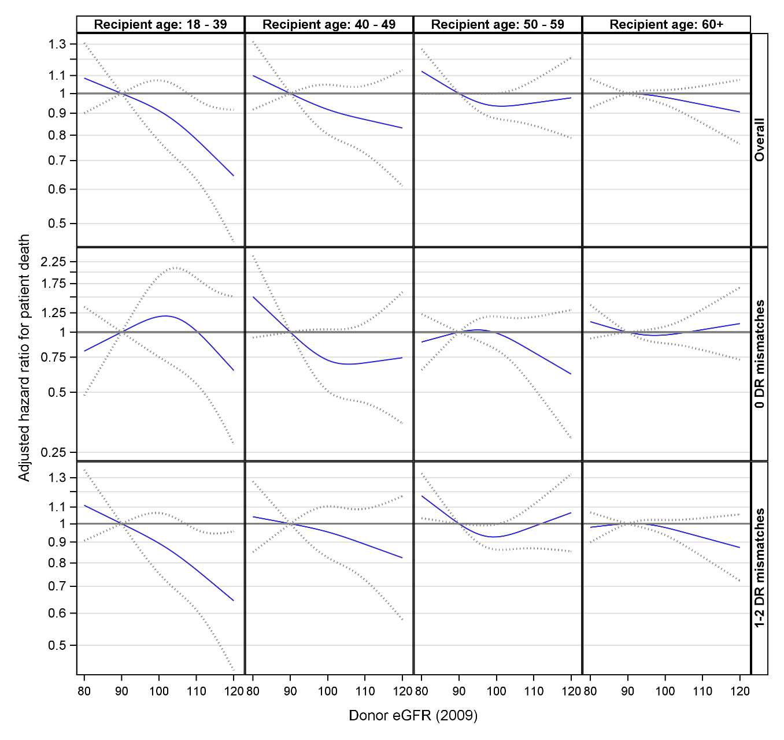

Models adjusted for recipient age, race/ethnicity, BMI, education, insurance, primary diagnosis, peak cPRA, time on dialysis, donor/recipient weight ratio, donor and recipient both male, donor and recipient of same race, ABOi, and donor and recipient related.

CKD-EPI: chronic kidney disease epidemiology collaboration; eGFR: estimated glomerular filtration rate