SUPPLEMENTARY INFORMATION

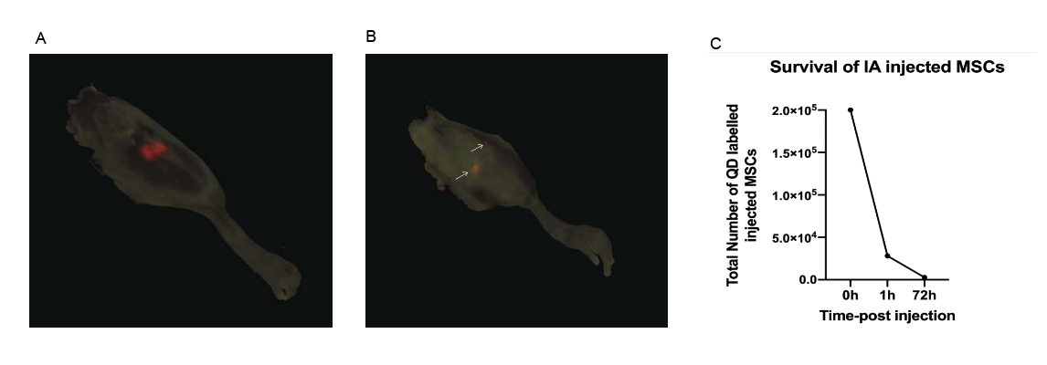

Fig. S1. CryoViz Imaging of murine hind limbs. IA-delivery of QDot labelled wild-type murine MSCs showed a positive signal cluster at the injection point at 1 hour post injection (A) and localized minor signals at 72 hours post injection (B) showing a rapid decline in cell survival (C).

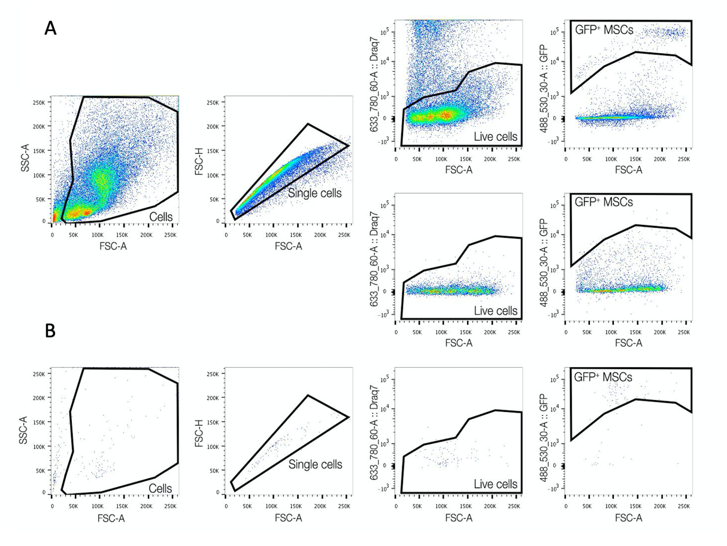
Fig. S2. Cell sorting of IA-administered GFP+ MSCs. Cell debris was gated out from the scatter plot. Doublets were excluded and live cells selected as DRAQ7 positive. GFP+ MSCs were identified using a negative control and the gate was used for cell sorting (A). Sorted cells were analysed for purity using the same gating strategy (B).

Receptor | Isotype | Clone | Fluoro-chrome | Supplier
CD105 | Rat IgG2a, κ | MJ7/18 | APC | BioLegend (120413)
CD106 | Rat IgG2a, κ | 429 (MVCAM.A) | PE | BioLegend (105713)
CD140b | Rat IgG2a, κ | APB5 | APC | eBioscience (17-1402-80)
CD146 | Rat IgG2a | ME-9F1 | PE | BioLegend (134703)
CD29 | Armenian hamster IgG | eBioHMb1-1 (HMb1-1) | APC | eBioscience (17-0291-80)
CD44 | Rat IgG2b, κ | IM7 | PE | BioLegend (103007)
CD90.2 | Rat IgG2a, κ | 53-2.1 | PE | BD Pharmingen (553005)
Ly-6A/E (Sca-1) | Rat IgG2a, κ | E13-161.7 | APC | BioLegend (122511)
CD11b | Rat IgG2b, κ | M1/70 | PE | BD Pharmingen (557397)
CD45 | Rat IgG2b, κ | 30-F11 | PE | BD Pharmingen (553081)
Table S1. Antibodies for cell surface marker characterization

Experimental replicate | Joint condition | Yield | % Injected | % Purity
Retrieval 1 | SHAM | 952 | 0.040 | /
 | CIOA | 7964 | 0.332 | /
Retrieval 2 | SHAM | 331 | 0.014 | 77.8%
 | CIOA | 634 | 0.026 | 88.9%
Retrieval 3 | SHAM | 251 | 0.010 | 69.2%
 | CIOA | 1067 | 0.044 | 90 %

Table S2: Cell sorting of retrieved MSCs from SHAM and CIOA murine joints. MSCs were consistently retrieved in higher number from CIOA vs SHAM joints. Purity of the retrieved cell populations was analyzed for retrieval experiments 2 and 3 showing elevated values in SHAM (69-77.8%) and CIOA (88.9-90%) joints.

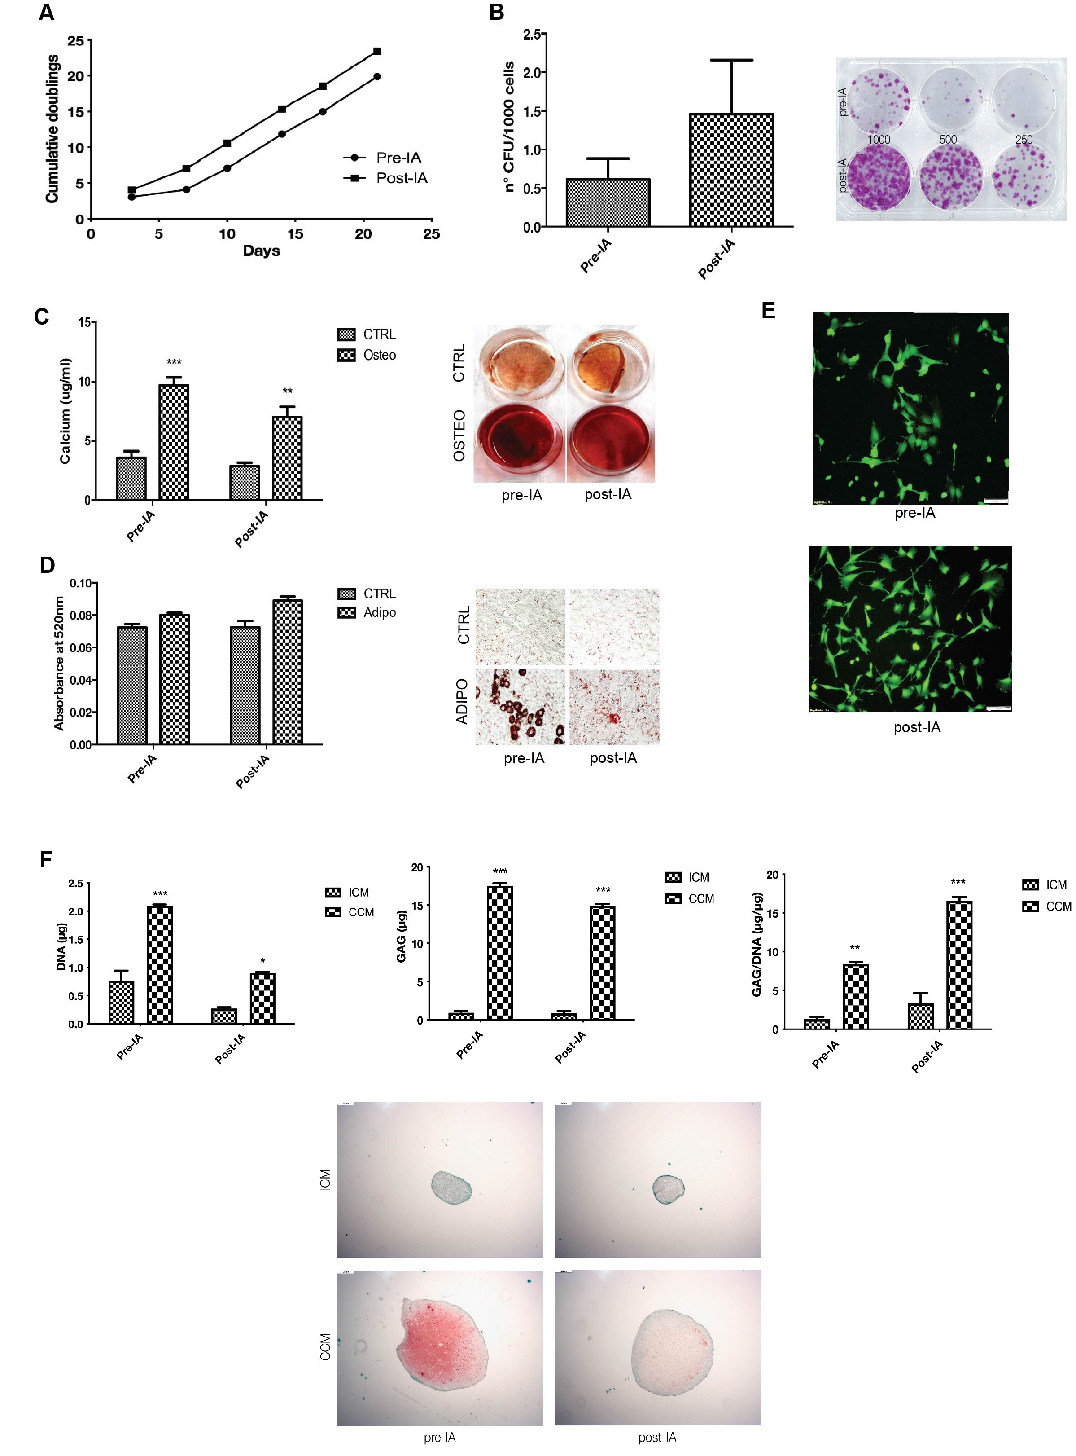
Fig. S3. Characterisation of retrieved MSCs. A: Proliferation rates of MSCs before (pre-IA) and after (post-IA) in vivo administration and FACS sorting (right) n=1. B: Clonogenicity of MSCs before (pre-IA) and after (post-IA) in vivo administration and FACS sorting (Mean±SEM, n=1, 3 technical replicates) C: Osteogenic differentiation of retrieved MSCs. Alizarin Red Staining (A) and calcium quantification (B) of MSC monolayers in osteogenic differentiation medium before (pre-IA) and after (post-IA) in vivo administration and FACS-sorting. Mean±SEM (n=1, 3 technical replicates). D: Adipogenic differentiation of retrieved MSCs. Oil red-O staining (A) and semi-quantification (B) of MSC monolayers in adipogenic differentiation medium, before (pre-IA) and after (post-IA) in vivo administration and FACS-sorting. Mean±SEM (n=1, 3 technical replicates) E: Representative inverted microscopy images of cultured MSCs before (pre-IA) and after (post-IA) in vivo administration and FACS-sorting. Scale bar = 100µm. F: Chondrogenic differentiation of retrieved MSCs. Safranin-O (red) and Fast Green (green) staining of chondrogenically-differentiated pellets (A). Incomplete Chondrogenic Medum (ICM), Complete Chondrogenic Medium (CCM). Quantification of glycosaminoglycans (GAG) (B), DNA (C) and GAG/DNA ratio (D) for chondrogenic-differentiated pellets of MSCs, before (pre-IA) and after (post-IA) in vivo administration and FACS sorting.

Receptor | Fluorochrome | Clone | Supplier
CD4 | PerCP/Cy5.5 | RM4-5 | BioLegend (100540)
CD8 | APC | 53-6.7 | BioLegend (100712)
CD25 | PE | PC61 | BioLegend (102008)

Table S3. Antibodies used in T cell co-culture analysis

Receptor | Isotype | Fluoro-chrome | Clone | Supplier
CD11b | Rat IgG2b, κ | PE | M1/70 | BD Pharmingen (557397)
Isotype Ctrl | Rat IgG2b, κ | PE | A95-1 | BD Pharmingen (553989)
CD45.2 | Mouse IgG2a, κ | APC | 104 | BioLegend (109813)
Isotype Ctrl | Mouse IgG2a, κ | APC | MOPC-173 | BioLegend (400221)
F4/80 | Rat IgG2a, κ | PE/Cy7 | BM8 | BioLegend (123113)
Isotype Ctrl | Rat IgG2a, κ | PE/Cy7 | RTK2758 | BioLegend (400521)
CD206 | Rat IgG2a, κ | Brilliant Violet 421 | C068C2 | BioLegend (141717)
CD86 | Rat IgG2a, κ | Brilliant Violet 510 | GL-1 | BioLegend (105039)
F4/80 | Rat IgG2a, κ | APC | BM8 | BioLegend (123115)
I-A/I-E (MHC-II) | Rat IgG2b, κ | PE | M5/114.15.2 | BioLegend (107607)

Table S4. Antibodies used for macrophage characterization

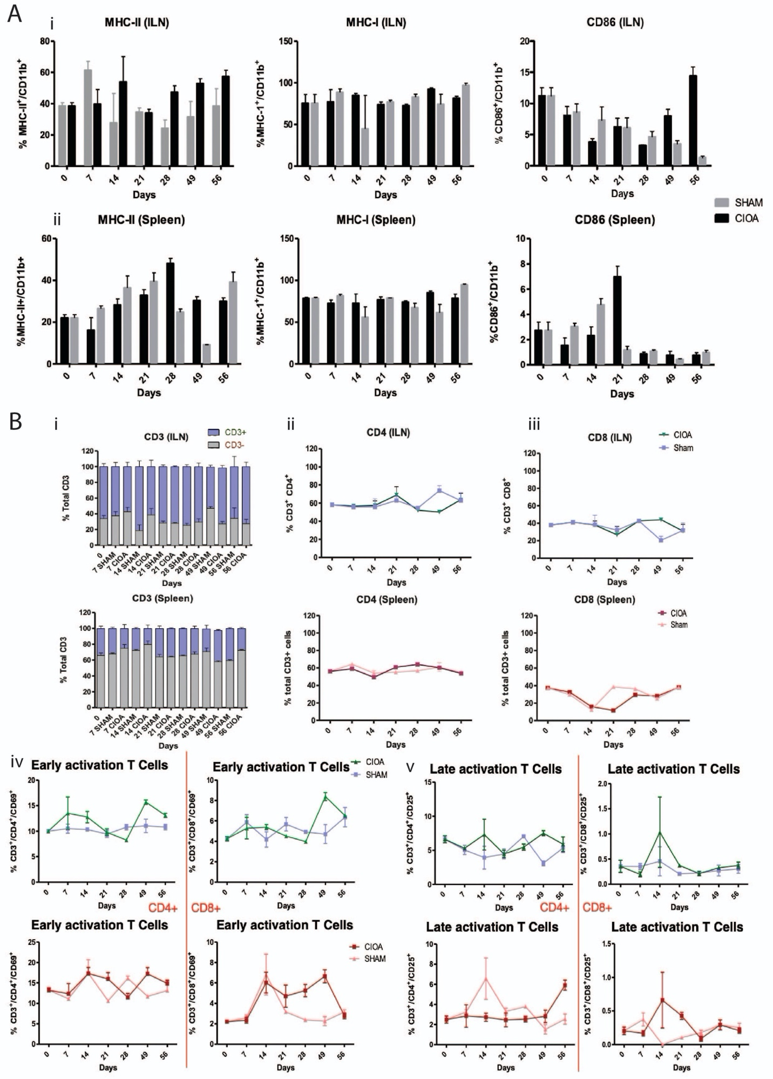
Fig. S4. Identification of the in vivo immunological profile in a collagenase induced OA. (A) Macrophage populations identified in the inguinal lymph nodes (i) and Spleen (ii) of Sham and CIOA groups over 56 days following CIOA. The % of MHC-II⁺/CD11b⁺ cells increased early (D14) in ILN and later (D28) in Spleen in CIOA versus Sham, while % of MHC-I⁺/CD11b⁺ cells increased in late OA (D49) in the Spleen. An increase in the % of CD86⁺/CD11b⁺ cells was also observed late (D56) in ILN and early (D21) in Spleen. (B) T cell populations found within the inguinal lymph nodes and Spleen of Sham and CIOA groups over 56 days following CIOA: CD3⁺ (i), CD3⁺/CD4⁺ (ii), CD3⁺/CD8⁺ (iii). Activation of T cells was analysed via measurement of CD69⁺ (iv) and CD25⁺ (v) populations.

Cytokines
G-CSF | IL-17A
GM-CSF | IL-23p19
GRO-α/CXCL1/KC | IL-27
HGF | IP-10/CXCL10/CRG-2
IFN-γ | MCP-1/CCL2/JE
IL-1 α | M-CSF
IL-1 β | MMP-3
IL-3 | MMP-9
IL-6 | RAGE
IL-10 | RANTES/CCL5
IL-12 (p70) | S100A8
IL-13 | VEGF
IL-16 | Thrombospondin-4
TNF- α

Table S5. Cytokines selected for Bioplex analysis
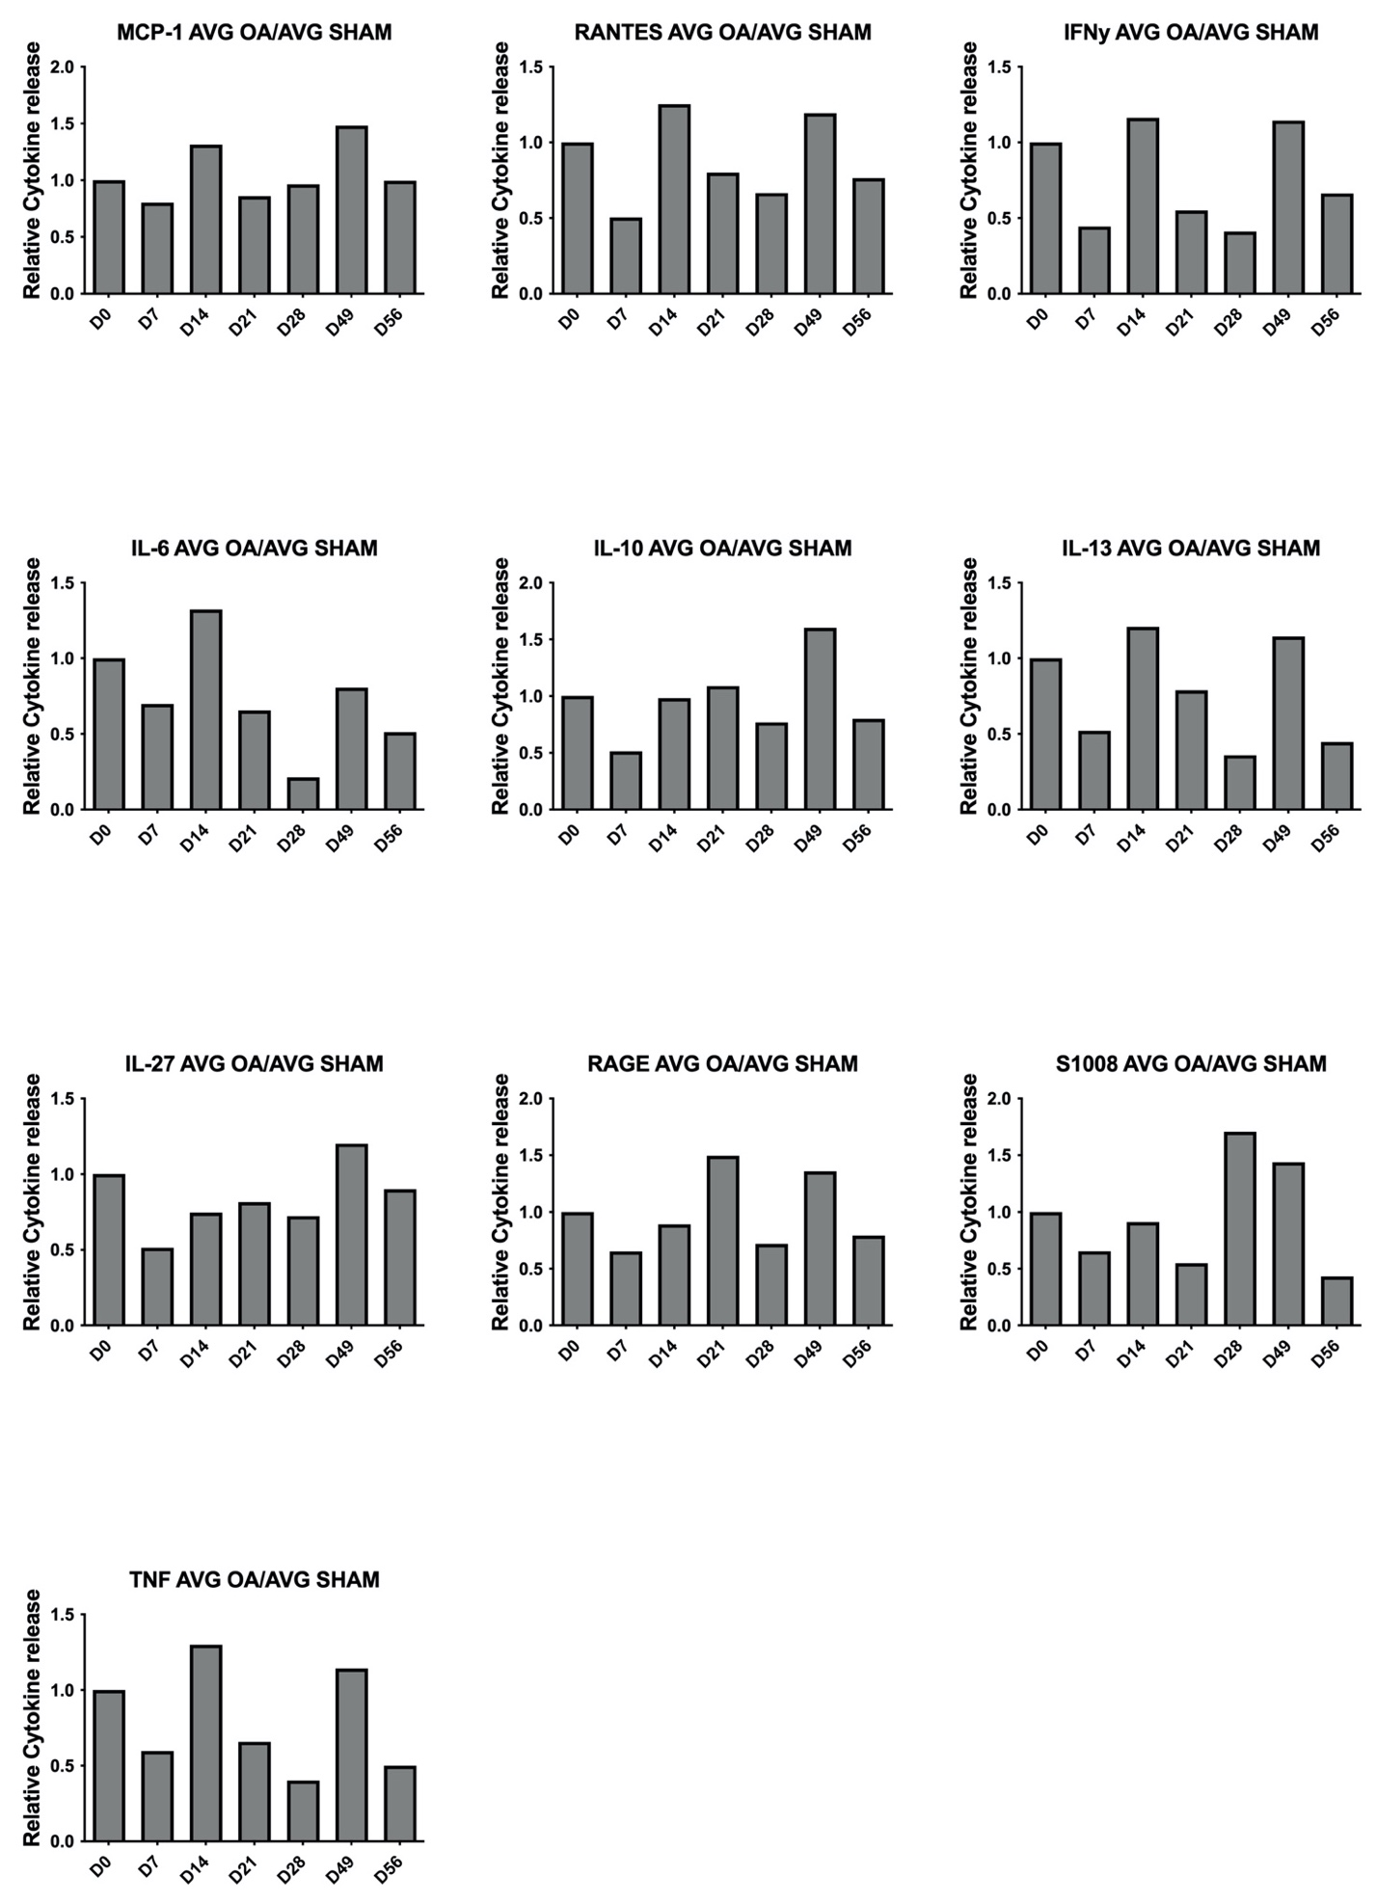
Fig. S5. Analysis of cytokine levels of a panel of OA associated cytokines over 56 days following CIOA in Sham versus CIOA. The concentration of each cytokine is shown relative to the CIOA group, with the average concentration in the CIOA group divided by the average concentration of the Sham group.

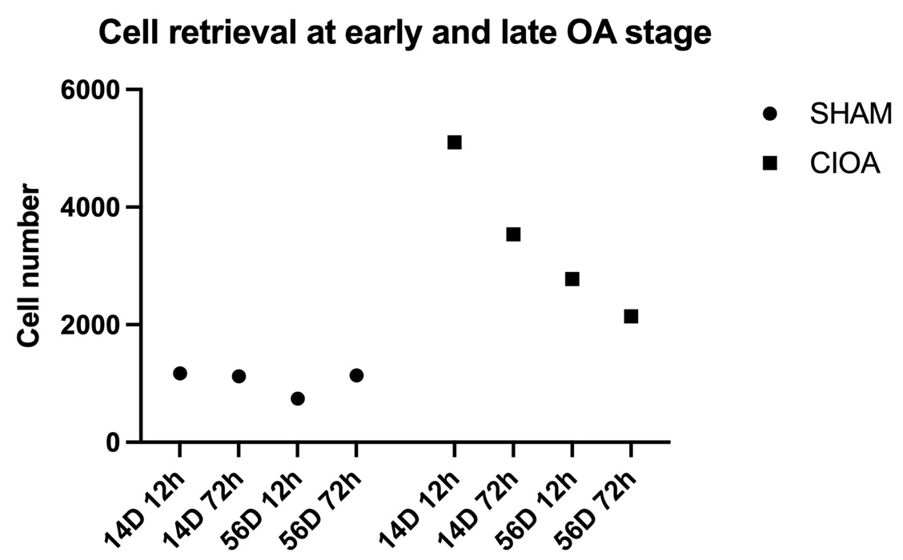

Fig. S6. Number of GFP+MSCs retrieved from CIOA and SHAM joints for RNA sequencing. For each time point cells were pooled and retrieved from n=8 mice (16 knee joints).

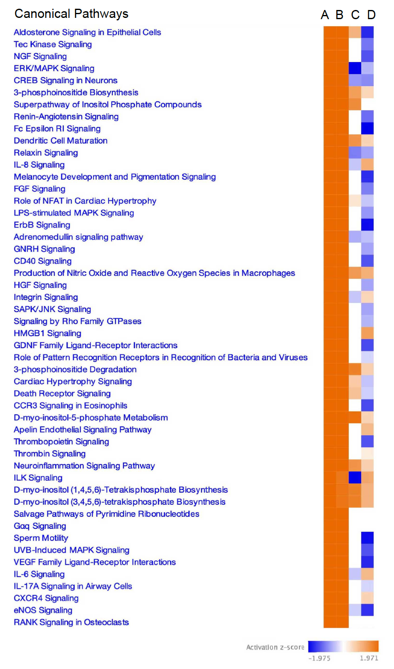

Fig. S7. Heatmap of activated canonical pathways. Retrieved MSCs at early 12-hour (A, B) and late 3-day time-points (C, D), showing activation of the majority of pathways at the early retrieval time point of 12 hours.

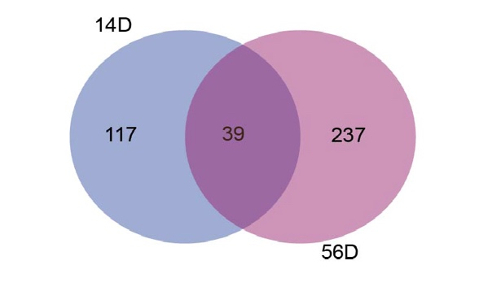
Fig. S8 Overlay of Predicted secreted elements in retrieved MSCs at D14 and D56 Venn diagram representing time-point specific and common proteins secreted by retrieved MSCs, indicating a higher number of elements at 56D.

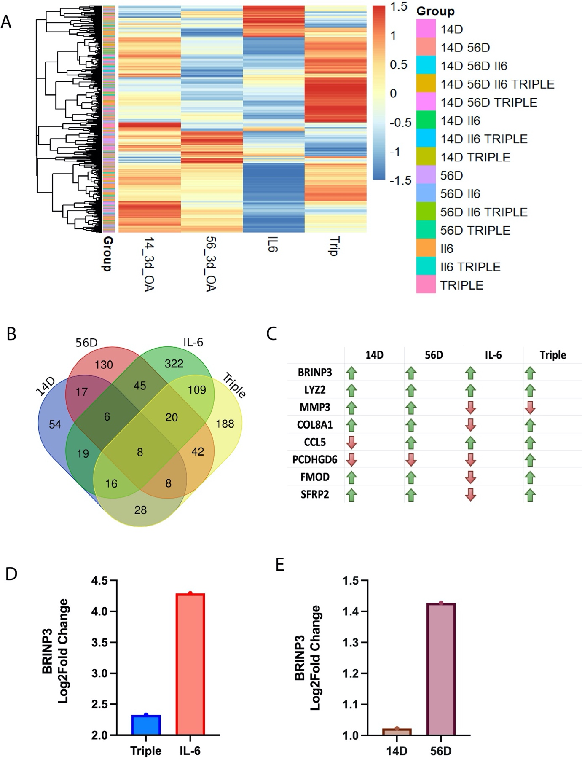

Fig. S9. Common expressed genes in licensed and retrieved MSCs. (A) Heatmap representing a hierarchal comparison of the predicted secreted elements from three-day retrieved cells at 14D and 56D CIOA and in vitro licensed cells with IL-6 and the triple combination (IL-6, MCP-1 and IFN-γ) licensing. (B) Venn diagram comparison of the predicted secretome of retrieved cells and licensed MSCs indicate eight common elements (C) Up-regulation and down-regulation of common genes expressed in the predicted secretome of retrieved and licensed MSCs (D) RNA Sequencing expression of BRINP3 in (D) in vitro licensed GFP+MSCs with IL-6 and triple combination vs naïve GFP+MSCs and in (E) three-day retrieved GFP+MSCs at 14D and 56D CIOA vs SHAM

#GeneSymbol | GeneName | Log2FC
Prokr1 | prokineticin receptor 1 | 4,46194
F13a1 | coagulation factor XIII, A1 subunit | 4,07296
Grem1 | gremlin 1, DAN family BMP antagonist | 3,64384
Megf6 | multiple EGF-like-domains 6 | 3,43041
Atp6v0d2 | ATPase, H+ transporting, lysosomal V0 subunit D2 | 3,41636
Ngp | neutrophilic granule protein | 3,35971
Fam198a | family with sequence similarity 198, member A | 3,27547
Pcdhga1 | protocadherin gamma subfamily A, 1 | 3,13658
Ccser1 | coiled-coil serine rich 1 | 3,11062
Xpnpep2 | X-prolyl aminopeptidase (aminopeptidase P) 2, membrane-bound | 3,02054
Trp53inp1 | transformation related protein 53 inducible nuclear protein 1 | 2,8636
Oas2 | 2'-5' oligoadenylate synthetase 2 | 2,83016
Rnd1 | Rho family GTPase 1 | 2,7993
Fgl2 | fibrinogen-like protein 2 | 2,77837
F8 | coagulation factor VIII | 2,72218
Gm14308 | predicted gene 14308 | 2,68641
Mmp12 | matrix metallopeptidase 12 | 2,62773
Mmp13 | matrix metallopeptidase 13 | 2,61103
Prg4 | proteoglycan 4 (megakaryocyte stimulating factor, articular superficial zone protein) | 2,60831
Gdpd2 | glycerophosphodiester phosphodiesterase domain containing 2 | 2,59065
Neurl1b | neuralized E3 ubiquitin protein ligase 1B | 2,56539
Cmpk2 | cytidine monophosphate (UMP-CMP) kinase 2, mitochondrial | 2,56079
Ccl20 | chemokine (C-C motif) ligand 20 | 2,55258
Angptl1 | angiopoietin-like 1 | 2,54484
Dnajc27 | DnaJ heat shock protein family (Hsp40) member C27 | 2,52886
1500015O10Rik | RIKEN cDNA 1500015O10 gene | 2,52443
Acp6 | acid phosphatase 6, lysophosphatidic | 2,50574
Zfp420 | zinc finger protein 420 | 2,48501
Egfl6 | EGF-like-domain, multiple 6 | 2,478
Bnip3l-ps | BCL2/adenovirus E1B interacting protein 3-like, pseudogene | 2,45969
Cdkn1c | cyclin-dependent kinase inhibitor 1C (P57) | 2,45235
Nos2 | nitric oxide synthase 2, inducible | 2,4331
Ifit3 | interferon-induced protein with tetratricopeptide repeats 3 | 2,42527
Gpnmb | glycoprotein (transmembrane) nmb | 2,42514
Fbln7 | fibulin 7 | 2,40116
Apod | apolipoprotein D | 2,37814
Chodl | chondrolectin | 2,36039
Elmo1 | engulfment and cell motility 1 | 2,35538
Zfp59 | zinc finger protein 59 | 2,34563
Fam71f2 | family with sequence similarity 71, member F2 | 2,33429
Fndc1 | fibronectin type III domain containing 1 | 2,33131
Camsap3 | calmodulin regulated spectrin-associated protein family, member 3 | 2,33072
Ifi207 | interferon activated gene 207 | 2,31823
Slc16a2 | solute carrier family 16 (monocarboxylic acid transporters), member 2 | 2,3028
Akr1c18 | aldo-keto reductase family 1, member C18 | 2,30042
Oas1b | 2'-5' oligoadenylate synthetase 1B | 2,2966
Zfp781 | zinc finger protein 781 | 2,28503
Gbp5 | guanylate binding protein 5 | 2,27757
Mmp2 | matrix metallopeptidase 2 | 2,21567

Gm4951 | predicted gene 4951 | 2,21413
Naalad2 | N-acetylated alpha-linked acidic dipeptidase 2 | 2,20552
Mmp3 | matrix metallopeptidase 3 | 2,19535
Rassf2 | Ras association (RalGDS/AF-6) domain family member 2 | 2,19313
Ggt5 | gamma-glutamyltransferase 5 | 2,18908
Igfbp5 | insulin-like growth factor binding protein 5 | 2,18433
Ddit4 | DNA-damage-inducible transcript 4 | 2,17282
Pcdhb9 | protocadherin beta 9 | 2,17245
Ppargc1a | peroxisome proliferative activated receptor, gamma, coactivator 1 alpha | 2,15562
Igf1 | insulin-like growth factor 1 | 2,12985
Cdc42bpg | CDC42 binding protein kinase gamma (DMPK-like) | 2,12138
Htra4 | HtrA serine peptidase 4 | 2,12138
Ptx4 | pentraxin 4 | 2,12138
Ctla2a | cytotoxic T lymphocyte-associated protein 2 alpha | 2,11018
Il6 | interleukin 6 | 2,06588
Zfp27 | zinc finger protein 27 | 2,05549
Il27ra | interleukin 27 receptor, alpha | 2,05035
Usp18 | ubiquitin specific peptidase 18 | 2,0461
Zfp239 | zinc finger protein 239 | 2,01545
Pla2g4b | phospholipase A2, group IVB (cytosolic) | 2,01347
Fam102a | family with sequence similarity 102, member A | 2,01199
Pcdhb14 | protocadherin beta 14 | 2,00804
Zfp185 | zinc finger protein 185 | 1,99468
Vtn | vitronectin | 1,97564
F830016B08Rik | RIKEN cDNA F830016B08 gene | 1,96627
Myo7a | myosin VIIA | 1,96214
Iigp1 | interferon inducible GTPase 1 | 1,95898
Klhl10 | kelch-like 10 | 1,95635
Map3k8 | mitogen-activated protein kinase kinase kinase 8 | 1,95389
Mfsd6 | major facilitator superfamily domain containing 6 | 1,93677
Bmper | BMP-binding endothelial regulator | 1,92203
Ctsw | cathepsin W | 1,91696
Sfrp2 | secreted frizzled-related protein 2 | 1,91013
Mx1 | MX dynamin-like GTPase 1 | 1,87973
Usp27x | ubiquitin specific peptidase 27, X chromosome | 1,87646
Nr1h4 | nuclear receptor subfamily 1, group H, member 4 | 1,87646
Il33 | interleukin 33 | 1,87473
Rad51d | RAD51 paralog D | 1,87002
Col8a2 | collagen, type VIII, alpha 2 | 1,8636
Sfrp4 | secreted frizzled-related protein 4 | 1,86068
Plcl2 | phospholipase C-like 2 | 1,85907
Rcan2 | regulator of calcineurin 2 | 1,85064
Zfp867 | zinc finger protein 867 | 1,85024
Hs6st2 | heparan sulfate 6-O-sulfotransferase 2 | 1,84515
Aoc3 | amine oxidase, copper containing 3 | 1,84514
Hilpda | hypoxia inducible lipid droplet associated | 1,8411
Itgb2 | integrin beta 2 | 1,8348
Fam131b | family with sequence similarity 131, member B | 1,83402
Hk2 | hexokinase 2 | 1,82919
Tnfsf9 | tumor necrosis factor (ligand) superfamily, member 9 | 1,81989
Fyb2 | FYN binding protein 2 | 1,81352
Table S6. Top 100 up-regulated DEGs in retrieved MSCs (14D CIOA vs 14D SHAM).

#GeneSymbol | GeneName | Log2FC
Uba52 | ubiquitin A-52 residue ribosomal protein fusion product 1 | -7,32197
Acan | aggrecan | -3,69007
Olr1 | oxidized low density lipoprotein (lectin-like) receptor 1 | -3,60373
Dpm3 | dolichyl-phosphate mannosyltransferase polypeptide 3 | -2,9975
Ndufb7 | NADH:ubiquinone oxidoreductase subunit B7 | -2,88509
Gtpbp6 | GTP binding protein 6 (putative) | -2,78429
Wdr62 | WD repeat domain 62 | -2,74532
Fam19a5 | family with sequence similarity 19, member A5 | -2,74356
Elob | elongin B | -2,7287
Lrrc29 | leucine rich repeat containing 29 | -2,72311
Ccdc124 | coiled-coil domain containing 124 | -2,70284
Dohh | deoxyhypusine hydroxylase/monooxygenase | -2,64849
Timm13 | translocase of inner mitochondrial membrane 13 | -2,63643
Ltbp4 | latent transforming growth factor beta binding protein 4 | -2,63024
Bola2 | bolA-like 2 (E. coli) | -2,60279
Pbp2 | phosphatidylethanolamine binding protein 2 | -2,59269
Pcdhgb6 | protocadherin gamma subfamily B, 6 | -2,57926
Znhit2 | zinc finger, HIT domain containing 2 | -2,56475
P2ry2 | purinergic receptor P2Y, G-protein coupled 2 | -2,54545
Lgr6 | leucine-rich repeat-containing G protein-coupled receptor 6 | -2,50834
Angptl7 | angiopoietin-like 7 | -2,48176
Edf1 | endothelial differentiation-related factor 1 | -2,47101
Olfm2 | olfactomedin 2 | -2,43324
Lrfn4 | leucine rich repeat and fibronectin type III domain containing 4 | -2,4302
Mt2 | metallothionein 2 | -2,41012
Hspb1 | heat shock protein 1 | -2,40978
Unc13c | unc-13 homolog C | -2,4045
Chpf | chondroitin polymerizing factor | -2,39721
Slurp1 | secreted Ly6/Plaur domain containing 1 | -2,38753
Zfp763 | zinc finger protein 763 | -2,38073
Junb | jun B proto-oncogene | -2,37058
Tppp3 | tubulin polymerization-promoting protein family member 3 | -2,31318
C1qtnf2 | C1q and tumor necrosis factor related protein 2 | -2,31208
Chtf18 | CTF18, chromosome transmission fidelity factor 18 | -2,30891
L1cam | L1 cell adhesion molecule | -2,29031
Crip2 | cysteine rich protein 2 | -2,27929
Pold1 | polymerase (DNA directed), delta 1, catalytic subunit | -2,25264
Fam213a | family with sequence similarity 213, member A | -2,25135
Acsbg1 | acyl-CoA synthetase bubblegum family member 1 | -2,24772
Cep131 | centrosomal protein 131 | -2,23732
Kcnk5 | potassium channel, subfamily K, member 5 | -2,21841
Tpgs1 | tubulin polyglutamylase complex subunit 1 | -2,21367
Zfp82 | zinc finger protein 82 | -2,20889
Smad9 | SMAD family member 9 | -2,20806
Ccnd1 | cyclin D1 | -2,18187
Mfsd3 | major facilitator superfamily domain containing 3 | -2,16819
Aldh1a3 | aldehyde dehydrogenase family 1, subfamily A3 | -2,15602
Lamb2 | laminin, beta 2 | -2,14246
Acad10 | acyl-Coenzyme A dehydrogenase family, member 10 | -2,12345
Tmem26 | transmembrane protein 26 | -2,12345
Fam19a2 | family with sequence similarity 19, member A2 | -2,11672
Trib3 | tribbles pseudokinase 3 | -2,11016
Fgfr3 | fibroblast growth factor receptor 3 | -2,09753
Acpp | acid phosphatase, prostate | -2,09207
Fancd2 | Fanconi anemia, complementation group D2 | -2,09152
Icam5 | intercellular adhesion molecule 5, telencephalin | -2,08095
Hspa1a | heat shock protein 1A | -2,0742
Thap7 | THAP domain containing 7 | -2,06643
Slc12a9 | solute carrier family 12 (potassium/chloride transporters), member 9 | -2,06569
Stra6 | stimulated by retinoic acid gene 6 | -2,06248
Rnaseh2c | ribonuclease H2, subunit C | -2,0614
Cspg4 | chondroitin sulfate proteoglycan 4 | -2,05874
Gchfr | GTP cyclohydrolase I feedback regulator | -2,05575
Psmb10 | proteasome (prosome, macropain) subunit, beta type 10 | -2,0538
Igfbp6 | insulin-like growth factor binding protein 6 | -2,04166
Ccdc141 | coiled-coil domain containing 141 | -2,01787
Card10 | caspase recruitment domain family, member 10 | -2,0167
Erdr1 | erythroid differentiation regulator 1 | -2,00335
Zfp189 | zinc finger protein 189 | -2,00018
Hspbp1 | HSPA (heat shock 70kDa) binding protein, cytoplasmic cochaperone 1 | -2,00016
Lgals7 | lectin, galactose binding, soluble 7 | -1,99739
Klrg2 | killer cell lectin-like receptor subfamily G, member 2 | -1,98652
Polr2f | polymerase (RNA) II (DNA directed) polypeptide F | -1,95696
Zfp414 | zinc finger protein 414 | -1,92811
Jmjd4 | jumonji domain containing 4 | -1,92514
Pcolce2 | procollagen C-endopeptidase enhancer 2 | -1,91977
Cenpm | centromere protein M | -1,9166
Ptpn22 | protein tyrosine phosphatase, non-receptor type 22 (lymphoid) | -1,89205
Glis1 | GLIS family zinc finger 1 | -1,88842
Zswim3 | zinc finger SWIM-type containing 3 | -1,88834
Slc6a17 | solute carrier family 6 (neurotransmitter transporter), member 17 | -1,88775
Lmna | lamin A | -1,88056
Csnk1g2 | casein kinase 1, gamma 2 | -1,8566
Odaph | odontogenesis associated phosphoprotein | -1,85124
Ubtd1 | ubiquitin domain containing 1 | -1,84807
Kcnn4 | potassium intermediate/small conductance calcium-activated channel, subfamily N, member 4 | -1,84666
Fzr1 | fizzy and cell division cycle 20 related 1 | -1,84279
Scrn2 | secernin 2 | -1,83715
Tspo | translocator protein | -1,82875
Ndufs7 | NADH:ubiquinone oxidoreductase core subunit S7 | -1,82691
Aldh16a1 | aldehyde dehydrogenase 16 family, member A1 | -1,81978
Mif | macrophage migration inhibitory factor (glycosylation-inhibiting factor) | -1,81817
Ndufa11 | NADH:ubiquinone oxidoreductase subunit A11 | -1,81742
Emilin1 | elastin microfibril interfacer 1 | -1,81466
Ppbp | pro-platelet basic protein | -1,81348
Plekhh3 | pleckstrin homology domain containing, family H (with MyTH4 domain) member 3 | -1,80605
Orai1 | ORAI calcium release-activated calcium modulator 1 | -1,80563
Trp53i13 | transformation related protein 53 inducible protein 13 | -1,79746
Esco2 | establishment of sister chromatid cohesion N-acetyltransferase 2 | -1,79543
Plppr4 | phospholipid phosphatase related 4 | -1,79478
Table S7. Top 100 down-regulated DEGs in retrieved MSCs (14D CIOA vs 14D SHAM)

#GeneSymbol | GeneName | Log2FC
Ctss | cathepsin S | 6,14732
Lcn2 | lipocalin 2 | 6,05642
C1qb | complement component 1, q subcomponent, beta polypeptide | 6,02481
Pgf | placental growth factor | 5,1662
C1qc | complement component 1, q subcomponent, C chain | 5,14797
Arg1 | arginase, liver | 5,10158
Cxcl3 | chemokine (C-X-C motif) ligand 3 | 5,02552
Scn7a | sodium channel, voltage-gated, type VII, alpha | 4,99685
Gm4724 | predicted gene 4724 | 4,96816
Serpina3n | serine (or cysteine) peptidase inhibitor, clade A, member 3N | 4,95951
Susd2 | sushi domain containing 2 | 4,87606
Cpne4 | copine IV | 4,78674
Odaph | odontogenesis associated phosphoprotein | 4,77609
Pcdhgb2 | protocadherin gamma subfamily B, 2 | 4,71834
Zfp420 | zinc finger protein 420 | 4,71811
Penk | preproenkephalin | 4,67959
Apcdd1 | adenomatosis polyposis coli down-regulated 1 | 4,6746
Tyrobp | TYRO protein tyrosine kinase binding protein | 4,60864
Zfp955b | zinc finger protein 955B | 4,60864
Moxd1 | monooxygenase, DBH-like 1 | 4,57232
Snx11 | sorting nexin 11 | 4,5135
Mgat4a | mannoside acetylglucosaminyltransferase 4, isoenzyme A | 4,50043
Alox5ap | arachidonate 5-lipoxygenase activating protein | 4,47985
Gbp9 | guanylate-binding protein 9 | 4,4382
Ms4a6d | membrane-spanning 4-domains, subfamily A, member 6D | 4,4378
Hexim2 | hexamethylene bis-acetamide inducible 2 | 4,4271
Csf3 | colony stimulating factor 3 (granulocyte) | 4,41153
Gtpbp8 | GTP-binding protein 8 (putative) | 4,37722
Cd177 | CD177 antigen | 4,36111
Serping1 | serine (or cysteine) peptidase inhibitor, clade G, member 1 | 4,36012
Gm28042 | predicted gene, 28042 | 4,29198
Tarsl2 | threonyl-tRNA synthetase-like 2 | 4,24399
Fcnb | ficolin B | 4,2069
Lyz2 | lysozyme 2 | 4,18611
Gm12258 | predicted gene 12258 | 4,18164
B3galt4 | UDP-Gal:betaGlcNAc beta 1,3-galactosyltransferase, polypeptide 4 | 4,12975
C1qa | complement component 1, q subcomponent, alpha polypeptide | 4,11649
Cd300c2 | CD300C molecule 2 | 4,11649
Zfp748 | zinc finger protein 748 | 4,11363
Laptm5 | lysosomal-associated protein transmembrane 5 | 4,10309
Enox1 | ecto-NOX disulfide-thiol exchanger 1 | 4,08959
D3Ertd751e | DNA segment, Chr 3, ERATO Doi 751, expressed | 4,08959
Eif5a2 | eukaryotic translation initiation factor 5A2 | 4,02287
Cxcr6 | chemokine (C-X-C motif) receptor 6 | 4,02003
Zfp790 | zinc finger protein 790 | 3,98951
C5ar1 | complement component 5a receptor 1 | 3,97664
A430033K04Rik | RIKEN cDNA A430033K04 gene | 3,97657
Cxcl9 | chemokine (C-X-C motif) ligand 9 | 3,97136
Sfrp1 | secreted frizzled-related protein 1 | 3,96821
Rnf113a2 | ring finger protein 113A2 | 3,96188
Tctn3 | tectonic family member 3 | 3,93965
Slc25a26 | solute carrier family 25 (mitochondrial carrier, phosphate carrier), member 26 | 3,92865
Kif26b | kinesin family member 26B | 3,91005
Bbs12 | Bardet-Biedl syndrome 12 (human) | 3,90273
Thnsl2 | threonine synthase-like 2 (bacterial) | 3,85067
Fkrp | fukutin related protein | 3,85036
Prdm9 | PR domain containing 9 | 3,8462
Thsd1 | thrombospondin, type I, domain 1 | 3,83803
Cdh23 | cadherin 23 (otocadherin) | 3,82177
Spry3 | sprouty RTK signaling antagonist 3 | 3,82177
Zfp781 | zinc finger protein 781 | 3,82177
1700066M21Rik | RIKEN cDNA 1700066M21 gene | 3,81831
Fmod | fibromodulin | 3,79743
Coro1a | coronin, actin binding protein 1A | 3,7887
Steap4 | STEAP family member 4 | 3,77971
Cdhr1 | cadherin-related family member 1 | 3,77188
Lilrb4a | leukocyte immunoglobulin-like receptor, subfamily B, member 4A | 3,77188
Ccdc39 | coiled-coil domain containing 39 | 3,73763
Pf4 | platelet factor 4 | 3,73763
Apln | apelin | 3,71607
Chrd | chordin | 3,70245
Cyb561d1 | cytochrome b-561 domain containing 1 | 3,68485
Sema4f | sema domain, immunoglobulin domain (Ig), TM domain, and short cytoplasmic domain | 3,68469
Hck | hemopoietic cell kinase | 3,68469
Havcr2 | hepatitis A virus cellular receptor 2 | 3,64828
Tcfl5 | transcription factor-like 5 (basic helix-loop-helix) | 3,64828
Iba57 | IBA57 homolog, iron-sulfur cluster assembly | 3,64828
Pcdhb16 | protocadherin beta 16 | 3,64517
Duoxa1 | dual oxidase maturation factor 1 | 3,63518
Pcsk9 | proprotein convertase subtilisin/kexin type 9 | 3,62973
Trmt12 | tRNA methyltranferase 12 | 3,62547
Zfp280b | zinc finger protein 280B | 3,61137
Ddias | DNA damage-induced apoptosis suppressor | 3,61094
Mylpf | myosin light chain, phosphorylatable, fast skeletal muscle | 3,59189
Thbs4 | thrombospondin 4 | 3,58663
Pcsk6 | proprotein convertase subtilisin/kexin type 6 | 3,5726
Arhgef6 | Rac/Cdc42 guanine nucleotide exchange factor (GEF) 6 | 3,56318
Mamdc2 | MAM domain containing 2 | 3,55957
Wnt7b | wingless-type MMTV integration site family, member 7B | 3,55718
B3gat2 | beta-1,3-glucuronyltransferase 2 (glucuronosyltransferase S) | 3,55302
Il1b | interleukin 1 beta | 3,53321
Ubd | ubiquitin D | 3,53321
Chrdl1 | chordin-like 1 | 3,52242
Zfp995 | zinc finger protein 995 | 3,51423
Cd48 | CD48 antigen | 3,51309
Plac1 | placental specific protein 1 | 3,51309
Comp | cartilage oligomeric matrix protein | 3,50445
Fabp4 | fatty acid binding protein 4, adipocyte | 3,49271
Cotl1 | coactosin-like 1 (Dictyostelium) | 3,48679
Cd83 | CD83 antigen | 3,47204

Table S8. Top 100 up-regulated DEGs in retrieved MSCs (56D CIOA vs 56D SHAM)

#GeneSymbol | GeneName | Log2FC
1700030J22Rik | RIKEN cDNA 1700030J22 gene | -5,10552
Acot11 | acyl-CoA thioesterase 11 | -5,05112
Zbtb14 | zinc finger and BTB domain containing 14 | -4,67226
Zbtb3 | zinc finger and BTB domain containing 3 | -4,62415
Snx32 | sorting nexin 32 | -4,56498
Efcc1 | EF hand and coiled-coil domain containing 1 | -4,51226
Ube2cbp | ubiquitin-conjugating enzyme E2C binding protein | -4,46883
Pcdhb4 | protocadherin beta 4 | -4,37138
Kctd19 | potassium channel tetramerisation domain containing 19 | -4,06474
Tspan32 | tetraspanin 32 | -4,01509
Tppp | tubulin polymerization promoting protein | -3,96367
Cacng1 | calcium channel, voltage-dependent, gamma subunit 1 | -3,85497
Exd2 | exonuclease 3'-5' domain containing 2 | -3,8233
Iyd | iodotyrosine deiodinase | -3,78264
Cd72 | CD72 antigen | -3,76773
Igflr1 | IGF-like family receptor 1 | -3,76773
Samd12 | sterile alpha motif domain containing 12 | -3,76773
Depdc7 | DEP domain containing 7 | -3,75266
Ppl | periplakin | -3,75041
Avil | advillin | -3,74685
Dnajc22 | DnaJ heat shock protein family (Hsp40) member C22 | -3,72204
Zfp493 | zinc finger protein 493 | -3,70445
Ahrr | aryl-hydrocarbon receptor repressor | -3,69726
Napsa | napsin A aspartic peptidase | -3,67485
Cct6b | chaperonin containing Tcp1, subunit 6b (zeta) | -3,67485
Dynap | dynactin associated protein | -3,64253
Hspa1l | heat shock protein 1-like | -3,62609
Lrrc71 | leucine rich repeat containing 71 | -3,59263
Apba1 | amyloid beta (A4) precursor protein binding, family A, member 1 | -3,58183
Cntnap4 | contactin associated protein-like 4 | -3,55746
Pth1r | parathyroid hormone 1 receptor | -3,52331
Lrba | LPS-responsive beige-like anchor | -3,51222
Ism1 | isthmin 1, angiogenesis inhibitor | -3,50545
Bcan | brevican | -3,48735
Kcnt2 | potassium channel, subfamily T, member 2 | -3,48201
U90926 | cDNA sequence U90926 | -3,46904
Trim43a | tripartite motif-containing 43A | -3,46904
1700012B09Rik | RIKEN cDNA 1700012B09 gene | -3,45048
Tmc4 | transmembrane channel-like gene family 4 | -3,43226
Prnd | prion like protein doppel | -3,43169
Fam163a | family with sequence similarity 163, member A | -3,41265
Rragd | Ras-related GTP binding D | -3,39627
Olfr99 | olfactory receptor 99 | -3,39336
Fbxl2 | F-box and leucine-rich repeat protein 2 | -3,38342
Cxcl13 | chemokine (C-X-C motif) ligand 13 | -3,37378
Nek11 | NIMA (never in mitosis gene a)-related expressed kinase 11 | -3,37378
Fgf2 | fibroblast growth factor 2 | -3,35497
Zfp296 | zinc finger protein 296 | -3,35397
Ptgdr2 | prostaglandin D2 receptor 2 | -3,35397
AI481877 | expressed sequence AI481877 | -3,35397
Coch | cochlin | -3,31346
Cela3b | chymotrypsin-like elastase family, member 3B | -3,31346
Slc25a29 | solute carrier family 25 (mitochondrial carrier, palmitoylcarnitine transporter), member 29 | -3,2928
Dpysl5 | dihydropyrimidinase-like 5 | -3,28016
Acad11 | acyl-Coenzyme A dehydrogenase family, member 11 | -3,26172
Ptx4 | pentraxin 4 | -3,24616
Bglap3 | bone gamma-carboxyglutamate protein 3 | -3,22892
Dnase2b | deoxyribonuclease II beta | -3,18471
Nfe2l3 | nuclear factor, erythroid derived 2, like 3 | -3,18471
Ifna4 | interferon alpha 4 | -3,18471
Eri2 | exoribonuclease 2 | -3,17447
Ttll11 | tubulin tyrosine ligase-like family, member 11 | -3,16208
Iqck | IQ motif containing K | -3,1527
Zfp941 | zinc finger protein 941 | -3,15052
Pla2g4b | phospholipase A2, group IVB (cytosolic) | -3,1406
Prkcb | protein kinase C, beta | -3,13594
Vmn2r1 | vomeronasal 2, receptor 1 | -3,11575
Sv2a | synaptic vesicle glycoprotein 2 a | -3,11495
Mmab | methylmalonic aciduria (cobalamin deficiency) cblB type homolog (human) | -3,10925
Lipc | lipase, hepatic | -3,06789
Sec1 | secretory blood group 1 | -3,06789
Coro2a | coronin, actin binding protein 2A | -3,04335
Rbm12b1 | RNA binding motif protein 12 B1 | -3,04335
Capn12 | calpain 12 | -3,04335
Slc14a2 | solute carrier family 14 (urea transporter), member 2 | -3,01837
Tle4 | transducin-like enhancer of split 4 | -3,01609
Zfp599 | zinc finger protein 599 | -3,01096
Omd | osteomodulin | -2,99825
Mob3b | MOB kinase activator 3B | -2,96687
Xkr8 | X-linked Kx blood group related 8 | -2,94963
Fbxo44 | F-box protein 44 | -2,945
Lrrc46 | leucine rich repeat containing 46 | -2,94078
Slc2a13 | solute carrier family 2 (facilitated glucose transporter), member 13 | -2,92384
Evi2b | ecotropic viral integration site 2b | -2,91396
Kcna4 | potassium voltage-gated channel, shaker-related subfamily, member 4 | -2,90568
Xrcc2 | X-ray repair complementing defective repair in Chinese hamster cells 2 | -2,89839
Spats1 | spermatogenesis associated, serine-rich 1 | -2,88664
Adtrp | androgen dependent TFPI regulating protein | -2,88664
Tnfsf13 | tumor necrosis factor (ligand) superfamily, member 13 | -2,88664
Kdm8 | lysine (K)-specific demethylase 8 | -2,86564
Vwc2l | von Willebrand factor C domain-containing protein 2-like | -2,85878
Glt28d2 | glycosyltransferase 28 domain containing 2 | -2,84294
Il1rap | interleukin 1 receptor accessory protein | -2,83394
Ssc4d | scavenger receptor cysteine rich family, 4 domains | -2,83037
Arhgap15 | Rho GTPase activating protein 15 | -2,83037
Pcdhga2 | protocadherin gamma subfamily A, 2 | -2,82696
Slc8a1 | solute carrier family 8 (sodium/calcium exchanger), member 1 | -2,81667
Nudt6 | nudix (nucleoside diphosphate linked moiety X)-type motif 6 | -2,80635
Rab11fip4 | RAB11 family interacting protein 4 (class II) | -2,80139
Gm527 | predicted gene 527 | -2,80139
Table S9. Top 100 down-regulated DEGs in retrieved MSCs (56D CIOA vs 56D SHAM)

14D Retrieved MSCs
Upstream Regulator | p-value | Activation Z-Score | Expressed LogRatio
IL1B | 2.21E-20 | 2.455
TNF | 1.60E-18 | 0.983
IFNG | 5.45-18 | 4.137
TP53 | 3.50E-16 | 0.127 | -0.058
APP | 2.86E-14 | 1.363 | -0.197
STAT3 | 5.73E-14 | 0.048 | 0.098
SIRT1 | 1.30E-13 | -1.450 | -0.002
TGFB1 | 6.13E-13 | -2.264 | 0.125
NFKBIA | 9.20E-13 | 2.345 | -0.142
HIF1A | 1.40-12 | 2.156 | 0.293
56D Retrieved MSCs
Upstream Regulator | p-value | Activation Z-score | Expressed LogRatio
IFNG | 7.73E-14 | 1.900
TCL1A | 6.77E-13 | 2.813
STAT3 | 2.01E-12 | 2.398 | 0.383
IFNAR1 | 7.18E-11 | -0.637 | 0.000
TMEM173 | 3.37E-10 | 1.540 | -0.635
STAT1 | 8.01E-09 | 0.448 | -1.083
IL1B | 8.23E-09 | 4.193 | 3.533
OSM | 4.46E-08 | 3.098
IFN alpha/beta | 9.52E-08 | -0.524
IRF3 | 9.52E-08 | -1.292 | -0.229
CCR2 | 1.03-07 | 2.276 | 1.569
PTGER4 | 3.37E-07 | 1.038 | 0.000
Table S10. Predicted upstream regulators for early and late OA retrieved MSCs with the corresponding p-value, activation z-score and the expressed log ratio when identified as DEGs.

Gene Ontology Enrichment of 14D Differentially Expressed Genes

GO Biological Process | P-value |  |  | Adjusted p-value |  | Odds ratio |  | Combined score
Regulation Of Smooth Muscle Cell Migration (GO:0014910) | 0.000006146 |  |  | 0.01045 |  | 8.91 |  | 106.91
Extracellular Matrix Organization (GO:0030198) | 9,75E-08 |  |  | 4,97E-04 |  | 3.50 |  | 80.71
Extracellular Matrix Disassembly (GO:0022617) | 2,05E-04 |  |  | 0.0005237 |  | 4.70 |  | 72.37
Positive Regulation Of Smooth Muscle Cell Migration (GO:0014911) | 0.0006129 |  |  | 0.1840 |  | 9.16 |  | 67.79
Establishment Of Apical/Basal Cell Polarity (GO:0035089) | 0.001347 |  |  | 0.2370 |  | 7.64 |  | 50.48
GO Molecular Function | P-value |  |  | Adjusted p-value |  | Odds ratio |  | Combined score
Insulin-Like Growth Factor II Binding (GO:0031995) | 0.002542 |  |  | 0.4876 |  | 9.82 |  | 58.66
Collagen Binding (GO:0005518) | 0.00001203 |  |  | 0.006924 |  | 4.85 |  | 54.9
Integrin Binding (GO:0005178) | 0.000002850 |  |  | 0.003280 |  | 3.90 |  | 49.79
Adenyl Nucleotide Binding (GO:0030554) | 0.01051 |  |  | 1.000 |  | 6.25 |  | 28.46
Adenyl-Nucleotide Exchange Factor Activity (GO:0000774) | 0.01051 |  |  | 1.000 |  | 6.25 |  | 28.46
GO Cellular Component | P-value |  |  | Adjusted p-value |  | Odds ratio |  | Combined score
Platelet Dense Granule Lumen (GO:0031089) | 0.0002255 |  |  | 0.1006 |  | 8.18 |  | 68.70
Filopodium Membrane (GO:0031527) | 0.001347 |  |  | 0.2003 |  | 7.64 |  | 50.48
Pseudopodium (GO:0031143) | 0.005713 |  |  | 0.4246 |  | 7.64 |  | 39.44
Platelet Dense Granule (GO:0042827) | 0.001777 |  |  | 0.1982 |  | 5.45 |  | 34.54
Mitotic Spindle Midzone (GO:1990023) | 0.007898 |  |  | 0.4403 |  | 6.87 |  | 33.27
Gene Ontology Enrichment of 56D Differentially Expressed Genes

GO Biological Process |  | P-Value | Adjusted P-Value |  | Odds Ratio |  | Combined Score
Leukocyte Aggregation (GO:0070486) |  | 0.00006036 | 0.1540 |  | 8.91 |  | 86.53
Amino Acid Import Across Plasma Membrane (GO:0089718) |  | 0.001184 | 0.5035 |  | 7.13 |  | 48.02
Regulation Of Macrophage Differentiation (GO:0045649) |  | 0.0002761 | 0.2348 |  | 5.75 |  | 47.16
Positive Regulation Of Macrophage Differentiation (GO:0045651) |  | 0.002218 | 0.4715 |  | 6.23 |  | 38.10
T-Helper Cell Lineage Commitment (GO:0002295) |  | 0.002218 | 0.4526 |  | 6.23 |  | 38.10
GO Molecular Function |  | P-Value | Adjusted P-Value |  | Odds Ratio |  | Combined Score
Cxcr Chemokine Receptor Binding (GO:0045236) |  | 0.00002116 | 0.02436 |  | 5.87 |  | 63.16
Basic Amino Acid Transmembrane Transporter Activity (GO:0015174) |  | 0.0001595 | 0.09179 |  | 6.23 |  | 54.51
Nadph Binding (GO:0070402) |  | 0.0005897 | 0.2263 |  | 6.23 |  | 46.36
Azole Transmembrane Transporter Activity (GO:1901474) |  | 0.008560 | 0.6568 |  | 6.23 |  | 29.68
Phospholipase Activator Activity (GO:0016004) |  | 0.008560 | 0.6158 |  | 6.23 |  | 29.68
GO Cellular Component |  | P-Value | Adjusted P-Value |  | Odds Ratio |  | Combined Score
Rad51b-Rad51c-Rad51d-Xrcc2 Complex (GO:0033063) |  | 0.01409 | 1.000 |  | 5.34 |  | 22.78
Atp-Binding Cassette (Abc) Transporter Complex (GO:0043190) |  | 0.02122 | 1.000 |  | 4.68 |  | 18.02
Replication Fork (GO:0005657) |  | 0.01503 | 1.000 |  | 2.88 |  | 12.08
Primary Lysosome (GO:0005766) |  | 0.04029 | 1.000 |  | 3.74 |  | 12.01
Scf Ubiquitin Ligase Complex (GO:0019005) |  | 0.009876 | 1.000 |  | 2.31 |  | 10.66

Table S11. Top 5 Gene ontology enrichment terms for differentially expressed genes in early and late OA retrieved MSCs. For each data set of DEGs we identified the enriched biological processes, molecular functions and cellular components with the corresponding p-value, adjusted p-value, odds ratio and combined score.

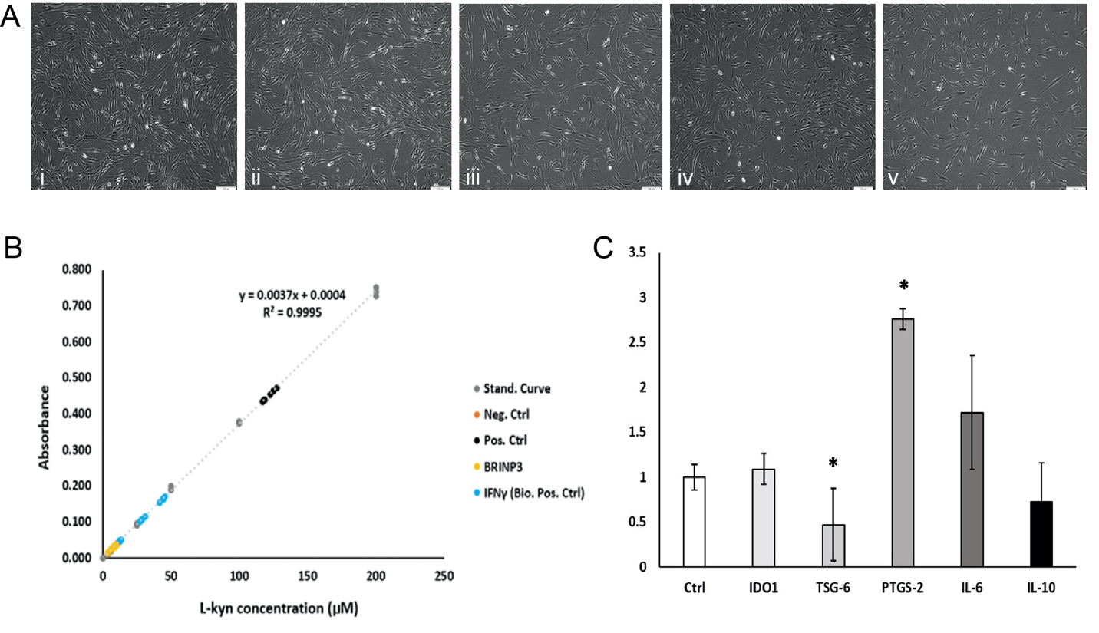
Fig. S10. BRINP3 as licensing factor for MSCs. (A): Morphology of control (i) and licensed hBM-MSCs (ii-v) with BRINP3 at corresponding concentrations of 10, 25, 50 and 100 ng/ml. All images were taken after 96 h of cultures. (B): IDO assay. The evaluation of the IDO production was assessed on the supernatants of cells licensed with IFNγ as positive control and BRINP3, after 96 h of cultures (72 h of exposure to the licensing factors). (C): qRT-PCR expression of anti-inflammatory genes after licensing with BRINP3 at 50 ng/ml. In each graph different expression results of five anti-inflammatory genes results are showed (IDO1, TSG-6, PTGS-2, IL-6, IL-10). Sample defined as “Ctrl” refers to unlicensed cell cultures used as controls. Results are represented as mean values ± SD of 3 independent experiments (3 donors). Ct values have been normalized to an unlicensed control and to a housekeeping gene (ACTB) prior the calculations of the ΔΔCt values. Results were considered significant when p-value was below 0.05.

Missing Gene | Matching Synonym
Ecrg4 | 1500015O10Rik
wisp2 | Ccn5
Siglec10 | Siglecg
Ero1b | Ero1lb
Nov | Ccn3
Ctgf | Ccn2
Chi3l1 | Chil1
Txn | Txn1
Cyr61 | Ccn1
Plac9 | Plac9b
C4bpa | C4bp
Dnase2b | Dnase2a
Lilrb3 | Pirb
Mtnd4 | mt-nd4
Mtnd6 | mt-nd4
Il4r | Il4ra
Gsdmdc1 | Gsdmd
Pigy | Pyurf
Mic13 | 2410015M20Rik
2610524H06Rik | 1500011B03Rik
Tmem167a | Tmem167
Gpi | Gpi1
Ca12 | Car12
Ugt1a6 | Ugt1a6a
Kitlg | Kitl
Ca11 | Car11
Table S12: Mismatched gene names between Ensemble annotation and symbols from expression data

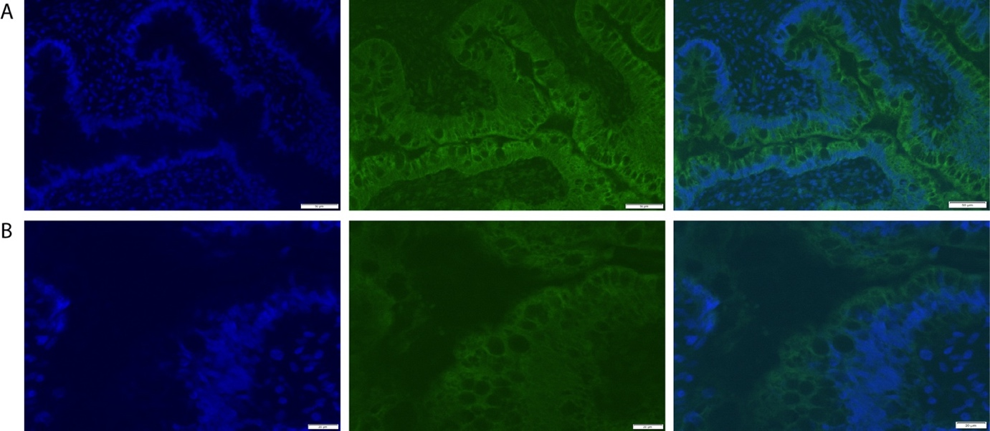

Fig. S11. Expression of BRINP3 in human teratomas at low magnification (A) and high magnification (B) images for antibody validation

