# Evaluation of nutrient loads conveyed to the deep subalpine lakes of Northern Italy through their main tributaries

Paolo Dezuanni1,2*,**, Diego Copetti3, Claudia Dresti2, Nicolò Pella1,2, Fabio Buzzi4, Andrea Fenocchi1,2

1Department of Civil Engineering and Architecture, University of Pavia, Pavia, Italy, 2National Research Council, Water Research Institute (CNR-IRSA), Verbania, Italy, 3National Research Council, Water Research Institute (CNR-IRSA), Brugherio, Italy, 4Department of Lecco, Regional Environmental Protection Agency of Lombardia (ARPA Lombardia), Oggiono, Italy

*present address: Department of Civil and Environmental Engineering, Politecnico di Milano, Milan, Italy

**e-mail corresponding author: [paolo.dezuanni@polimi.it](mailto:paolo.dezuanni@polimi.it)

## SUPPLEMENTARY MATERIAL

### S1: Time series of the annual mean discharges of the MTs

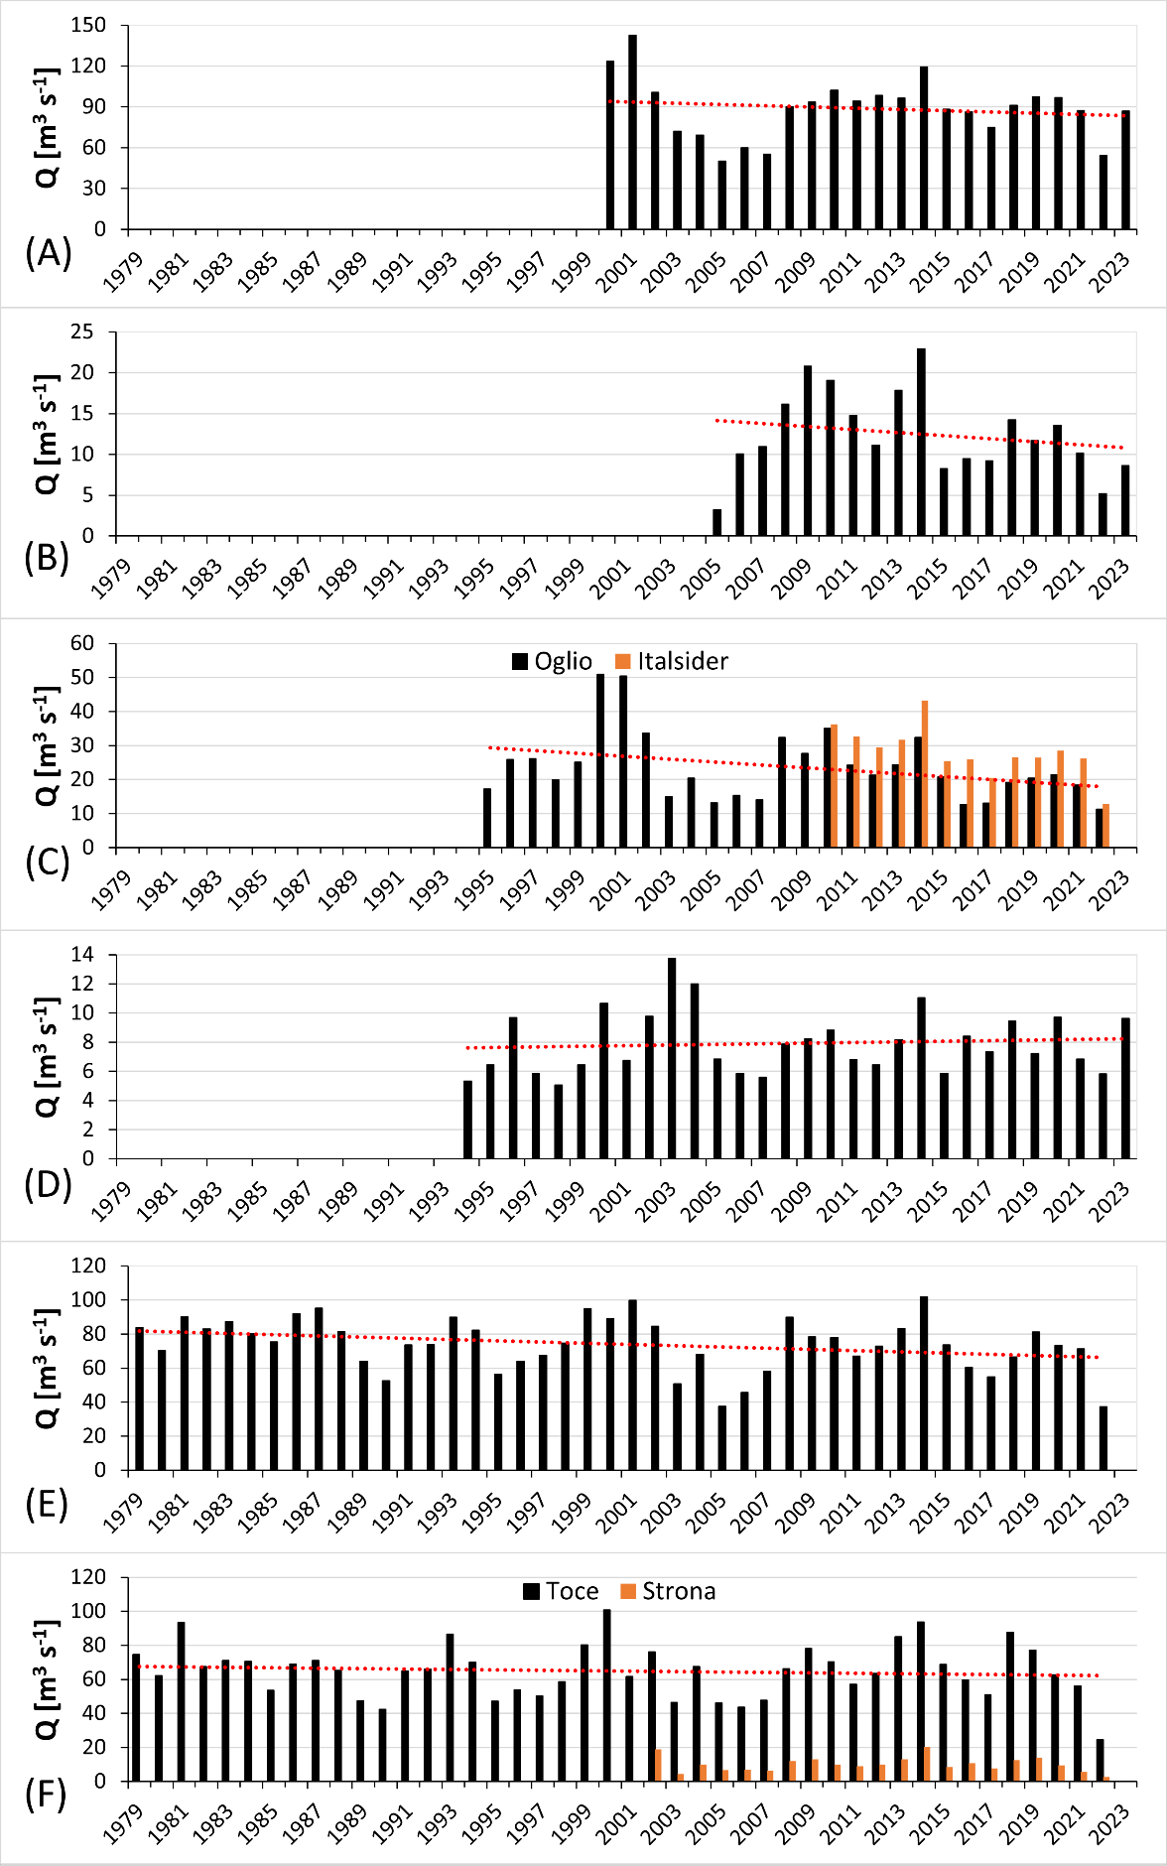

*Attachment 1:* Time series of the annual mean discharges for: *Adda River* (A), *Chiese River* (B), *Oglio River (with Italsider industrial channel)* (C), *Sarca River* (D), *Ticino River* (E), *Toce River (with Strona River)* (F) (the red dashed lines report the linear trends of the load series; *the trends for the Oglio River and Toce River don’t consider the industrial channel Italsider and the Strona River, respectively*).

### S2: Comparison of measured nutrient concentrations between the natural Oglio River and the Italsider industrial channel

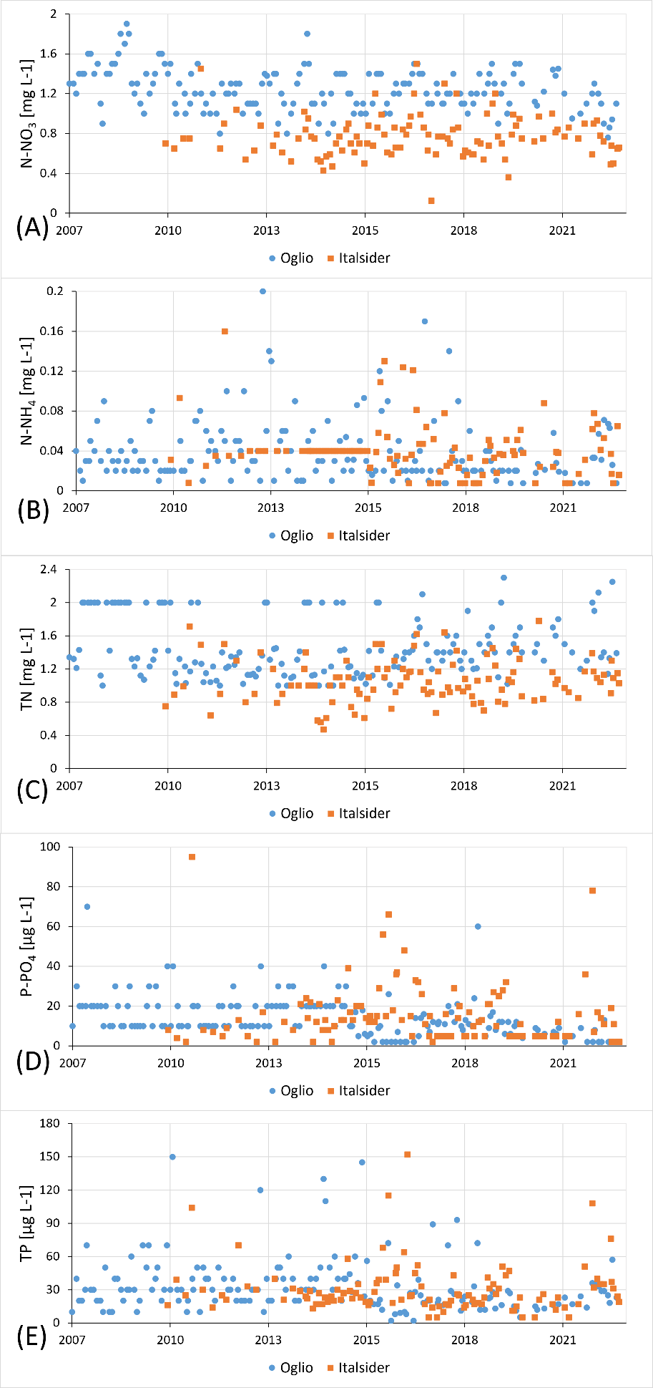

*Attachment 2*: Measured concentrations of *N-NO3* (A), *N-NH4*(B), *TN* (C), *P-PO4* (D), *TP* (E) for the natural Oglio River and the Italsider channel (data provided by ARPA Lombardia).

### S3: Statistical features and absolute and normalized linear trends of mean annual discharges and of cumulated annual nutrient loads of the considered MTs over 2008-2022

|  |  |  |  |  |  |  |  |  |  |  |  |  |  |  |
| --- | --- | --- | --- | --- | --- | --- | --- | --- | --- | --- | --- | --- | --- | --- |
| **Adda** | **Q [m3 s-1]** | **N-NO3** | **N-NH4** | **TN** | **P-PO4** | **TP** | **Chiese** | **Q [m3 s-1]** | **N-NO3** | **N-NH4** | **TN** | **P-PO4** | **TP** | **Unit** |
| Max | 119.4 | 2368.7 | 571.1 | 3706.0 | 68.9 | 109.4 | Max | 22.9 | 622.0 | 67.2 | 781.6 | 12.2 | 22.2 | [t a-1] |
| 2014 | 2001 | 2001 | 2001 | 2001 | 2001 | 2014 | 2014 | 2014 | 2014 | 2014 | 2014 | - |
| Min | 54.3 | 891.3 | 157.6 | 1691.7 | 19.7 | 42.8 | Min | 5.2 | 139.3 | 14.5 | 171.5 | 3.5 | 6.3 | [t a-1] |
| 2022 | 2022 | 2017 | 2005 | 2022 | 2022 | 2022 | 2022 | 2022 | 2022 | 2006 | 2022 | - |
| Mean | 91.4 ±13.58 | 1599.8 ±275.26 | 192.5 ±20.11 | 2941.8  ±322.08 | 33.3  ±6.77 | 64.7  ±9.41 | Mean | 13.6  ±4.85 | 366.5  ±133.40 | 39.3  ±14.54 | 458.2  ±169.57 | 7.6  ±2.12 | 13.1  ±4.01 | [t a-1] |
| Abs. trend | -4E-03 | -1E-01 | -7E-03 | -8E-03 | -4E-03 | -5E-03 | Abs. trend | -2E-03 | -5E-02 | -6E-03 | -7E-02 | -5E-05 | -7E-04 | [t a-2] |
| Norm. trend | -4E-05 | -8E-05 | -4E-05 | -3E-06 | -1E-04 | -8E-05 | Norm. trend | -1E-04 | -1E-04 | -1E-04 | -1E-04 | -7E-06 | -5E-05 | [a-1] |
| **Oglio** | **Q [m3 s-1]** | **N-NO3** | **N-NH4** | **TN** | **P-PO4** | **TP** | **Sarca** | **Q [m3 s-1]** | **N-NO3** | **N-NH4** | **TN** | **P-PO4** | **TP** | **Unit** |
| Max | 35.0 | 1315.8 | 61.8 | 1510.2 | 23.0 | 104.5 | Max | 11.1 | 343.4 | 16.2 | 627.8 | 6.1 | 21.9 | [t a-1] |
| 2011 | 2010 | 2010 | 2008 | 2010 | 2010 | 2014 | 2014 | 2014 | 2023 | 2023 | 2020 | - |
| Min | 12.6 | 414.8 | 14.2 | 535.4 | 2.9 | 11.2 | Min | 5.8 | 168.7 | 3.8 | 185.0 | 1.9 | 4.3 | [t a-1] |
| 2017 | 2022 | 2022 | 2016 | 2022 | 2022 | 2022 | 2022 | 2008 | 2015 | 2015 | 2015 | - |
| Mean | 22.5  ±6.74 | 832.9  ±279.41 | 35.5  ±14.07 | 971.9  ±295.07 | 11.4  ±5.68 | 40.9  ±23.23 | Mean | 7.9  ±1.43 | 231.1  ±43.46 | 10.3  ±3.90 | 302.6  ±61.71 | 2.9  ±0.97 | 8.2  ±4.68 | [t a-1] |
| Abs. trend | -2E-03 | -1E-01 | -7E-03 | -1E-01 | -3E-03 | -1E-02 | Abs. trend | -1E-04 | -6E-03 | 2E-03 | 3E-03 | 3E-04 | 1E-03 | [t a-2] |
| Norm. trend | -8E-05 | -2E-04 | -2E-04 | -1E-04 | -3E-04 | -2E-04 | Norm. trend | -1E-05 | -3E-05 | 2E-04 | 1E-05 | 1E-04 | 2E-04 | [a-1] |
| **Ticino** | **Q [m3 s-1]** | **N-NO3** | **N-NH4** | **TN** | **P-PO4** | **TP** | **Overall Toce** | **Q [m3 s-1]** | **N-NO3** | **N-NH4** | **TN** | **P-PO4** | **TP** | **Unit** |
| Max | 101.9 | 2414.2 | 168.8 | 2888.8 | 33.5 | 74.4 | Max | 114.1 | 2464.0 | 161.7 | 2922.9 | 43.8 | 68.0 | [t a-1] |
| 2014 | 2001 | 1979 | 2001 | 1981 | 1981 | 2014 | 2014 | 2014 | 2014 | 2014 | 2014 | - |
| Min | 37.2 | 812.3 | 21.2 | 938.7 | 4.4 | 8.2 | Min | 27.2 | 439.9 | 52.7 | 591.5 | 16.5 | 25.1 | [t a-1] |
| 2022 | 2022 | 2022 | 2022 | 2005 | 2022 | 2022 | 2022 | 2022 | 2022 | 2022 | 2022 | - |
| Mean | 72.7  ±14.59 | 1679.0  ±359.19 | 36.8  ±7.72 | 1922.4  ±416.58 | 10.4  ±2.68 | 16.6  ±3.88 | Mean | 77.3  ±20.02 | 1575.4  ±464.84 | 116.5  ±23.15 | 1920.5  ±540.56 | 32.1  ±6.15 | 50.1  ±9.73 | [t a-1] |
| Abs. trend | -5E-03 | -1E-01 | -3E-03 | -2E-01 | -7E-04 | -1E-03 | Abs. trend | -5E-03 | -2E-01 | -5E-03 | -2E-01 | -9E-04 | -1E-03 | [t a-2] |
| Norm. trend | -7E-05 | -9E-05 | -7E-05 | -9E-05 | -7E-05 | -8E-05 | Norm. trend | -6E-05 | -1E-04 | -4E-05 | -1E-04 | -3E-05 | -3E-05 | [a-1] |

*Attachment 3: Statistical features and absolute and normalized linear trends of mean annual discharges and of cumulated annual nutrient loads of the considered MTs over the common data availability period 2008-2022 (the Italsider channel is not included, water quality data for it being available from 2014 onwards only).*