Supplementary Figure

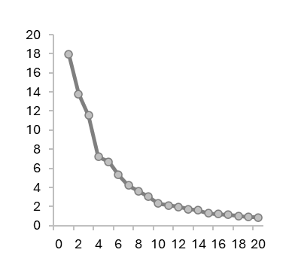

Explained variance

(%)

Principal component

**Supplementary Figure 1**. Scree plot of principal component analysis (PCA), showing the variance explained by each principal component.