Supplementary Material

# Supplementary Data

All the original sequences used in the article have been uploaded to the NCBI official website with the serial number PRJNA1133986.

# Supplementary Figures

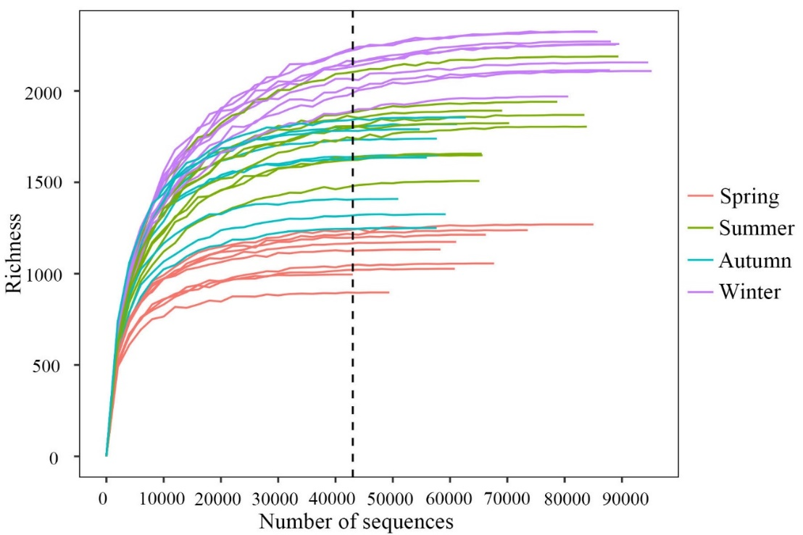

Supplementary Figure 1. Dilution curves of bacterial communities in sediment samples (Richness)

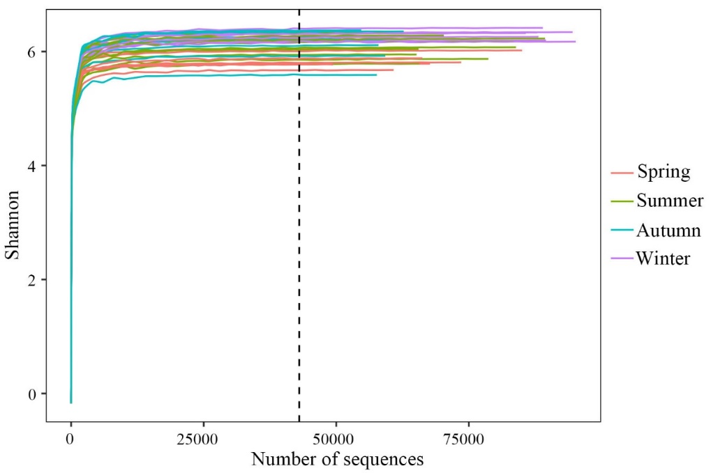

Supplementary Figure 2. Dilution curves of bacterial communities in sediment samples (Shannon)

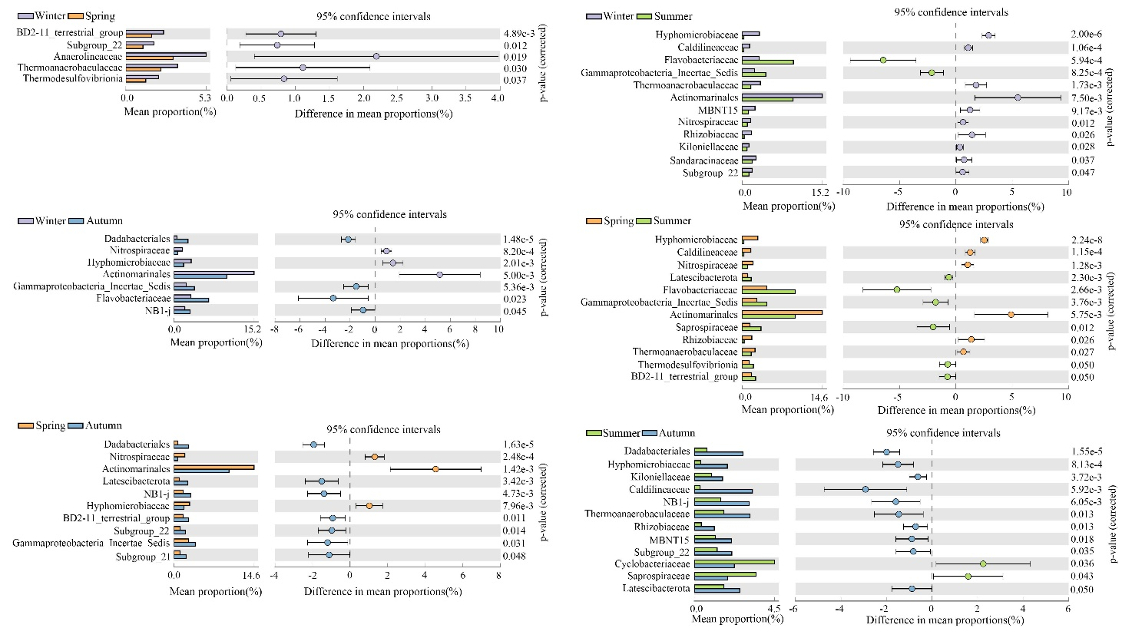

Supplementary Figure 3. Bacteria families with significant differences in relative abundance between seasons

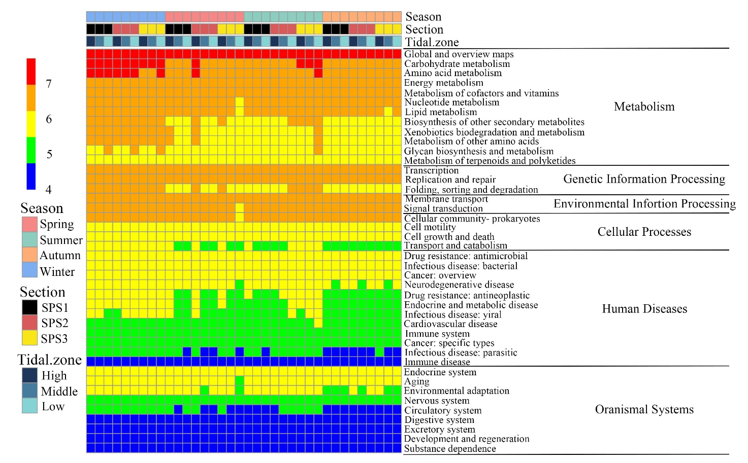

Supplementary Figure 4. Heatmap showing the distributions of bacterial functions that were assigned by PICRUSt2 across season

# Supplementary Tables

Supplementary Table 1. Bacterial community diversity index of mangrove sediments in this study

|  |  |  |  |  |  |  |
| --- | --- | --- | --- | --- | --- | --- |
| Season | Sample | Richness | Shannon | Simpson | Pielou | goods_coverage |
| Winter | S1H2111 | 2114 | 9.138 | 0.996 | 0.827 | 1 |
| S1M2111 | 2323 | 9.121 | 0.994 | 0.816 | 1 |
| S1L2111 | 2156 | 9.148 | 0.994 | 0.826 | 1 |
| S2H2111 | 2254 | 9.254 | 0.995 | 0.831 | 1 |
| S2M2111 | 2326 | 9.130 | 0.995 | 0.816 | 1 |
| S2L2111 | 2109 | 8.906 | 0.993 | 0.807 | 1 |
| S3H2111 | 1970 | 8.926 | 0.994 | 0.816 | 1 |
| S3M2111 | 2271 | 9.029 | 0.993 | 0.810 | 1 |
| S3L2111 | 2257 | 8.934 | 0.994 | 0.802 | 1 |
| Spring | S1H2205 | 1056 | 8.345 | 0.993 | 0.831 | 1 |
| S1M2205 | 1132 | 8.725 | 0.995 | 0.860 | 1 |
| S1L2205 | 1174 | 8.348 | 0.990 | 0.819 | 1 |
| S2H2205 | 1269 | 8.681 | 0.994 | 0.842 | 1 |
| S2M2205 | 897 | 8.327 | 0.994 | 0.849 | 1 |
| S2L2205 | 1027 | 8.188 | 0.988 | 0.818 | 1 |
| S3H2205 | 1238 | 8.380 | 0.989 | 0.816 | 1 |
| S3M2205 | 1213 | 8.485 | 0.992 | 0.828 | 1 |
| S3L2205 | 995 | 8.333 | 0.993 | 0.837 | 1 |
| Summer | S1H2208 | 1507 | 8.580 | 0.993 | 0.813 | 1 |
| S1M2208 | 1657 | 8.717 | 0.993 | 0.815 | 1 |
| S1L2208 | 1648 | 8.352 | 0.988 | 0.782 | 1 |
| S2H2208 | 1892 | 9.125 | 0.995 | 0.838 | 1 |
| S2M2208 | 1824 | 9.060 | 0.995 | 0.836 | 1 |
| S2L2208 | 1941 | 8.469 | 0.987 | 0.775 | 1 |
| S3H2208 | 1869 | 8.923 | 0.994 | 0.821 | 1 |
| S3M2208 | 1805 | 8.763 | 0.993 | 0.810 | 1 |
| S3L2208 | 2189 | 8.983 | 0.992 | 0.810 | 1 |
| Autumn | S1H2211 | 1739 | 9.034 | 0.993 | 0.839 | 1 |
| S1M2211 | 1635 | 9.153 | 0.996 | 0.857 | 1 |
| S1L2211 | 1649 | 8.816 | 0.991 | 0.825 | 1 |
| S2H2211 | 1818 | 8.956 | 0.992 | 0.827 | 1 |
| S2M2211 | 1409 | 8.973 | 0.995 | 0.858 | 1 |
| S2L2211 | 1250 | 8.065 | 0.984 | 0.784 | 1 |
| S3H2211 | 1325 | 8.548 | 0.993 | 0.824 | 1 |
| S3M2211 | 1790 | 9.193 | 0.994 | 0.851 | 1 |
| S3L2211 | 1855 | 9.163 | 0.994 | 0.844 | 1 |

Supplementary Table 2. Sedimentary environmental parameters of different seasons at each sampling site in this study

|  |  |  |  |  |  |  |  |  |  |  |  |  |
| --- | --- | --- | --- | --- | --- | --- | --- | --- | --- | --- | --- | --- |
| Sample | Date | Longitude (E) | Latitude (N) | Temperature (℃) | Salinity (ppt) | pH | Clay (%) | Silt (%) | Sand (%) | TN (mg/g) | TC (mg/g) | TC/TN |
|
| S1H2111 | 2021.12.04 | 120°51'58.92" | 27°56'55.17" | 13.90 | 18.95 | 7.78 | 34.23 | 59.72 | 6.04 | 1.265 | 12.621 | 9.976 |
| S1M2111 | 2021.12.04 | 120°52'0.33" | 27°56'56.14" | 14.50 | 20.97 | 7.82 | 33.20 | 57.76 | 9.03 | 1.217 | 13.419 | 11.025 |
| S1L2111 | 2021.12.04 | 120°52'1.42" | 27°56'56.68" | 14.40 | 18.16 | 7.86 | 35.76 | 62.92 | 1.31 | 1.014 | 11.956 | 11.789 |
| S2H2111 | 2021.12.04 | 120°51'42.09" | 27°57'4.84" | 14.50 | 18.63 | 7.75 | 33.94 | 58.77 | 7.28 | 1.075 | 12.191 | 11.344 |
| S2M2111 | 2021.12.04 | 120°51'43.23" | 27°57'6.15" | 13.50 | 20.80 | 7.88 | 37.83 | 62.17 | 0.00 | 1.317 | 13.481 | 10.234 |
| S2L2111 | 2021.12.04 | 120°51'46.03" | 27°57'8.93" | 14.30 | 17.05 | 7.98 | 32.07 | 67.74 | 0.18 | 0.983 | 11.187 | 11.381 |
| S3H2111 | 2021.12.04 | 120°51'26.54" | 27°57'15.06" | 13.30 | 22.05 | 7.69 | 37.86 | 60.92 | 1.21 | 1.085 | 11.404 | 10.507 |
| S3M2111 | 2021.12.04 | 120°51'27.00" | 27°57'16.92" | 13.20 | 20.73 | 7.97 | 37.17 | 62.36 | 0.46 | 1.274 | 15.037 | 11.804 |
| S3L2111 | 2021.12.04 | 120°51'28.61" | 27°57'18.61" | 13.80 | 25.67 | 7.37 | 34.48 | 64.75 | 0.76 | 1.204 | 13.494 | 11.210 |
| S1H2205 | 2022.05.15 | 120°51'59.14" | 27°56'55.06" | 18.90 | 12.08 | 7.17 | 39.72 | 58.94 | 1.33 | 1.250 | 14.324 | 11.464 |
| S1M2205 | 2022.05.15 | 120°52'0.31" | 27°56'56.04" | 18.80 | 13.16 | 7.05 | 40.60 | 59.21 | 0.98 | 1.213 | 14.003 | 11.548 |
| S1L2205 | 2022.05.15 | 120°52'2.05" | 27°56'56.43" | 18.30 | 11.97 | 7.33 | 39.64 | 59.74 | 0.61 | 1.095 | 12.205 | 11.151 |
| S2H2205 | 2022.05.15 | 120°51'41.81" | 27°57'4.87" | 19.30 | 12.86 | 7.05 | 40.81 | 58.38 | 0.80 | 1.171 | 13.008 | 11.108 |
| S2M2205 | 2022.05.15 | 120°51'43.10" | 27°57'5.86" | 19.60 | 12.73 | 7.17 | 40.18 | 59.22 | 0.59 | 1.144 | 12.675 | 11.080 |
| S2L2205 | 2022.05.15 | 120°51'45.63" | 27°57'9.26" | 18.10 | 10.84 | 7.46 | 39.66 | 58.30 | 2.03 | 1.037 | 12.194 | 11.758 |
| S3H2205 | 2022.05.15 | 120°51'25.06" | 27°57'16.29" | 17.80 | 11.29 | 7.59 | 36.35 | 63.21 | 0.43 | 1.284 | 13.481 | 10.498 |
| S3M2205 | 2022.05.15 | 120°51'25.77" | 27°57'17.06" | 17.20 | 11.24 | 7.64 | 38.50 | 60.94 | 0.55 | 1.269 | 13.492 | 10.636 |
| S3L2205 | 2022.05.15 | 120°51'27.29" | 27°57'19.39" | 18.50 | 18.73 | 6.85 | 41.51 | 57.11 | 1.37 | 1.049 | 11.626 | 11.081 |
| S1H2208 | 2022.08 | 120°51'58.98" | 27°56'54.63" | 29.80 | 14.50 | 7.63 | 43.33 | 56.67 | 0.00 | 1.300 | 14.265 | 10.972 |
| S1M2208 | 2022.08 | 120°52'1.64" | 27°56'57.03" | 30.00 | 25.30 | 7.91 | 32.36 | 67.27 | 0.37 | 0.910 | 12.718 | 13.973 |
| S1L2208 | 2022.08 | 120°52'2.05" | 27°56'56.43" | 30.60 | 21.10 | 7.32 | 35.44 | 64.45 | 0.10 | 1.035 | 11.739 | 11.337 |
| S2H2208 | 2022.08 | 120°51'46.54" | 27°57'2.28" | 31.40 | 23.90 | 8.66 | 41.64 | 57.96 | 0.39 | 1.387 | 14.272 | 10.290 |
| S2M2208 | 2022.08 | 120°51'45.84" | 27°57'4.53" | 30.02 | 22.30 | 8.78 | 38.98 | 60.14 | 0.87 | 1.213 | 14.695 | 12.119 |
| S2L2208 | 2022.08 | 120°51'48.46" | 27°57'7.66" | 29.20 | 19.00 | 7.81 | 37.38 | 61.27 | 1.34 | 1.015 | 11.284 | 11.118 |
| S3H2208 | 2022.08 | 120°51'25.34" | 27°57'15.21" | 39.30 | 22.50 | 8.26 | 40.30 | 58.70 | 1.00 | 1.156 | 12.406 | 10.734 |
| S3M2208 | 2022.08 | 120°51'25.91" | 27°57'16.35" | 31.02 | 21.90 | 7.69 | 39.11 | 58.66 | 2.23 | 1.091 | 11.440 | 10.482 |
| S3L2208 | 2022.08 | 120°51'27.26" | 27°57'18.35" | 30.10 | 19.70 | 7.62 | 39.31 | 60.09 | 0.59 | 1.061 | 11.829 | 11.145 |
| S1H2211 | 2022.10.30 | 120°51'59.14" | 27°56'55.06" | 19.10 | 33.80 | 7.53 | 35.20 | 64.80 | 0.00 | 1.171 | 11.911 | 10.168 |
| S1M2211 | 2022.10.30 | 120°52'0.31" | 27°56'56.04" | 19.80 | 32.00 | 7.44 | 39.95 | 56.77 | 3.28 | 1.002 | 11.305 | 11.282 |
| S1L2211 | 2022.10.30 | 120°52'15.57" | 27°56'46.56" | 19.90 | 26.60 | 8.08 | 39.45 | 59.36 | 1.18 | 1.027 | 12.286 | 11.962 |
| S2H2211 | 2022.10.30 | 120°51'41.81" | 27°57'4.87" | 19.50 | 32.50 | 7.28 | 36.66 | 63.34 | 0.00 | 1.186 | 12.377 | 10.433 |
| S2M2211 | 2022.10.30 | 120°51'43.10" | 27°57'5.86" | 20.60 | 30.30 | 7.24 | 40.90 | 59.10 | 0.00 | 1.093 | 11.560 | 10.580 |
| S2L2211 | 2022.10.30 | 120°52'3.16" | 27°56'54.90" | 20.10 | 26.70 | 8.08 | 42.80 | 57.20 | 0.00 | 1.012 | 12.205 | 12.062 |
| S3H2211 | 2022.10.30 | 120°51'25.06" | 27°57'16.29" | 19.80 | 35.60 | 7.33 | 35.26 | 64.46 | 0.28 | 1.756 | 21.749 | 12.386 |
| S3M2211 | 2022.10.30 | 120°51'25.77" | 27°57'17.06" | 20.00 | 33.30 | 7.30 | 41.32 | 58.18 | 0.50 | 1.012 | 11.373 | 11.235 |
| S3L2211 | 2022.10.30 | 120°51'27.29" | 27°57'19.39" | 20.80 | 23.40 | 7.95 | 37.51 | 61.30 | 1.18 | 0.980 | 11.171 | 11.405 |