Supplementary Material

# Supplementary method: Phase image of MCXI

The phase of the move contrast refers to the time sequence and rate of grayscale variation resulting from media movement among the detector pixels. The grayscale value of one of the projected images at time *t* and position (*x*0, *y*0) isexpressed asa function *g* (*x*0, *y*0, *t*). After a period Δ*t*, the media of interest moves to the next position (*x*1, *y*1). If the time interval is short enough and (*x*1, *y*1) is close to (*x*0, *y*0), grayscale value at (*x*0, *y*0) can be assumed ‘transmitted’ to (*x*1, *y*1), and we have:

 (5)

Based on Euler formula, we can deduce that the amplitude of *G* (*x*1, *y*1, *k*) remains the same as *G* (*x*0, *y*0, *k*), while a phase shift of 2π*kΔt*/*tN* is introduced. Referring to Eq. (5), we have:

 (6)

According to Eq. (6), the phase distribution *φ*(*x*, *y*, *k*) in the real space (*x*, *y*) represents the time sequence of movement for the media of interest at a frequency *k*. For points located at the track of media movement, the moving direction and speed can be obtained according to the phase difference between these two points. For points that no media passes through, *φ*(*x*, *y*, *k*) signifies nothing but random noises. Taken together, the phase image *φ*(*x*, *y*, *k*) reveals the direction of media of interest surrounded by random noises, as long as media movement occurs at the time domain frequency *k*. Referring to the interested frequency components of amplitude *AIFC*(*x, y*)as shown in Eq. (4), the correspondent *φIFC*(*x*, *y*) is also obtained by selecting a typical frequency *ka*among the specified frequency band (*kL*, *kU*). *φIFC*(*x*, *y*) undergoes a continuous change along the moving direction, whereas the media of interest moves through a point (*x*, *y*) in real space. In common cases, the media of interest move at various speeds, and *ka* is usually located in a time-domain frequency band. Furthermore, if the locations and phase values of two points in Eq. (6) is known, the average velocity during transport can be calculated using the following formula:

$\bar{v}=\frac{2πkS}{[φ(x_{0},y_{0},k)-φ(x_{1},y_{1},k)]∙t_{N}}$ (7)

Where S is the spatial distance between (*x*0, *y*0) and (*x*1, *y*1). For specific cases, such as water-refilling cavitated vessels in plants, the typical frequency *ka=*1 because, in this case, the grayscale variation is a step signal. Correspondently, the step signal of *φIFC*(*x*, *y*) from π to -π corresponds to the chronological order of frontends of water movement.

# Supplementary Figures

## Supplementary Figure S1: CNR comparison between TXI and MCXI

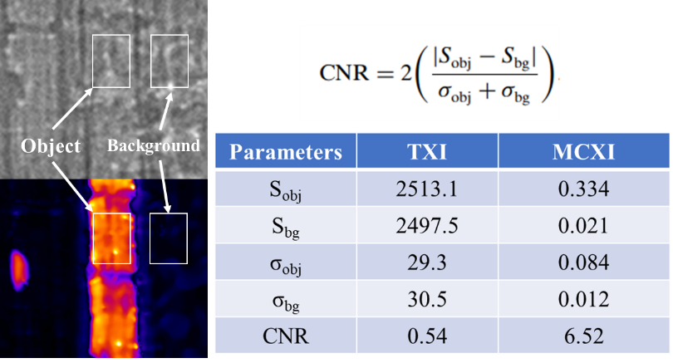

**Supplementary Figure S1**: **CNR comparison between TXI and MCXI**. Calculation of the CNR value using the same object section and background section in TXI and MCXI.

In order to calculate the CNR value of the TXI and MCXI, sections contains only object and only background was selected as shown in white rectangles in **Figure S1**. According to the CNR formula (Lovric G, et al., 2013), the average value of the object section (Sobj), the average value of the background section (Sbg), the standard deviation of the object section (σobj) and the standard deviation of the background section (σbg) are measured and given in the table. Finally, the CNR value of TXI is 0.54, while the CNR value of MCXI is 6.52, which is 12 times larger than TXI.

## Supplementary Figure S1: Three-dimensional microstructure of xylem vessels in a maize leaf

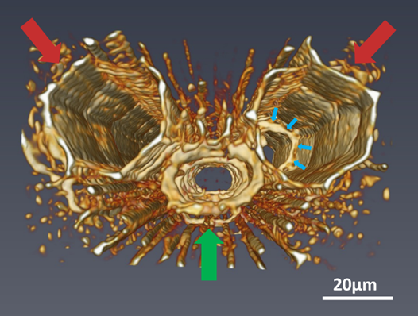

**Supplementary Figure S2**: **3D view of xylem vessels in a maize leaf by phase contrast X-ray microtomography**. Protoxylem vessel is marked with green arrow, metaxylem vessels are marked with red arrows and a node in a metaxylem vessel is also indicated with slim blue arrows.

In order to obtain three-dimensional structure of vessels in a maize leaf, a phase contrast micro- CT was conducted at BL13HB beamline of SSRF. The photon energy used is 12keV, equivalent pixel size of the detector system (20×) is 0.325μm and the distance from sample to detector is 0.1m. 1080 projections from 0 to 180°was collected with an exposure time of 2s for each projection. A software called PITRE was used for phase retrieval and slice reconstruction(Chen et al., 2012). The reconstructed slices were imported into a commercial software called Amira for three-dimensional rendering and the results are shown in **Figure S2**. A typical set of vessels in a maize leaf consists of two metaxylem vessels and one protoxylem vessel. Track of water transport imaged by MCXI is usually located in a metaxylem vessel. The nodes between sections in amplitude image of MCXI correspond to annular microstructure in metaxylem vessel (indicated by blue arrows in **Figure S2**).

## Supplementary Figure S3: Average velocity analysis on water refilling with the phase image of MCXI

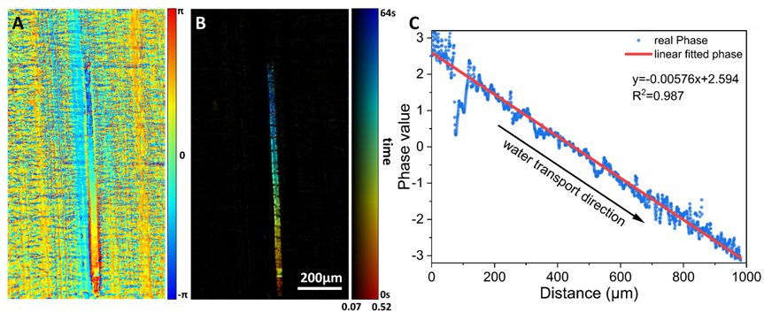

**Supplementary Figure S3: Average velocity analysis on water refilling with the phase image of MCXI. A:** Phase image of MCXI. **B:** Move contrast image including the track together with the chronological information. **C:** Phase value distribution along water refilling direction in B together with the linearly fitted line.

The phase image for water refilling along the xylem vessel is given in **Figure S3A**. By fusing the amplitude image (**Figure 2B**) with the phase image, the move contrast image is obtained as shown in **Figure S3B**, in which the color labels the sequential order of water refilling and its brightness represents the intensity of amplitude image. This means that the track of water refilling and its chronological information can be depicted simultaneously in the move contrast image of MCXI. According to the color distribution in the move contrast image (**Figure S3B**), it is obvious that the time sequence of water refilling from the bottom up is consistent with the actual situation. For quantitative analysis, the phase distribution along the water refilling direction is given in **Figure S3C** together with the linearly fitted line. According to Eq. (7), the average velocity can be calculated based on the slope of the fitted line of the phase distribution and the value is 16.8μm/s. The discontinuity of phase distribution at the position of 100μm implies that the water refilling is interrupted by water exchange between vessel and the adjacent tissues or some kind of embolism. According to the TXI image sequence, the distance of water refilling along the xylem vessel is 1,107μm in a time period of 64s. As a result, the average velocity is 17.3μm/s, which is quite close to the velocity of 16.8μm/s obtained by phase analysis. Therefore, the slope of the phase distribution of MCXI can be used for the quantitative analysis to the rate of water refilling.