***Supplementary Material***

**The olfactory hole-board test: a new paradigm to study aversion and preferences to odors in rats**

Kerstin E.A. Wernecke1,2,*, Markus Fendt1,2

*1Institute for Pharmacology and Toxicology, Otto-von-Guericke University Magdeburg, Magdeburg, Germany, 2Center for Behavioral Brain Sciences, Magdeburg, Germany*

*Correspondence:

Institute for Pharmacology and Toxicology

Otto-von-Guericke University Magdeburg

Leipziger Strasse 44

D-39120 Magdeburg, Germany

[kerstin.wernecke@med.ovgu.de](mailto:kerstin.wernecke@med.ovgu.de)

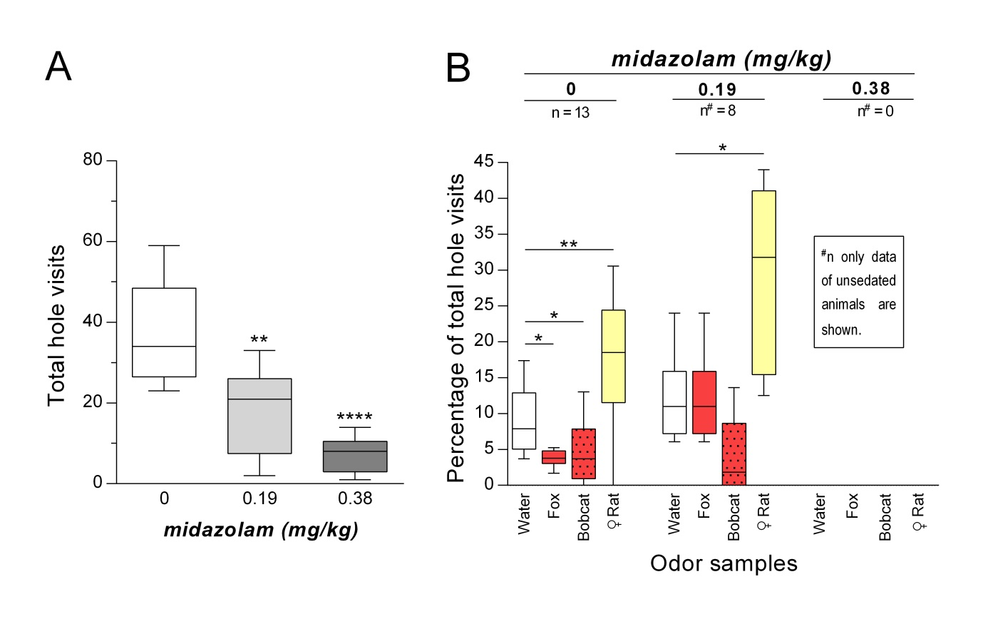

**SUPPLEMENTARY FIGURE 1 Midazolam treatment dose-dependently sedated rats (n = 13) (A)** Total number of hole visits (median) of rats after treatment with midazolam (0; 0.19; 0.38 mg/kg midazolam). **(B)** Percentages of total hole visits (median) for the different corner holes and for each treatment are shown. **p < 0.01; ****p < 0.0001 comparison to saline treatment (0 mg/kg); *p < 0.05; **p < 0.01 comparison as indicated (Holm-Sidak’s/Dunn’s multiple comparison test after significant main effects in an ANOVA/ Friedman test).