Supplementary Material

## Supplementary Figures

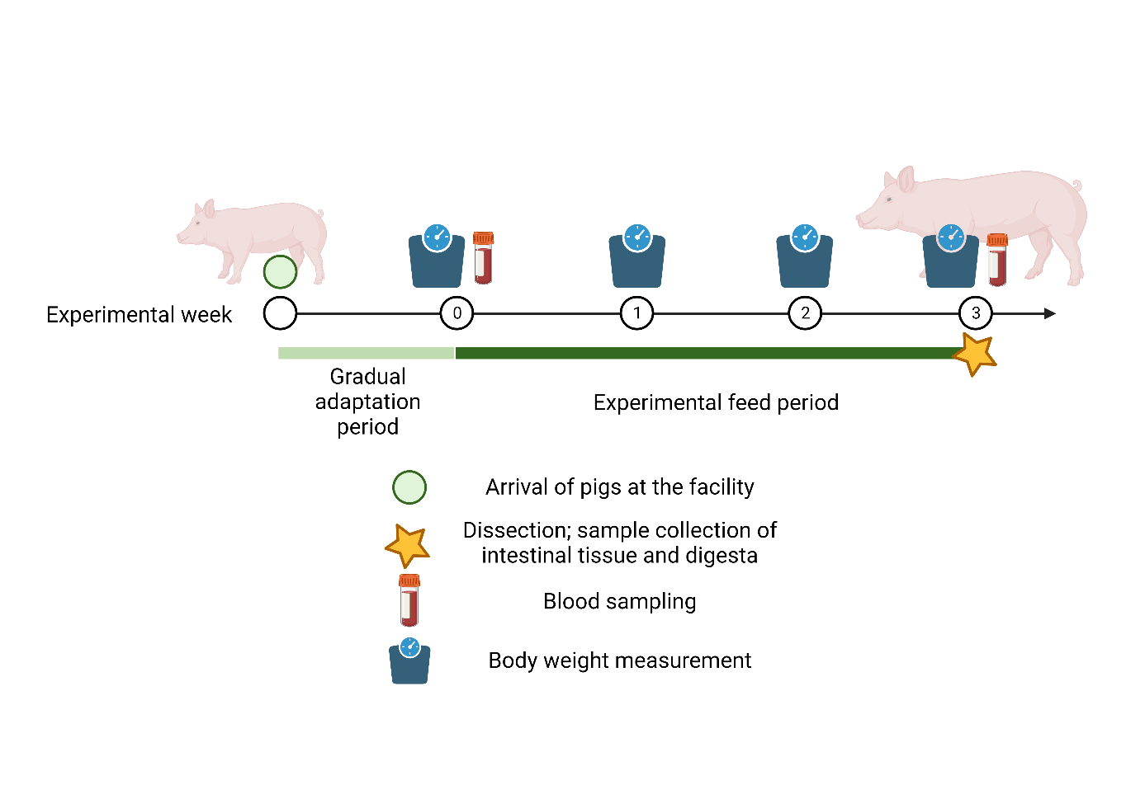

**Supplementary Figure 1.** Schematic representation of the experimental design.

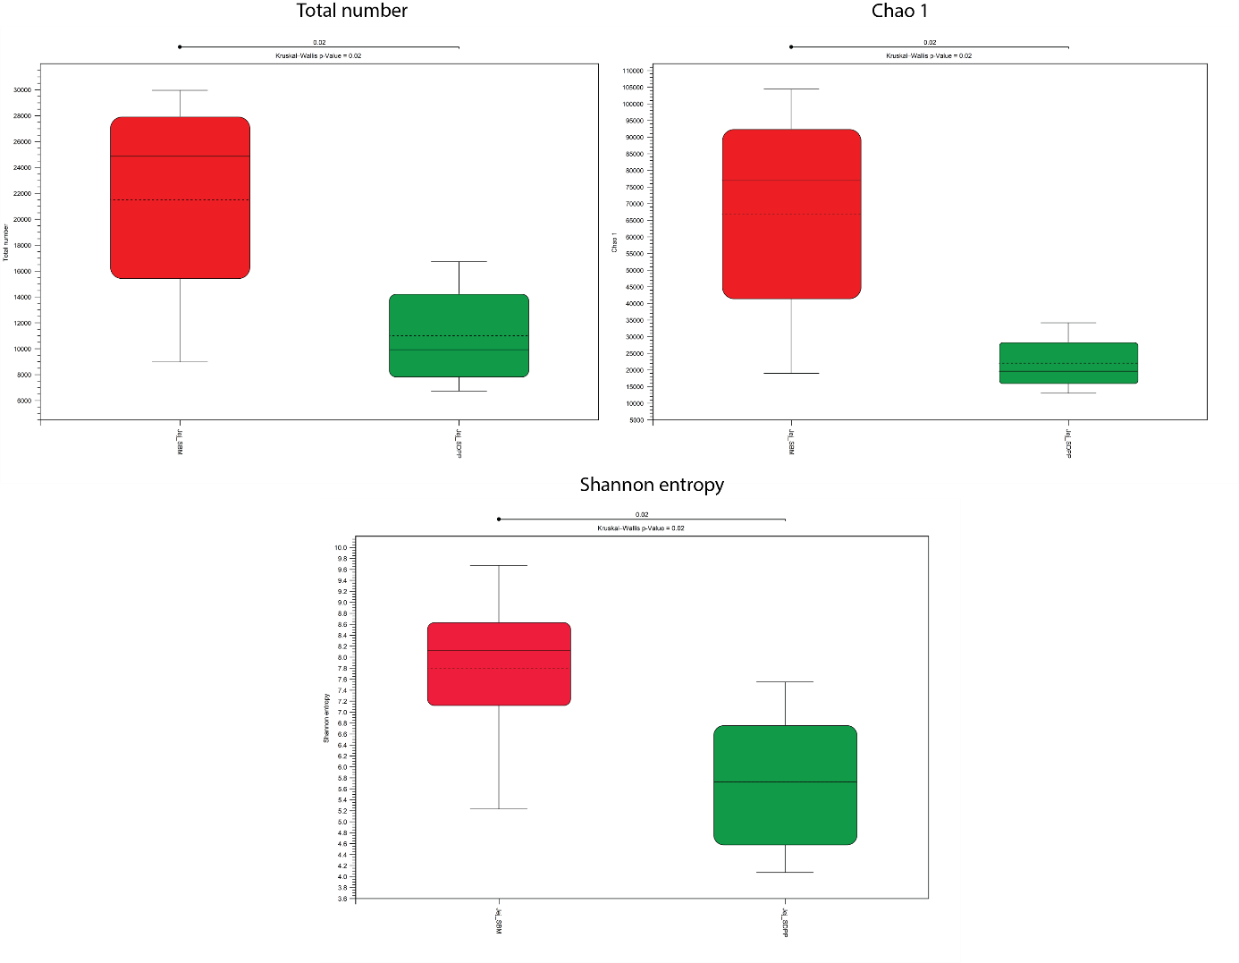**Supplementary Figure 2.** Alpha diversity metrics of the intestinal microbiome in pigs were assessed when comparing diets containing soybean meal (SBM) and spray-dried porcine plasma (SDPP). Left top panel shows the Total number of species (richness), the top right panel shows the Chao1 index, and the bottom panel shows the Shannon entropy. Where SBM is depicted in red, and SDPP in green.

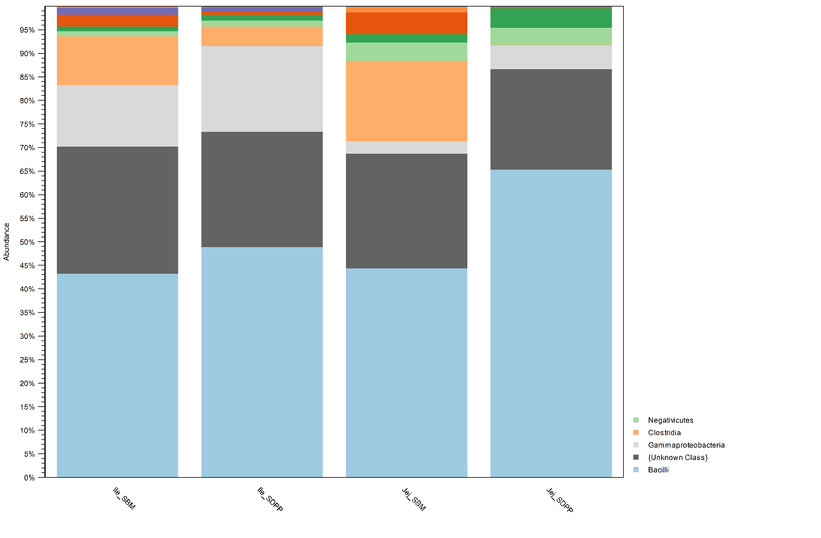**Supplementary Figure 3.** Relative abundance of most abundant phyla (A) and class (B) of bacteria in jejunal and ileal microbiome in pigs fed a soybean meal (SBM) or spray-dried porcine plasma (SDPP) based diet.

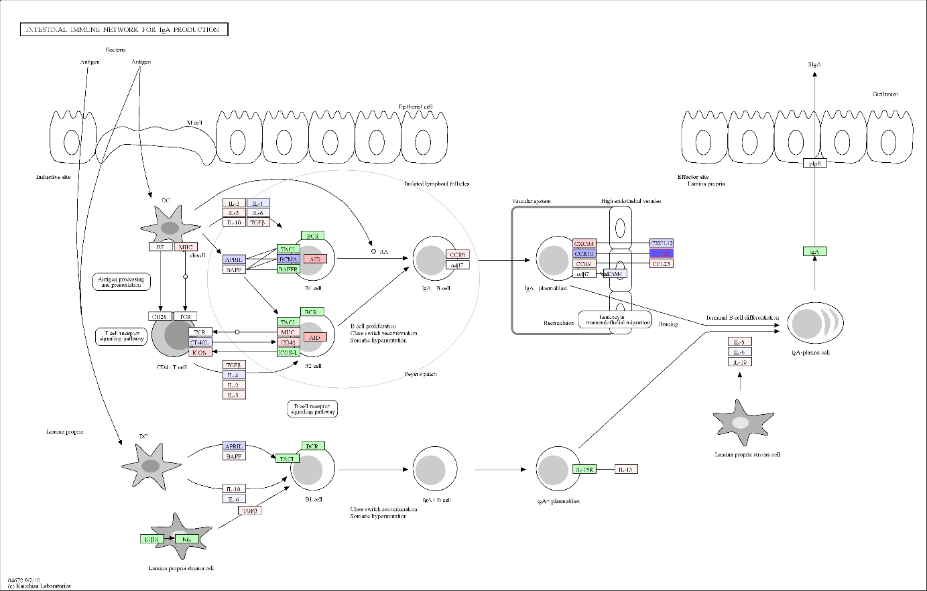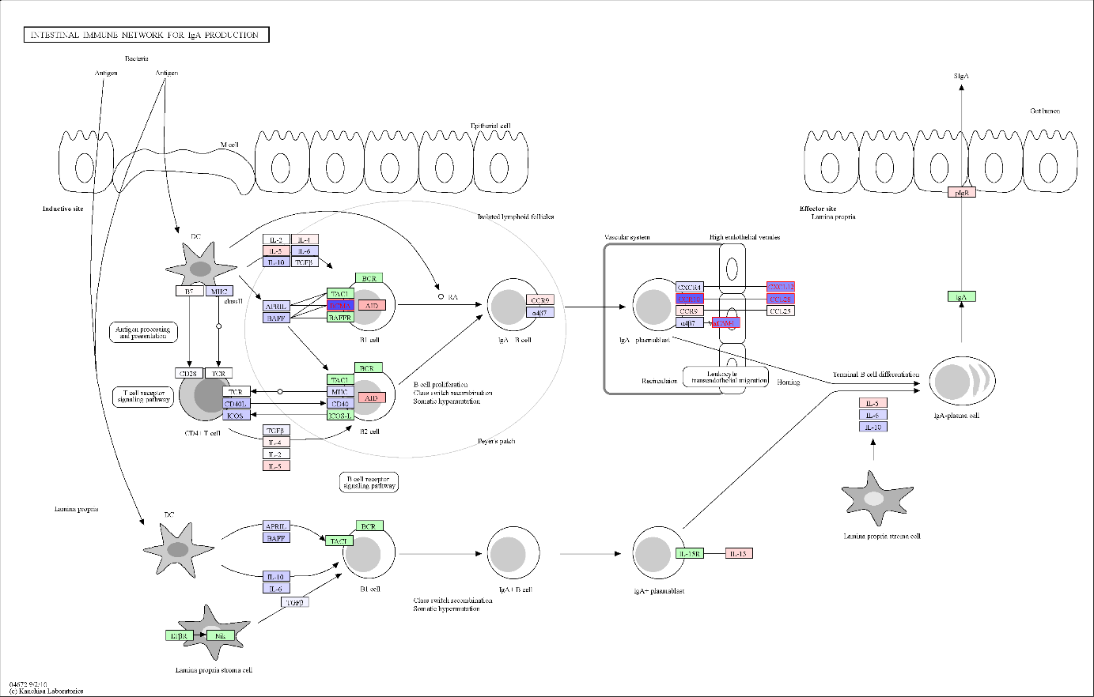**Supplementary Figure 4.** Visualized gene expression values on Intestinal immune network for IgA production pathway. Top panel shows the jejunal gene expression and lower panel the ileal gene expression depicted here shows higher expression in SDPP as red, and lower in SDPP as blue. In addition, green rectangles mean the gene was not mapped/observed in our dataset. Each rectangle represents a gene (cluster), whereas an arrow represents a known (solid) or putative (dashed) link between genes and/or biological processes, where a pointed head arrow stands for positive feedback and a blunt head arrow for negative feedback. Small circles represent compounds and rounded rectangles represent other pathways.

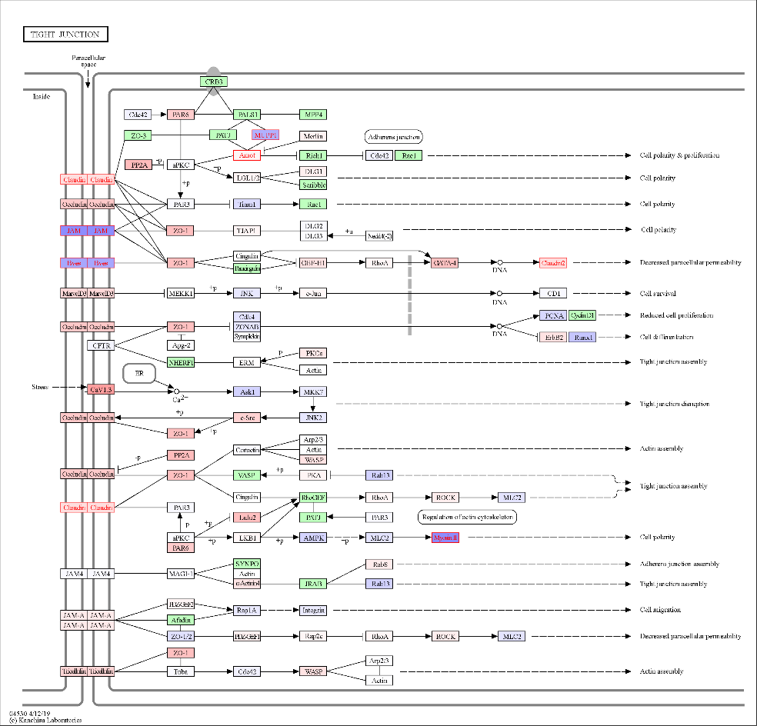

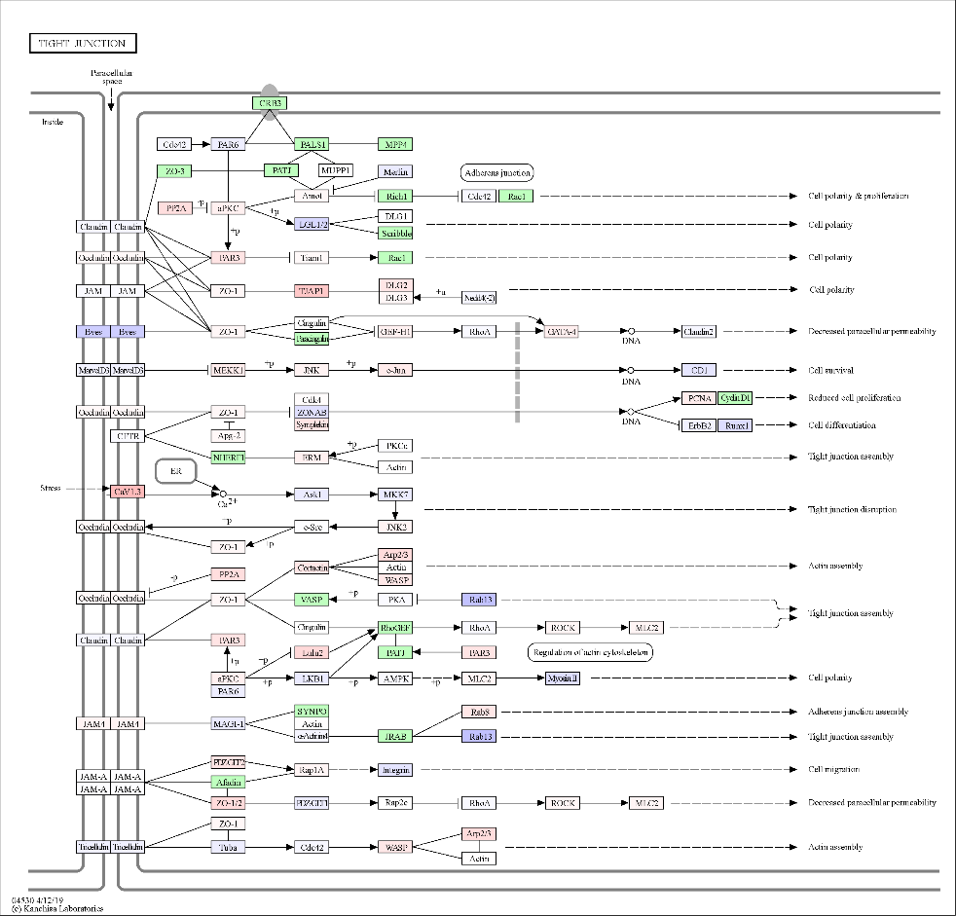

**Supplementary Figure 5.** Visualized gene expression values on Intestinal immune network for IgA production pathway. Top panel shows the jejunal gene expression and lower panel the ileal gene expression depicted here shows higher expression in SDPP as red, and lower in SDPP as blue. In addition, green rectangles mean the gene was not mapped/observed in our dataset. Each rectangle represents a gene (cluster), whereas an arrow represents a known (solid) or putative (dashed) link between genes and/or biological processes, where a pointed head arrow stands for positive feedback and a blunt head arrow for negative feedback. Small circles represent compounds and rounded A picture containing logo
rectangles represent other pathways.

**Supplementary Figure 6.** Systemic inflammatory marker response in pigs receiving a SBM or SDPP based diet. The left panel shows the Kynurenine (Kyn) to Tryptophan (Trp) ratio, the middle panel the concentration of interferon gamma (IFNg; pg/ml), and the right panel the concentration of interleukin 12p40 (Il12p40; pg/ml). In all boxplots SBM is depicted by red, whereas SDPP is depicted by green.

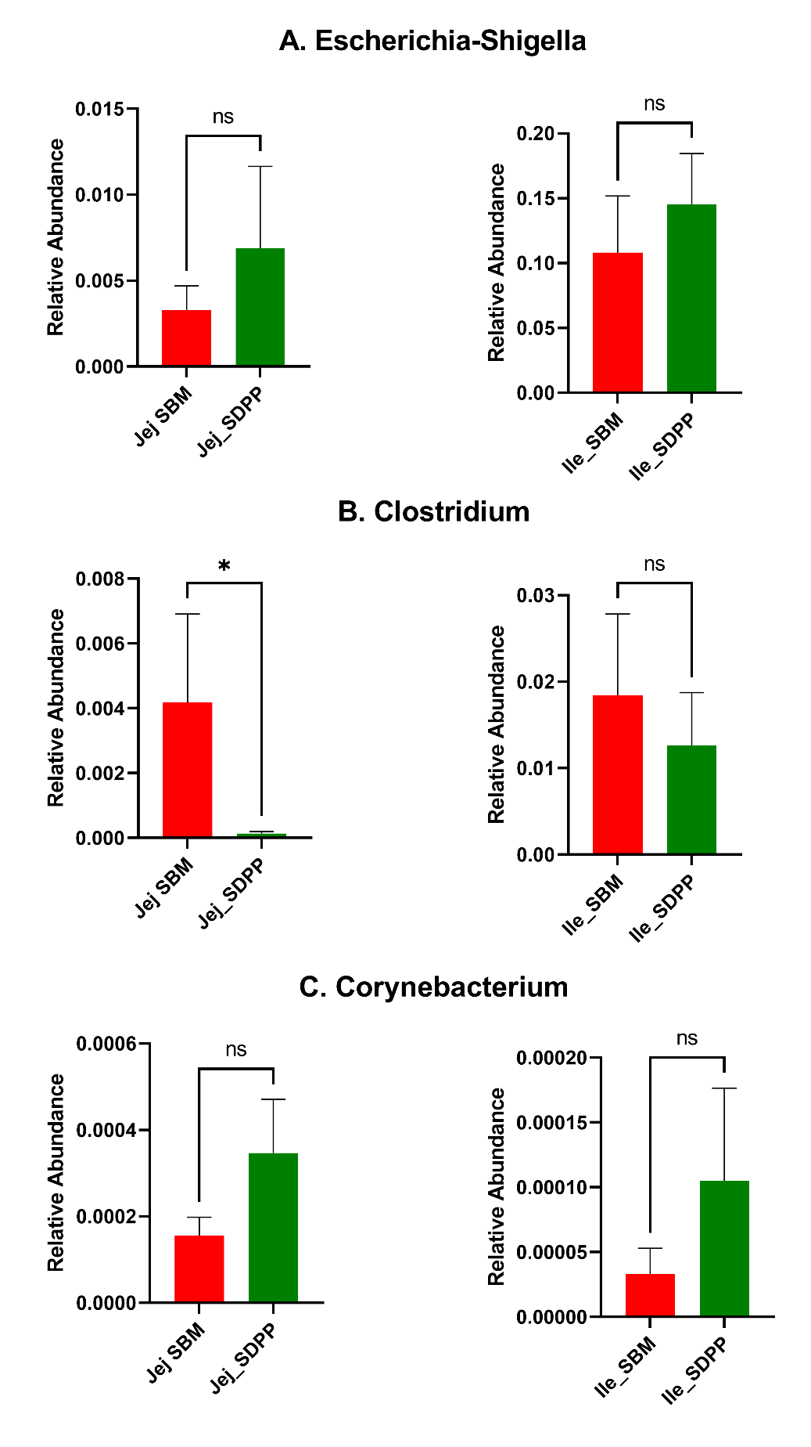

**Supplementary Figure 7.** Average relative selected pathogen contribution in pigs fed soybean meal (SBM) compared to spray-dried porcine plasma (SDPP). The relative abundance of pathogenic microbes aggregated at Genus level for Escherichia / Shigella (A), Clostridium (B), and Corynebacterium (C). The panels on the left depict jejunum and panels on the right depict ileum, where SBM is represented in red and SDPP in green; Jej is jejunum and Ile is ileum.

## Supplementary Tables

**Supplementary Table 1.** Overview of number of pigs per technique1

|  |  |  |
| --- | --- | --- |
| **Technique** | **SBM** | **SDPP** |
| Microbiota - Jejunum | 7 | 6 |
| Microbiota - Ileum | 5 | 6 |
| Microarray - Jejunum | 8 | 6 |
| Microarray - Ileum | 8 | 7 |
| Plasma amine - Metabolites | 8 | 7 |
| Cytokine and chemokines | 6 | 6 |
| Body weight | 8 | 82 |
| 1 these are pigs left after Quality control  2 lost one pig in week 3 in SDPP group |  |  |

**Supplementary Table 2.** Internal standards used to detect and analysed amine metabolites in plasma samples of individual pig fed with either SDPP- or SBM-based diets.

|  |
| --- |
| **Internal Standards** |
| 2-(4-hydroxy-3-methoxyphenyl) ethyl-1, 1,2,2-d4-amine |
| Ala_C13N15 |
| Arg_C13N15 |
| Asn_C13N15 |
| Asp_C13N15 |
| Beta-alanine-2,2,3,3,-d4 |
| Gln_C13N15 |
| Glu_C13 N15 |
| Gly_C13N15 |
| Histamine-a,a,P,P-d4 2HCl |
| L-2-aminobutyric acid-d6 acid |
| Leu_C13N15 |
| L-lle C13N15 |
| L-Methionine |
| L-NT-methyl-d3-L-histidine |
| L-ornithine-3,3,4, 4,5,5,-d6 |
| Lys_C13N15 |
| Phe_C13N15 |
| Ser_C13N15 |
| Thr_C13N 15 |
| Trp_C13N15 |
| Tyr_C13N15 |
| Val_C13N15 |