Culture-based bacterial profiling of colorectal cancer biopsies from Indian patients

Manish Kushwaha^{1, 2}, Shubham Chaudhary³, Akhilesh Kumar Singh², Govind K. Makharia³, Anil Kumar^{1,} *

Supplementary Figures and Table

Sample ID | CRC/Adjacent biopsy
P1, P2, P3, P4, P5, P6, P7, P8 and P9 | Colorectal cancer biopsy (47)
A1, A2, A3, A4, A5, A6, A7, A8, and A9 | Adjacent biopsy (28)
TABLE S1 List of bacterial isolates from tumor tissue and adjacent tissue. 47 bacterial isolates were obtained from nine different tumor biopsy samples, while 28 bacterial isolates were isolated from nine adjacent biopsy samples.

TABLE S2 List of bacteria isolated from a tumor biopsy sample. Classification includes domain, phylum, class, order, family, and genera. Similarity% shows the resemblance of the sequence with the nearest relative present in the taxonomically united database of 16S rRNA gene sequences (Ezbiocloud.com). ATCC no. represents the top hit strain reference

S.No | Sample | Identification | Similarity | Top hit
 | P1
1. |  | Klebsiella pneumoniae subsp. ozaenae | 99.79 | ATCC 11296
2. |  | Enterococcus faecalis | 99.27 | ATCC 19433
3. |  | Enterococcus gallinarum | 97.61 | NBRC 100675
4. |  | Enterococcus gallinarum | 99.73 | NBRC 100675
5. |  | Enterococcus durans | 99.10 | NBRC 100479
6. |  | Citrobacter portucalensis | 99.86 | A60
7. |  | Veillonella atypica | 99.95 | KON
8. |  | Citrobacter portucalensis | 99.25 | A60
9. |  | Klebsiella huaxiensis | 99.86 | WCHKl090001
10. |  | Klebsiella pneumoniae subsp. ozaenae | 98.52 | ATCC 11296
11. |  | Morganella morganii subsp. sibonii | 99.8 | DSM 14850
12. |  | Citrobacter freundii | 99.73 | DSM 30039(T)
 | P2
13. |  | Klebsiella pneumoniae subsp. ozaenae | 99.79 | ATCC 11296
14. |  | Citrobacter portucalensis | 99.73 | A60
15. |  | Klebsiella pneumoniae subsp. ozaenae | 99.79 | ATCC 11296
16. |  | Escherichia marmotae | 99.45 | HT073016
17 |  | Escherichia marmotae | 99.25 | HT073016
18. |  | CP040443_s 93 | 99.12 | E4742
19. |  | Escherichia ruysiae | 99.25 | OPT1704(T)
20. |  | Klebsiella quasipneumoniae subsp. quasipneumoniae | 99.72 | HG933296
21 |  | Klebsiella variicola subsp. variicola | 99.52 | DSM 15968(T)
22. |  | Escherichia marmotae | 99.31 | HT073016
 | P3
23. |  | Enterococcus faecium | 99.59 | LMG 11423
24. |  | Enterococcus durans | 99.66 | NBRC 100479
25. |  | CP040443_s | 99.45 | E4742
26. |  | LFHY_s | 99.32 | B1147
27. |  | Escherichia marmotae | 98.40 | HT073016
28. |  | Escherichia fergusonii | 99.11 | ATCC 35469(T)
29. |  | Shigella flexneri | 99.18 | ATCC 29903(T)
30. |  | Escherichia marmotae | 99.39 | HT073016
 | P4
31. |  | Enterococcus faecalis | 99.93 | ATCC 19433
32. |  | Enterococcus faecium | 99.73 | LMG 11423
33. |  | CP040443_s | 99.32 | E4742
 | P5
34. |  | Enterococcus faecalis | 98.9 | ATCC 19433
35. |  | Escherichia fergusonii | 99.79 | ATCC 35469
 | P6
36. |  | Escherichia coli | 99.13 | ATCC 11775
37. |  | Enterococcus faecalis | 98.8 | ATCC 19433
38. |  | Enterococcus faecalis | 98.35 | ATCC 19433
39. |  | Enterococcus faecalis | 99 | ATCC 19433
 | P7
40. |  | Shigella flexneri | 97.97 | ATCC 29903
41. |  | Shigella flexneri | 99.5 | ATCC 29903
42. |  | Shigella flexneri | 99.79 | ATCC 29903
 | P8
43. |  | Escherichia fergusonii | 99.18 | ATCC 35469
44. |  | LFHY_s (Escherichia coli) | 97.23 | --
45. |  | Enterococcus durans | 98.92 | NBRC 100479
46. |  | Enterococcus faecalis | 99.23 | ATCC 19433
 | P9
47. |  | Escherichia fergusonii | 99.59 | ATCC 35469

** Four bacterial strains are not identified.

TABLE S3 List of bacteria isolated from adjacent biopsy samples. Classification includes Domain; Phylum; Class; Order; Family; Genus. Similarity % shows the resemblance of sequence with the nearest relative present in taxonomically united database of 16S rRNA gene sequences (Ezbiocloud.com). ATCC no. represents the top hit strain reference.

S.No | Sample | Classification | Similarity | Top hit
 | A1
1. |  | Escherichia | 99.55 | B1147
2. |  | Shigella flexneri | 99.59 | ATCC 29903(T)
3. |  | Escherichia fergusonii | 99.73 | ATCC 35469
4. |  | Escherichia | 99.59 | E4742
5. |  | Escherichia marmotae | 99.45 | HT073016
6. |  | Escherichia coli | 99.58 | ATCC 11775(T)
7. |  | Escherichia fergusonii | 99.59 | ATCC 35469
8. |  | Shigella flexneri | 99.45 | ATCC 29903(T)
 | A2
9. |  | Shigella sonnei | 99.66 | CECT 4887(T)
10. |  | Escherichia coli | 98.65 | ATCC 11775(T)
11. |  | Escherichia fergusonii | 99.73 | ATCC 35469
12. |  | Shigella boydii | 99.32 | GTC 779(T)
13. |  | Escherichia coli | 99.37 | ATCC 11775(T)
14. |  | Streptococcus lutetiensis | 99.79 | CIP 106849
15. |  | Enterococcus faecium | 99.66 | LMG 11423
16. |  | Escherichia | 99.73 | E4742
 | A3
17. |  | Escherichia ruysiae | 99.32 | OPT1704(T)
18. |  | Enterococcus durans | 99.73 | NBRC 100479
19. |  | Escherichia | 99.59 | B1147
 | A4
20. |  | Shigella flexneri | 99.5 | ATCC 29903
 | A5
21. |  | Escherichia fergusonii | 99.72 | ATCC 35469
 | A6
22. |  | Streptococcus lutetiansis | 97.96 | CIP 106489
23. |  | Enterococcus lactis | 97.26 | BT 159
 | A7
24. |  | Shigella flexneri | 99.66 | ATCC 29903
25. |  | Shigella flexneri | 98.64 | ATCC 29903
26. |  | Shigella flexneri | 99.29 | ATCC 29903
 | A8
27. |  | Enterococcus lactis | 99.03 | BT 159
 | A9
28. |  | Enterococcus lactis | 97.87 | BT 159

TABLE S4 Clinical and pathological characteristics of colorectal cancer patients
S.No. | CRC Stage | Sex | Age | CRC Location Distribution
1 | Adenocarcinoma with signet ring cells and extracellular poor mucin | F | 46 | Ascending Colon
2 | Moderately Differentiated Adenocarcinoma | F | 64 | Ileocaecal Junction
3 | Moderately Differentiated Adenocarcinoma | F | 52 | Rectum
4 | Chronic Inflammation in Lamina Propria | M | 53 | Rectum
5 | Differentiated Adenocarcinoma | M | 36 | Rectum
6 | Adenocarcinoma | M | 35 | Rectum
7 | Adenocarcinoma | M | 63 | Rectum
8 | Differentiated Adenocarcinoma | F | 47 | Rectum
9 | Differentiated Adenocarcinoma | M | 42 | Hepatic Flexure

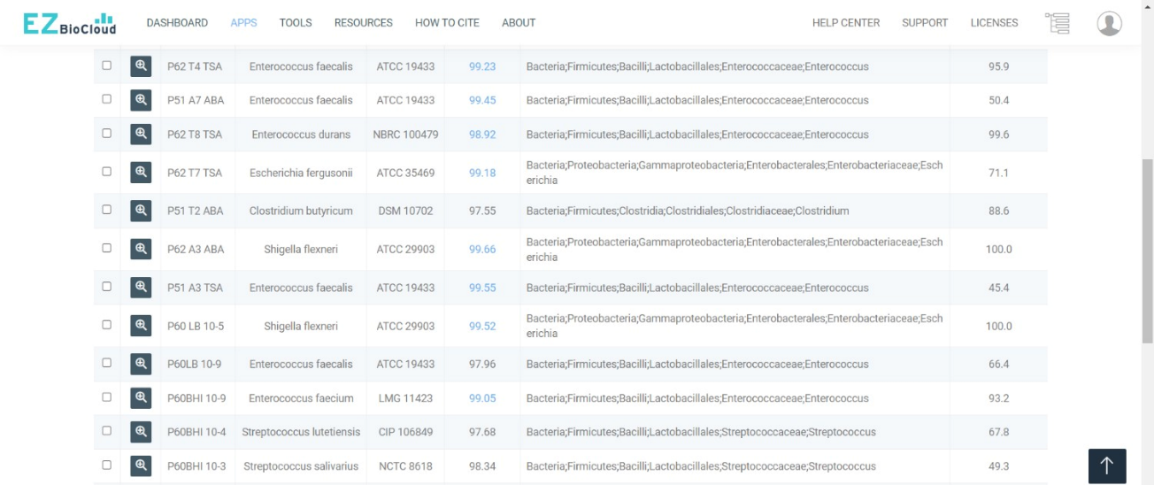

SUPPLEMENTARY FIGURE 1 16S rRNA gene-based taxonomic identification of bacterial isolates using the EZBioCloud platform.

