***Supplementary Material***

**1 Supplementary Figures**

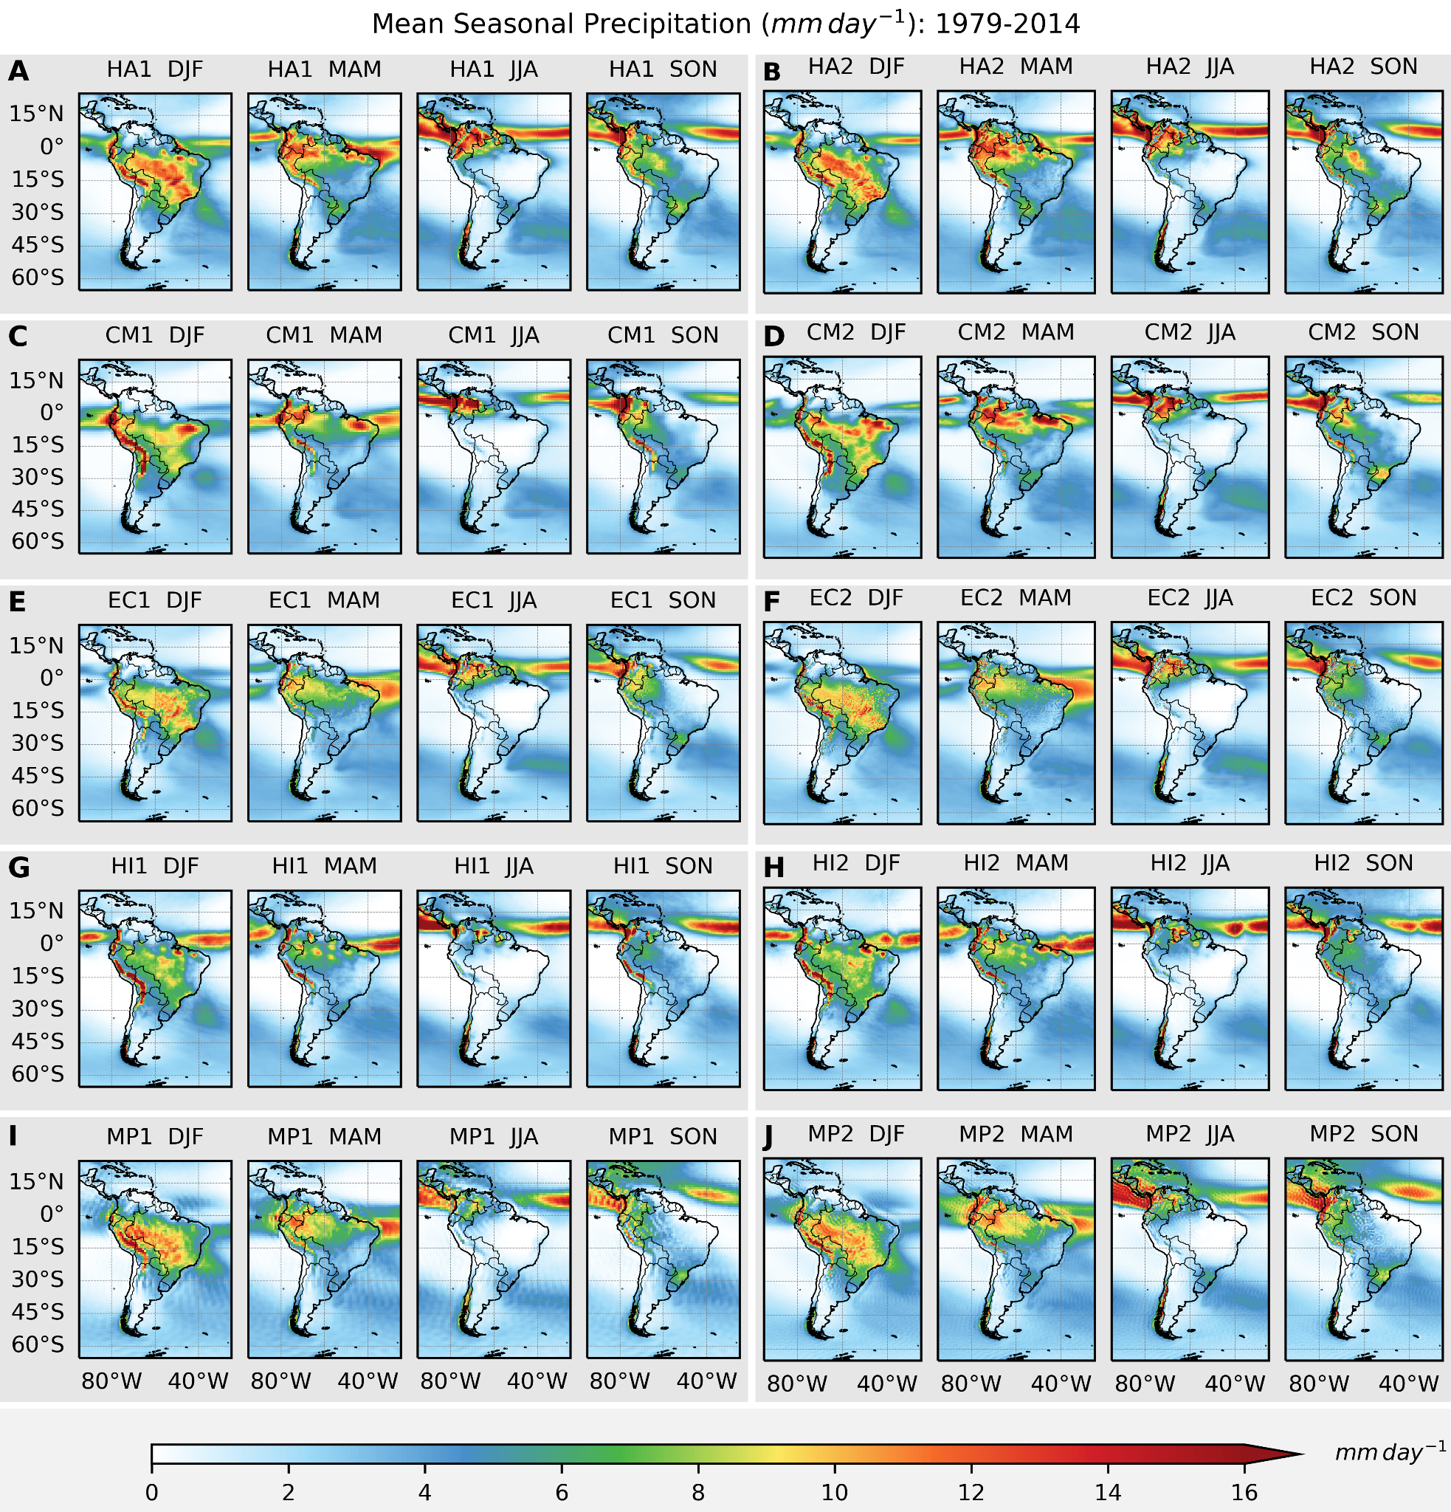

**Supplementary Figure S1:** Seasonal precipitation (mm day-1) climatology (1979–2014) simulated by the CMIP6-HighResMIP coupled models at low (left) and high (right) resolution: (A) HA1, (B) HA2, (C) CM1, (D) CM2, (E) EC1, (F) EC2, (G) HI1, (H) HI2, (I) MP1, (J) MP2.

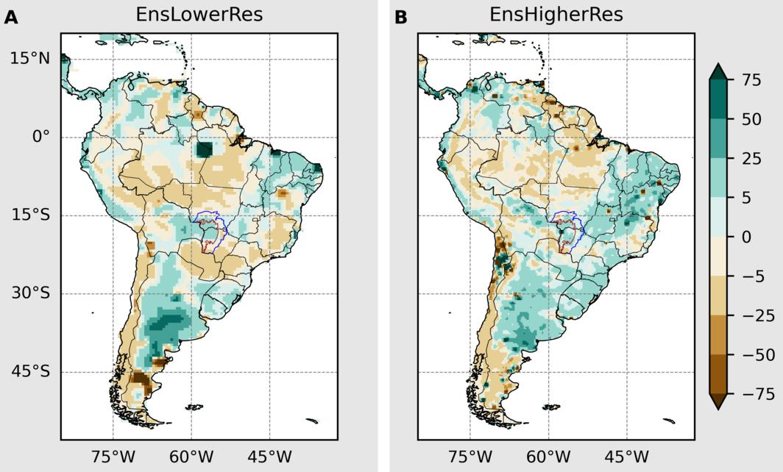

**Supplementary Figure S2:** Relative (%) annual future changes (2015-2050) in the water resources by ensemble mean from HighResMIP models in **(A)** low and **(B)** high-resolutions.

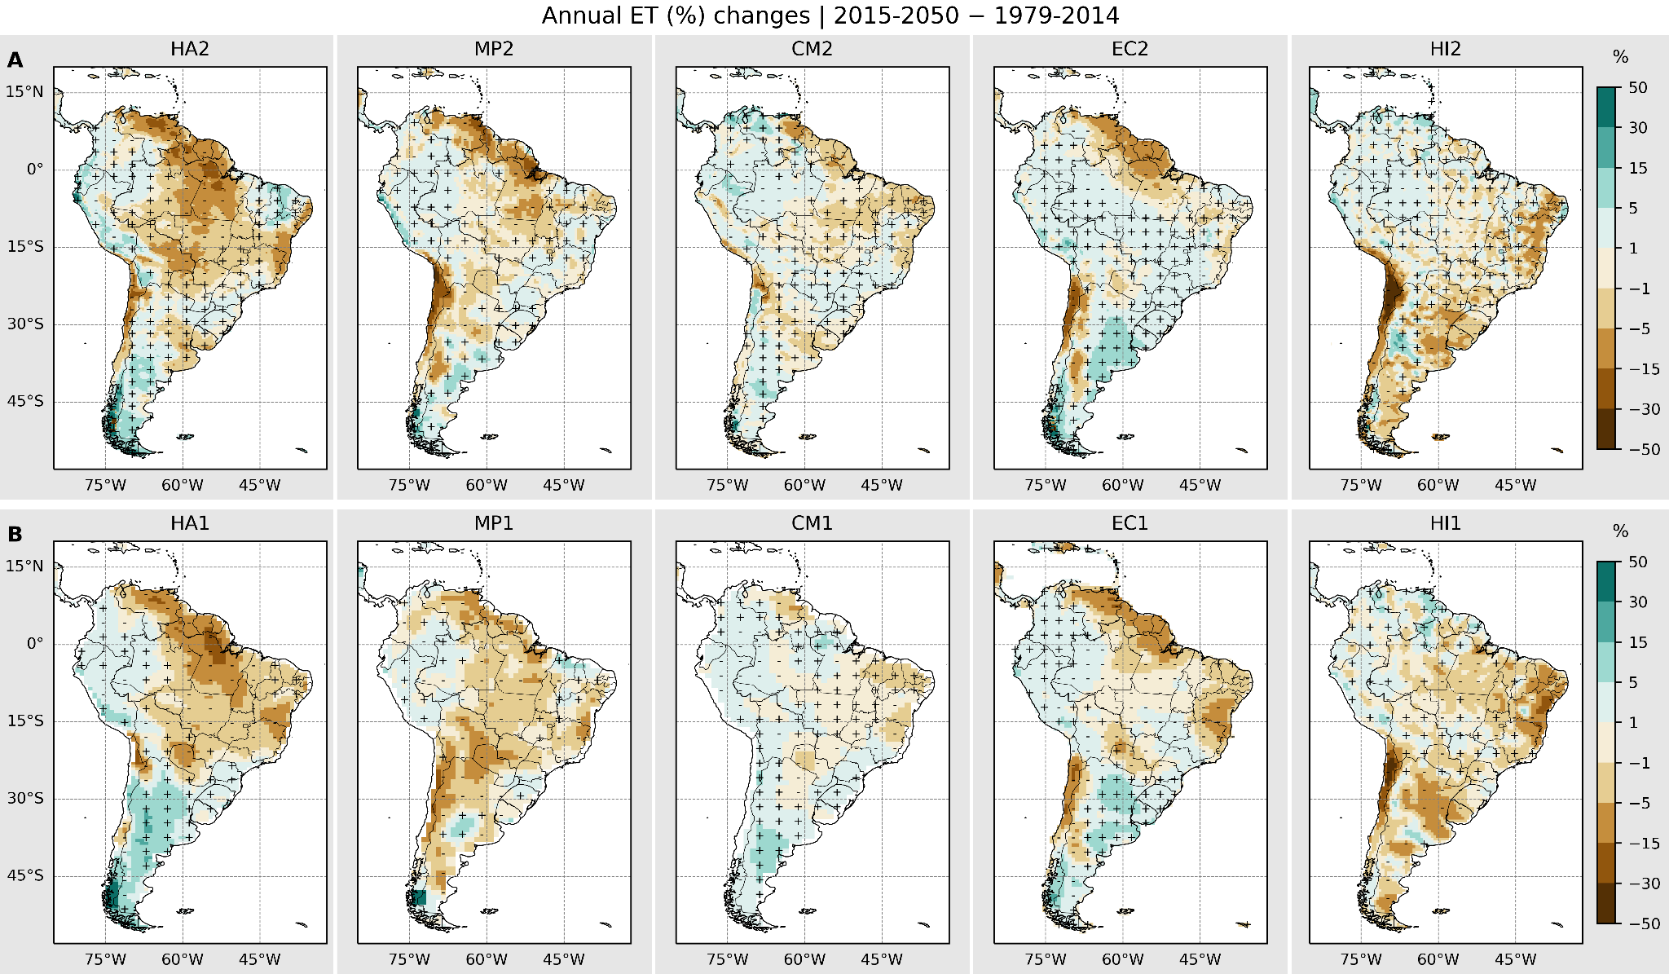

**Supplementary Figure S3:** Relative (%) annual future changes in the evapotranspiration projected by HighResMIP models in (A) high and (B) low-resolutions. The "+" and "-" signs indicate areas where future projections show an increase or decrease in precipitation, respectively.