Supplementary Material

# Supplementary Figures

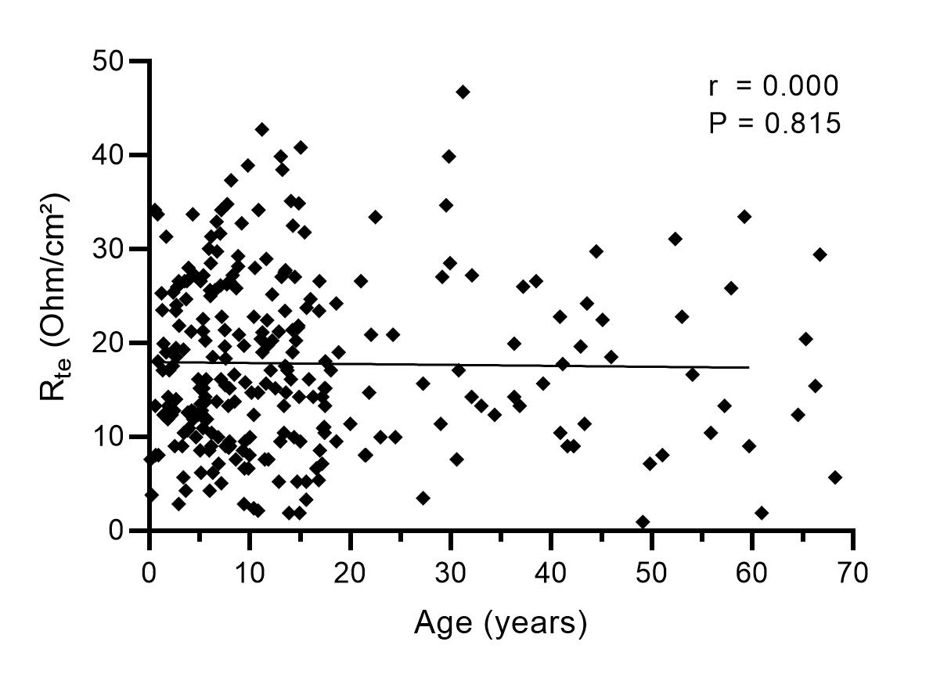

**Supplementary Figure S1.** Transepithelial resistance (Rte) of human rectal tissue from people without CF, n = 258.



**Supplementary Figure S2.** **Expression of CFTR in rectal tissues from children compared to adults.** Transcript levels of CFTR in rectal tissues from people without CF aged 0 - 4 years and ≥ 22 years. Data are expressed as fold changes over people aged 0 - 4 years. n = 8 per group. *, P< 0.05.