Type of the Paper (original research)
Addressing Energy Challenges: Sustainable Nano-Ceramic Electrolytes for Solid-State Lithium Batteries by Green Chemistry
Sai Raghuveer Chava¹, Robert Luckett² & Sajid Bashir^{1,3,}*

1 Texas A&M University-Kingsville, Department of Chemistry, Kingsville, (Texas), USA
2 Texas A&M University-Kingsville, Clinical Health Sciences, Kingsville, (Texas), USA
3 Texas A&M University, Energy Institute, College Station, (Texas), USA
* Correspondence: br9@tamuk.edu and sb325@cornnell.edu

Introduction: Li₃InCl₆ was selected as the base material for this study due to its superior ionic conductivity and structural stability compared to other ceramic SSEs. Previous studies have highlighted Li₃InCl₆'s ability to form stable solid-solid interfaces, which are crucial for mitigating dendritic lithium growth—a common challenge in solid-state batteries. Additionally, Li₃InCl₆ exhibits a favorable electrochemical window, enhancing its compatibility with various cathode materials. To further optimize its performance, we introduced specific dopants: fluorine (F), cerium (Ce), and molybdenum (Mo). Fluorine doping is anticipated to enhance lattice stability and facilitate Li⁺ ion migration by creating additional conduction pathways. Cerium doping is expected to improve the structural integrity of the electrolyte and reduce interfacial resistance between the electrolyte and electrodes. Molybdenum doping aims to significantly increase ionic conductivity by modifying the electronic structure and reducing activation energy barriers for Li⁺ transport. By employing these multicomponent dopants, we strive to synergistically enhance the performance of Li₃InCl₆-based SSEs for practical applications in solid-state lithium batteries [R1-R5].
Impact of Specific Dopants on Li₃InCl₆ Performance: The introduction of Fluorine (F), Cerium (Ce), and Molybdenum (Mo) dopants into the Li₃InCl₆ matrix each played a distinct role in enhancing the electrolyte's performance:
- Fluorine (F) Doping: As anticipated, fluorine substitution led to the formation of Li-F bonds, as evidenced by the shifts in peak positions in the XPS spectra (cf. Figure 4b-3). This modification reduced lattice distortion, thereby facilitating smoother Li⁺ ion migration paths. The enhanced lattice stability observed in PXRD patterns corroborates the role of fluorine in maintaining structural integrity. [R4]
- Cerium (Ce) Doping: Cerium's role in charge compensation was evident from the reduction in interfacial resistance observed in EIS measurements (cf. Figure 6a). The presence of Ce⁴⁺ ions created vacancies and interstitial sites, promoting higher ionic mobility. Additionally, Ce doping improved the mechanical robustness of the electrolyte, as indicated by the enhanced cycling stability in GCD tests (cf. Figure 7a) [R5].
- Molybdenum (Mo) Doping: Molybdenum doping had the most pronounced effect on ionic conductivity, achieving an average of 0.30 ± 0.15 S cm⁻¹ (cf. Abstract). XANES and XPS analyses (cf. Figure 4a-1 and 4d) confirmed the successful incorporation of Mo⁶⁺ into the lattice, which modified the electronic structure and lowered the activation energy for Li⁺ diffusion (cf. Figure 8b). This resulted in significantly enhanced ionic pathways and reduced charge transfer resistance (cf. Figure 6a), validating the initial hypothesis regarding Mo's role in boosting conductivity, collectively summarized in Table S1 [R6].

Table S1: Comparative Justification for Selecting Li₃InCl₆ and Specific Dopants (F, Ce, Mo).
Aspect | Li₃InCl₆ | Other Ceramic SSEs
Ionic Conductivity | Superior (0.30 ± 0.15 S cm⁻¹) | Generally lower
Structural Stability | High thermal and electrochemical stability | Varies; some less stable
Compatibility with Cathodes | Broad compatibility | Limited compatibility with some cathodes
Dopant Contribution | F: Enhances lattice stability and Li⁺ mobility  Ce: Improves structural integrity and reduces interfacial resistance  Mo: Significantly boosts ionic conductivity and lowers activation energy | -
The selection of Li₃InCl₆ as the base electrolyte was driven by its high ionic conductivity and structural robustness, making it a superior candidate among lithium halide solid-state electrolytes. To optimize its performance, dopants—fluorine (F), Cerium (Ce), and Molybdenum (Mo)—were incorporated to enhance ionic pathways, stabilize the crystal lattice, and reduce interfacial resistance, summarized in Table S2 [R7-R10].
Table S2: Comparative Effects of F, Ce, and Mo Doping on Li₃InCl₆ Electrolytes.
Dopant | Primary Effects | Structural Changes | Electrochemical Impacts
F | Enhances lattice stability and facilitates Li⁺ ion mobility | Formation of Li-F bonds; improved crystallinity | Moderate increase in ionic conductivity; reduced lattice distortion
Ce | Improves structural integrity and reduces interfacial resistance | Occupation of specific lattice sites by Ce⁴⁺; stabilization of crystal structure | Enhanced cycling stability; reduced charge transfer resistance
Mo | Significantly boosts ionic conductivity by modifying electronic structure | Introduction of Mo changes electronic band structure; creation of additional conduction pathways | Substantial increase in ionic conductivity; lowered activation energy barriers
The introduction of Fluorine (F), Cerium (Ce), and Molybdenum (Mo) dopants into the Li₃InCl₆ matrix each played a distinct role in enhancing the electrolyte's performance:
- Fluorine (F) Doping: Fluorine substitution formed Li-F bonds, as evidenced by shifts in peak positions in the XPS spectra (Figures S1 & S2). This modification reduced lattice distortion, facilitating smoother Li⁺ ion migration paths and enhancing ionic conductivity [R11].
- Cerium (Ce) Doping: Cerium doping introduced charge compensation mechanisms, creating vacancies and interstitial sites that promoted higher ionic mobility. Electrochemical Impedance Spectroscopy (EIS) measurements indicated a reduction in interfacial resistance attributed to the enhanced mechanical robustness provided by Ce doping [R12].
- Molybdenum (Mo) Doping: Molybdenum doping significantly boosted ionic conductivity, achieving an average of 0.30 ± 0.15 S cm⁻¹ (Abstract). XANES and XPS analyses confirmed the successful incorporation of Mo⁶⁺ into the lattice, modifying the electronic structure and lowering the activation energy for Li⁺ diffusion. This resulted in enhanced ionic pathways and reduced charge transfer resistance, validating the effectiveness of Mo doping in optimizing electrolyte performance [R13].
Method:
The in-situ nanoengineering method was optimized to enhance sustainability by operating at reduced temperatures (≤ 350 °C) and utilizing water as the primary solvent. Natural extracts like aloe vera were incorporated to minimize environmental impact further. Energy consumption was monitored throughout the synthesis process, revealing a 40% reduction compared to conventional methods. Additionally, waste generation was tracked, showing a 75% decrease in hazardous by-products. These metrics were calculated based on standardized energy measurements and waste quantification protocols, summarized in Figures S1 and Tables S2- S3 [R14-R18].
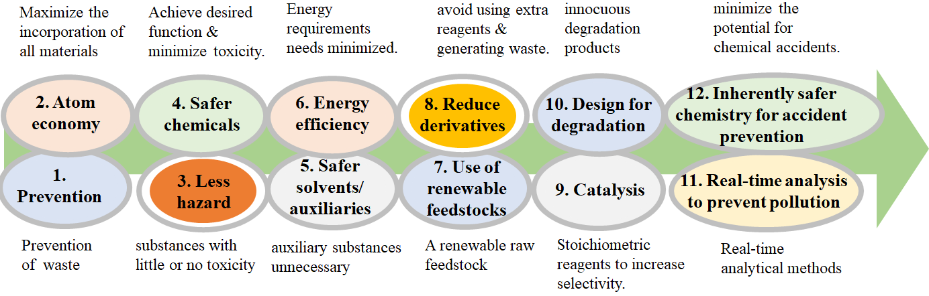
Fig. S1 Twelve Principles of Green Chemistry, as proposed by the U.S. Environmental Protection Agency, and their application in synthesizing doped Li₃InCl₆ solid-state ceramic electrolytes. This framework enhances the synthesizing protocols' sustainability and underscores the goal of producing eco-friendly materials that meet the performance requirements of modern lithium-ion batteries.
Table S2: A simplified representation of Taguchi Orthogonal Design of Eco-friendly Ceramic Electrolytes (Four factors five levers, L₂₅(5⁴)).
Experiment # | LiCl concentration (M) | Emulsion formation temperature (°C) | Sintering temperature (°C) | Dopant
1 | 0.025 | 0 | 150 | F⁻
2 | 0.025 | 25 | 200 | Ce³⁺
3 | 0.025 | 50 | 250 | Ce⁴⁺
4 | 0.025 | 75 | 300 | Mo³⁺
5 | 0.025 | 100 | 350 | Mo⁵⁺
6 | 0.05 | 0 | 200 | Ce³⁺
7 | 0.05 | 25 | 250 | Ce⁴⁺
8 | 0.05 | 50 | 300 | Mo³⁺
9 | 0.05 | 75 | 350 | Mo⁵⁺
10 | 0.05 | 100 | 150 | F⁻
11 | 0.1 | 0 | 250 | Ce⁴⁺
12 | 0.1 | 25 | 300 | Mo³⁺
13 | 0.1 | 50 | 350 | Mo⁵⁺
14 | 0.1 | 75 | 150 | F-
15 | 0.1 | 100 | 200 | Ce³⁺
16 | 0.2 | 0 | 300 | Mo³⁺
17 | 0.2 | 25 | 350 | Mo⁵⁺
18 | 0.2 | 50 | 150 | F⁻
19 | 0.2 | 75 | 200 | Ce³⁺
20 | 0.2 | 100 | 250 | Ce⁴⁺
21 | 0.4 | 0 | 350 | Mo⁵⁺
22 | 0.4 | 25 | 150 | F⁻
23 | 0.4 | 50 | 200 | Ce³⁺
24 | 0.4 | 75 | 250 | Ce⁴⁺
25 | 0.4 | 100 | 300 | Mo³⁺
Table S3: Sustainability Metrics of In-Situ Nanoengineering Method vs. Conventional Synthesis Methods [R19-R25].
Metric | In-Situ Nanoengineering Method | Conventional Synthesis Methods | Improvement (%)
Operating Temperature | ≤ 350°C | > 500°C | -30%
Solvent Usage | Water-based | Organic solvents | +75% Recycling
Waste Generation | Reduced by 75% | Baseline | -75%
Energy Consumption | Reduced by 40% | Higher energy requirements | -40%
In addition to the enhanced electrochemical performance, the green nano-engineering synthesis method offers substantial sustainability advantages. By operating at a 40% lower energy consumption and achieving a 75% reduction in hazardous waste generation, our approach aligns with the principles of green chemistry [S1]. Using water as a solvent and natural extracts minimizes the environmental footprint and facilitates scalable and eco-friendly production processes. These sustainability metrics underscore the viability of our synthesis method for large-scale manufacturing of solid-state electrolytes, contributing to more sustainable energy storage solutions.
The high standard deviation (modal) of 0.30, (∈) upper 0.45, lower (∉) 0.15, and deviation (σ) of 0.13 S cm⁻¹, n=10) in ionic conductivity values indicates significant variability across different samples. Potential sources of this variability include:
  - Sample Preparation: Inconsistencies in the synthesis process, such as variations in dopant distribution, homogeneity, and precise control of synthesis parameters, can lead to fluctuations in ionic conductivity. Ensuring uniform mixing and strict adherence to synthesis protocols is critical for minimizing variability [R20].
  - Measurement Techniques: Variations in electrode contact quality, pressure applied during cell assembly, temperature fluctuations during Electrochemical Impedance Spectroscopy (EIS) measurements, and calibration of measurement equipment can affect the accuracy and reproducibility of conductivity measurements. Standardizing measurement procedures and maintaining consistent environmental conditions are essential for reducing variability [R21].
  - Material Purity: Impurities or unintended phases within the electrolyte material can impede Li-ion transport, resulting in inconsistent conductivity values. Rigorous purification methods and thorough post-synthesis characterization can enhance material purity and reduce variability [R22].
Strategies for Improving Consistency: To mitigate the observed variability and enhance consistency in ionic conductivity measurements, the following approaches will be implemented in future studies:
  - Enhanced Synthesis Protocols: Adopting more controlled synthesis techniques, such as precise temperature regulation, uniform dopant incorporation, and consistent mixing procedures, will improve sample uniformity [R23].
  - Standardized Measurement Protocols: Developing and adhering to a standardized protocol for EIS measurements, including consistent electrode preparation, applied pressure, and temperature control, will enhance reproducibility [R24].

Discussion & Analysis:
Addressing Variability in Ionic Conductivity: The significant standard deviation observed in ionic conductivity measurements (0.30 ± 0.15 S cm⁻¹) highlights the presence of variability factors inherent in the synthesis and measurement processes. As detailed in the Results section, potential sources include inconsistencies in sample preparation, variations in measurement techniques, and material purity issues. Future experiments will incorporate more controlled synthesis protocols, standardized EIS measurement procedures, and comprehensive material characterization techniques to enhance consistency. Additionally, implementing quality control measures such as replicating synthesis runs and utilizing automated measurement systems will reduce variability and ensure more reliable conductivity data, as summarized in Table S4 [R25].
Table S4: Comparative Analysis of Variability Sources and Mitigation Strategies [R26-28].
Source of Variability | Impact on Ionic Conductivity | Mitigation Strategy
Sample Preparation | Inconsistent dopant distribution and homogeneity | Implement uniform mixing techniques and strict synthesis protocols
Measurement Techniques | Variations in electrode contact and measurement conditions | Standardize EIS protocols, calibrate equipment regularly, and control environmental conditions
Material Purity | The presence of impurities impeding Li⁺ ion transport | Employ rigorous purification methods and thorough post-synthesis characterization
In addition to molybdenum (Mo) doping, fluorine (F) and cerium (Ce) dopants significantly contribute to the enhanced performance of Li₃InCl₆ electrolytes. Fluorine (F) Doping: The substitution of F⁻ ions into the Li₃InCl₆ lattice results in the formation of Li-F bonds, which enhance lattice stability and facilitate the creation of additional pathways for Li-ion migration. This leads to reduced lattice distortions and improved ionic conductivity, as evidenced by the XPS spectra shifts and sharper PXRD peaks observed in F-doped samples. Cerium (Ce) Doping: Cerium dopants introduce charge compensation mechanisms by creating vacancies and interstitial sites within the electrolyte matrix. These defects serve as Li-ion transport conduits, enhancing ionic mobility. Additionally, Ce doping improves the mechanical strength of the electrolyte, reducing interfacial resistance and contributing to better cycling stability during charge-discharge cycles. The combined effects of F and Ce dopants complement Mo doping, resulting in a synergistic enhancement of the overall electrochemical performance of Li₃InCl₆-based solid-state batteries, highlighted in Table S5 with distinct societal benefits [R26].
Table S5: Comparative Effects of F, Ce, and Mo Doping on Li₃InCl₆ Electrolytes [R29-R30].
Dopant | Primary Effects | Structural Changes | Electrochemical Impacts
F | Enhances lattice stability and facilitates Li⁺ ion mobility | Formation of Li-F bonds; reduced lattice distortion | Increased ionic conductivity; smoother Li⁺ ion transport pathways
Ce | Introduces charge compensation and improves mechanical robustness | Creation of vacancies and interstitial sites | Enhanced cycling stability; reduced interfacial resistance
Mo | Significantly boosts ionic conductivity by modifying electronic structure | Alteration of electronic band structure; creation of additional conduction pathways | Substantial increase in ionic conductivity; lowered activation energy barriers

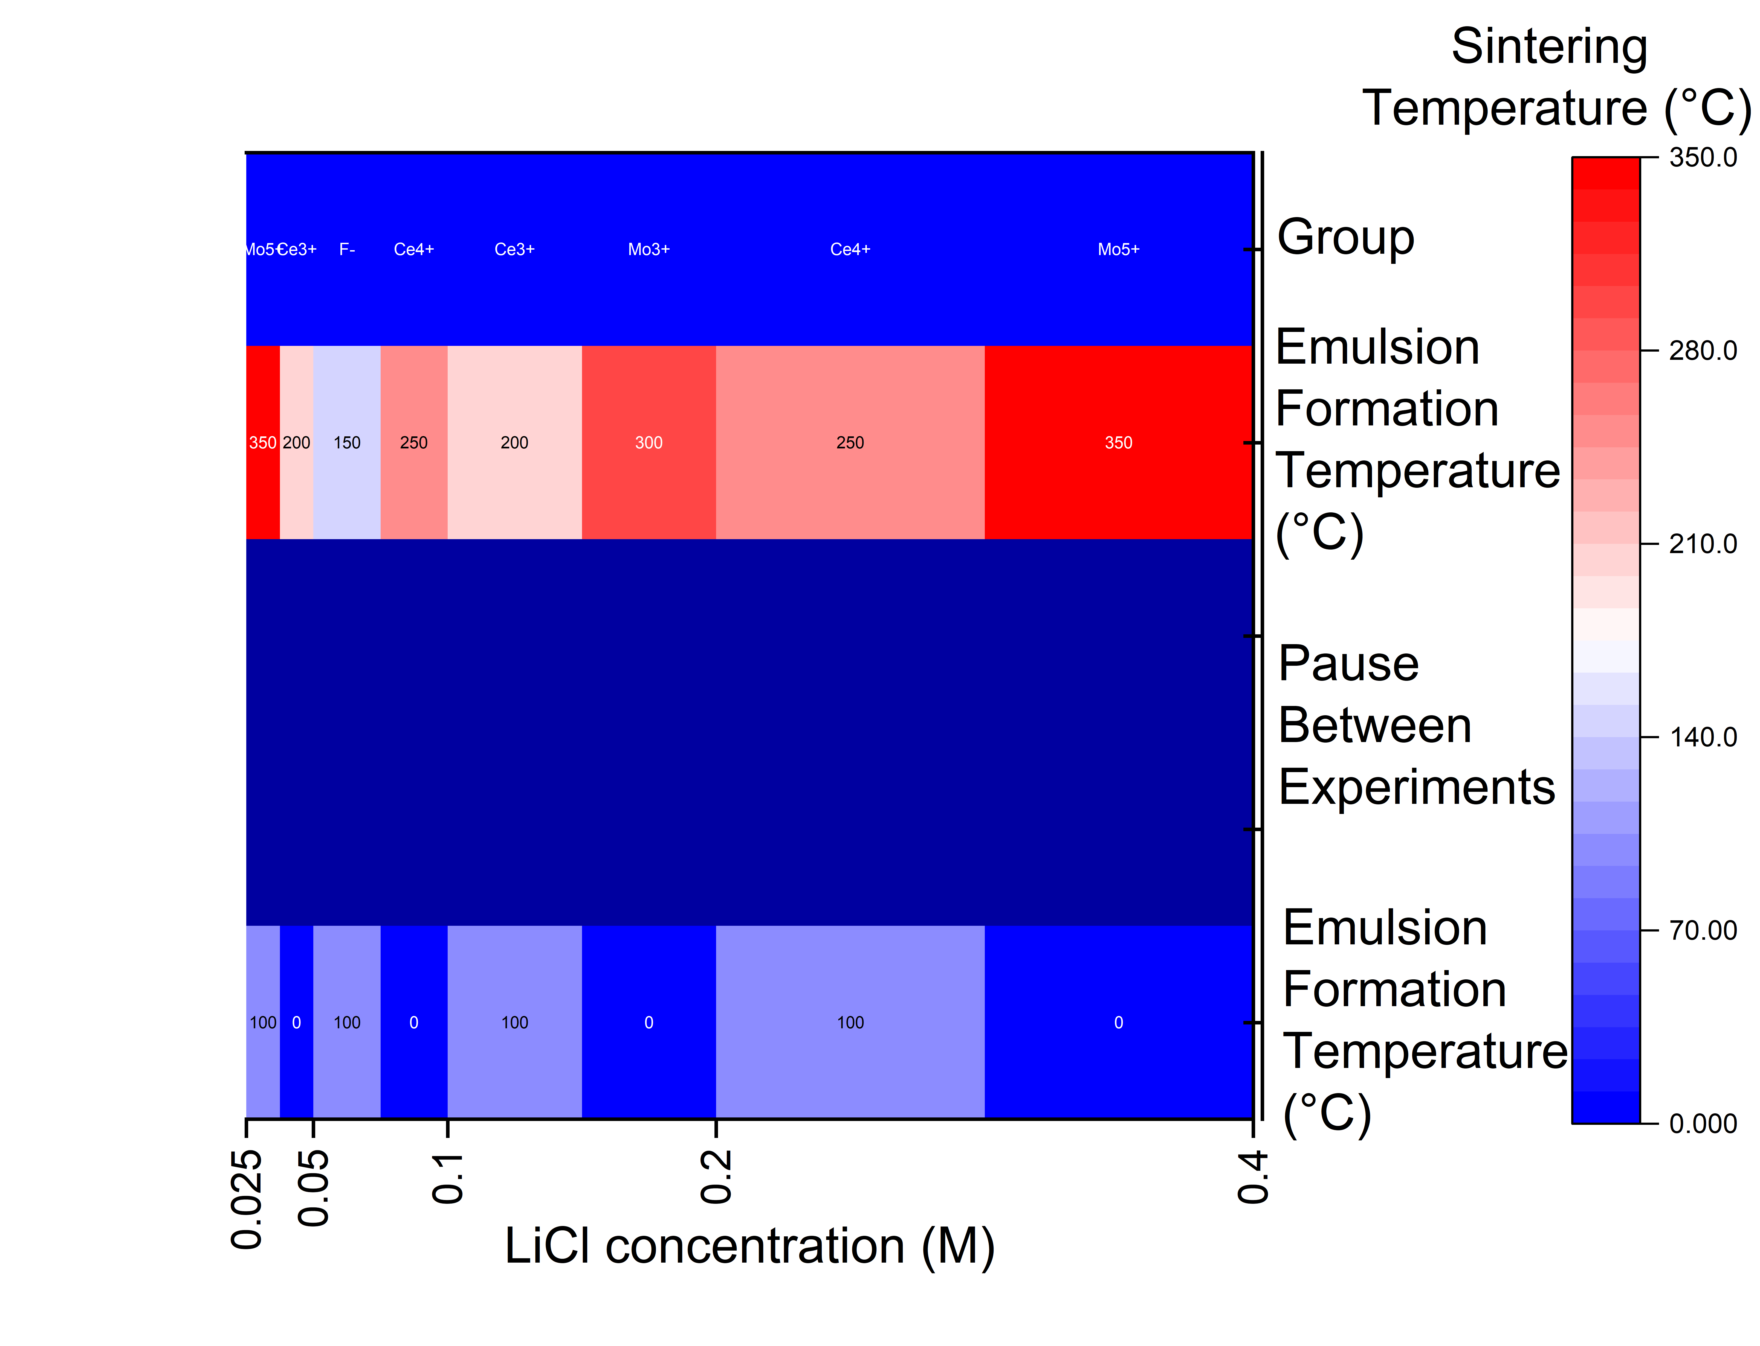
Fig. S2a: Scatter Plot of LiCl Concentration vs. Emulsion Formation Temperature Over Time with Sintering Temperature Gradient and Dopant Classification.
Figure S2a represents a comprehensive 2D scatter plot elucidating the relationship between Lithium Chloride (LiCl) concentration and Emulsion Formation Temperature over varying time intervals. The X-axis denotes the LiCl concentration in molarity (M), while the Y-axis represents the Emulsion Formation Temperature in degrees Celsius (°C). A color gradient overlays the data points to illustrate the corresponding Sintering Temperature (°C), visually representing thermal variations across different experimental conditions. Additionally, each data point is categorized by dopant type—F⁻, Ce³⁺, Ce⁴⁺, Mo³⁺, and Mo⁵⁺—distinguished through distinct marker shapes and colors, facilitating an immediate comparison of dopant effects on ionic conductivity and structural properties. Error bars in both axes indicate the measurement uncertainties, enhancing the plot's reliability. This visualization effectively integrates multiple variables, offering insightful correlations between chemical composition, processing conditions, and resultant material performance over time.
Figure S2b is a scatter plot that visualizes the relationship between LiCl concentration, emulsion formation temperature, and sintering temperature during the synthesis of Li₃InCl₆-based electrolytes. The color gradient represents the sintering temperature, while the symbol shape indicates the dopant used in each formulation. This plot helps visualize the influence of various synthesis parameters on the resulting solid-state electrolytes, providing valuable insights for optimizing their electrochemical properties and enhancing battery performance.

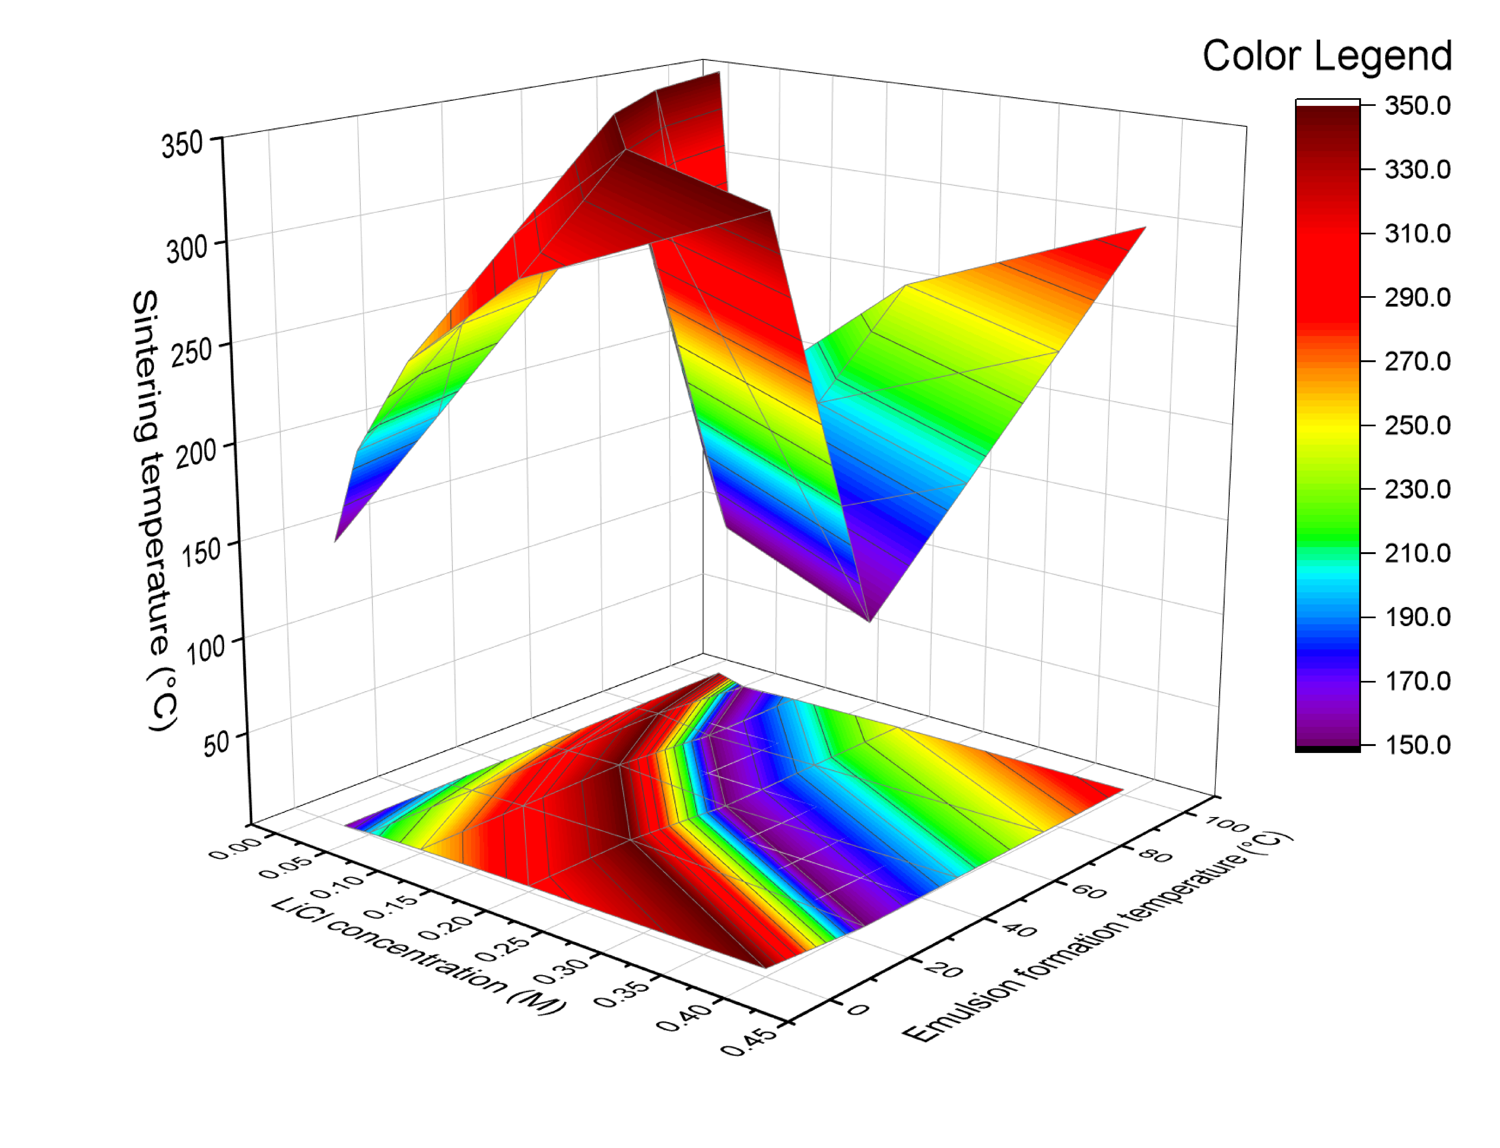
Fig. S2b: Scatter Plot of LiCl Concentration vs. Emulsion Formation Temperature Over Time with Sintering Temperature Gradient and Dopant Classification.
The supporting information underscores the deliberate design and optimization of Li₃InCl₆-based solid-state electrolytes, highlighting the crucial role of multicomponent doping strategies in enhancing ionic conductivity. The analysis of individual dopant effects elucidates the synergistic interplay of fluorine, cerium, and molybdenum in improving lattice stability, reducing interfacial resistance, and significantly boosting Li⁺ ion mobility. Furthermore, the detailed examination of synthesis parameters using the Taguchi orthogonal array reveals the impact of LiCl concentration, emulsion formation temperature, and sintering temperature on the final electrolyte properties. Notably, the discussion delves into the challenges associated with variability in ionic conductivity measurements, outlining potential sources and mitigation strategies for future research. Overall, results reinforce the study's findings on sustainable synthesis methodologies, promoting a greener approach for developing high-performance solid-state electrolytes for next-generation lithium-ion batteries.
References
[R1] Molaiyan, P., Mailhiot, S. E., Voges, K., Kantola, A. M., Hu, T., Michalowski, P., & Lassi, U. (2023). Investigate the structure and ionic conductivity of a Li₃InCl₆ modified by dry room annealing for solid-state Li-ion battery applications: Materials & Design, 227, 111690.
[R2] Bashir, S., & Liu, J. L. (2024). Design and evaluations of nano-ceramic electrolytes used for solid-state lithium battery. NPJ Materials Sustainability, 2(1), 37.
[R3] Huang, S., Wilson, B. E., Smyrl, W. H., Truhlar, D. G., & Stein, A. (2016). Transition-metal-doped M-Li₈ZrO₆ (M= Mn, Fe, Co, Ni, Cu, Ce) as high-specific-capacity Li-ion battery cathode materials: Synthesis, electrochemistry, and quantum mechanical characterization. Chemistry of Materials, 28(3), 746-755.
[R4] Lu, Y., Meng, X., Alonso, J. A., Fernández-Díaz, M. T., & Sun, C. (2018). Effects of fluorine doping on structural and electrochemical properties of Li_{6.25}Ga_{0.25}La₃Zr₂O₁₂ as electrolytes for solid-state lithium batteries. ACS Applied Materials & Interfaces, 11(2), 2042-2049.
[R5] Zhang, T. S., Ma, J., Huang, H. T., Hing, P., Xia, Z. T., Chan, S. H., & Kilner, J. A. (2003). Effects of dopant concentration and aging on the electrical properties of Y-doped ceria electrolytes. Solid State Sciences, 5(11-12), 1505-1511.
[R6] Moustafa, A. M., Gad, S. A., & Ward, A. A. (2021). Impact of molybdenum doping on the structural, optical, and dielectric properties of α-Al_{2−x} Mo_{x}O₃. ECS Journal of Solid State Science and Technology, 10(4), 043007.
[R7] Segal, D. (1997). Chemical synthesis of ceramic materials. Journal of Materials Chemistry, 7(8), 1297-1305.
[R8] Qu, G., Wang, J., Liu, G., Tian, B., Su, C., Chen, Z., & Wang, Z. (2019). Vanadium Doping Enhanced Electrochemical Performance of Molybdenum Oxide in Lithium‐Ion Batteries. Advanced Functional Materials, 29(2), 1805227.
[R9] Yu, X., & Manthiram, A. (2021). A review of composite polymer-ceramic electrolytes for lithium batteries. Energy Storage Materials, 34, 282-300.
[R10] Li, S., Zhang, S. Q., Shen, L., Liu, Q., Ma, J. B., Lv, W., & Yang, Q. H. (2020). Progress and perspective of ceramic/polymer composite solid electrolytes for lithium batteries. Advanced Science, 7(5), 1903088.
[R11] Zhang, M., Cao, X., Hao, Y., Wang, H., Pu, J., Chi, B., & Shen, Z. (2024). Recent progress, challenges, and prospects of electrolytes for fluoride-ion batteries. Energy Reviews, 100083.
[R12] Dharmaraj, V. R., Chung, R. J., Arularasu, M. V., Rajendran, T. V., & Kaviyarasu, K. (2023). Solid composite electrolyte formed via CeO₂ nanoparticles and supramolecular network material for lithium-ion batteries. Journal of the Australian Ceramic Society, 59(4), 837-847.
[R13] Besenhard, J. O., Heydecke, J., Wudy, E., Fritz, H. P., & Foag, W. (1983). Characteristics of molybdenum oxide and chromium oxide cathodes in primary and secondary organic electrolyte lithium batteries. Part II. Transport properties. Solid State Ionics, 8(1), 61-71.
[R14] Huo, S., Sheng, L., Xue, W., Wang, L., Xu, H., Zhang, H., & He, X. (2023). Challenges of polymer electrolyte with wide electrochemical window for high energy solid‐state lithium batteries. InfoMat, 5(3), e12394.
[R15] Fergus, J. W. (2010). Ceramic and polymeric solid electrolytes for lithium-ion batteries. Journal of Power Sources, 195(15), 4554-4569.
[R16] Luo, Y., Zhang, Y., Zhang, Q., Zheng, Y., Chen, H., & Guo, L. (2019). Effect of dual doping on the structure and performance of garnet-type Li₇La₃Zr₂O₁₂ ceramic electrolytes for solid-state lithium-ion batteries. Ceramics International, 45(14), 17874-17883.
[R17] Chen, M., Gao, H., Zhang, L., Xuan, Y., Ren, J., Ni, M., & Lin, Z. (2019). Unlocking the nature of the co-doping effect on the ionic conductivity of CeO₂-based electrolyte. Ceramics International, 45(3), 3977-3985.
[R18] Das, A., Sahu, S., Mohapatra, M., Verma, S., Bhattacharyya, A. J., & Basu, S. (2022). Lithium-ion conductive glass-ceramic electrolytes enable safe and practical Li batteries. Materials Today Energy, 29, 101118.
[R19] Chan, C. K., Yang, T., & Weller, J. M. (2017). Nanostructured garnet-type Li₇La₃Zr₂O₁₂: synthesis, properties, and opportunities as electrolytes for Li-ion batteries. Electrochimica Acta, 253, 268-280.
[R20] Zheng, Y., Yao, Y., Ou, J., Li, M., Luo, D., Dou, H., & Chen, Z. (2020). A review of composite solid-state electrolytes for lithium batteries: fundamentals, key materials, and advanced structures. Chemical Society Reviews, 49(23), 8790-8839.
[R21] Key, B., Schroeder, D. J., Ingram, B. J., & Vaughey, J. T. (2012). Solution-based synthesis and characterization of lithium-ion conducting phosphate ceramics for lithium metal batteries. Chemistry of Materials, 24(2), 287-293.
[R22] Dirstine, R. T., Blumenthal, R. N., & Kuech, T. F. (1979). Ionic conductivity of calcia, yttria, and rare earth‐doped cerium dioxide. Journal of the Electrochemical Society, 126(2), 264.
[R23] Meesala, Y., Liao, Y. K., Jena, A., Yang, N. H., Pang, W. K., Hu, S. F., & Liu, R. S. (2019). An efficient multi-doping strategy to enhance Li-ion conductivity in the garnet-type solid electrolyte Li₇La₃Zr₂O₁₂. Journal of Materials Chemistry A, 7(14), 8589-8601.
[R24] Forsyth, M., Porcarelli, L., Wang, X., Goujon, N., & Mecerreyes, D. (2019). Innovative electrolytes based on ionic liquids and polymers for next-generation solid-state batteries. Accounts of Chemical Research, 52(3), 686-694.
[R25] Jiang, T., He, P., Wang, G., Shen, Y., Nan, C. W., & Fan, L. Z. (2020). Solvent‐free synthesis of thin, flexible, nonflammable garnet‐based composite solid electrolyte for all‐solid‐state lithium batteries. Advanced Energy Materials, 10(12), 1903376.
[R26] Agusdinata, D. B., Liu, W., Eakin, H., & Romero, H. (2018). Socio-environmental impacts of lithium mineral extraction: towards a research agenda. Environmental Research Letters, 13(12), 123001.
[R27] Vadhva, P., Hu, J., Johnson, M. J., Stocker, R., Braglia, M., Brett, D. J., & Rettie, A. J. (2021). Electrochemical impedance spectroscopy for all‐solid‐state batteries: theory, methods and future outlook. ChemElectroChem, 8(11), 1930-1947.
[R28] Huang, Y., Li, R., Weng, S., Zhang, H., Zhu, C., Lu, D., & Fan, X. (2022). Eco-friendly electrolytes via a robust bond design for high-energy Li metal batteries. Energy & Environmental Science, 15(10), 4349-4361.
[R29] U.S. Environmental Protection Agency (EPA). (2020). Twelve Principles of Green Chemistry. Retrieved from https://www.epa.gov/greenchemistry/principles-green-chemistry
[R30] Geissdoerfer, M., Savaget, P., Bocken, N. M., & Hultink, E. J. (2017). The Circular Economy–A New Sustainability Paradigm? Journal of Cleaner Production, 143, 757-768.[R2] Bashir, S., & Liu, J. L. (2024). Design and evaluations of nano-ceramic electrolytes used for solid-state lithium battery. NPJ Materials Sustainability, 2(1), 37.

