Supplementary Material

# Supplementary Data

# Materials and Methods

***Self-organising map (SOM) modelling analysis***

In this study, a two-dimensional Kohonen network constructed with artificial neurones (processing elements) connected to input neurones was used to pattern and cluster the study sites. The input for the network was the data on limnological variables *i* and *xi* identified during the study period. Every node *j* in the output layer was connected to each node *i* in the input layer. A hexagonal array of neurones was selected. The weight vector, w*(t)*, represented the connection between the input and output layers. As the training proceeded, each weight value, was adaptively changed at each iteration t. Initially, w*(t)* s randomly and uniformly distributed in the network architecture. As the input signals entered the network, each neurone computed the summed distance between the weight and input.

The neurone with the maximum response among the given input data was selected as the winning neurone, whose weight vector had the minimum distance from the input vector. The winning neurone and its neighbourhood could be identified by changing the weights to reduce the distance between the weight and the input vector. Further details have been described previously (Kohonen, 1989).

**References**

Kohonen T., (1989). Self-organization and associative memory. Springer, Heidelberg. [doi: 10.1007/978-3-642-88163-3](https://doi.org/10.1007/978-3-642-88163-3)

# Supplementary Figures and Tables

**Supplementary Figure 1.** Diverse regulatory gate forms. (A) The picture of regulatory gate (gate number 9). (B) The regulatory gate remains closed, blocking freshwater and seawater mixing. (C) The underflow and (D) the overflow method for opening the regulatory gate.

**Supplementary Figure 2.** The patterning results for species type of fish individuals on the SOM plane. Colour scale is related to distances between map units. Black colours represent large distances and white colours represent small distances. The red line indicates the division of the clusters into five groups according to SOM results.

**Supplementary Table 1.** Specific information of opening experiments conducted.

**Supplementary Table 2.** Specific information of survey date by NRE re-opening. OP, opening period; CP, closing period

**Supplementary Table 3.** Specific information of sites

**Supplementary Table 4.** Comparison of water quality parameters in the surface water Closing period and Opening period in the Nakdong River Estuary (NRE). DO: dissolved oxygen; BOD: biological oxygen demand; TN: total nitrogen; TP: total phosphorus; The bold character indicates significant p-values; *, *p* < 0.05; **, *p* < 0.01; ***, *p* < 0.001

## Supplementary Figures

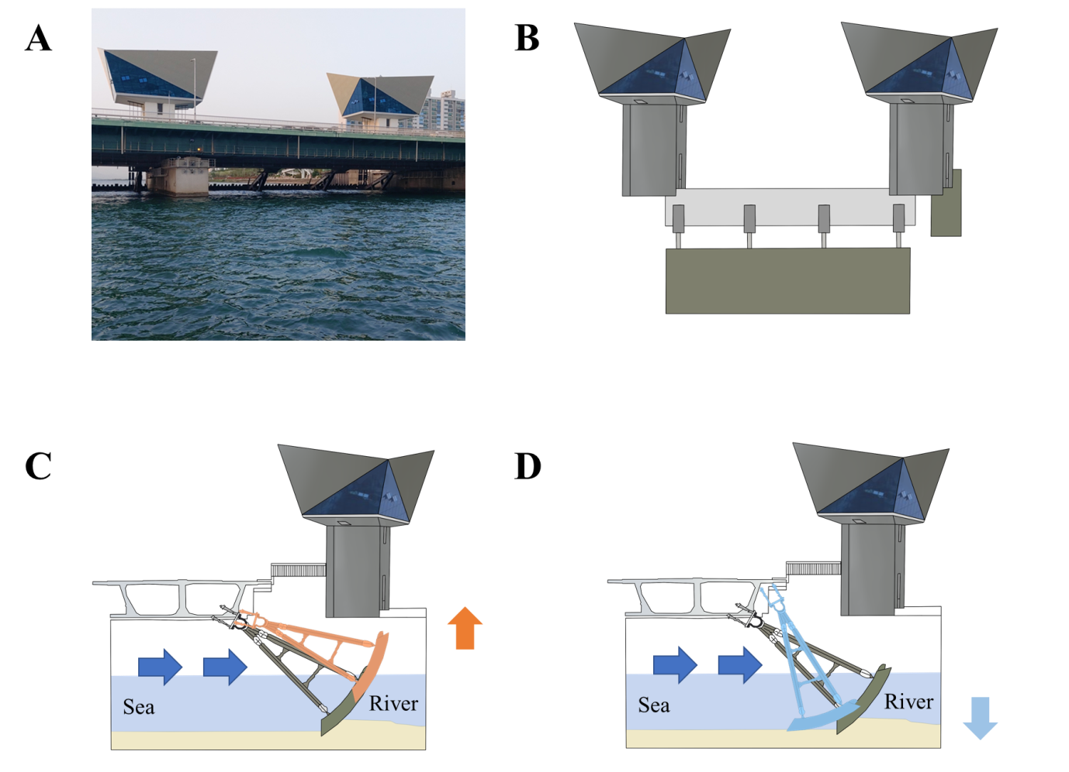**Supplementary Figure 1.** Diverse regulatory gate forms. (A) The picture of regulatory gate (gate number 9). (B) The regulatory gate remains closed, blocking freshwater and seawater mixing. (C) The underflow and (D) the overflow method for opening the regulatory gate

.



**Supplementary Figure 2.** The patterning results for species type of fish individuals on the SOM plane. Colour scale is related to distances between map units. Black colours represent large distances and white colours represent small distances. The red line indicates the division of the clusters into five groups according to SOM results.



**Supplementary Figure 2.** Continue

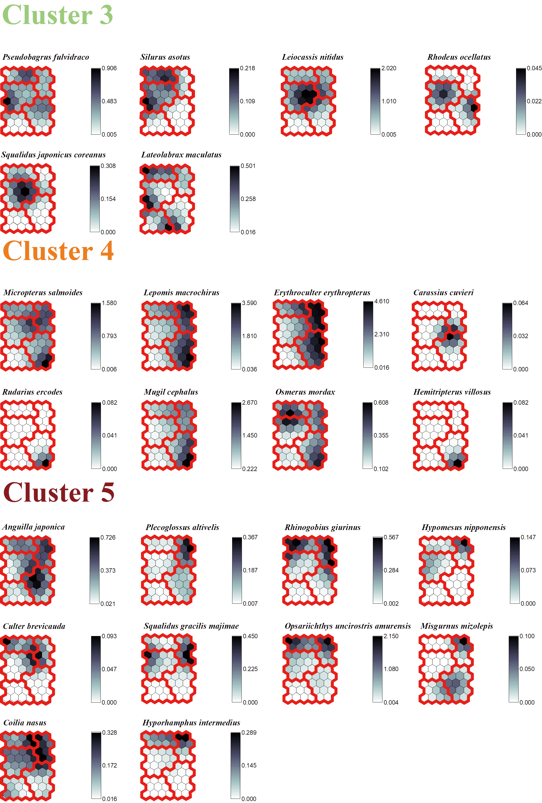

**Supplementary Figure 2.** Continue

## Supplementary Tables

**Supplementary Table 1.** Specific information of opening experiments conducted.

|  |  |  |  |  |  |  |
| --- | --- | --- | --- | --- | --- | --- |
| Number of Experiment | Starting date | Experiment duration | Total amount of seawater intruded | | | |
| ton | | Percentage (%) | |
| 1st | 26th of April, 2021 | 25days | | 1,790,000 | | 17.6 |
| 2rd | 22th of June, 2021 | 28days | | 2,070,000 | | 20.4 |
| 3th | 20th of August, 2021 | 32days | | 3,680,000 | | 36.2 |
| 4th | 19th of October, 2021 | 25days | | 970,000 | | 9.5 |
| Total of 2021 | | 110days | | 8,510,000 | | 83.7 |
| 5th | 17th of February, 2022 | 2days | | 41,620 | | 0.4 |
| 6th | 18th of April, 2022 | 2days | | 127,002 | | 1.2 |
| 7th | 30th of April, 2022 | 3days | | 55,205 | | 0.5 |
| 8th | 16th of May, 2022 | 2days | | 105,810 | | 1.0 |
| 9th | 30th of May, 2022 | 4days | | 210,732 | | 2.1 |
| 10th | 29th of August, 2022 | 4days | | 128,238 | | 1.3 |
| 11th | 12th of September, 2022 | 3days | | 220,896 | | 2.2 |
| 12th | 26th of September, 2022 | 5days | | 335,334 | | 3.3 |
| 13th | 6th of October, 2022 | 6days | | 434,802 | | 4.3 |
| Total of 2022 | | 31days | | 1,659,639 | | 16.3 |

**Supplementary Table 2.** Specific information of survey date by NRE re-opening. OP, opening period; CP, closing period

|  |  |  |
| --- | --- | --- |
| Number of Experiment | Survey date | NRE re-opening |
|
| 1st | 22th of April, 2021 | CP |
| 2rd | 08th of May, 2021 | OP |
| 3th | 17th of June, 2021 | CP |
| 4th | 21th of June, 2021 | OP |
| 5th | 01st of July, 2021 | OP |
| 6th | 26st of July, 2021 | OP |
| 7th | 16th of August, 2021 | CP |
| 8th | 09th of September, 2021 | OP |
| 9th | 14th of September, 2021 | OP |
| 10th | 11th of October, 2021 | CP |
| 11th | 23th of October, 2021 | CP |
| 12th | 09th of November, 2021 | OP |
| 13th | 24th of November, 2021 | OP |
| 14th | 02rd of May, 2022 | OP |
| 15th | 13th of May, 2022 | OP |
| 16th | 27th of May, 2022 | OP |
| 17th | 25th of June, 2022 | OP |
| 18th | 28th of July, 2022 | CP |
| 19th | 26th of August, 2022 | CP |
| 20th | 30th of September, 2022 | OP |
| 21st | 02rd of November, 2022 | OP |
| 22nd | 18th of November, 2022 | OP |
| 23rd | 13th of April, 2023 | CP |
| 24th | 18th of May, 2023 | CP |
| 25th | 16th of June, 2023 | CP |
| 26th | 03th of August, 2023 | CP |
| 27th | 24th of August, 2023 | CP |

**Supplementary Table 3.** Specific information of sites

|  |  |  |  |
| --- | --- | --- | --- |
| No. | Site | GPS | |
| N | E |
| 1 | A-1 | 35°05′46.97″ | 128°57′02.11″ |
| 2 | A-2 | 35°04′37.39 | 128°56′24.58″ |
| 3 | A-3 | 35°03′28.59″ | 128°55′28.91″ |
| 4 | B | 35°06′42.94″ | 128°56′59.09″ |
| 5 | C | 35°08′54.47″ | 128°57′27.59″ |
| 6 | D | 35°11′27.20″ | 128°58′36.47″ |
| 7 | E | 35°12′25.39″ | 128°59′22.70″ |
| 8 | F | 35°14′21.94″ | 128°59′47.84″ |

**Supplementary Table 4.** Comparison of water quality parameters in the surface water Closing period and Opening period in the Nakdong River Estuary (NRE). DO: dissolved oxygen; BOD: biological oxygen demand; TN: total nitrogen; TP: total phosphorus; The bold character indicates significant p-values; *, *p* < 0.05; **, *p* < 0.01; ***, *p* < 0.001

| Sites | Water quality | Closing period (n= 12) | | | | | Opening period (n= 15) | | | | |
| --- | --- | --- | --- | --- | --- | --- | --- | --- | --- | --- | --- |
| Mean | Standard deviation | Standard error | Min. | Max. | Mean | Standard deviation | Standard error | Min. | Max. |
| A | Water temperature (℃) | 23.1 | 4.5 | 1.9 | 15.4 | 28.5 | 20.7 | 4.9 | 1.2 | 12.7 | 29.2 |
|  | DO (mg/L) | 7.6 | 1.2 | 0.5 | 5.6 | 8.9 | 8.6 | 1.6 | 0.4 | 6.9 | 12.8 |
|  | BOD | 1.7 | 0.8 | 0.3 | 0.6 | 2.8 | 1.7 | 0.6 | 0.1 | 0.8 | 3.1 |
|  | TN (mg/L) | 1.5 | 0.2 | 0.1 | 1.2 | 2.1 | 1.7 | 0.7 | 0.2 | 1.0 | 3.4 |
|  | TP (mg/L) | 0.1 | 0.0 | 0.0 | 0.0 | 0.1 | 0.0 | 0.0 | 0.0 | 0.0 | 0.1 |
|  | **Conductivity (10 3 ×μS/㎝) \*\*\*** | **267.2** | **90.0** | **36.7** | **113.7** | **402.4** | **285.6** | **40.9** | **10.2** | **218.8** | **340.9** |
|  | **Salinity (psu) \*\*** | **13.8** | **1.9** | **0.8** | **10.2** | **14.8** | **18.4** | **5.0** | **1.2** | **11.7** | **28.1** |
| B | Water temperature (℃) | 24.0 | 4.9 | 2.0 | 15.0 | 29.0 | 21.3 | 4.9 | 1.2 | 13.0 | 29.1 |
|  | **DO (mg/L) \*** | **8.8** | **1.6** | **0.6** | **7.0** | **11.5** | **9.3** | **0.9** | **0.2** | **7.6** | **11.1** |
|  | BOD | 2.2 | 0.3 | 0.1 | 1.3 | 3.7 | 1.8 | 1.0 | 0.2 | 0.7 | 3.8 |
|  | **TN (mg/L) \*\*\*** | **3.2** | **0.6** | **0.3** | **1.2** | **6.3** | **2.1** | **0.4** | **0.1** | **1.3** | **3.2** |
|  | TP (mg/L) | 0.0 | 0.0 | 0.0 | 0.0 | 0.1 | 0.0 | 0.0 | 0.0 | 0.0 | 0.1 |
|  | **Conductivity (μS/㎝) \*** | **347.0** | **59.4** | **24.2** | **163.6** | **694.0** | **466.7** | **241.3** | **60.3** | **139.0** | **966.0** |
|  | **Salinity (psu) \*** | **0.1** | **0.0** | **0.0** | **0.1** | **0.2** | **0.2** | **0.1** | **0.0** | **0.1** | **0.5** |
| C | Water temperature (℃) | 24.0 | 4.8 | 1.9 | 14.7 | 28.7 | 21.5 | 4.7 | 1.2 | 13.2 | 28.8 |
|  | DO (mg/L) | 9.0 | 1.2 | 0.5 | 6.9 | 11.4 | 9.5 | 1.1 | 0.3 | 7.8 | 12.2 |
|  | BOD | 2.2 | 0.3 | 0.1 | 1.3 | 3.9 | 1.7 | 0.8 | 0.2 | 0.9 | 3.4 |
|  | **TN (mg/L) \*\*\*** | **3.2** | **0.5** | **0.2** | **1.3** | **6.6** | **2.1** | **0.4** | **0.1** | **1.3** | **3.1** |
|  | TP (mg/L) | 0.1 | 0.0 | 0.0 | 0.0 | 0.1 | 0.0 | 0.0 | 0.0 | 0.0 | 0.1 |
|  | **Conductivity (μS/㎝) \*** | **317.0** | **45.0** | **18.4** | **185.6** | **533.0** | **384.6** | **157.2** | **40.6** | **147.5** | **667.0** |
|  | **Salinity (psu) \*** | **0.1** | **0.0** | **0.0** | **0.1** | **0.2** | **0.2** | **0.1** | **0.0** | **0.1** | **0.4** |

**Supplementary Table 4.** Continue

|  |  |  |  |  |  |  |  |  |  |  |  |
| --- | --- | --- | --- | --- | --- | --- | --- | --- | --- | --- | --- |
| D | Water temperature (℃) | 24.1 | 4.5 | 1.9 | 14.8 | 28.5 | 21.6 | 4.6 | 1.1 | 13.3 | 28.5 |
|  | DO (mg/L) | 9.3 | 1.3 | 0.5 | 6.9 | 12.6 | 9.6 | 1.4 | 0.3 | 7.9 | 13.2 |
|  | BOD | 2.0 | 0.5 | 0.2 | 1.0 | 2.9 | 1.7 | 0.7 | 0.2 | 0.9 | 3.4 |
|  | **TN (mg/L) \*\*\*** | **3.2** | **0.4** | **0.2** | **1.2** | **6.3** | **2.1** | **0.5** | **0.1** | **1.3** | **3.1** |
|  | TP (mg/L) | 0.0 | 0.0 | 0.0 | 0.0 | 0.1 | 0.0 | 0.0 | 0.0 | 0.0 | 0.1 |
|  | Conductivity (μS/㎝) | 277.7 | 41.0 | 16.7 | 145.9 | 470.0 | 288.1 | 83.9 | 21.7 | 156.0 | 435.0 |
|  | **Salinity (psu) \*** | **0.1** | **0.0** | **0.0** | **0.1** | **0.2** | **0.1** | **0.1** | **0.0** | **0.1** | **0.3** |
| E | Water temperature (℃) | 24.1 | 4.7 | 1.9 | 14.8 | 28.7 | 21.5 | 4.5 | 1.1 | 13.3 | 29.1 |
|  | DO (mg/L) | 9.1 | 1.0 | 0.4 | 7.0 | 12.1 | 9.4 | 1.0 | 0.3 | 7.8 | 11.2 |
|  | BOD | 2.2 | 0.5 | 0.2 | 1.3 | 3.6 | 1.5 | 0.6 | 0.2 | 0.8 | 2.9 |
|  | **TN (mg/L) \*\*\*** | **3.2** | **0.5** | **0.2** | **1.3** | **6.2** | **2.2** | **0.4** | **0.1** | **1.4** | **3.1** |
|  | TP (mg/L) | 0.0 | 0.0 | 0.0 | 0.0 | 0.1 | 0.0 | 0.0 | 0.0 | 0.0 | 0.1 |
|  | Conductivity (μS/㎝) | 278.7 | 35.5 | 14.5 | 151.6 | 442.0 | 287.3 | 87.4 | 22.6 | 148.5 | 441.0 |
|  | Salinity (psu) | 0.1 | 0.0 | 0.0 | 0.1 | 0.2 | 0.1 | 0.0 | 0.0 | 0.1 | 0.2 |
| F | Water temperature (℃) | 24.2 | 4.9 | 2.0 | 14.6 | 29.3 | 21.4 | 4.4 | 1.1 | 13.3 | 29.6 |
|  | DO (mg/L) | 8.9 | 0.9 | 0.4 | 6.6 | 13.3 | 9.1 | 1.0 | 0.3 | 7.4 | 11.1 |
|  | BOD | 2.1 | 0.6 | 0.3 | 1.3 | 3.7 | 1.4 | 0.6 | 0.2 | 0.4 | 2.4 |
|  | TN (mg/L) | 3.4 | 0.6 | 0.2 | 1.3 | 6.2 | 2.3 | 0.4 | 0.1 | 1.4 | 3.1 |
|  | TP (mg/L) | 0.0 | 0.0 | 0.0 | 0.0 | 0.1 | 0.0 | 0.0 | 0.0 | 0.0 | 0.1 |
|  | Conductivity (μS/㎝) | 281.2 | 33.5 | 13.7 | 153.6 | 444.0 | 281.1 | 91.5 | 22.9 | 141.0 | 447.0 |
|  | Salinity (psu) | 0.1 | 0.0 | 0.0 | 0.1 | 0.2 | 0.1 | 0.0 | 0.0 | 0.1 | 0.3 |